PROJECT DIRECTOR

User Manual
  - Photo • Video • Animation • GIF
Web editor • Project version 0.1.0 • Updated August 5, 2026

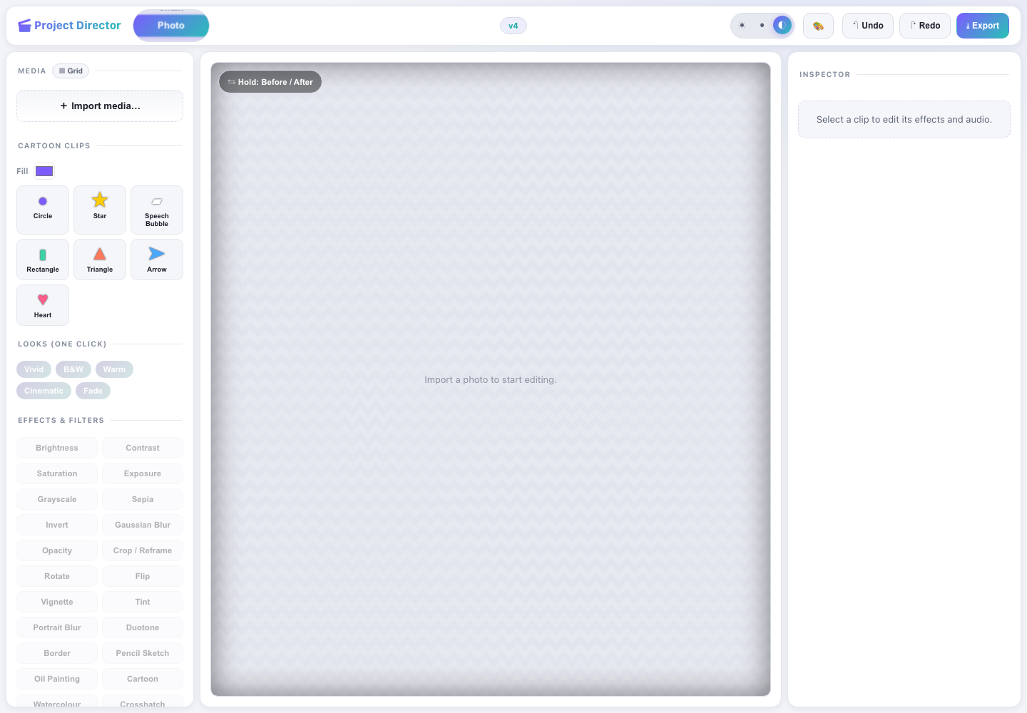
The Project Director workspace. Use the wheel at the top left to change editing modes.
What this manual covers The current web editor in this repository: importing media, editing clips, animation, timelines, export, themes, undo/redo, and the mode-specific tools visible in the live application.

Contents
Section | What you will learn
1. Quick start | Launch the editor and create a first project.
2. Workspace tour | Find the wheel, media bin, preview, Inspector, and timeline.
3. Shared editing tools | Import, selection, effects, animation, transitions, themes, and history.
4. Photo mode | Edit a still image and export PNG.
5. Video mode | Arrange, animate, edit, preview, and export MP4.
6. Animation mode | Build motion from cartoon clips, presets, and keyframes.
7. GIF mode | Configure and export an optimized animated GIF.
8. Export guide | Choose settings and understand browser requirements.
9. Shortcuts | Work faster with keyboard and wheel controls.
10. Troubleshooting | Resolve common import, encoder, and export problems.

1. Quick start

Requirements
- Node.js 20 or newer and pnpm 9 when running from source.
- A modern desktop browser. Chromium-based browsers are recommended for MP4 export because video export requires WebCodecs.
- Enough memory for the source media and rendered frames. GIF export intentionally caps the base render at 300 frames.

Launch the web editor
- Open a terminal in the repository root.
- Install dependencies with pnpm install if they are not already installed.
- Start the editor with the command below.
- Open the local URL printed by Vite, normally http://localhost:5173/.
pnpm --filter @director/web dev
Non-destructive by design Imported originals are never overwritten. Edits are represented as project operations, and exports create new downloadable files.

Your first edit
- Choose Photo, Video, Animation, or GIF on the mode wheel.
- Click Import media… and select an image, video, or audio file—or choose a Cartoon Clip in Animation mode.
- Select the clip in the preview, media bin, or timeline.
- Apply a Look, effect, animation preset, transition, or mode-specific tool.
- Use Undo/Redo to review the change.
- Click Export and choose the output appropriate to the current mode.

2. Workspace tour

The uncluttered starting workspace before media is added.
Area | Purpose
Mode wheel | Switches among Photo, Video, Animation, and GIF. Click, scroll, drag vertically, or use arrow keys.
Media panel | Imports files, lists assets, creates cartoon clips, applies one-click Looks and effects, and displays command history.
Preview | Shows the composited result. Hold Before / After to compare the edited view with the original.
Inspector | Edits animation tracks, transitions, effect parameters, and audio gain/pan for the selected clip.
Transport | Start, previous frame, play/pause, next frame, seek, timecode, and duration controls.
Timeline | Adds tracks and arranges clips. Split, delete, select, drag, and zoom are available in timeline-based modes.
Top bar | Theme/skin controls, Undo, Redo, project version badge, and Export.

Using the mode wheel
- Mouse: click a mode, roll the wheel, or drag the drum vertically.
- Keyboard: focus the wheel and use Arrow keys. Home selects Photo; End selects GIF.
- Only controls relevant to the selected mode are emphasized. GIF settings, for example, appear only in GIF mode.

3. Shared editing tools

Import and timeline behavior
- Import accepts supported image, video, and audio files. A successfully decoded asset is registered and added to the appropriate timeline track.
- Images receive a default five-second duration. Video and audio duration comes from browser metadata when available.
- Use the + button beside a media item to place another instance on the timeline.
- Select a clip before applying effects, animation, transitions, audio controls, Split, or Delete.
- Dragged clips snap to clip edges, the playhead and the sequence start; hold Alt while dropping to place a clip exactly where it is released. Each clip edge carries a trim handle, and holding Shift while trimming ripples the later clips on that track.
- Shift-click or Cmd/Ctrl-click selects several clips. Delete removes them; Ripple Delete removes them and closes the gap behind them. Each gesture is a single Undo step, however many clips it moved.
- Clip speed runs from 0.25x to 4x under Speed in the Inspector. Retiming keeps the same frames and spreads them over more or less timeline, and the clips after it ripple to make room or close the gap. Audio is resampled with the picture, so a slowed clip drops in pitch; pitch-preserving stretch is not implemented.

Looks and effects
- One-click Looks: Vivid, B&W, Warm, Cinematic, and Fade. A Look adds an editable effect stack.
- Common effects include brightness, contrast, saturation, exposure, blur, opacity, crop/reframe, rotate, flip, artistic treatments, text, and background removal.
- Photo-focused choices include grayscale, sepia, vignette, tint, portrait blur, duotone, and border. Video adds hue rotation and retro noise.
- Colour grading, in Photo and Video mode: White Balance (Warmth, Tint), Levels (Blacks, Whites, Gamma), Tone Curve (Shadows, Midtones, Highlights), and Vibrance. Grading is applied before artistic treatments and is included in every export.
- Every effect is adjustable and removable in the Inspector. Undo removes command-based edits in reverse order.
- Audio effects on any clip that carries sound: Fade In / Out, EQ (low, mid and high in dB) and Compressor (threshold, ratio, attack, release and makeup gain). They sit under Audio in the Inspector, beside gain and pan.

Animation and transitions on visual clips
- Animate Position X, Position Y, Scale, Rotation, and Opacity.
- Choose linear, hold, ease-in, ease-out, or ease-in-out between keyframes.
- Crossfade and dip transitions are edited per clip. Crossfade blends with content underneath; dip ramps against its selected color.

4. Photo mode
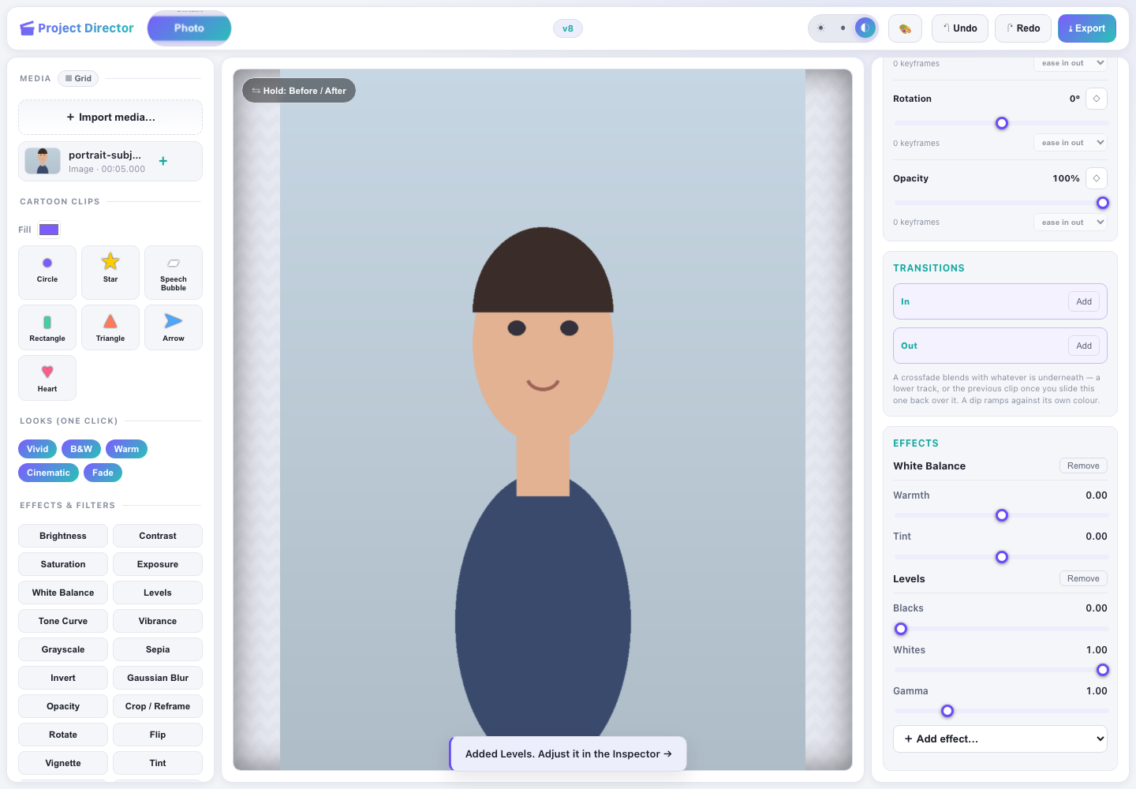
Example: a portrait image selected in Photo mode. Photo tools are on the left; AI removal and animation controls appear in the Inspector.

Best for
Single-image correction, creative styling, precise pixel edits, portrait cleanup, captions, background removal, and PNG export.

Photo features
Feature group | Available tools
Fast styling | Vivid, B&W, Warm, Cinematic, Fade.
Adjustments | Brightness, contrast, saturation, exposure, grayscale, sepia, invert, blur, opacity, crop/reframe, rotate, flip, vignette, tint.
Creative effects | Portrait Blur, Duotone, Border, Pencil Sketch, Oil Painting, Cartoon, Watercolour, Crosshatch, Halftone, Text.
Raster editor | Move, Crop, Transform, Brush, Eraser, Clone Stamp, Lasso, Magic Wand, Sharpen, Smart Fill, Remove Background, AI Remove Background.
Motion on stills | Position, scale, rotation, opacity, keyframes, easing, and Auto Motion presets.
Output | Current composited frame exported as a full-resolution PNG.

Example: polish a portrait and remove its background
- Select Photo on the wheel.
- Import a portrait image. The image appears in the preview and media panel.
- Select Warm for a quick look, or add Brightness and Portrait Blur individually.
- Grade the image: add White Balance to correct the light, Levels to set the contrast window, Tone Curve to move shadows or highlights on their own, and Vibrance to strengthen muted colour without oversaturating skin.
- Hold Before / After to compare the edit with the source.
- For one-click subject isolation, choose AI Remove Background. For manual control, choose Edit Photo and use Lasso, Magic Wand, Eraser, or Clone Stamp.
- Inside the raster editor, click Apply to create a new edited asset. Raster strokes remain provisional until Apply.
- Click Export. Project Director downloads export.png at the current cropped/native frame size.
Photo-mode detail The main timeline is hidden to keep still-image work focused, but the selected image remains a five-second clip internally. This is why animation controls such as Ken Burns are available.

5. Video mode
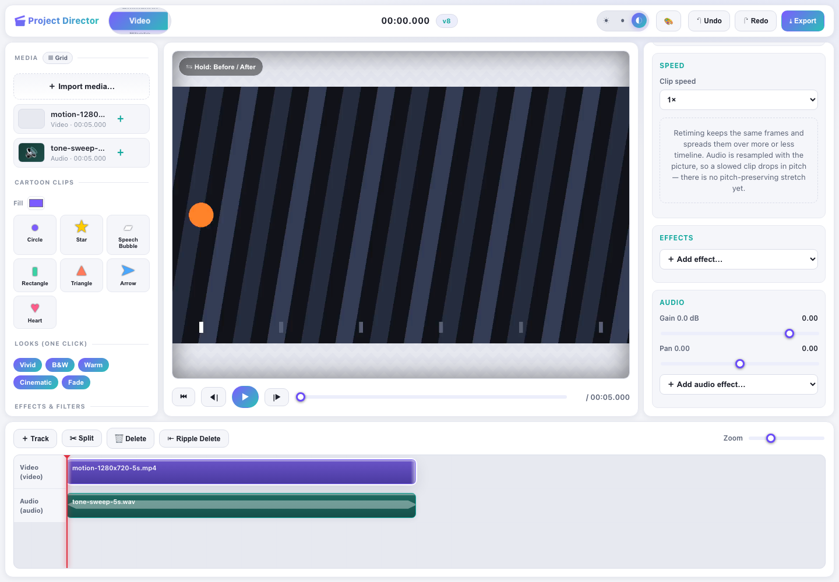
Example: a five-second MP4 on the timeline in Video mode, with transport and clip animation controls visible.

Best for
Timeline editing, visual effects, current-frame retouching, motion/keyframe work, transitions, audio gain/pan, and browser-rendered MP4 export.

Video features
Feature group | Available tools
Timeline | Video/audio tracks, sequential clip placement, clip selection, split, delete, drag, and zoom.
Playback | Go to start, previous frame, play/pause, next frame, seek, timecode, and synchronized audio monitoring.
Visual editing | Brightness, contrast, saturation, exposure, hue rotation, invert, Gaussian blur, opacity, crop/reframe, rotate, flip.
Creative effects | Retro Noise, Pencil Sketch, Oil Painting, Cartoon, Watercolour, Crosshatch, Halftone, Text, Remove Background.
Frame retouching | Edit Current Frame opens Brush, Clone, Magic Wand, and related raster tools; applying creates an edited image asset at the playhead.
Motion and transitions | Five animation properties, nine Auto Motion presets, keyframes, easing, crossfade, and dip.
Audio | Per-clip gain from −60 to +12 dB and stereo pan from left to right.
Output | H.264 video in MP4; audio is mixed and encoded when compatible audio is present.

Example: make a short stylized video
- Select Video and import an MP4 or MOV supported by your browser.
- Use Play or Space to preview. Drag the seek slider to inspect another time.
- Move the playhead and click Split to divide the selected clip. Delete unwanted segments.
- Trim by dragging a clip edge, reorder by dragging the clip itself, and use Ripple Delete to remove a clip without leaving a hole.
- Apply the Cinematic Look, then adjust its effect stack in the Inspector.
- Add colour grading to match shots to one another: White Balance, Levels, Tone Curve, and Vibrance are available on video clips too.
- Choose Pan Left or Drift under Auto motion and click Apply.
- Add crossfade or dip transitions where appropriate.
- Set audio Gain and Pan for clips that carry audio.
- Pick a clip speed under Speed if a shot should run fast or slow.
- Shape the sound: add Fade In / Out, EQ or Compressor under Audio. Sliding two clips over each other on one audio track crossfades them automatically at equal power, so the overlap neither dips nor clips.
- Click Export, choose 1080p, 720p, or 480p and a High, Medium, or Low bitrate, then start the MP4 export.
Browser requirement MP4 export uses VideoEncoder, AudioEncoder, and VideoFrame. If the browser reports that WebCodecs is unavailable, use a recent Chromium-based browser in a permitted/secure context.

6. Animation mode
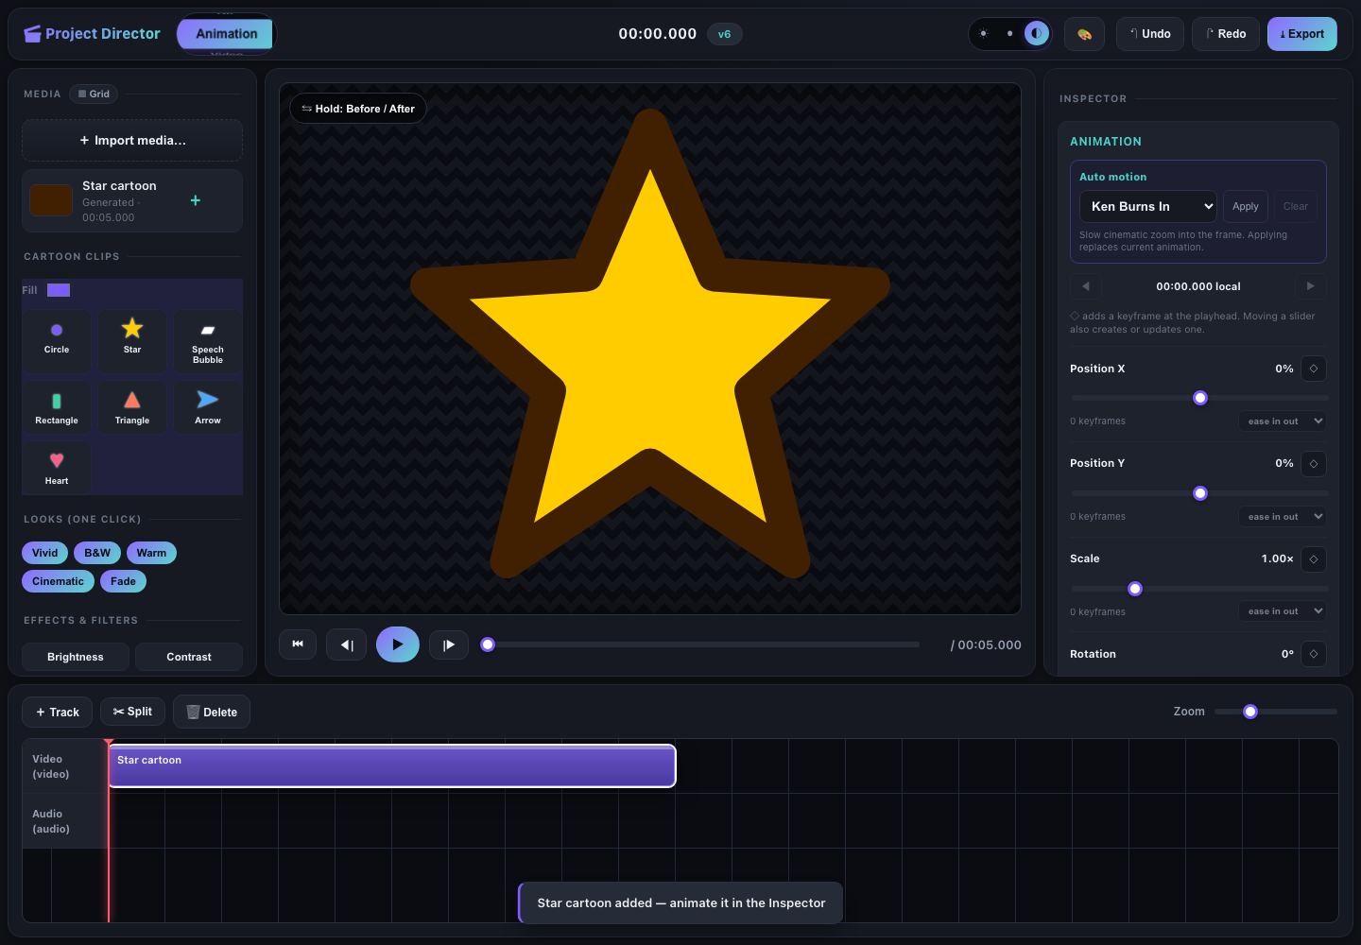
Example: a generated Star cartoon clip in Animation mode. The preview, timeline, Auto Motion control, and manual keyframe controls are all active.

Best for
Motion graphics made from generated shapes, imported images, or video clips—without requiring an external animation package.

Animation features
Feature | How it works
Cartoon clips | Circle, Star, Speech Bubble, Rectangle, Triangle, Arrow, and Heart. Set a fill color before adding a shape.
Auto Motion | Ken Burns In, Ken Burns Out, Pan Left, Pan Right, Fade In, Fade Out, Pop, Drift, and Loop Pulse.
Manual keyframes | At the playhead, use the diamond beside Position X/Y, Scale, Rotation, or Opacity. Moving a slider also creates or updates a keyframe.
Navigation | Previous/next keyframe buttons jump through authored points. Timeline diamonds mark keyframe times.
Easing | Linear, hold, ease-in, ease-out, and ease-in-out.
Shared styling | Looks, photo-oriented effects, artistic filters, Text, and transitions remain available.
Output | Use Export for MP4, or switch to GIF mode to configure a looping GIF from the same timeline.

Example: create a pulsing star
- Select Animation on the wheel.
- Choose a fill color and click Star under Cartoon Clips. A generated five-second clip appears on the timeline.
- Select Loop Pulse under Auto motion and click Apply. The preset creates scale keyframes that return to the starting value for a seamless loop.
- Press Play to preview. Adjust the Scale keyframes or easing if the pulse is too strong.
- Optionally add Rotation keyframes: place the playhead at the start, add a 0° keyframe; move near the end, set 360°, and add/update the keyframe.
- Export as MP4, or select GIF and configure the loop settings.
Undo-friendly presets Applying an Auto Motion preset replaces the current animation as one command. Undo removes the whole preset instead of requiring one undo per generated keyframe.

7. GIF mode
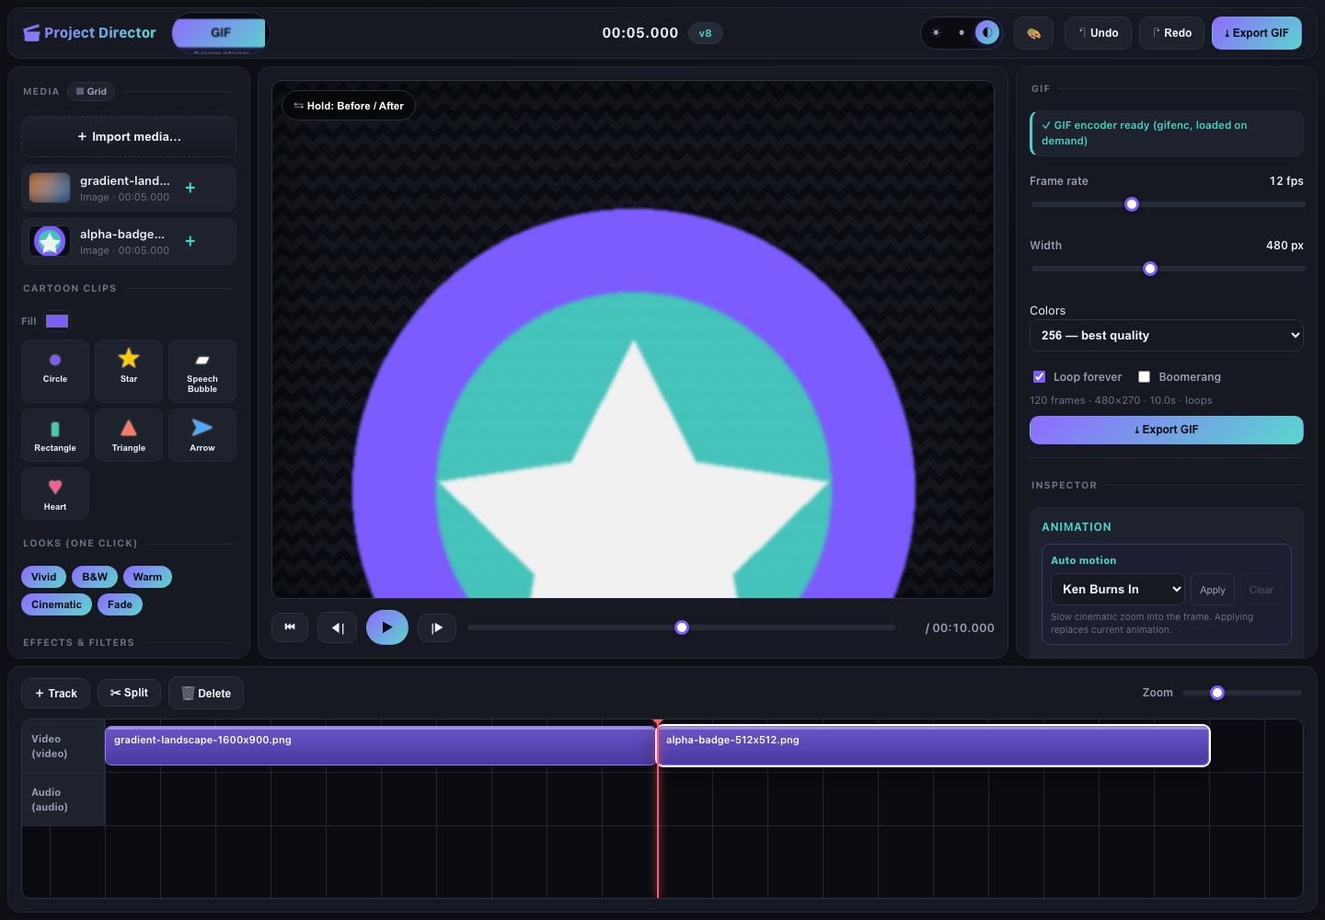
Example: two still images form a ten-second GIF timeline. The right panel shows encoder status, frame rate, width, palette, loop, boomerang, and output summary.

Best for
Short looping animations assembled from photos, video, generated shapes, effects, transitions, and keyframed motion.

GIF controls
Control | Range or behavior
Frame rate | 2–30 fps; default 12 fps.
Width | 120–960 px in 40 px steps; default 480 px. Height follows the source aspect ratio.
Colors | 256 for best quality, 128 for a smaller file, or 64 for the smallest palette.
Loop forever | Enabled by default.
Boomerang | Appends the reverse frame order for forward-and-back playback.
Summary | Displays frame count, output dimensions, estimated duration, and loop/play-once state.
Encoder | gifenc loads on demand when GIF mode is selected.
Frame cap | The base render is capped at 300 frames to prevent excessive memory use.

Example: create a looping two-photo GIF
- Select GIF on the wheel. Wait for “GIF encoder ready.”
- Import two photos. They appear sequentially on the video track.
- Choose 12 fps, 480 px, and 256 colors for a balanced starting point.
- Leave Loop forever enabled. Enable Boomerang if you want the sequence to reverse before repeating.
- Add Fade In/Out keyframes or transitions if the cut is too abrupt.
- Review the live summary, then click Export GIF. The editor renders the same effects, crops, layers, and animation shown in the preview.
File-size tuning Reduce width first, then frame rate, then colors. These changes usually save more space than shortening a palette alone.

8. Export guide
Current mode | Export result | Important details
Photo | PNG | Exports the composited frame at native/post-crop size with effects baked in.
Video | MP4 | H.264 video, optional Opus audio mix, selectable resolution and bitrate; requires browser WebCodecs.
Animation | MP4 | Uses the same timeline renderer as Video, including shapes, effects, keyframes, transitions, and audio.
GIF | GIF | gifenc palette encoder; selectable frame rate, width, colors, loop, and boomerang.

Video presets
Resolution | Dimensions
1080p | 1920 × 1080
720p (default) | 1280 × 720
480p | 854 × 480

Quality | Video bitrate
High | 12 Mbps
Medium (default) | 8 Mbps
Low | 4 Mbps

Before exporting
- Select the intended mode. Photo and GIF use direct mode-specific export; Video and Animation open the video export dialog.
- Preview the full timeline, including transitions and audio.
- Check the selected clip’s effect stack and animation tracks in the Inspector.
- For GIF, confirm that the encoder status says ready and review the frame/duration summary.
- Do not close the tab during rendering. Video export can be cancelled from the progress dialog.

9. Shortcuts and efficient navigation
Input | Action
Cmd/Ctrl + Z | Undo the most recent project command.
Cmd/Ctrl + Shift + Z | Redo the most recently undone command.
Space | Play or pause when focus is on the page body.
Delete / Backspace | Delete the selected timeline clip when focus is on the page body.
Wheel Arrow keys | Move to the previous or next editor mode.
Wheel Home / End | Jump to Photo / GIF.
Before / After button | Press and hold to compare the current edit with the unprocessed source view.

10. Troubleshooting
Problem | What to do
A file does not import | Confirm that it is an image, video, or audio format the current browser can decode. Try a common PNG/JPEG or H.264 MP4.
The preview is blank | Select the clip, move the playhead inside its timeline range, and confirm the asset decoded successfully.
GIF encoder failed to load | Check network/module loading, then leave GIF mode and reselect it to retry.
GIF is too large | Lower width, frame rate, or palette colors; shorten the timeline; avoid unnecessary boomerang frames.
MP4 export is unavailable | Use a recent Chromium browser with WebCodecs and run in a permitted local or secure context.
AI background removal fails | Confirm the bundled U²-Net model and ONNX Runtime Web assets are reachable. Use manual Remove Background, Magic Wand, or Lasso as a fallback.
An effect button is disabled | Select a clip first. Effects and Looks require a current clip.
Undo does not reverse a brush stroke | Raster strokes use their own local Undo/Redo until Apply. After Apply, project Undo reverses the registered edited asset/operation.
Keyboard shortcut does nothing | Click an empty part of the page first. Global shortcuts intentionally avoid firing while a form control has focus.

Current scope and data safety
- Project Director does not modify imported source media.
- Command-driven edits are validated and recorded for undo, redo, and deterministic replay.
- Raster sessions, playback, and export progress are temporary session state; Apply or Export is required to keep their result.
- Downloaded exports are separate files. Keep source files and exports in locations you control.
Manual basis This document was generated from the live editor and current repository source on August 5, 2026. The included screenshots were captured from the running application, not mockups.

