Katleho Senqhe
202101690 · katlehochristophersenqhe@gmail.com
CS4433 – Software Engineering
Phase 6: Configuration Management and Quality Assurance
Phase 7: Deployment
Moderated Learning Management System (LMS)

Part A – Phase 6: Configuration Management

A.1 Repository
Hosted repository: https://github.com/katlehochristophersenqhe-maker/CS4433-LMS
The repository holds the full C++17 source, SQL schema, tests, documentation and CI configuration. Build instructions are in README.md and docs/BUILD.md.

A.2 Branching strategy
This individual project uses a main-based pull-request workflow; there is no develop branch:
- main – integration branch and source for releases; changes merge by pull request.
- feature/<name> – short-lived branch for one feature or fix.
- hotfix/<name> – urgent fix, also merged into main by pull request.
Feature and hotfix branches are reviewed and merged into main via pull request. CI runs on pushes to main/feature/**/hotfix/** and pull requests targeting main. Commit messages explain the change; see docs/BRANCHING.md.

A.3 Continuous integration
GitHub Actions workflow .github/workflows/ci.yml runs on pushes to main, feature/** and hotfix/**, and pull requests targeting main. It:
- Checks out the source on Ubuntu.
- Configures and builds with CMake and g++.
- Runs CTest against the configured lms_tests target and uploads the CTest log as an artifact.
The workflow builds lms and lms_tests with CMake on Ubuntu, runs CTest, and uploads build/Testing/Temporary/LastTest.log. The repository has an active CI workflow; consult GitHub Actions for run-specific status.

A.4 Tagged releases
Published release tags: v1.0 and v1.1. Tag v1.1 identifies the CR1 release; the current main branch has moved beyond it.
v1.0 points to 39e592c27ea6cbc388cf7690ae3ddee04d53c95b; v1.1 points to 81afa92567b43348c17821092a37c328f0df8c2c.
Published v1.1 release: https://github.com/katlehochristophersenqhe-maker/CS4433-LMS/releases/tag/v1.1.

Part B – Phase 6: Quality Assurance

B.1 Static analysis
cppcheck is used as the static analyser (allowed by the brief). Example command:
cppcheck 2.21.0 exhaustive analysis completed with exit code 0 and no unsuppressed diagnostics; see docs/QA_STATIC_ANALYSIS.md for exact command and suppressions.
Findings are recorded in docs/QA_STATIC_ANALYSIS.md. Each important warning is either fixed or justified. Re-run after fixes and keep the report under docs/.

B.2 Code metrics
Measured physical line counts across application source files in src/ and include/ (28 .cpp/.hpp/.h files), and five test .cpp files; tests/catch.hpp is excluded. These are source-line counts, not a cyclomatic-complexity measure.
Application LOC: 1,869 Test LOC: 367

B.3 Self code review
A checklist was applied against the Phase 3 design and coding standard (see docs/QA_STATIC_ANALYSIS.md). Examples of checks: abstract User and polymorphism present; all SQL behind repositories; parameterised queries; salted hashes; audit on mark change; .gitignore excludes databases and build products. Changes made after review are listed in the checklist table (Y / N / Fixed).

Part C – Phase 7: Deployment

C.1 Deployment diagram
Logical deployment topology: one school workstation runs the LMS console executable and uses a local SQLite database file; schema.sql initializes the database. No application server or runtime network connection is required. Backups may be copied to controlled school storage. This is a textual topology description, not an inserted UML diagram.
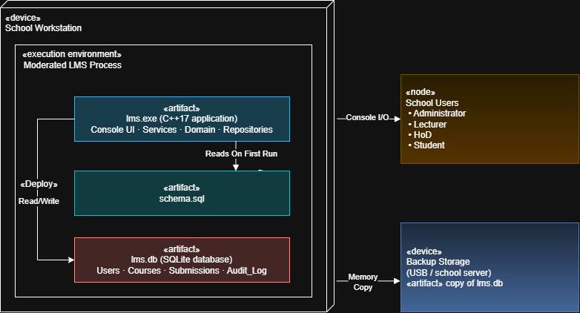

Runtime data is stored in lms.db in the application working directory; restrict workstation access and protect database backups because the SQLite file is not encrypted.

C.2 Installation guide
A technician-facing guide is provided in docs/INSTALLATION.md. The published v1.1 Windows x64 release is available on GitHub; source builds use CMake:
- Install a C++17 toolchain (MSYS2/MinGW on Windows, g++ on Linux).
- Download the v1.1 Windows x64 archive or clone the repository; the guide describes both source builds and release use.
- Configure and build with CMake (for example, cmake -S . -B build; cmake --build build).
- Run from the build folder; schema is applied and demo data may be seeded on first run.
- Back up lms.db regularly; change default passwords before real use.

C.3 User manuals
Role manuals are in docs/USER_MANUALS.md:
- Administrator – departments, users, courses, enrolment.
- Lecturer – assignments, marking with feedback, individual and class-wide deadline extensions; current main additionally supports browsing/selecting all available submissions.
- HoD – moderate (reason required if mark changes), release marks, and view released marks; an empty-state notification appears when there are no marked submissions to review.
- Student – list assignments, submit/resubmit, view released marks only.
Demo accounts for evaluation: admin/admin123, lec1/lec123, hod1/hod123, stu1/stu123.

C.4 Release notes
Release v1.0 introduced role-based access, late penalties, moderation, audit logging, SQLite storage and salted passwords. v1.1 added CR1 class-wide deadline extensions with migration support. See docs/RELEASE_NOTES_v1.0.md and docs/RELEASE_NOTES_v1.1.md. Known limitations include a console-only interface and a single local database file.
Current-main scope note
At the time of this report, main is commit 33305a6c22c3edd0345d218c8da73fd7d8561526, after the v1.1 tag. Lecturer-wide submission browsing and expanded presentation sample data are current-main changes and are not part of the v1.1 release package. Attribute these features to a later tagged release only after one is published.

References
GitHub Actions documentation. https://docs.github.com/actions
cppcheck. https://cppcheck.sourceforge.io/
Sommerville, I. (2016) Software Engineering. 10th ed. Harlow: Pearson.
CS4433 assignment brief – Phases 6 and 7.

