Case Study
In
Payroll Management System
SUBJECT: Database Administration

Created by:

Leah B. Ignacio
Irene Charisse D. Tolibas
Kin Kin Dizon
Raniel Fajardo
Student Name

Submitted to:

Yvon Salamones
Instructor

- Introduction

In today’s dynamic business environment, efficient payroll management is indispensable for fostering employee satisfaction and ensuring compliance with labor regulations. Many organizations, particularly small to medium-sized enterprises (SMEs), continue to rely on manual payroll processes, which are inherently error-prone, time-consuming, and unscalable. Traditional methods involving manual calculations, paper-based records, and fragmented data storage frequently result in delays, inaccuracies, and inefficiencies, ultimately undermining operational productivity. Recognizing these challenges, the Payroll Management System emerges as a digital solution designed to automate and streamline payroll operations, addressing critical gaps identified through research and stakeholder interviews.
A Payroll Management System offers a smarter solution. It automates salary computations, keeps employee data organized in one place, and gives managers real-time insights through reports and dashboards. This not only speeds up payroll processing but also improves accuracy, security, and decision-making.
In short, switching to a digital payroll system helps reduce admin work, ensures employees are paid correctly and on time, and gives businesses better control over their finances, setting them up for long-term success.

1.1 Purpose of the Project

The purpose of this project is to develop a Payroll Management System specifically designed for schools to simplify and organize the processing of staff salaries. The system enables administrators to manage employee records, assign departments and salary grades, and compute salaries accurately. It also features a dashboard for quick access to key payroll data and a salary history section to track previous payments. By centralizing employee information and automating salary calculations, the system reduces manual work, minimizes errors, and improves payroll efficiency within the school setting.

1.2 Scope of the project
The Payroll Management System is focused on internal use by school administrators or HR personnel. Key features include managing employee profiles, processing salaries, setting up departments and salary grades, and viewing salary history. The dashboard provides an overview of payroll statistics, and security features ensure that only authorized users can access sensitive information. While teachers and staff do not directly use the system, they benefit from timely and accurate salary disbursements, contributing to a more organized and transparent payroll process in the school.

2. Entity Relationship Diagram

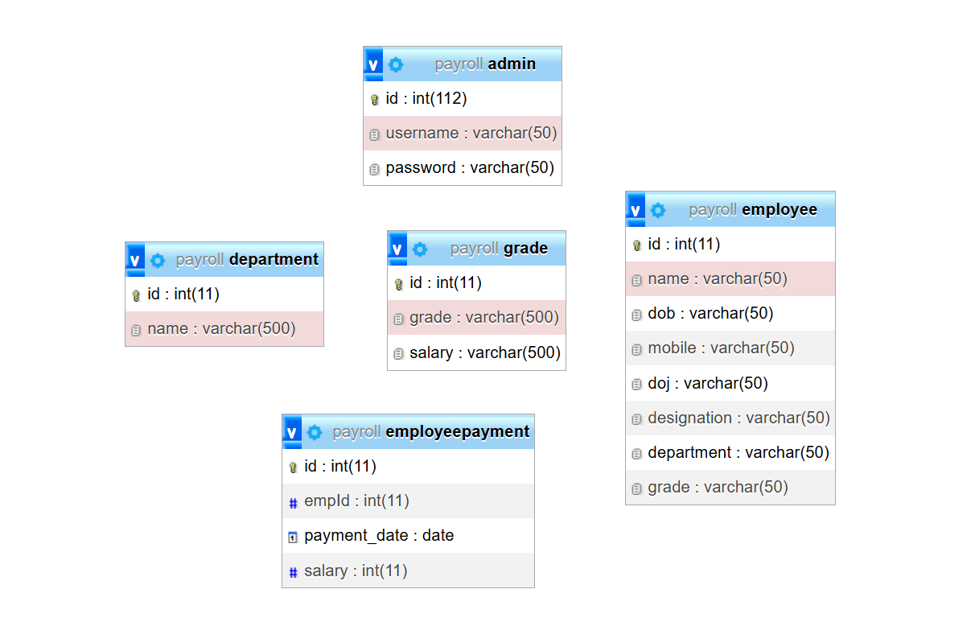

3. System’s Interface

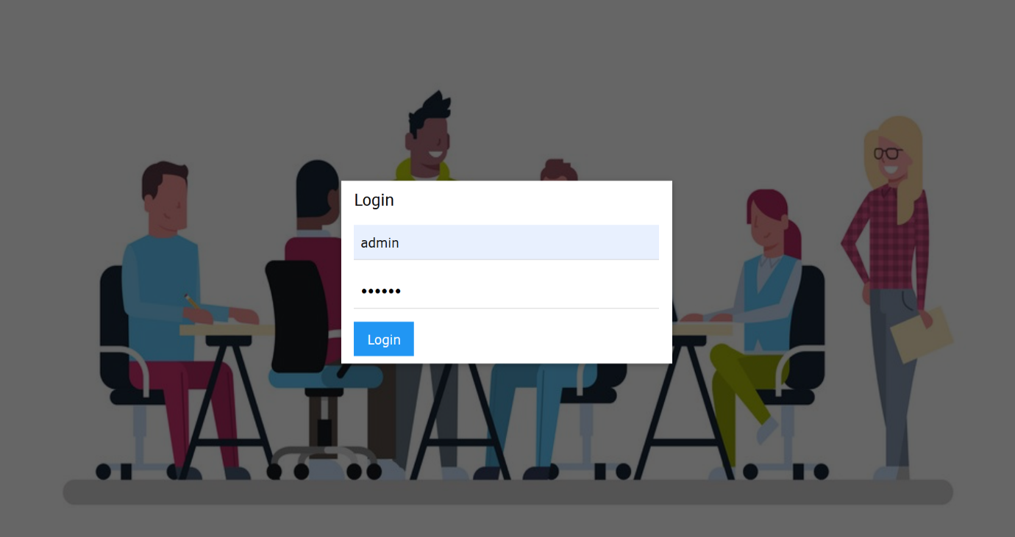
The Figure 1 shows the login interface where the user will input the given user name as well as the password to access the system.
Figure 1. Login Interface

Figure 2 shows the Dashboard of the System to see the total number of employee, total salary released and number of department.
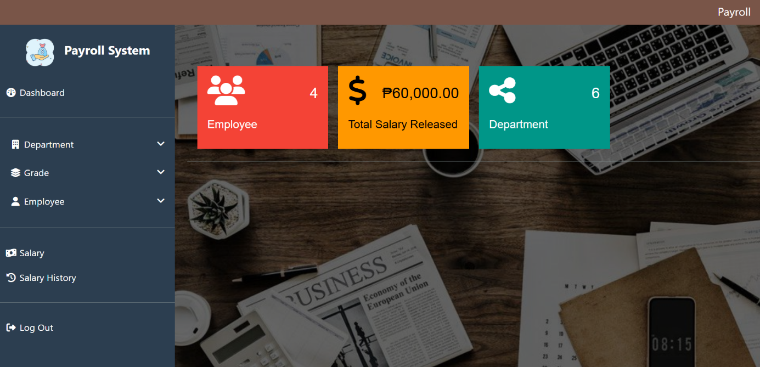

Figure 2. Dashboard Interface
The Figure 3 shows the Add Department interface where user can add new department and will be display the add department in the table. Also user can edit and delete it.
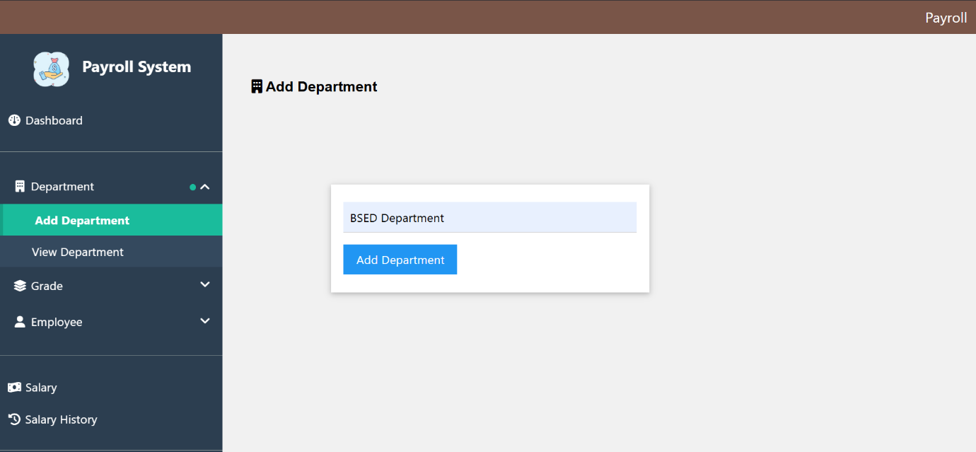

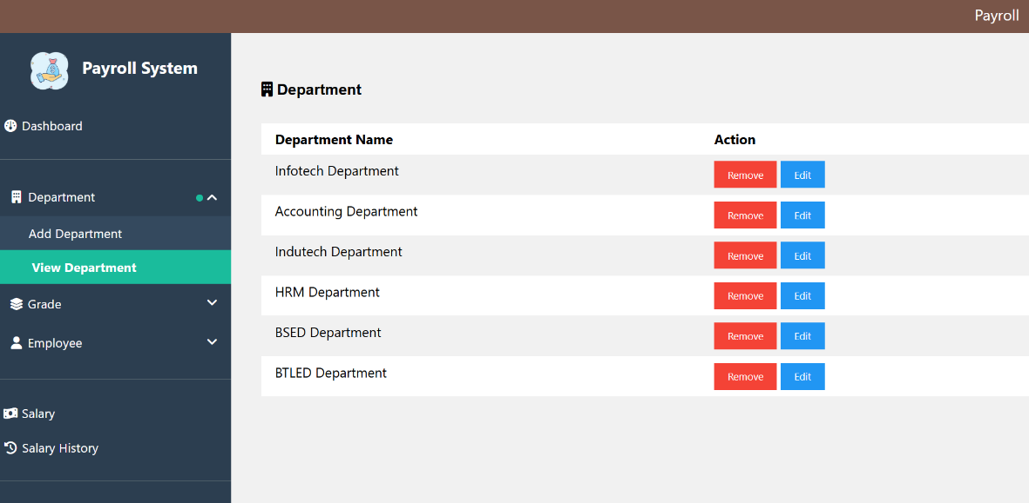

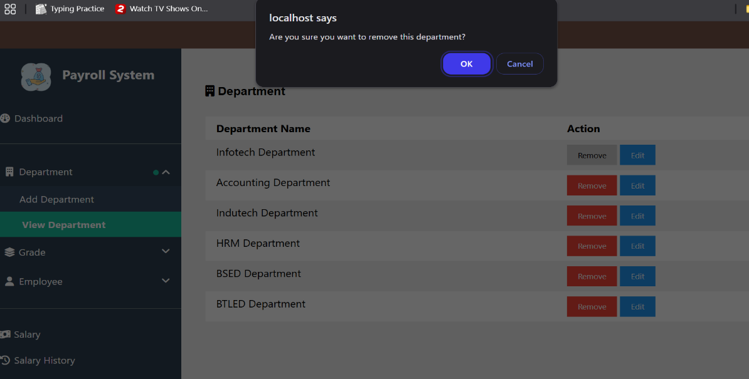

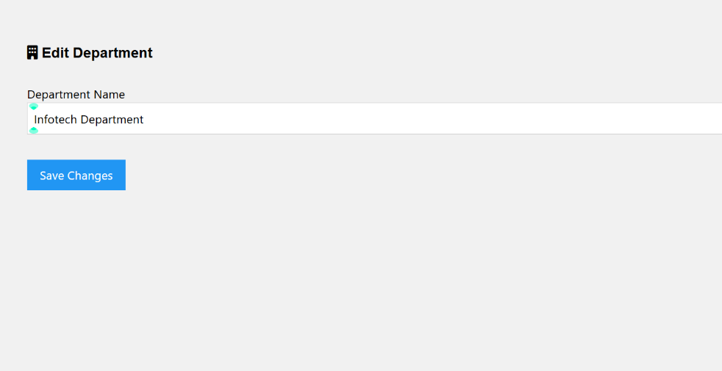

Figure 3. Add/View Department

The Figure 4 shows the add Grade Management interface to add the grade/assigned then displayed in the table when added it successfully. Also user can edit and delete.
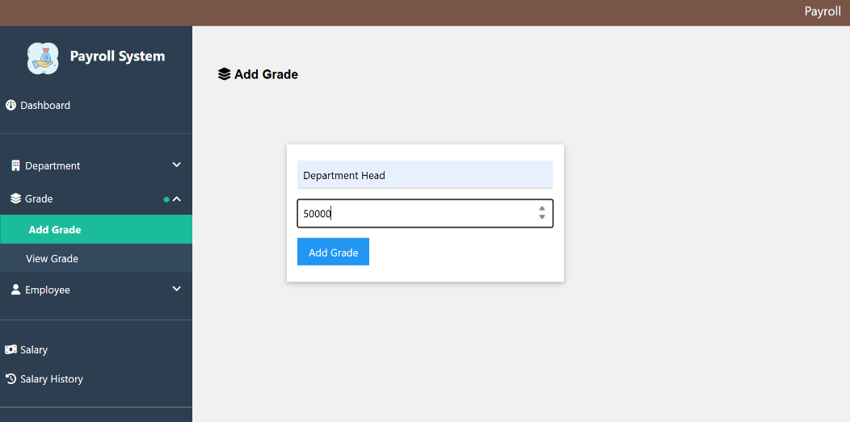

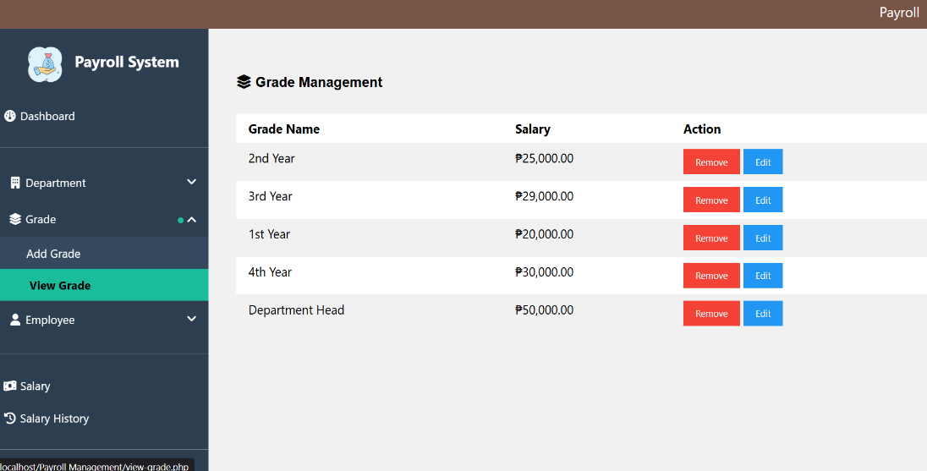

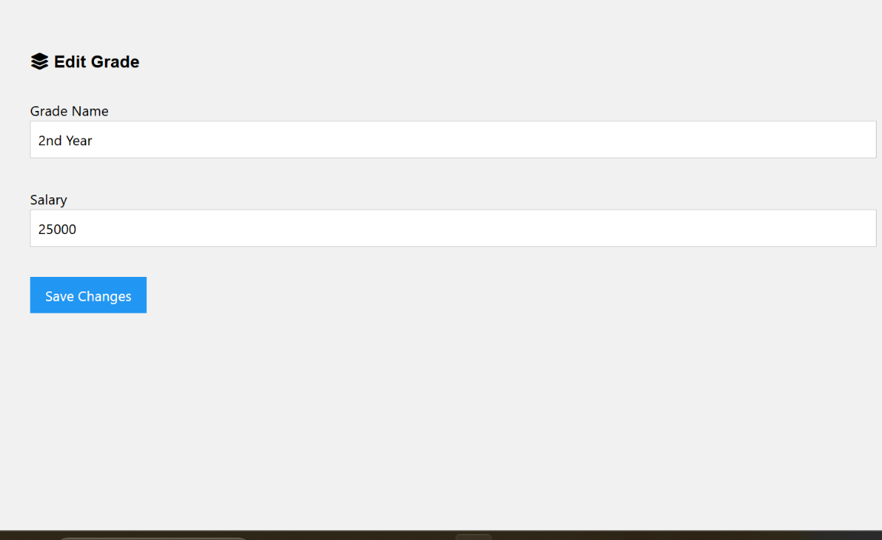

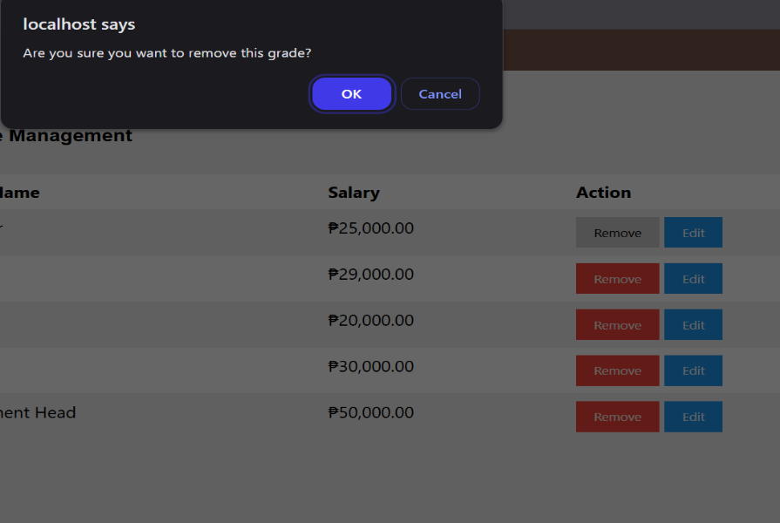

Figure 4. Add/View Grade Management

The Figure 5 shows the add Employee interface where user add the employee and then displayed in the table after added it successfully. Also user can edit and delete the employee.
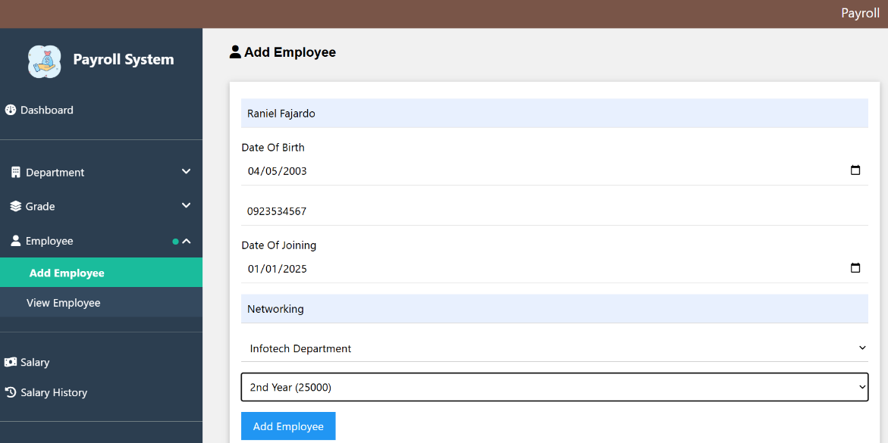

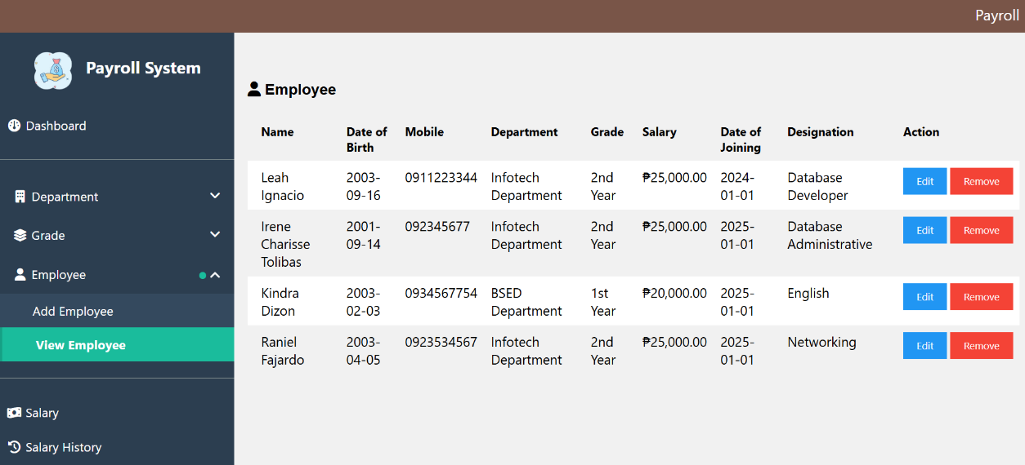

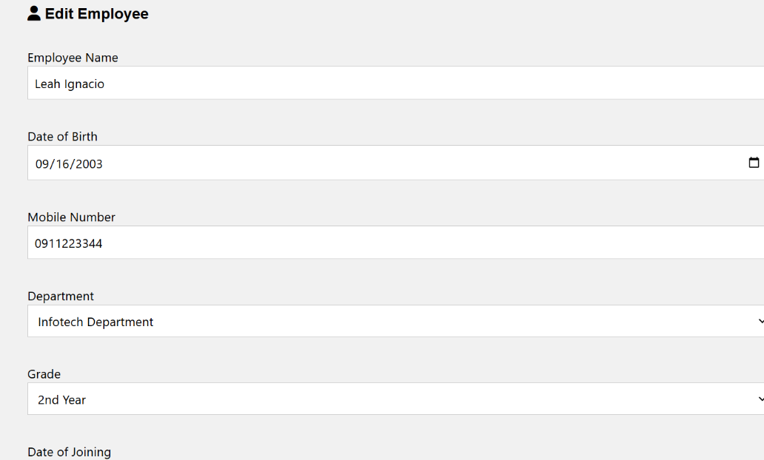

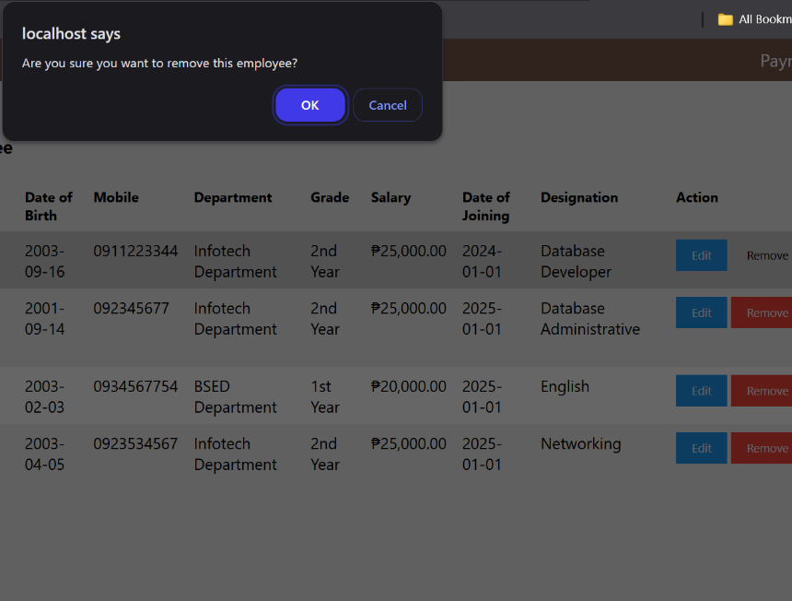

Figure 5. Add/View Employee
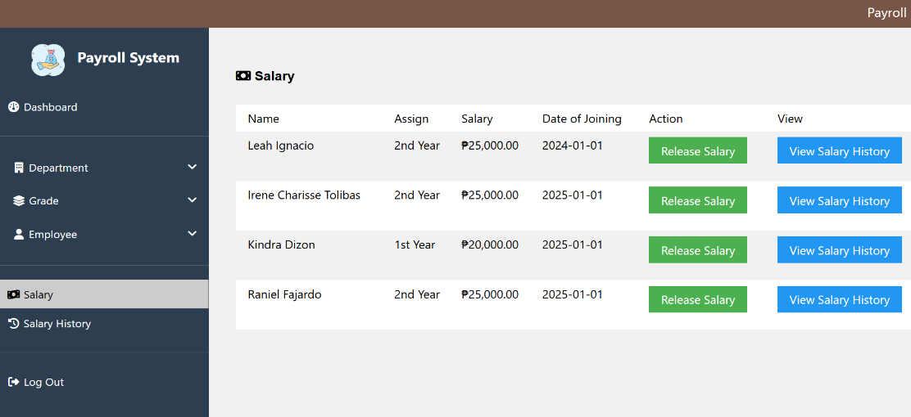
The Figure 6 shows the Salary Interface where user can release the salary of the employee and can view salary history on that employee. Also user can print the records of the salary released.

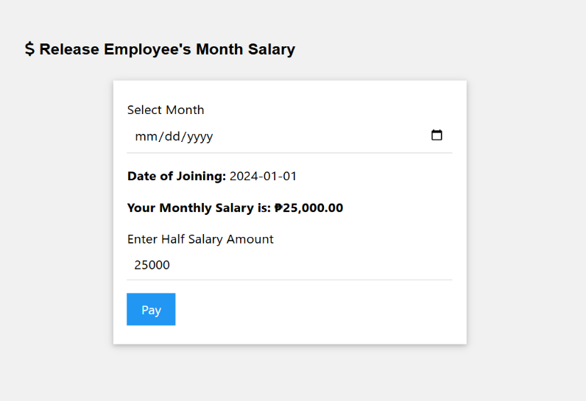
Release Salary Interface

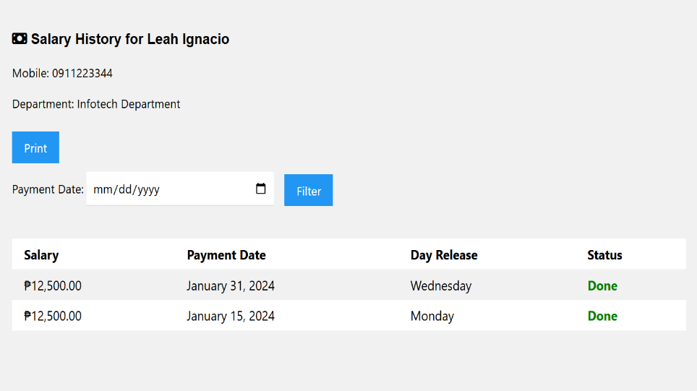
Salary History of one Employee

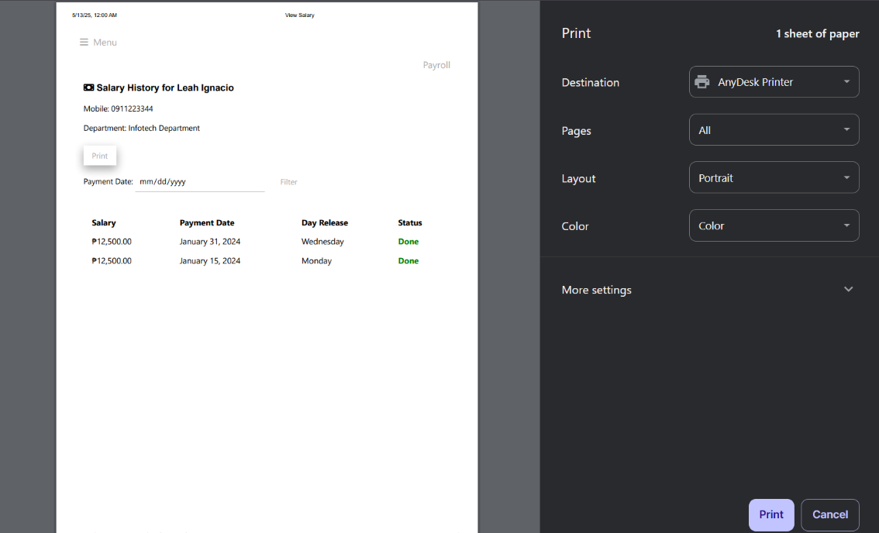
Printing Records

Figure 6. Salary Interface

The Figure 7 shows the Salary History interface of all the employees where user see the list of employee’s salary paid.
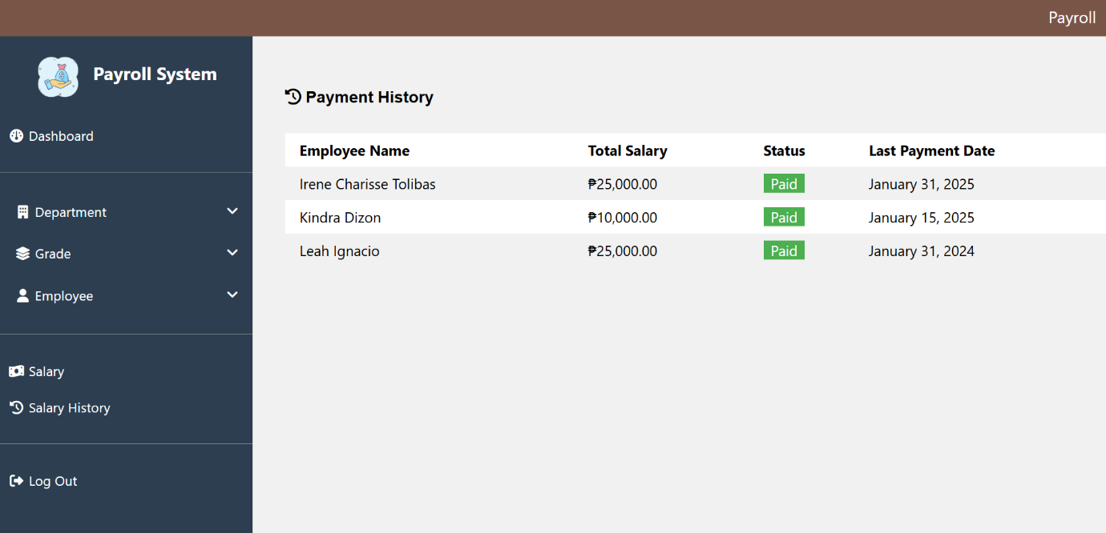

Figure 7. Salary History Interface

The Figure 8 shows the Logout interface
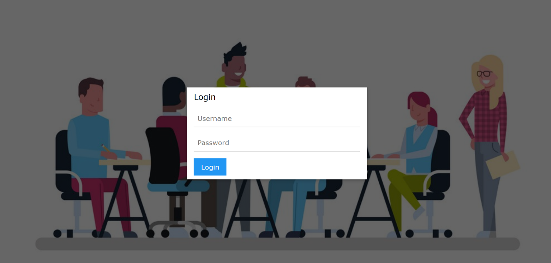

Figure 8. Logout Interface

- Complete Code

5. References

- https://youtu.be/FJ0OYXCK6vQ?si=SPr-bbIYLMQOwJ2K
- https://youtu.be/ygrKPaJ-2EQ?si=roo-nGxiSOSJTNcE
- https://chatgpt.com/c/6822de5a-b74c-800c-8c8a-09b8c1e32fb1

6. Curriculum Vitae
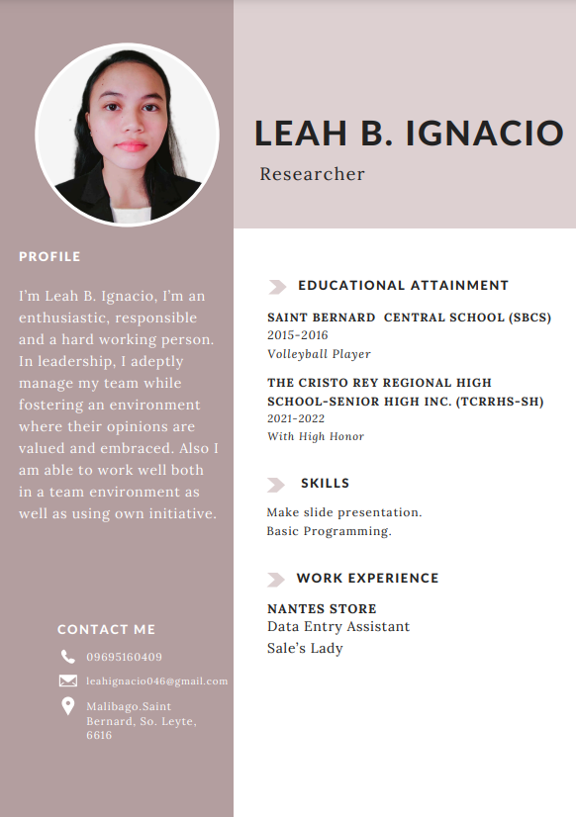

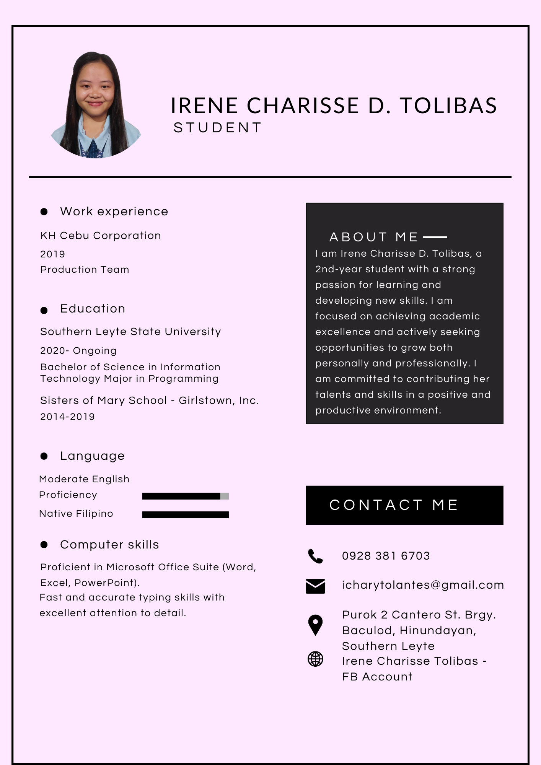


Dizon, Kin- kin M.
Purok 6, Himbangan, Saint Bernard, Southern Leyte
Contact Number : 09153942739
Email Address: dizonkinkin28@gmail.com

OBJECTIVES
- To acquire and enhance my knowledge and skills in programming to be able to share thoughts and ideas and help the company to fulfill their mission and vision and become successful.

EDUCATIONAL ATTAINMENT
TERTIARY
Collage: San Juan, Southern Leyte State University
Bachelor of Science in Information Technology
SECONDARY
Senior High School: The Humanities and Social Sciences (HUMSS)
S.Y. 2020-2021
PRIMARY
Elementary: Himbangan Elementary School
S.Y. 2015-2016
LANGUAGE
- TagLish
COMPUTER SKILLS
- Beginner in Programming
- Photo Editing
WORK EXPERIENCE
- Cashier 2018-2021
- SalesLady 2021-2023
MOTTO
"Stay true to yourself


Raniel R. Fajardo

BS Information Technology
Address: Sta. Cruz, San Juan, Southern Leyte
Contact No.: 09383309254
Email: ranielfardz@gmail.com

PERSONAL INFORMATION

Age : 20
Date of Birth : October 6, 2003
Height : 178cm (5’10ft)
Weight : 85kg
Gender : Male
Marital Status : Single
Religion : Roman Catholic
Nationality : Filipino

ACADEMIC BACKGROUND

Tertiary : Southern Leyte State University
(SLSU)Bachelor of Science in Information
Technology Major in Programming San Jose, San Juan, Southern Leyte. (S.Y. 2023)

Secondary : San Juan National High School San Jose, San Juan, Southern Leyte (S.Y. 2021-2022)

Primary : Saint Joseph College San Juan,
San Juan, Southern Leyte (S.Y. 2015-2016)

