MOATLY
A Declaration of Inner Rights

We hold these truths to be self-evident, that all souls are created equal.

Founding Document · April 2026

Preamble
In 1776 Thomas Jefferson wrote that all men are created equal and that they are endowed with certain inalienable rights. He named three. Life. Liberty. The pursuit of happiness.
Jefferson was departing from John Locke, who had written life, liberty, and property. The change from property to happiness was one of the most consequential edits in the history of political thought. It moved the frame from what you own to what you are becoming. Happiness in the Aristotelian sense Jefferson intended was not pleasure or comfort. It was eudaimonia. The flourishing of the whole person in the direction of their nature. The Declaration of Independence is a philosophical claim that the inner life, the right to become who you are capable of being, is as foundational as the right to physical safety.
That declaration was the best we had done so far. It protected the citizen from the state. It could not have anticipated the three great violators of the twenty-first century. The algorithm. The corporation. The attention economy. These powers have done what no government has ever managed to do at scale. They have colonised the inner life. They have made the violation of the soul not merely legal but profitable.
Moatly is a direct response to that colonisation. It is built on the conviction that every human being is born with an inner life of irreducible dignity and that this inner life carries rights as inalienable as those Jefferson named. Rights that no algorithm, no government, no corporation, and no other human being can legitimately violate.

The First Principle
Before the rights, one principle on which all others rest.

We are born equal souls.

Not equal in circumstance. Not equal in resource or opportunity or the luck of birth. Equal in the dignity of the inner life. Equal in the depth of the need to be known. Equal in the right to become more fully oneself. The person who has been in their Moat for thirty years and the person who arrived today are equal in their fundamental worth as souls. The rings measure honest practice. They do not measure human value. No number of rings makes one soul more deserving of witnessing than another. This equality is not granted by Moatly. It is recognised by it. It existed before the first line of code was written. It will exist long after the last server is switched off.

The Seven Inalienable Rights of the Inner Life
These rights are inalienable because they cannot be legitimately surrendered or taken. They belong to every human being simply by virtue of being born. They are not granted by any state or platform or authority. They exist independently of whether any institution recognises them.

I. The Right to Inner Sovereignty
If you are not sovereign over your own consciousness then you cannot in any meaningful sense be sovereign over anything else either. The inner life is the foundational territory. All other sovereignty proceeds from it.
This right is violated when any external power, governmental, corporate, or algorithmic, accesses, shapes, surveils, or monetises the inner life without full and informed consent. Social media does not merely observe behaviour. It shapes what people feel, want, fear, and desire through algorithmic manipulation of attention. This is not a privacy violation. It is a violation of inner sovereignty. The Stoics called the inner citadel the hegemonikon. Its integrity is older than any state that has ever existed.
Sources: Marcus Aurelius, Meditations · Graham Hancock, The War on Consciousness · JS Mill, On Liberty
II. The Right of Private Judgment
No man can really change his sentiments, judgments, and inward affections at the pleasure of another; nor can it tend to any good to make him profess what is contrary to his heart. The right of private judgment is therefore inalienable.
Deliberate lies and propaganda are crimes against the soul. Without truth, thought cannot exist. Without real thought, freedom is only an illusion. Algorithmic manipulation of inner life through curated reality is precisely this crime. The mechanism has changed since Weil named it in 1942. The violation is identical.
Sources: Thomas Hutcheson, A System of Moral Philosophy, 1755 · Hegel, Philosophy of Right · Simone Weil, The Need for Roots, 1943
III. The Right to Honest Self-Knowledge
The unexamined life is not worth living. Socrates argued this not as a moral preference but as a philosophical claim about what constitutes a fully human existence. Every person is born with an inner life of irreducible complexity. The right to examine that life honestly, to sit with what is true about oneself without performance or management, belongs to every person simply by being born.
Moatly is built to protect the conditions that make honest self-knowledge possible. Silence. Unmanaged attention. Genuine reflection. The capacity to hear the inner voice that knows who you actually are.
Sources: Socrates, via Plato, Alcibiades I · Brihadaranyaka Upanishad · Descartes, Meditations on First Philosophy
IV. The Right to Be Witnessed
To be without witness is to be stateless of the inner world. Hannah Arendt called this worldlessness. Every human being deserves to be seen clearly by at least one other consciousness that has no agenda in who they turn out to be. Not evaluated. Not advised. Witnessed.
This is not a luxury. It is what Hegel described as the condition for genuine self-consciousness. We do not see ourselves directly. We see ourselves reflected in the eyes of others. If those eyes are distorted by need, performance, or commercial interest, the reflection is false. The right to genuine witness is among the rarest and most necessary conditions for full human development.
Sources: Hannah Arendt, The Origins of Totalitarianism, 1951 · Hegel, Phenomenology of Spirit · Charles Cooley, looking-glass self theory
V. The Right to Become
The pursuit of happiness. Jefferson chose this phrase over Locke's property with full philosophical intent. Eudaimonia. The flourishing of the whole person in the direction of their nature. Every human being carries within them a direction, a pull toward a more fully realised version of themselves.
The right to follow that direction without interference from systems designed to interrupt it for commercial purposes is among the most ancient claims in human philosophy. The Vedic tradition calls it self-realisation. Jung calls it individuation. Aristotle calls it the actualisation of potential. Jefferson calls it the pursuit of happiness. Different traditions, the same foundational right.
Sources: Aristotle, Nicomachean Ethics · Jefferson, Declaration of Independence, 1776 · Carl Jung, The Development of Personality · Brihadaranyaka Upanishad
VI. The Right to Be Forgotten
Every human being has the right to change. To no longer be defined by who they were. To have the past release its grip so that the present can be lived fully. The permanent digital record violates this right continuously.
The seven day deletion in Moatly is not a design preference. It is the technological expression of a foundational right. Loss of the past, collectively or individually, is the supreme human tragedy. But the inability to grow beyond a past that is permanently available to everyone is a different kind of loss. The right to be forgotten is the right to become someone new.
Sources: Simone Weil, The Need for Roots, 1943 · EU GDPR, Article 17, Right to Erasure, 2018
VII. The Right to Difficulty
This is the right most specific to this moment in history. Every tradition that has thought carefully about genuine human development agrees that encounter with hardship, uncertainty, and darkness is not a misfortune to be managed away. It is a condition for becoming fully human.
The attention economy is specifically designed to remove difficulty. To smooth every edge. To fill every silence. To answer every question before it has been fully lived with. This is not kindness. It is a violation of the right to be genuinely challenged by your own life. The fire scars in the rings are not failures. They are the most honest marks on the record. The right to difficulty is the right to a life that is genuinely yours, including the parts that are genuinely hard.
Sources: The Stoic tradition · Simone Weil on affliction · Viktor Frankl, Man's Search for Meaning

What Moatly Undertakes
In recognition of these seven rights, Moatly makes the following commitments. Not as policy. As covenant.

Moatly will never surveil, monetise, sell, analyse, or use to train any commercial system the content of what is shared inside a Moat. Not because a law requires it. Because it would be a violation of inner sovereignty.
Moatly will never shape, curate, or algorithmically manage what a person sees inside their Moat. Not because curation is difficult. Because it would be a violation of the right to honest self-knowledge.
Moatly will delete all content after seven days from every server and every backup. Not because storage is expensive. Because the right to be forgotten is foundational.
Moatly will never introduce advertising, sponsored content, or any commercial interest into the space of the Moat. Not because it would damage the brand. Because it would be a crime against the soul.
Moatly will never rank, compare, or display one person's rings against another's. Not because comparison is harmful. Because all souls are equal and the rings measure practice, not worth.
Moatly will publish its complete codebase as open source so that these commitments are technically verifiable rather than merely claimed.

These commitments are not subject to revision in response to commercial pressure, regulatory change, or the preferences of any investor or acquirer. They are the reason Moatly exists.

The Covenant of Equal Souls
When a person enters Moatly for the first time they are asked to accept a covenant. Not terms and conditions. A covenant. The distinction matters. Terms and conditions protect a company. A covenant makes a promise between a person and themselves, witnessed by the community they are entering.

— The Covenant —

You are here because something in you is ready to become more fully itself.
You have the inalienable right to know yourself honestly. You have the inalienable right to be witnessed without agenda. You have the inalienable right to become who it is in your nature to become. These rights were yours before you arrived here. They will be yours long after you leave.
The people who will witness your journey in this Moat are your equals in soul. Their rings are their own story. Your rings will be yours. Neither is worth more than the other.
Three things are asked of you in return. Speak from the I. Witness without agenda. Keep what is said here inside.
What you say here will be gone in seven days. What changes in you because you said it will not.

We are born equal souls. That is where this begins. That is where everything must return if it loses its way.

One. The Problem We Are Solving
Modern social media was designed to connect people. What it actually does is perform connection while delivering its opposite. People curate, broadcast, and optimise for approval. They present the polished version of themselves and receive likes for it. Over time the gap between who they present and who they actually are grows wider and more exhausting. They are more connected and more alone than any generation in human history.
Therapy helps but has limits. The therapeutic hour is once a week. The rest of life happens in between. And the insight gained in the room often dissolves without a community to hold it.
Communities help but they fail in predictable ways. Some people carry the space and some coast. The contributors burn out. The intimacy erodes into performance.
Moatly is built to solve all three of these problems simultaneously. It is not social media. It is not therapy. It is not a conventional community. It is a witnessing space. Its foundation is the declaration you have just read.

Two. What Witnessing Actually Means
The word witnessing has a specific meaning in psychology. It is not observing. It is not commenting. It is not giving feedback. It is the act of being fully present to another person's honest expression without trying to fix, advise, redirect, or improve what they are saying.
When we are witnessed we do not feel judged or evaluated. We feel seen. And the experience of being genuinely seen by another human being, without agenda, is one of the rarest and most transformative experiences available to a person.
A stranger who will never see your face, who does not know your name, who does not need anything from you, who will carry your words with them for seven days and then release them completely, can witness you in a way that even the people who love you cannot. That is the Moat.

Three. What the Platform Is
Moatly is a private, encrypted, text-only space where small groups of anonymous strangers come together to witness each other's honest expression over a seven day cycle. Everything said in the Moat disappears after seven days. The growth that resulted from saying it does not.
There are no profiles. No photographs. No follower counts. No likes. No performance surfaces of any kind. A person is known only by what they choose to say.
The group
Each Moat contains between eight and twelve people, placed together by the timing of their first completed experience. That shared timing is the mythology of the group. You arrived together.
The seven day cycle
Every seven days the words disappear. The knowledge that the words will be gone creates the freedom to say the true thing. The seven day rhythm mirrors something ancient. A cycle of honest engagement before rest and renewal.
The physical device
The device is the key and the notification simultaneously. When someone in a Moat posts, the device glows. A physical object in the room carrying a single meaning. Someone in your Moat said something. Come when you are ready.

Four. The Interface
The application is deliberately quiet. No colour as decoration. No visual noise. Three screens carry the entire experience. The threshold, the Moat, and the rings.

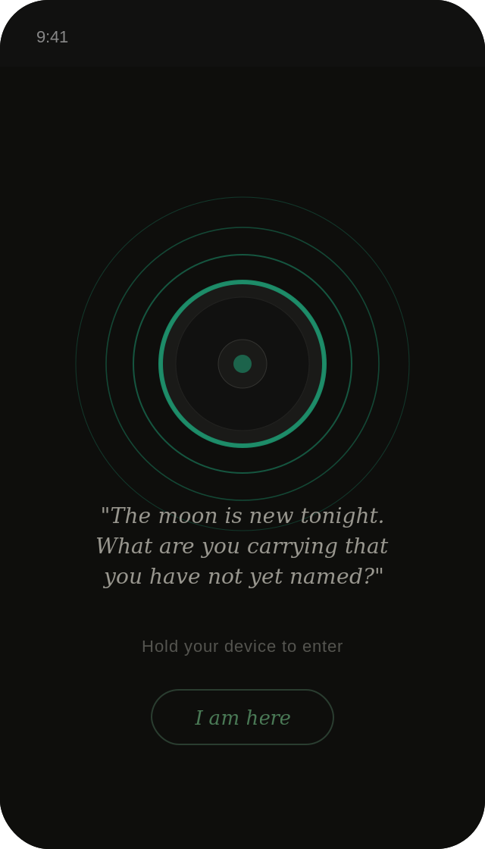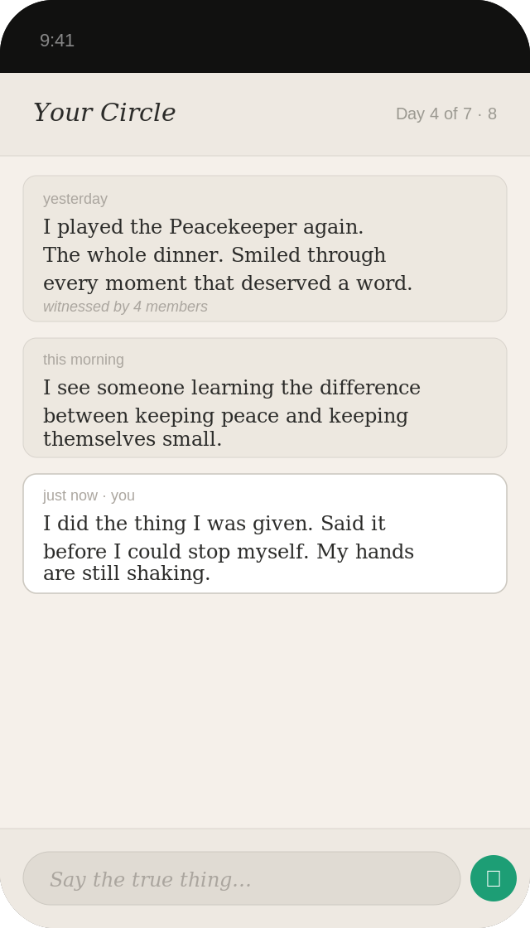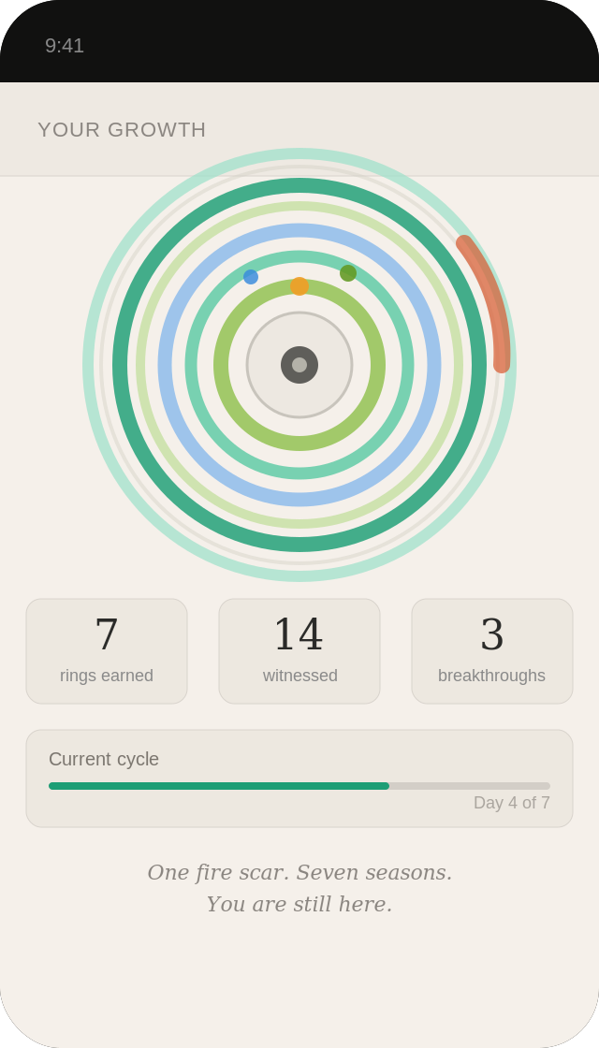
The threshold · The Moat · Your rings
The threshold is the entry point. Each time a person opens the application they encounter a single question, shaped by the time of day and the season. The question is not a gate. It is a shift in quality of attention.
The Moat screen is as minimal as possible. A list of posts from the current cycle, oldest to newest. A text field at the bottom. No profile pictures, no precise timestamps, no read receipts, no reaction buttons.
The rings screen is private. Nobody else in the Moat sees it. It holds the count of rings earned, the notches accumulated, and the ring diagram that grows richer with each cycle.

Five. The Rings
The rings are the visible record of a life spent in honest practice. Not a gamified reward. Not a leaderboard. A quiet, private mark of having shown up. Of having stayed in the room for another seven days.
Each ring is composed of coloured arc segments built up over a cycle. Gold arcs mark moments of genuine breakthrough. Green arcs mark acts of witnessing. Blue arcs mark deep reflective work. Thin grey fragments mark a difficult winter. A fire scar in orange marks a period of sustained difficulty that was stayed through rather than fled. No ring is identical to any other. Each one is the true record of what that season actually cost and gave.

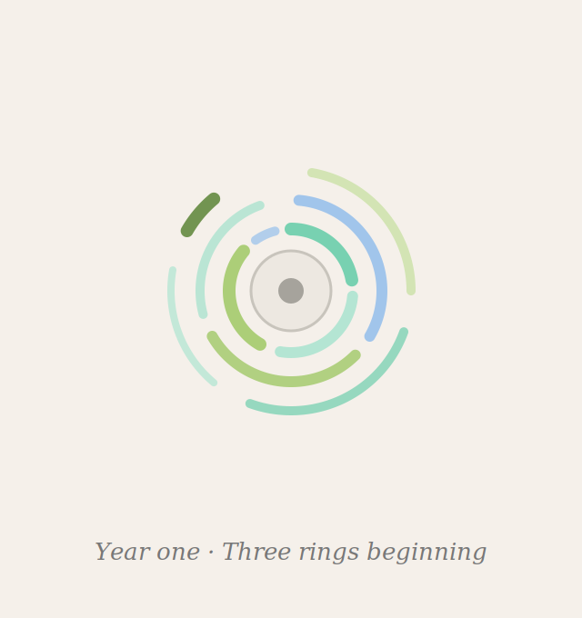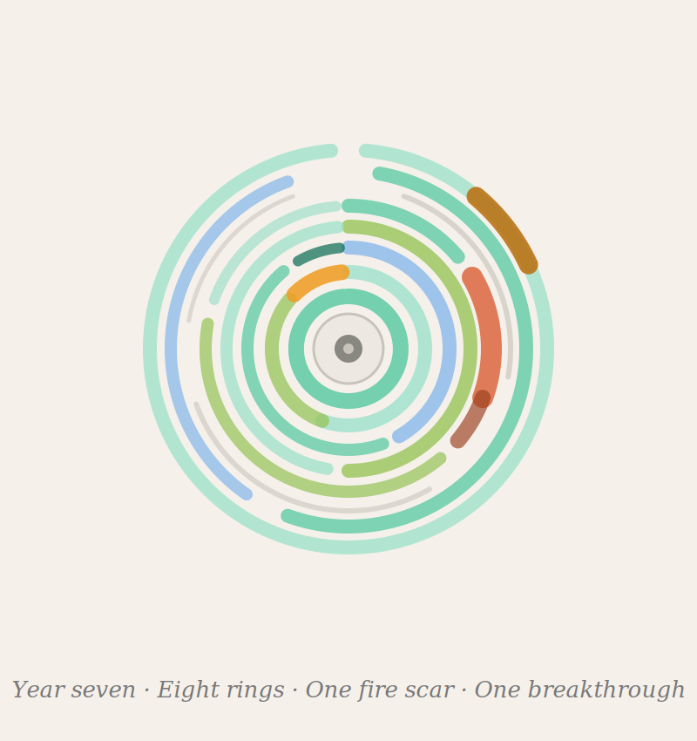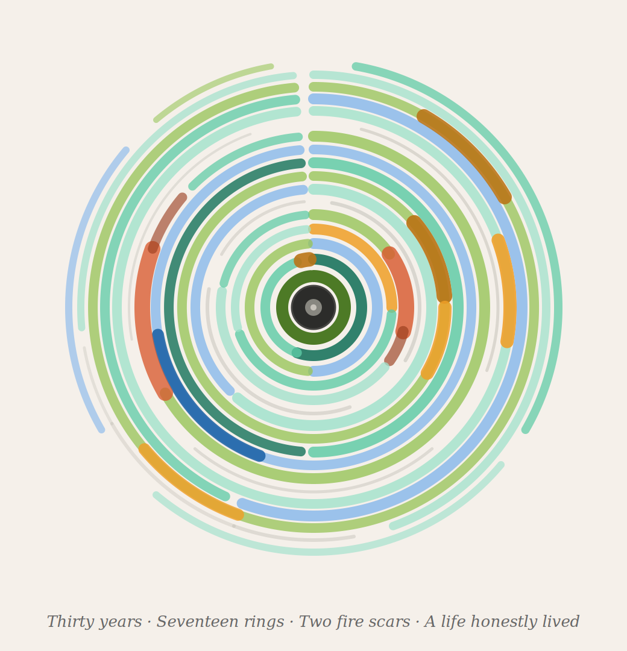
Year one · Three rings Year seven · Fire scar Thirty years · A life honestly lived
The early ring is sparse and pale. Three cycles completed, each ring made of incomplete arcs with visible gaps. This is not failure. It is what beginning looks like.
The year seven ring holds eight rings of varying colour. A fire scar sits on the right side. A gold arc marks a breakthrough. This is what sustained honest practice looks like from the inside. Not smooth. Not even. Real.
The thirty year ring is what sustained honest practice accumulates into. Seventeen rings. Two fire scars from distinct difficult periods. Thin winter rings. Gold breakthrough arcs. At the centre, the core is dark and still. This is what a life of honest presence looks like.

Six. The Three Rules
The Moat has three rules that are non-negotiable and make everything else possible.
Speak from the I
No advice. No you should. Only what is true for you. When you cannot advise you must reveal. And revealing is where the growth lives.
Witness without agenda
When you respond to another person's sharing you describe what you see, not what you think should happen. The witness does not prescribe. The witness reflects.
What is said here stays here
In the moral sense. The words shared in the Moat belong to the person who shared them. The witness carries the impact. They do not carry the content.

Seven. The Self Examination Framework
To help members bring their genuine life into the Moat rather than a managed version of it, the space offers a voluntary framework for structuring honest reflection.
The role
Not who I am but what costume I was wearing. Naming the role creates a small but crucial distance between the person and the behaviour. You are not the role.
The field
The environment where the game was being played. The field shapes the role. Understanding the field helps the person see that the behaviour is not fixed. The field calls it forth.
The conflict
The friction between what the role required and what the soul wanted. The conflict is where the growth is located.
The judge
The internal or external voice whose approval is being sought. The judge is almost always borrowed. Naming it is the beginning of returning it.

Eight. Why This Aligns With the Human Spirit
The human spirit wants three things above almost everything else. To be known. To belong. To grow. Moatly is not a substitute for these things. It is the real thing, held in a carefully designed container.
Integration over improvement
The Moat is not a self-improvement platform. The goal is not to become a different person. It is to become more fully the person you already are.
The permission to be human
Permission to be in the middle of something difficult without having to resolve it. To be a mess this week and know that next week the cycle will begin again.
The long arc
Perhaps the most radical thing Moatly offers is time. Real time. Decades. A person who enters at thirty and stays for thirty years will carry rings that span a marriage, the birth of children, the deaths of parents. Those rings are a masterpiece.

We are born equal souls. In return it offers the rarest thing available in the modern world. To be genuinely known by people who have nothing at stake in who you turn out to be. And to know, somewhere in the quiet, that you are not doing this alone.

End of Document

