**Unit 5 Project Sample:**

**Kat M{art} Design Website**

**Step 1: Define Audience / Tone**

* Who will visit your site? Potential employers? New clients or customers?
  + Potential clients and collaborators
  + Potential Employers
* What can make you and/or your product stand out against your competitors?
  + Variety/non-traditional arts/writing education background
  + Emerging skills in code
  + Solid visual samples with potential to grow
* How would you speak to your clientele if you were communicating in person? How could you translate that style and tone digitally?
  + I would be focused, light-hearted, and ready to get down to business. In order to translate this digitally, I want to create a simple site with a beautiful image up front and easy architecture under the hood.
* What colors represent you or your product?
  + Dark indigo and a bluish toned purple for depth and inventiveness, and splashes of peach tones to illuminate off the darkness.
  + The purple will also shift into warm lavendar tones to balance the darker colors.
* What images illustrate your message?

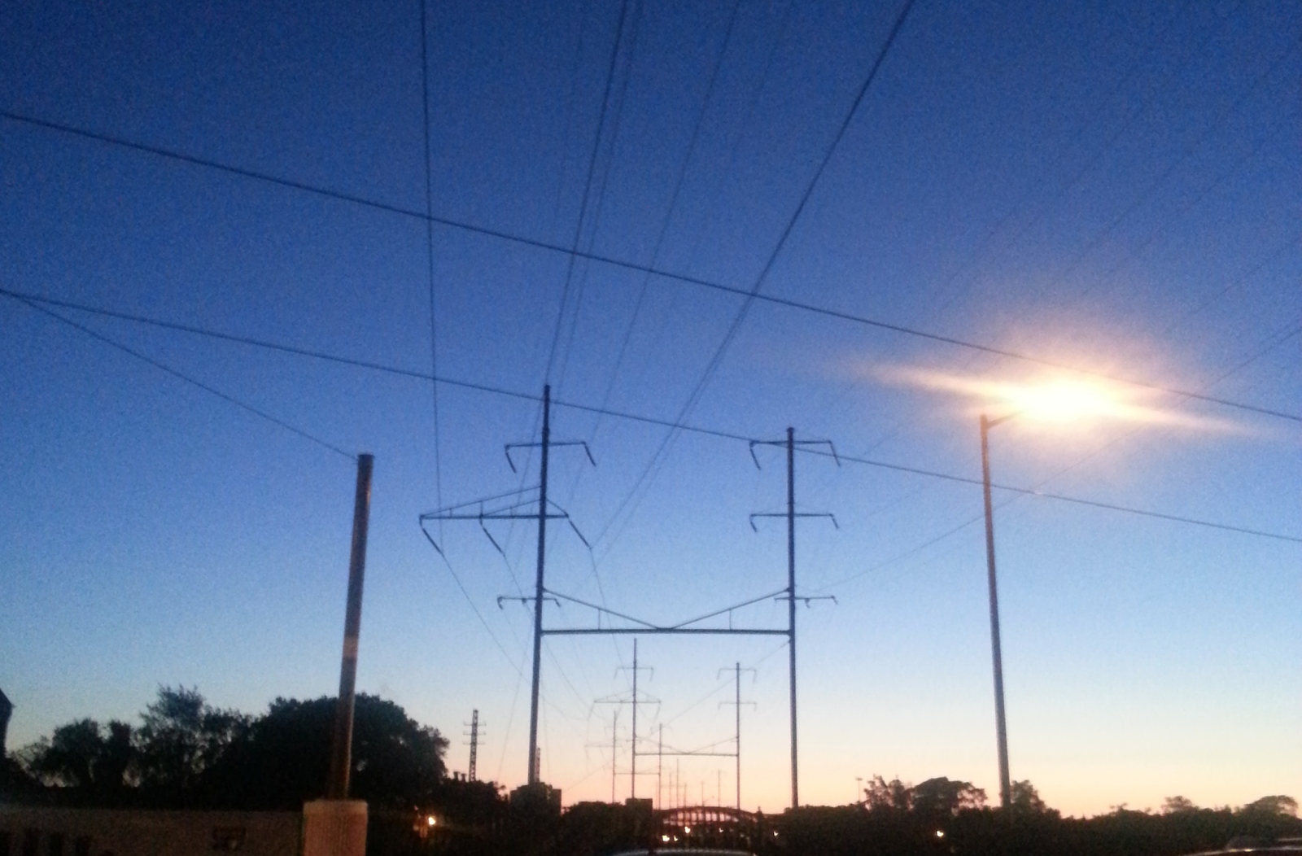

**Step 2: Define Site Structure**

What are the three-to-five pages titled?

Projects, About, Blog

* What will be the purpose for each?
  + Projects - To showcase my various creative projects
    - Design - Web, Print, Production
    - Paintings - Random sampling of paintings
    - Photography
  + About - This will include a blurb and resume
  + Blog - The blog link will link to writing samples

**Homepage - Kat Mart Design**

Contains:

* Logo
* Navigation
* Hero Image
* Footer with Social Media Icons

**Work**

*Showcase the design and development portfolio*

* Title
* Navigation
* Images linking to portfolio work. 3x3 columns/rows
  + Design - Web, Print, Production
  + Paintings - Random sampling of paintings
  + Photography

**About**

*About our process and philosophy*

* Title
* Navigation
* About Paragraph
* Resume
* Contact Information

**Blog**

* Link to a WordPress Blog