CEMSS v11.2: The Ultimate Campus Intelligence System

Comprehensive Operational Guide & Technical Blueprint

Prepared for: University Administration & Security Stakeholders

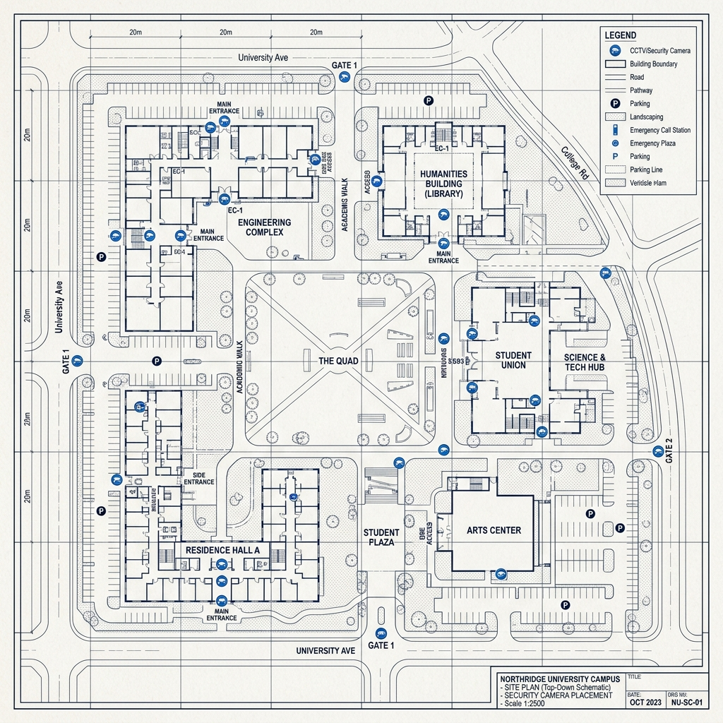
Figure: CEMSS Campus-Wide Surveillance Blueprint

1. System Vision & Overview
CEMSS (Campus Event Management and Surveillance System) is not just a security tool; it is a comprehensive ecosystem that bridges the gap between safety, communication, and community management. Built on the powerful CASS v11.2 engine, it provides a 'Digital Twin' of campus safety.

1.1 The Core Problem & Solution
Traditional CCTV systems require humans to watch screens 24/7. Fatigue and human error lead to missed incidents. CEMSS solves this by using AI that NEVER sleeps. It analyzes every frame of every camera simultaneously, detecting threats in milliseconds.

2. System Architecture & Blueprint
The following flowchart illustrates how data flows from a physical event on campus to an alert on a security officer's phone.
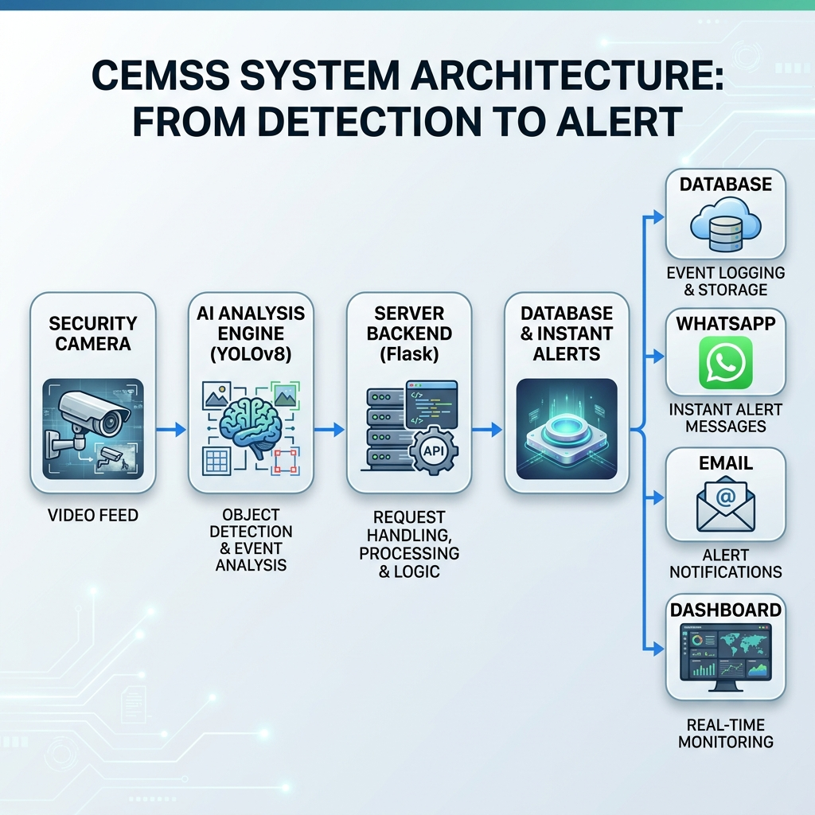
Figure: CEMSS 4-Layer Architecture Flow

2.1 Operational Components
- Layer 1: Input: Standard IP security cameras or USB webcams streaming live RTSP/video feeds.
- Layer 2: AI Processor: The YOLOv8 Engine. This is where the 'vision' happens. It looks for people, fights, falls, and crowds.
- Layer 3: Controller: The Flask Backend. It handles logic, manages databases, and decides when to trigger an alert.
- Layer 4: Interface: The React Dashboard. Where users see the results, live feeds, and historical data.

3. AI Detection Operations (The Eyes)

3.1 Real-Time Violence & Fight Detection
The system uses a Deep Learning model trained on the RWF-2000 dataset. It doesn't just look for 'people'; it looks for the specific motion patterns of physical altercations. Below is the evaluation performance of our AI engine.
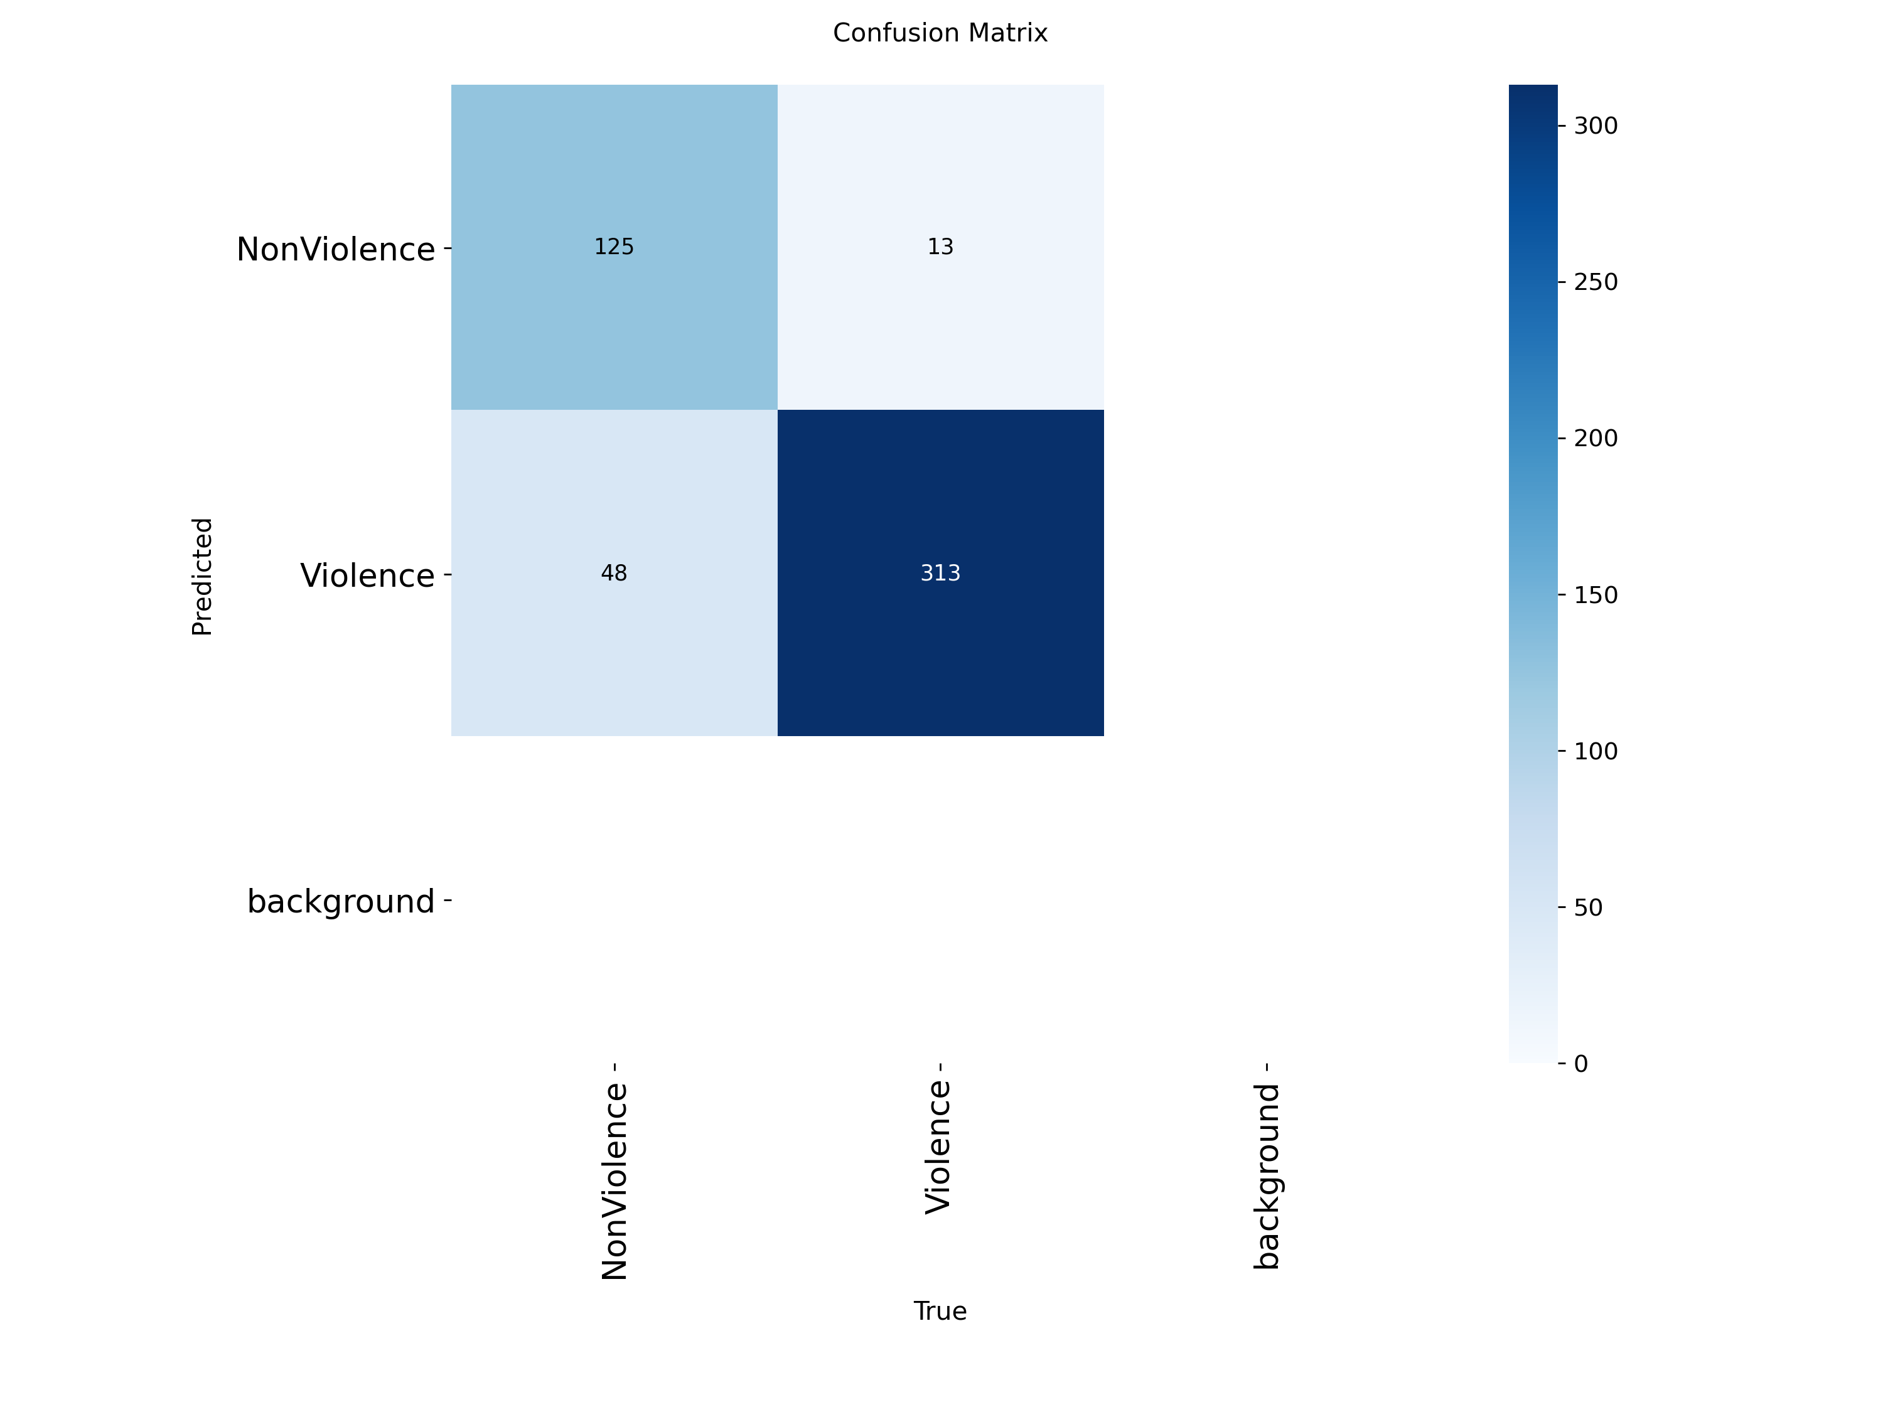
Figure: AI Precision Evaluation (Confusion Matrix)

3.2 Automated Fall Detection
By analyzing the 'bounding box' height and width ratios, the system can tell if a person is standing, walking, or has suddenly collapsed. If a person stays horizontal for more than 5 seconds, an emergency alert is triggered.

3.3 Intelligent Crowd Management
The system counts every individual detected in a zone. If the count exceeds the pre-set threshold (default: 3 people), the area is highlighted red on the dashboard. This prevents overcrowding in high-risk zones.

Figure: Real-time AI Overlay with Person Detection Boxes

4. Incident Response System
A detection is useless without a reaction. CEMSS features a multi-channel notification engine.
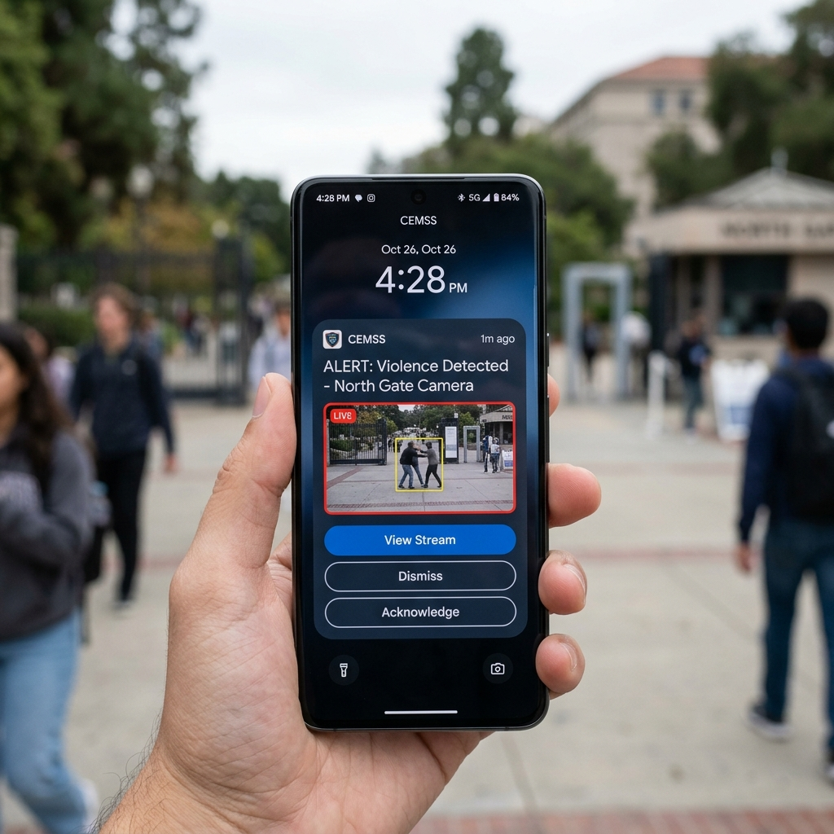
Figure: Mobile Alert Mockup (WhatsApp/Push Notification)

4.1 Alert Hierarchy
- 1. LEVEL 1: Visual Alert. The dashboard camera feed flashes red.
- 2. LEVEL 2: Digital Log. The incident is saved to the database with a screenshot.
- 3. LEVEL 3: Instant Notification. WhatsApp/Email sent to campus security within 2 seconds.

5. Campus Portals & Community Hub

5.1 The Admin Dashboard
Full control over camera streams, system settings, and AI sensitivity. Admins can view analytics to see which campus zones are busiest or have the most safety alerts.

5.2 The Student & Faculty Portal
This is the social side of CEMSS. Features include:
- Event Management: Schedule and register for campus events.
- Digital Magazine: A platform for student news and departmental updates.
- Interactive Feed: Real-time community discussions and announcements.

6. Maintenance & Future Roadmap
The system is designed to be future-proof. Upcoming enhancements include Facial Recognition for authorized personnel and Fire/Smoke detection integration.

7. Technical References
• YOLOv8 Real-time Detection: https://docs.ultralytics.com/
• React Frontend Framework: https://react.dev/
• RWF-2000 Violence Dataset: https://arxiv.org/abs/2002.04618

