PROG 37721 – Assignment 1

# Snapshot #1 – Generation of 5 Random Numbers

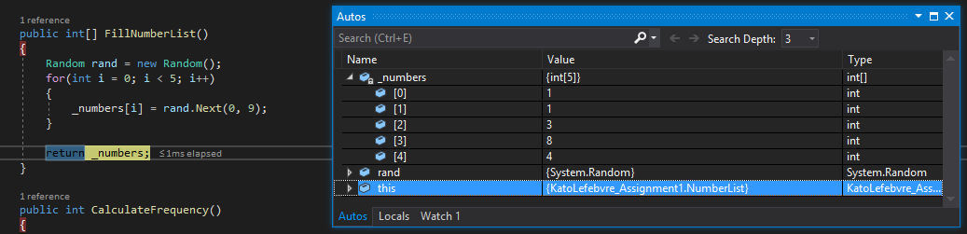

Using a for loop, a new number is generated for each index of the array _numbers. Once each index has been filled, the array is returned from the method in order to populate the Windows form and to calculate the score for that round.

# Snapshot #2 – Calculation of Score

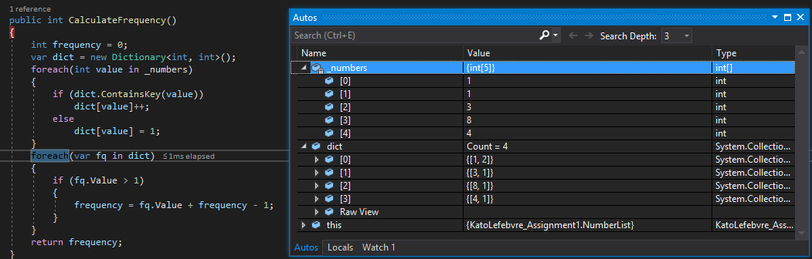

The method CalculateFrequency() counts how many times a specific value appears in the array and returns the frequency specified using a Dictionary to keep track of the values. In the screenshot, the number 1 appears twice in the array.

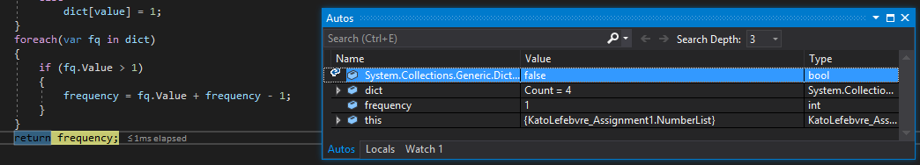

In order to simplify the calculations, the frequency of this array is 1, since only one number appears one other time in the array. Because the value of fq will be 2, the number needs to be subtracted by 1 in order to for the score to be calculated correctly. This is to ensure that numbers that appear more than twice in the array, or other numbers that appear more than once, do not mess up the scoring calculations.

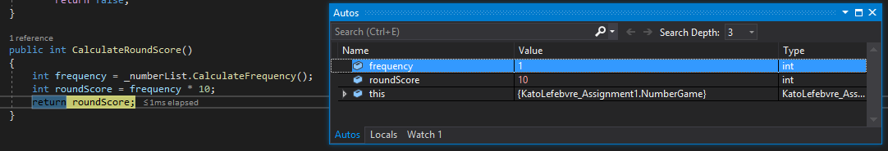

The frequency is then returned from the method in order to be calculated.

# Snapshot #3 – Decision on Win or Loss

Once the 5 rounds have been played, the final score is then displayed, and the decision is made on whether the player won or lost. A new form is shown with their final score and a Win, Draw, or Lose message.

