User manual for Rave Application
Rave restaurant application consists of the customer interface, where customers can selects different dishes have to for a given day.
Steps taken when ordering foods.
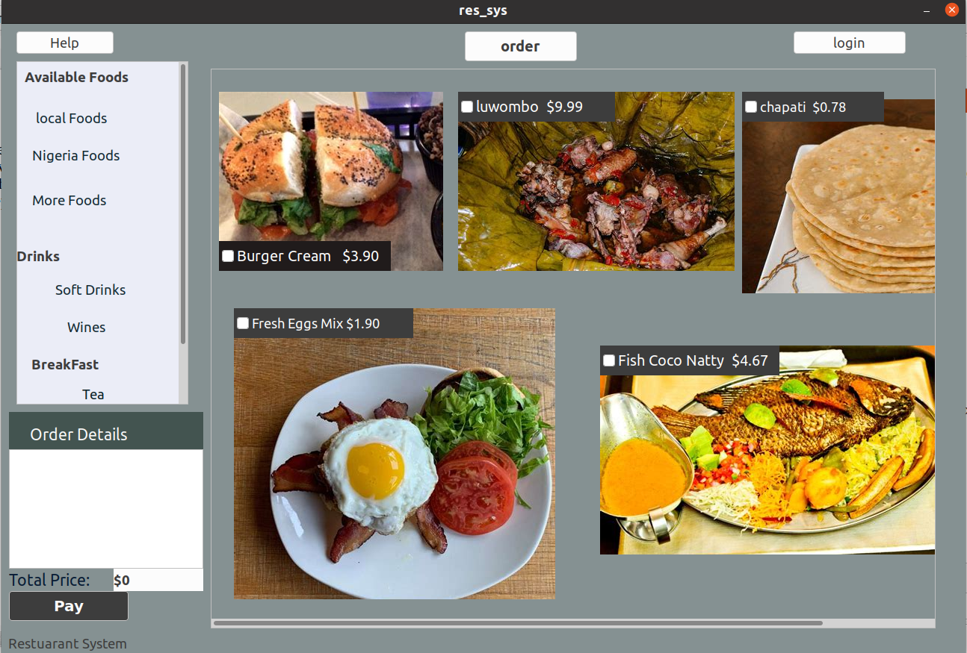
1. Open desktop Rave restaurant application.

This interface is where customer selects specific foods, drinks, tea. Under foods, customer is provided with a variety of foods both local and foreign foods such as Nigeria foods , more foods ( foods from different parts of the world ).

2. Select from a variety of available foods such as local, Nigeria and more , drinks for example soft drinks , wines , breakfast such as tea. The arrows show selected foods
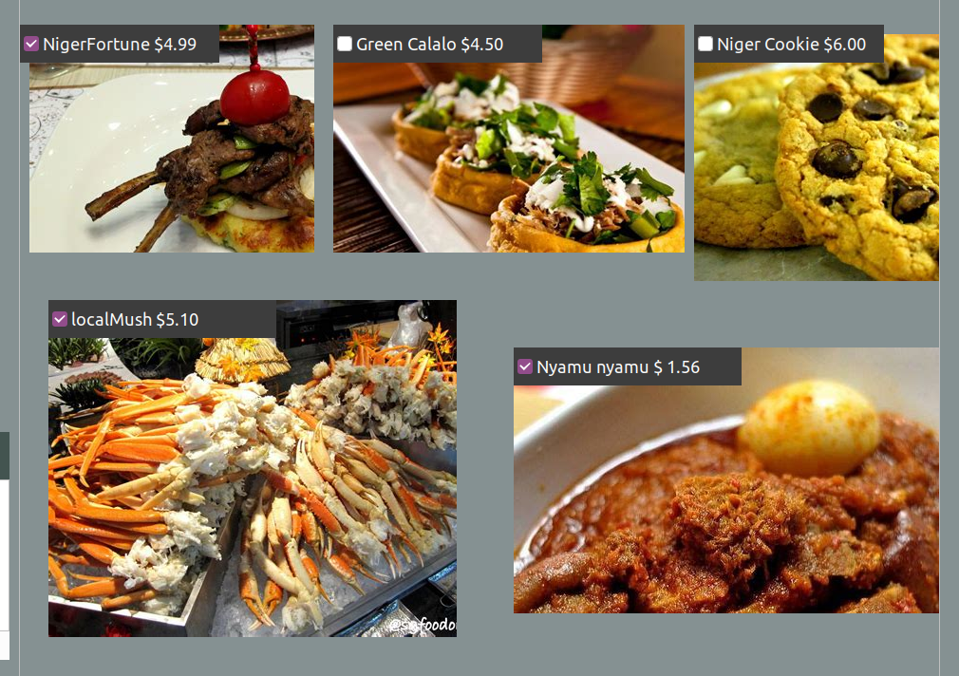
3. After selecting the foods to consume, Next is to place an Order so that the order can be worked upon.
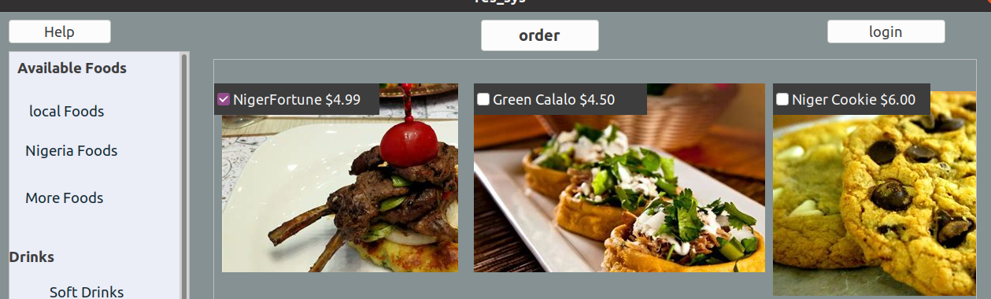
4. After placing an order, selected Items are listed under the Order details. This includes a list of all selected items. And the total bill to be paid off is shown.
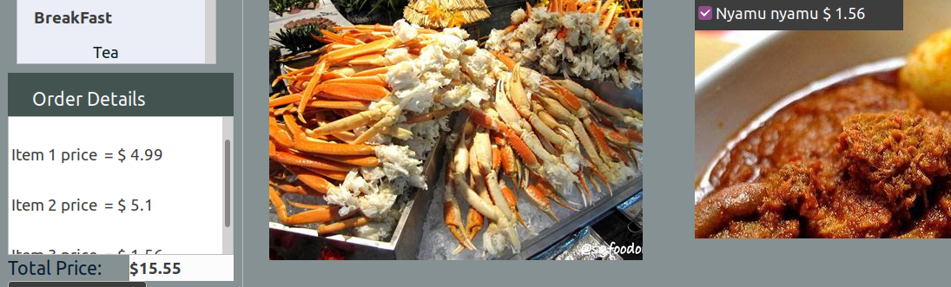
5. From here you can press Pay button to make payment.

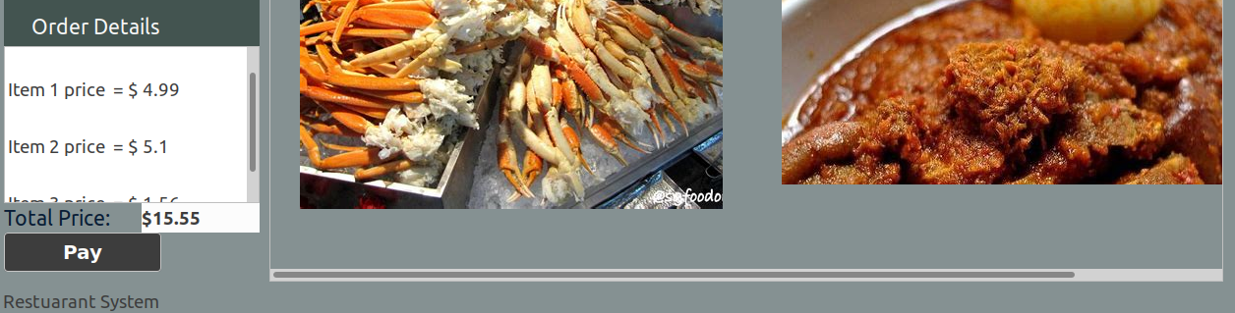
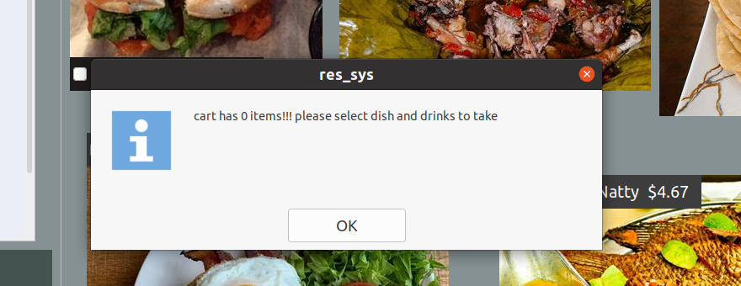
NB: When the customer presses Order button when no items selected, the application renders a message box, with a message “cart has 0 items!!! please select dish and drinks”

6. After Pay button has been pressed, Raves Payment window will pop up. This contain a value field where the customer inserts value (the bill ) to be paid.
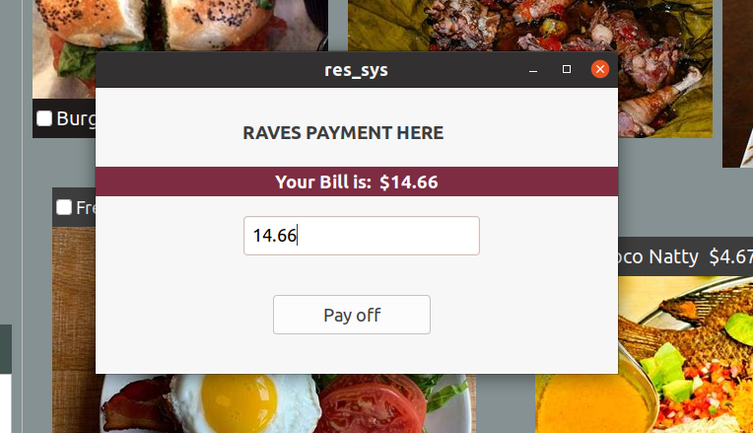

7. Complete the payment by pressing Pay off button,
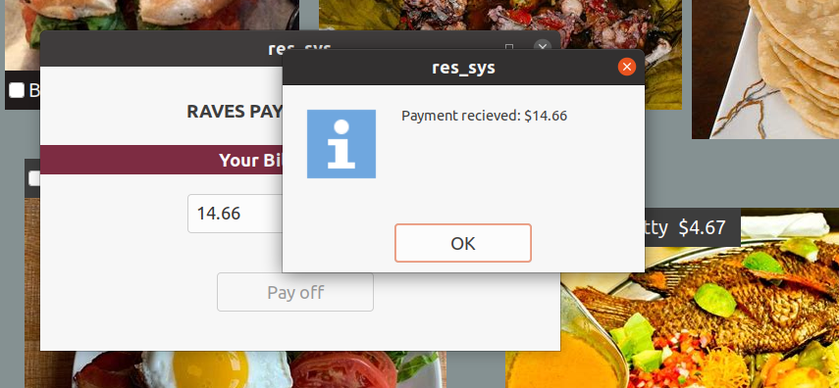

This application was developed in GAMBAS
For more info: errortor@gmail.com [ dev.to ]

8. The Admin can login, and see how many employee accounts are present in the databases.
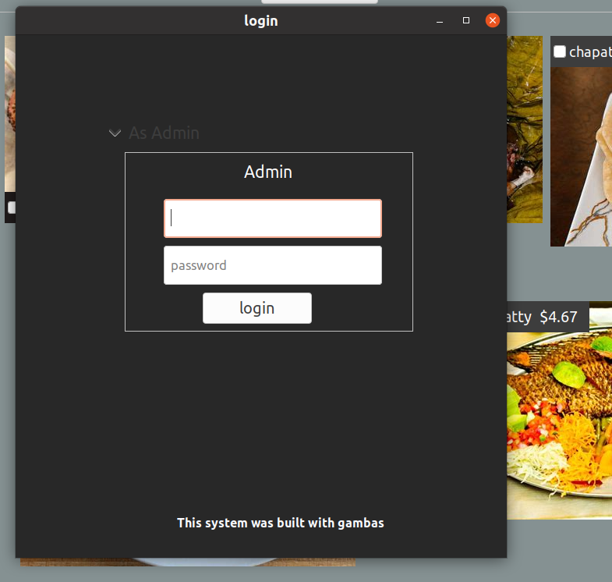

9. Admin dashboard consists of a section where the employee accounts are created.



