Fuzzy condition-based maintenance Prediction for Naval Propulsion Systems (8 pages)

First Author's Name*
First author's affiliation, an Institution with a very long name, xxxx@gmail.com
Second Author's Name
Second author's affiliation, possibly the same institution, xxxx@gmail.com
Third Author's Name
Third author's affiliation, possibly the same institution, xxxx@gmail.com

The reliability and availability of a vessel’s propulsion system critically depend on the effective planning of maintenance activities, which represent a substantial cost to the shipbuilding companies. Predictive maintenance approaches enable component replacement decisions to be driven by observed and inferred degradation states rather than by fixed time schedules, thereby providing a structured condition-based framework capable of minimizing unnecessary interventions while improving system safety and operational continuity. However, most existing studies primarily focus on the fault detection stage, proposing performant models while offering limited support for model verification and interpretability, which ultimately undermines the transparency and trustworthiness of the decision-making process. In this study, fuzzy logic–based modeling techniques are applied to a condition-based maintenance dataset derived from a vessel equipped with a combined diesel-electric and gas propulsion system, with the objective of predicting component degradation states while simultaneously ensuring model interpretability through the use of saliency maps and decision tree representations. The proposed approach provides a transparent decision-support framework that enhances trust in predictive maintenance outcomes and facilitates informed maintenance planning in safety-critical maritime applications.
.CCS CONCEPTS • Insert your first CCS term here • Insert your second CCS term here • Insert your third CCS term here
Additional Keywords and Phrases: Fuzzy logic, Failure Prediction, Condition-Based Maritime, Propulsion System
- Introduction
Estimating degradation level of components within a condition-based maintenance framework is a critical task in maritime applications, as it directly affects the reliability, availability, and overall efficiency of a vessel throughout its operational lifecycle. This lifecycle is inherently dynamic, with maintenance requirements and associated costs being strongly influenced by multiple factors, including-but not limited to-operating profiles, cumulative working hours, load variability, and environmental conditions. Consequently, an efficient maintenance program is fundamental to maintaining design-level performance while minimizing the risk of hazardous failures and costly unplanned dry-docking
[1].

Maintenance strategies in industrial and maritime systems are commonly classified into corrective and preventive approaches. Corrective Maintenance (CM ) entails component replacement only after failure occurrence, often resulting in reduced system availability, unplanned downtime, and significant economic losses
[2]. Preventive Maintenance (PM), by contrast, schedules maintenance actions prior to failure, typically relying on predefined lifecycle estimates or conservative operating thresholds
[3]. Although such strategies can reduce the likelihood of unexpected breakdowns, they may lead to premature component replacement and increased costs, and they do not fully account for variability in operating conditions, usage profiles, and environmental stressors across vessels
[4] . Condition-Based Maintenance (CBM) addresses these limitations by exploiting condition monitoring and degradation assessment to schedule maintenance actions according to the actual health state of each component. In the maritime context, condition monitoring and failure prediction are closely related yet distinct processes, as accurate failure prediction depends on the ability to reliably detect and quantify performance degradation. [Maybe here a bit more]
Since, in most cases, the decay state of each component cannot be tracked with a sensor, CBM requires a model able to predict it based on other sensors available. In this study, we analyze simulated data of a COmbined Diesel-eLectric And Gas (CODLAG) propulsion system used in a frigate, initially created by Coraddu et al.
[5] (detailed at section xx) . Past works have focused on the predictive performance of their architecture and have applied various machine learning algorithms to tackle the detection task, including traditional ML and deep learning algorithms. Cipollini et al.

(contributions)
This paper presents a teacher-guided modeling framework for predicting engine degradation states in condition-based maintenance applications. The primary predictive model consists of a neural network equipped with a fuzzy-logic-based classifier head, complemented by a gradient-based explainability module that enables root cause analysis through saliency maps. To further enhance interpretability, we introduce a post-hoc student model that performs local model extraction by constructing fuzzy decision trees over instance-specific neighborhoods. These locally trained surrogate models approximate the behavior of the teacher in the vicinity of individual predictions and enable the extraction of relevant, human-interpretable decision rules.

The rest of the paper is organized as follows: Section 2 includes the methodology, whereas section 3 presents the experiments and results for the fuzzy failure prediction of the naval propulsion system as well as an explainable example of failure prediction. Finally, the conclusions derived from this study are summarized in section 4.
- Methodology
The proposed method consists of two parts: an offline train step and an inference system, as illustrated in Fig. x.x. The offline phase is responsible for training a neural network to predict degradation states of the engine, whereas the online phase performs inference on incoming samples and provides relevant explanations.

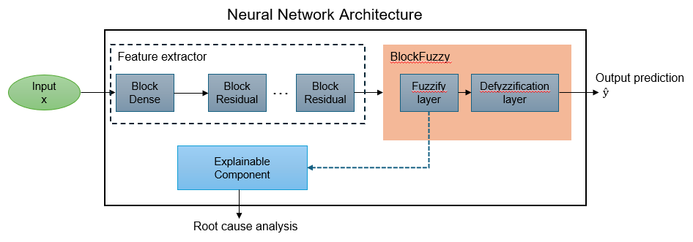
Fig x.x An illustration of the proposed neural network architecture.

2.1 Train step
The proposed methodology employs a deep neural network classifier-hereafter referred to as the teacher model-comprising an input layer, three hidden layers, and a final classification head. The input layer is implemented through a custom module, termed BlockDense, which consists of a linear transformation followed by batch normalization and a dropout layer for regularization. The intermediate layers, referred to as BlockResidual, extend the BlockDense module by incorporating skip connections that add the layer inputs to the corresponding outputs. This residual formulation facilitates improved gradient flow, thereby enhancing training stability and optimization performance.
The final layer, denoted as BlockFuzzy, integrates fuzzy logic into the prediction process through two internal components: a fuzzification layer and a defuzzification layer that produces the final classification output. The proposed FuzzyLayer implements a differentiable fuzzy membership function within a neural network framework, following the paradigm of neuro-fuzzy systems such as ANFIS and its deep extensions. Each output neuron represents a fuzzy rule whose activation is computed as an exponential decay based on a transformed Euclidean distance. Specifically, for a given input vector, the layer applies a learnable affine transformation composed of scaling, rotation, and translation parameters, followed by an ℓ₂-norm and an exponential mapping to obtain membership degrees. This design allows end-to-end training while retaining the uncertainty modeling of a fuzzy-based architecture. More formally, the layer implements a generalized membership function:
$$μ_{c}\left(x\right)=\exp\left(-|A_{c}x+b_{c}|_{2}\right)$$
Here, $μ_{c}(x)$ represents the membership degree of the input vector $x∈R^{d}$to fuzzy rule $c$. The matrix $A_{c}∈R^{d×d}$is a learnable linear transformation that controls the orientation and scaling of the fuzzy membership function, while $b_{c}∈R^{d}$is the rule centroid (shift). The Euclidean norm of the transformed input is mapped via the exponential to a value in $[0,1]$ such that smaller distances correspond to higher membership degrees. Additionally, the defuzzification process is also implemented through a learnable linear layer, often referred to as a Sugeno-style layer in neuro-fuzzy systems. This layer aggregates the activations of all fuzzy rules to produce a crisp output suitable for prediction tasks. Specifically, for a batch sample $b$, the defuzzified output $y_{b}∈R^{d_{\text{out}}}$is computed as a weighted sum of the rule consequence vectors $z_{c}∈R^{d_{\text{out}}}$, normalized by the total activation:
$$y_{b}=\frac{\sum_{c=1}^{C}{α_{c}\left(x\right)} z_{c}}{\sum_{c=1}^{C}{α_{c}\left(x\right)}}$$
Here, $α_{c}\left(x_{b}\right)$denotes the activation of fuzzy rule $c$ for input $x$ and $C$ is the total number of fuzzy rules. The numerator computes the contribution of each rule to the final prediction, while the denominator ensures a convex combination, mapping fuzzy reasoning into a crisp, differentiable output. Thus, the design of the FuzzyLayer ensures differentiability enabling end-to-end training via backpropagation while maintaining the core aspects of a fuzzy process, such as interpretability and uncertainty.
Explainable component
Additionally, the architecture incorporates an explainability module that leverages the trained membership functions within the FuzzyLayer. For a given input $x$, gradient-based saliency is first defined as the sensitivity of the model output with respect to the input features. Formally, let $p_{T}(y^{\text{\backslash C}\text{lass}}∣x)$denote the model output associated with the target class $y^{\text{\backslash C}\text{lass}}$. The saliency of the $i$-th input feature is defined as:
$$S_{i}\left(x\right)=\left|\frac{∂p_{T}\left(y^{\backslash Class} ∣ x\right)}{∂x_{i}}\right|$$
In contrast to standard output-gradient saliency methods, the proposed explainability mechanism does not aggregate gradients of the output logits or class probabilities. Feature relevance is computed solely from gradients of the dominant fuzzy rule activations, ensuring that explanations are directly rooted in the fuzzy inference mechanism. Thus, to obtain localized, rule-aware explanations, the proposed method further conditions this analysis on the most strongly activated fuzzy rules. Let $C_{k}$denote the set of top-$k$ fuzzy rules with the highest membership values $μ_{c}(x)$. The final feature relevance scores are computed by aggregating the absolute gradients of the corresponding rule activations:
$$\tilde{S_{i}}\left(x\right)=\sum_{c∈C_{k}}{\left|\frac{∂μ_{c}\left(f\left(x\right)\right)}{∂x_{i}}\right|}$$
Using rule-conditioned saliency by differentiating individual fuzzy rule activations with respect to the input can provide an interpretable root cause analysis process via a visualization of feature importance, grounded in both fuzzy rule activations and gradient information, enhancing the transparency of the proposed architecture. This procedure yields localized, rule-aware explanations that directly link input features to the dominant fuzzy decision mechanisms.

2.2 Inference system
During inference, a state represented by a feature vector $x∈R^{d}$, where $d$denotes the dimensionality of the input space, is processed by the neural network to produce class prediction probabilities. In parallel, the NN’s explainability module generates an initial interpretation of the prediction by computing a saliency-based feature importance ranking, highlighting the input dimensions that most strongly influence the model’s decision as mentioned in the previous paragraph.
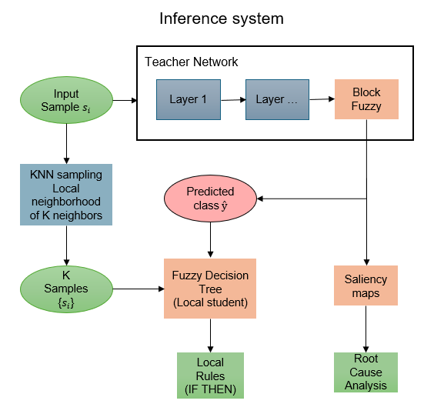
Fig x.x The proposed inference system.
In addition, the inference system processes the input data with a linguistic labelling process based on centroid-based statistics. Specifically, the local manifold surrounding a target sample x is characterized by extracting a neighborhood $N_{k}$ via a k-nearest neighbors approach. This local representation is subsequently processed by a teacher model to yield proxy predictions $\hat{y_{K}}$. The localized context state pair {$N_{k}$, $y_{K}$} serves as the training input for a Fuzzy Decision Tree (FDT), which is optimized to distill complex decision boundaries into human-intelligible linguistic rules. In contrast to conventional decision trees, the FDT accommodates epistemic uncertainty by facilitating partial membership across multiple concurrent branches. This architecture employs overlapping Gaussian membership functions to partition the continuous feature space, with set centers initialized via linear interpolation between the global extrema. The tree construction utilizes a weighted fuzzy entropy criterion for recursive splitting, ultimately yielding smooth decision surfaces. Each unique path from the root to a leaf node constitutes a fuzzy rule, where predictions are determined by the aggregate firing strength of the activated linguistic antecedents, resulting in a rule base of the following form:
$$\text{IF }feature_{1}\text{ IS Low AND }feature_{2}\text{ IS High THEN class = }c[\text{support}=s, \text{confidence}=p]$$

Where support signifies the empirical coverage of a fuzzy rule across the training manifold, representing the total aggregated firing strength of all samples that satisfy the rule’s specific path. Higher support values indicate that a rule characterizes a statistically significant region of the feature space, accounting for the partial memberships inherent in the fuzzy partitioning. Conversely, confidence quantifies the rule’s conditional reliability, defined as the proportion of the total support that aligns with the predicted class c. This metric serves as a measure of the rule's local precision, ensuring that the linguistic antecedents provide a robust and consistent mapping to the target label.
Consequently, the inference system generates a comprehensive ensemble of outputs characterized by high semantic alignment, thereby enhancing interpretability and transparency. The integration of differentiable fuzzy layers and post-hoc linguistic labeling via FDTs results in an end-to-end explainable framework. This system effectively mitigates the 'black-box' nature of deep learning by anchoring predictions in rule-based logic and saliency-based feature importance. The following sections demonstrate the efficacy of this methodology in providing accurate and transparent degradation predictions.

- experiments and results
  - Dataset Description and Preprocessing
Our benchmark dataset is based on the dataset published through the University of California Irvine (UCI) website coming from a simulator of a Frigate that is equipped with a CODLAG (Combined Diesel Electric And Gas) propulsion plant as detailed in \cite[Coradu et al original paper]. The data represent a degradation model of the propulsion plant, artificially constructed by introducing a fouling in the Gas turbine (GT) that increases the specific fuel flow consumption and the temperature of the exhaust gas. It is characterized by two parameters, the compression degradation coefficient ($kM_{c}$) and the turbine degradation coefficient ($kM_{t}$), expressing the GT and the Gas turbine compressor (GTC) respectively. Specifically, the decays of the GT and GTC of the power plant are modeled in the discrete range of:

- GT decay: $kM_{t} ∈$ [0.975, 1.0], total of 51 values.
- GTC decay: $kM_{c}$ [0.95,1.0], total of 26 values.

And an input parameter, the speed of the vessel, characterized by the vessel’s lever position ($l_{p}$) that can assume a finite number of positions $l_{p_{i}}$ with $i ∈$ {1, … ,9}. These positions correspond to correlated ship’s speed ranging from 3 to 27 knots in 9 discrete settings as well, in increments of 3 knots. Therefore, the space of all possible states is described via the following cartesian product of the individual simulation parameters:
$Ω= kM_{t}×kM_{c}×l_{p}$ = $51 ×26 ×9 = 11934$ configuration states.

These configuration states produce a 18-feature vector for each state (including 2 degradation states and the input of the lever position), representing the measures available from the continuous monitoring system. These features are as follows:

1. Lever position (lp) []
2. Ship speed (v) [knots]
3. Gas turbine shaft torque (GTT) [kN m]
4. Gas turbine rate of revolutions (GTn) [rpm]
5. Gas Generator rate of revolutions (GGn)
[rpm]
6. Starboard Propeller Torque (Ts) [kN]
7. HP Turbine exit temperature (T48) [C]
8. GT Compressor outlet air temperature (T2) [C]
9. HP Turbine exit pressure (P48) [bar]
10. GT Compressor outlet air pressure (P2) [bar]
11. Gas turbine exhaust gas pressure (Pexh) [bar]
12. Turbine Injection Control (TIC) [%]
13. Fuel flow (mf) [kg/s]

Before applying machine-learning algorithms, three features with fixed values were removed from the dataset. These features were:
1. GT Compressor inlet air pressure (P1) [bar]
2. GT Compressor inlet air temperature (T1) [C]
3. Port Propeller Torque (Tp) [kN] T
Since the task of this study is to provide condition-based predictive maintenance insights, we also adopt a binary classification approach by applying thresholds to the $kM_{c}$ and $kM_{t}$ target variables as described in \cite{Dataset second paper}. Following the authors’ rationale, an effective service time of 2000 h per year is considered reasonable for both GT and GTC, given the typical operating profile of this type of vessel. Under this assumption, the implementation of a condition-based maintenance (CBM) framework is feasible. In agreement with these considerations, the authors defined the following thresholds based on prior knowledge of the time-domain decay functions:

$$KM_{c}\left\{\begin{aligned}… \\ \end{aligned}\right.$$

$$KM_{t}\left\{\begin{aligned}… \\ \end{aligned}\right.$$

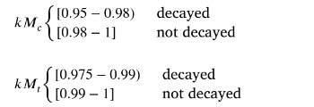

Add the curly braces image in text with binary classification labels along

And thus, the binary classification problem is produced via a mapping of {not decayed:0} and {decayed:1} of the aforementioned state ranges.

In addition, the feature space of the dataset is normalized using z-score normalization, whereby each feature is rescaled to have zero mean and unit variance. Finally, to ensure for an unbiased, robust and reliable performance estimation process, we use a 5-fold stratified cross validation that leads into a total of 5 variations of the dataset into non-overlapping training and test subsets.

  - Classification Results
In order to evaluate the performance of the proposed model the following metrics presented in Eq. (1)-(3) were used: accuracy, sensitivity, specificity, and Area under the ROC Curve (AUC) [ref].

$Accuracy= \frac{TP+TN}{TP+TN+FP+FN}$ (1)
$Specificity=\frac{TN}{TN+FP}$ (2)
$Sensitivity=\frac{TP}{TP+FN}$ (3)
where TP: True Positive, TN: True Negative, FP: False Positive, FN: False Negative.
As presented in Tables 1, 2 the proposed model was compared to the following well-known classifiers Support Vector Machine (SVM), k-Nearest Neighbors (k-NN) algorithm, Binary Decision Tree (BDT) …. as well as the state-of-the art models: … [ref]
Table 1: Comparisons of the proposed model with well-known and state-of-the-art classifiers for the compressor.
Models/Metrics | Accuracy | AUC | Specificity | Sensitivity
SVM
k-NN
Proposed model

Table 2: Comparisons of the proposed model with well-known and state-of-the-art classifiers for the turbine.
Models/Metrics | Accuracy | AUC | Specificity | Sensitivity
SVM
k-NN
Proposed model

  - Explainable Example of Failure Prediction

- conclusions
Papers may be written in languages other than English or include titles, subtitles, keywords and abstracts in different languages (as a rule, a paper in a language other than English should include an English title and an English abstract). “Select Main Language” from ACM template menu for the main language of the paper, English is the default language and there is no requirement to select it. For example, please select “French” as the main language for a French paper with additional titles and abstracts in English and German.

ACKNOWLEDGMENTS

REFERENCES
- Atul Adya, Paramvir Bahl, Jitendra Padhye, Alec Wolman, and Lidong Zhou. 2004. A multi-radio unification protocol for IEEE 802.11 wireless networks. In Proceedings of the IEEE 1st International Conference on Broadnets Networks (BroadNets’04) . IEEE, Los Alamitos, CA, 210–217. https://doi.org/10.1109/BROADNETS.2004.8
- Sam Anzaroot and Andrew McCallum. 2013. UMass Citation Field Extraction Dataset. Retrieved May 27, 2019 from http://www.iesl.cs.umass.edu/data/data-umasscitationfield
- Martin A. Fischler and Robert C. Bolles. 1981. Random sample consensus: a paradigm for model fitting with applications to image analysis and automated cartography. Commun. ACM 24, 6 (June 1981), 381–395. https://doi.org/10.1145/358669.358692
- Chelsea Finn. 2018. Learning to Learn with Gradients. PhD Thesis, EECS Department, University of Berkeley.
- Jon M. Kleinberg. 1999. Authoritative sources in a hyperlinked environment. J. ACM 46, 5 (September 1999), 604–632. https://doi.org/10.1145/324133.324140
- Matthew Van Gundy, Davide Balzarotti, and Giovanni Vigna. 2007. Catch me, if you can: Evading network signatures with web-based polymorphic worms. In Proceedings of the first USENIX workshop on Offensive Technologies (WOOT ’07) . USENIX Association, Berkley, CA, Article 7, 9

* Place the footnote text for the author (if applicable) here.

