**1. Implement Exhaustive search techniques using**

**a.BFS**

**Program:**

n=int(input("Enter number of nodes in graph:")) #READING INPUT

for i in range(n):

print(chr(65+i),end=' ')

print("are the nodes")

d={}

for i in range(n):

print("Enter the child nodes of",chr(i+65),end='')

c=list(map(str,input(":").split()))

if c[0]!='0':

d[chr(i+65)]=c

else:

d[chr(i+65)]=[]

source=input("Enter source node:")

key=input("Enter destination node:")

#INITIALISING OPEN AND CLOSED LISTS

open_list=[source]

closed_list=[]

print("Open List--Closed List")

print(''.join(open_list),''.join(closed_list),sep='--')

while open_list:

source=open_list.pop(0)

closed_list.append(source)

if source==key:

print('Required node is found',key)

break

for i in d[source]:

if i not in closed_list and i not in open_list:

open_list.append(i)

#PRINTING OPEN AND CLOSED LIST FOR EACH ITERATION.

print(''.join(open_list),''.join(closed_list),sep='--')

**OUTPUT:**

**I.**

**GRAPH:**

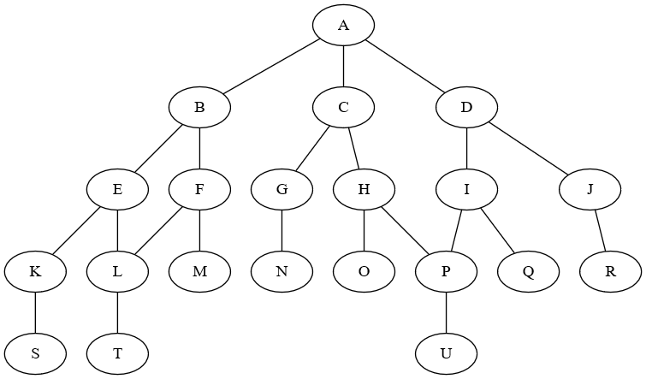

Enter number of nodes in graph:21

A B C D E F G H I J K L M N O P Q R S T U are the nodes

Enter the child nodes of A:B C D

Enter the child nodes of B:E F

Enter the child nodes of C:G H

Enter the child nodes of D:I J

Enter the child nodes of E:K L

Enter the child nodes of F:L M

Enter the child nodes of G:N

Enter the child nodes of H:O P

Enter the child nodes of I:P Q

Enter the child nodes of J:R

Enter the child nodes of K:S

Enter the child nodes of L:T

Enter the child nodes of M:0

Enter the child nodes of N:0

Enter the child nodes of O:0

Enter the child nodes of P:U

Enter the child nodes of Q:0

Enter the child nodes of R:0

Enter the child nodes of S:0

Enter the child nodes of T:0

Enter the child nodes of U:0

Enter source node:A

Enter destination node:U

Open List--Closed List

A--

B--A

BC--A

BCD--A

CDE--AB

CDEF--AB

DEFG--ABC

DEFGH--ABC

EFGHI--ABCD

EFGHIJ--ABCD

FGHIJK--ABCDE

FGHIJKL--ABCDE

GHIJKL--ABCDEF

GHIJKLM--ABCDEF

HIJKLMN--ABCDEFG

IJKLMNO--ABCDEFGH

IJKLMNOP--ABCDEFGH

JKLMNOP--ABCDEFGHI

JKLMNOPQ--ABCDEFGHI

KLMNOPQR--ABCDEFGHIJ

LMNOPQRS--ABCDEFGHIJK

MNOPQRST--ABCDEFGHIJKL

QRSTU--ABCDEFGHIJKLMNOP

Required node is found U

**II.**

**GRAPH:**

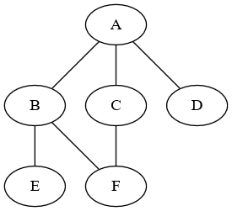

Enter number of nodes in graph:6

A B C D E F are the nodes

Enter the child nodes of A:B C D

Enter the child nodes of B:E F

Enter the child nodes of C:F

Enter the child nodes of D:0

Enter the child nodes of E:0

Enter the child nodes of F:0

Enter source node:A

Enter destination node:E

Open List--Closed List

A--

B--A

BC--A

BCD--A

CDE--AB

CDEF--AB

DEF--ABC

Required node is found E

**b.DFS**

**Program:**

n=int(input("Enter number of nodes in graph:")) # READING INPUT

for i in range(n):

print(chr(65+i),end=' ')

print("are the nodes")

d={}

for i in range(n):

print("Enter the child nodes of",chr(i+65),end='')

c=list(map(str,input(":").split()))

if c[0]!='0':

d[chr(i+65)]=c

else:

d[chr(i+65)]=[]

source=input("Enter source node:")

key=input("Enter destination node:")

#INITIALISING OPEN AND CLOSED LISTS.

open_list=[source]

closed_list=[]

print("Open List--Closed List")

print(''.join(open_list),''.join(closed_list),sep='--')

while open_list:

source=open_list.pop(0)

closed_list.append(source)

if source==key:

print('Required node is found',key)

break

for i in d[source]:

if i not in closed_list and i not in open_list:

open_list.insert(0,i)

#PRINTING OPEN AND CLOSED LIST FOR EACH ITERATION.

print(''.join(open_list),''.join(closed_list),sep='--')

**OUTPUT:**

**I.**

**GRAPH:**



Enter number of nodes in graph:21

A B C D E F G H I J K L M N O P Q R S T U are the nodes

Enter the child nodes of A:B C D

Enter the child nodes of B:E F

Enter the child nodes of C:G H

Enter the child nodes of D:I J

Enter the child nodes of E:K L

Enter the child nodes of F:L M

Enter the child nodes of G:N

Enter the child nodes of H:O P

Enter the child nodes of I:P Q

Enter the child nodes of J:R

Enter the child nodes of K:S

Enter the child nodes of L:T

Enter the child nodes of M:0

Enter the child nodes of N:0

Enter the child nodes of O:0

Enter the child nodes of P:U

Enter the child nodes of Q:0

Enter the child nodes of R:0

Enter the child nodes of S:0

Enter the child nodes of T:0

Enter the child nodes of U:0

Enter source node:A

Enter destination node:U

Open List--Closed List

A--

B--A

CB--A

DCB--A

ICB--AD

JICB--AD

RICB--ADJ

PCB--ADJRI

QPCB--ADJRI

UCB--ADJRIQP

Required node is found U

**II.**

**GRAPH:**



Enter number of nodes in graph:6

A B C D E F are the nodes

Enter the child nodes of A:B C D

Enter the child nodes of B:E F

Enter the child nodes of C:F

Enter the child nodes of D:0

Enter the child nodes of E:0

Enter the child nodes of F:0

Enter source node:A

Enter destination node:E

Open List--Closed List

A--

B--A

CB--A

DCB--A

FB--ADC

E--ADCFB

E--ADCFB

Required node is found E

**c.Uniform Cost Search**

**Program:**

def UCS(graph, s, goal):

# FRONTIER IS THE DICTIONARY THAT STORES THE PATH AND ITS COST.

frontier = {s: 0}

#EXPLORED IS A LIST THAT HAS ALL THE NODES THAT ARE ALREADY EXPLORED TO AVOID INFINITE LOOPING.

explored = []

while frontier:

print(f"Open list: {frontier}")

print(f"Closed list: {explored}")

node = min(frontier, key=frontier.get)

val = frontier[node]

print(node, " : ", val)

del frontier[node]

if goal == node:

return f"Goal reached with cost: {val}"

explored.append(node)

for neighbour, pathCost in graph[node].items():

if neighbour not in explored or neighbour not in frontier:

frontier.update({neighbour: val + pathCost})

elif neighbour in frontier and pathCost > val:

frontier.update({neighbour: val})

return "Goal not found"

# A FUNCTION TO READ INPUT GRAPH

def create_graph():

num_nodes = int(input("Enter number of nodes in graph: "))

graph = {}

nodes = input("Enter the nodes separated by space: ").split()

for node in nodes:

children = input(f"Enter the child nodes of {node}: ").split()

graph[node] = {}

for child in children:

if child != '0':

cost = int(input(f"Enter the cost from {node} to {child}: "))

graph[node][child] = cost

return graph

graph = create_graph() #READING INPUT

s = input("Enter source node: ")

g = input("Enter goal node: ")

print(UCS(graph, s, g)) #FUNCTION CALL

**OUTPUT:**

**I.**

**Graph:**

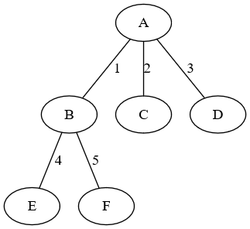

Enter number of nodes in graph: 6

Enter the nodes separated by space: A B C D E F

Enter the child nodes of A: B C D

Enter the child nodes of B: E F

Enter the child nodes of C: F

Enter the child nodes of D: 0

Enter the child nodes of E: 0

Enter the child nodes of F: 0

Enter source node: A

Enter goal node: E

Enter the cost from A to B: 1

Enter the cost from A to C: 2

Enter the cost from A to D: 3

Enter the cost from B to E: 4

Enter the cost from B to F: 5

Open list: {'A': 0}

Closed list: []

A : 0

Open list: {'B': 1, 'C': 2, 'D': 3}

Closed list: ['A']

B : 1

Open list: {'C': 2, 'D': 3, 'E': 5, 'F': 6}

Closed list: ['A', 'B']

E : 5

Goal reached with cost: 5

**II.**

**Graph:  
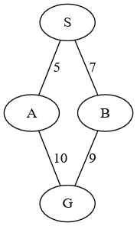**

Enter number of nodes in graph: 4

Enter the nodes separated by space: S A B G

Enter the child nodes of S: A B

Enter the child nodes of A: G

Enter the child nodes of B: G

Enter the child nodes of G: 0

Enter source node: S

Enter goal node: G

Enter the cost from S to A: 5

Enter the cost from S to B: 7

Enter the cost from A to G: 10

Enter the cost from B to G: 9

Open list: {'S': 0}

Closed list: []

S : 0

Open list: {'A': 5, 'B': 7}

Closed list: ['S']

A : 5

Open list: {'B': 7, 'G': 15}

Closed list: ['S', 'A']

B : 7

Open list: {'G': 15}

Closed list: ['S', 'A', 'B']

G : 15

Goal reached with cost: 15

**d.Depth-First Iterative Deepening**

**Program:**

def dfs(d, source, key):

#BASIC DFS FUNCTION

open_list = [source]

closed_list = []

while open_list:

source = open_list.pop(0)

closed_list.append(source)

if source == key:

return [closed_list, open_list, 1]

for i in d[source]:

if i not in closed_list and i not in open_list:

open_list.insert(0, i)

return [closed_list, open_list, 0]

def depthxtree(graph, depth, source):

#THIS FUNCTION GENERATES TREES/GRAPHS TILL A CERTAIN LEVEL (HEIGHT)

c = 1

d = {}

templis = []

all_nodes = []

all_nodes.append(source + str(c))

while c <= depth:

if c == 1:

d[source] = []

templis = graph[source]

parent = source

if c == 2:

for i in templis:

d[i] = []

d[parent].append(i)

all_nodes.append(i + str(c))

else:

for j in all_nodes:

if j[-1] == str(c - 1):

templis = graph[j[:-1]]

for i in templis:

d[i] = []

d[j[:-1]].append(i)

all_nodes.append(i + str(c))

c += 1

return d

def iddfs(graph, source, key):

depth = 1

while 1:

d = depthxtree(graph, depth, source)

y = dfs(d, source, key)

print("DEPTH=", depth)

print("Open_list=", y[1])

print("Closed_list=", y[0])

depth += 1

if len(d) == len(graph) or y[2] == 1:

break

# READING INPUT

n = int(input("Enter number of nodes in graph: "))

for i in range(n):

print(chr(65 + i), end=' ')

print("are the nodes")

graph = {}

for i in range(n):

print("Enter the child nodes of", chr(65 + i), end='')

c = list(map(str, input(": ").split()))

if c[0] != '0':

graph[chr(65 + i)] = c

else:

graph[chr(65 + i)] = []

source = input("Enter source node: ")

destination = input("Enter destination node: ")

iddfs(graph, source, destination) #FUNCUTION CALL

**OUTPUT:**

**I.**

**GRAPH:**



Enter number of nodes in graph:21

A B C D E F G H I J K L M N O P Q R S T U are the nodes

Enter the child nodes of A:B C D

Enter the child nodes of B:E F

Enter the child nodes of C:G H

Enter the child nodes of D:I J

Enter the child nodes of E:K L

Enter the child nodes of F:L M

Enter the child nodes of G:N

Enter the child nodes of H:O P

Enter the child nodes of I:P Q

Enter the child nodes of J:R

Enter the child nodes of K:S

Enter the child nodes of L:T

Enter the child nodes of M:0

Enter the child nodes of N:0

Enter the child nodes of O:0

Enter the child nodes of P:U

Enter the child nodes of Q:0

Enter the child nodes of R:0

Enter the child nodes of S:0

Enter the child nodes of T:0

Enter the child nodes of U:0

DEPTH= 1

Open_list= []

Closed_list= ['A']

DEPTH= 2

Open_list= []

Closed_list= ['A', 'D', 'C', 'B']

DEPTH= 3

Open_list= []

Closed_list= ['A', 'D', 'J', 'I', 'C', 'H', 'G', 'B', 'F', 'E']

DEPTH= 4

Open_list= []

Closed_list= ['A', 'D', 'J', 'R', 'I', 'Q', 'P', 'C', 'H', 'O', 'G', 'N', 'B', 'F', 'M', 'L', 'E', 'K']

DEPTH= 5

Open_list= ['C', 'B']

Closed_list= ['A', 'D', 'J', 'R', 'I', 'Q', 'P', 'U']

**II.**

**GRAPH:**



**Enter number of nodes in graph: 6**

**A B C D E F are the nodes**

**Enter the child nodes of A: B C D**

**Enter the child nodes of B: E F**

**Enter the child nodes of C: F**

**Enter the child nodes of D: 0**

**Enter the child nodes of E: 0**

**Enter the child nodes of F: 0**

**Enter source node: A**

**Enter destination node: F**

**DEPTH= 1**

**Open_list= ['B', 'C', 'D']**

**Closed_list= ['A']**

**DEPTH= 2**

**Open_list= ['E', 'F']**

**Closed_list= ['A', 'B', 'C', 'D']**

**DEPTH= 3**

**Open_list= []**

**Closed_list= ['A', 'B', 'C', 'D', 'E', 'F']**

**e.Bidirectional Search**

**Program:**

def BFS(direction, graph, frontier, reached):

if direction == 'F': # FROM ONE SIDE(SAY FRONT F)

d = 'c'

elif direction == 'B': : # FROM ONE SIDE(SAY BACK B)

d = 'p'

node = frontier.pop(0)

for child in graph[node][d]:

if child not in reached:

reached.append(child)

frontier.append(child)

return frontier, reached

def isIntersecting(reachedF, reachedB):

intersecting = set(reachedF).intersection(set(reachedB))

return list(intersecting)[0] if intersecting else -1

def BidirectionalSearch(graph, source, dest):

frontierF = [source]

frontierB = [dest]

reachedF = [source]

reachedB = [dest]

while frontierF and frontierB:

print("From front: ")

print(f"\tFrontier: {frontierF}")

print(f"\tReached: {reachedF}")

print("From back: ")

print(f"\tFrontier: {frontierB}")

print(f"\tReached: {reachedB}")

frontierF, reachedF = BFS('F', graph, frontierF, reachedF)

frontierB, reachedB = BFS('B', graph, frontierB, reachedB)

intersectingNode = isIntersecting(reachedF, reachedB)

if intersectingNode != -1:

print("From front: ")

print(f"\tFrontier: {frontierF}")

print(f"\tReached: {reachedF}")

print("From back: ")

print(f"\tFrontier: {frontierB}")

print(f"\tReached: {reachedB}")

print("Path found!")

path = reachedF[:-1] + reachedB[::-1]

return path

print("No path found!")

return []

def create_graph():

graph = {}

n = int(input("Enter number of nodes in graph: "))

for i in range(n):

print(chr(65 + i), end=' ')

print("are the nodes")

for i in range(n):

node = chr(65 + i)

children = input(f"Enter the child nodes of {node}: ").split()

graph[node] = {'c': [], 'p': []}

for child in children:

if child != '0':

graph[node]['c'].append(child)

graph[child]['p'].append(node)

return graph

s = input("Enter source node: ")

g = input("Enter goal node: ")

graph = create_graph()

path = BidirectionalSearch(graph, s, g)

if len(path):

print("Path:", path)

**OUTPUT:**

**I.**

**GRAPH:**



Enter number of nodes in graph: 21

A B C D E F G H I J K L M N O P Q R S T U are the nodes

Enter the child nodes of A: B C D

Enter the child nodes of B: E F

Enter the child nodes of C: G H

Enter the child nodes of D: I J

Enter the child nodes of E: K L

Enter the child nodes of F: L M

Enter the child nodes of G: N

Enter the child nodes of H: O P

Enter the child nodes of I: P Q

Enter the child nodes of J: R

Enter the child nodes of K: S

Enter the child nodes of L: T

Enter the child nodes of M: 0

Enter the child nodes of N: 0

Enter the child nodes of O: 0

Enter the child nodes of P: U

Enter the child nodes of Q: 0

Enter the child nodes of R: 0

Enter the child nodes of S: 0

Enter the child nodes of T: 0

Enter the child nodes of U: 0

Enter source node: A

Enter destination node: U

From front:

Frontier: ['A']

Reached: ['A']

From back:

Frontier: ['U']

Reached: ['U']

Path found!

Path: ['A', 'P', 'U'] ['A']

**II.**

**GRAPH:**



Enter number of nodes in graph: 7

A B C D E F G are the nodes

Enter the child nodes of A: B C

Enter the child nodes of B: D

Enter the child nodes of C: D E

Enter the child nodes of D: F

Enter the child nodes of E: F G

Enter the child nodes of F: 0

Enter the child nodes of G: 0

Enter source node: A

Enter goal node: G

From front:

Frontier: ['A']

Reached: ['A']

From back:

Frontier: ['G']

Reached: ['G']

Path found!

Path: ['A', 'C', 'E', 'G']**2. a) Implement water jug problem with Search tree generation using BFS**

**Program:**

def fill(x,jug,i): # FILL FUNCTION RETURNS A STATE WITH MENTIONED FILLED JUG

x=list(x)

x[i]=jug

return tuple(x)

def empty(x,i): # EMPTY FUNCTION RETURNS A STATE WITH MENTIONED JUG EMPTY

x=list(x)

x[i]=0

return tuple(x)

def transfer(x,jug1,jug2,i): # TRANSFER FUNCTION RETURNS A STATE WITH POSSIBLE TRANSFER FROM JUG i TO j.

x=list(x)

if i==1:

available=jug2-x[1]

if x[0]>available:

x[0]-=available

x[1]+=available

else:

x[1]+=x[0]

x[0]=0

elif i==2:

available=jug1-x[0]

if x[1]>available:

x[1]-=available

x[0]+=available

else:

x[0]+=x[1]

x[1]=0

return tuple(x)

def make_tree(d,jug1,jug2,vol): #GENERATING STATE SPACE TREE

all_nodes=[(0,0)]

flag=1

while(flag):

if flag==2:

break

flag=0

source=all_nodes[0]

for i in [1,2]:

x=jug2

if i==1:

x=jug1

f=fill(source,x,i-1)

if f not in all_nodes:

all_nodes.insert(0,f)

d[source].append(f)

d[f]=[]

flag=1

if f[0]==vol or f[1]==vol:

break

f=empty(source,i-1)

if f not in all_nodes:

all_nodes.insert(0,f)

d[source].append(f)

d[f]=[]

flag=1

if f[0]==vol or f[1]==vol:

break

f=transfer(source,jug1,jug2,i)

if f not in all_nodes:

all_nodes.insert(0,f)

d[source].append(f)

d[f]=[]

flag=1

if f[0]==vol or f[1]==vol:

flag=2

break

jug1,jug2=map(int,input('Enter capacities of jug1 and jug2:').split()) #INPUT READING

vol=int(input('Enter Volume to make:'))

d={}

d[(0,0)]=[]

make_tree(d,jug1,jug2,vol) #FUNCTION CALL TO GENERATE STATE SPACE TREE

final=[] # FINAL[-1] HOLDS THE FINAL REQUIRED STATE

for i,j in d.items():

if j==[]:

if i[0]!=vol and i[1]!=vol:

pass

else:

final.append(i)

else:

final.append(i)

#BFS

open_list=[(0,0)]

closed_list=[]

print("Open List--Closed List")

print(''.join(str(open_list)),''.join(str(closed_list)),sep='--')

while open_list:

source=open_list.pop(0)

closed_list.append(source)

if source==final[-1]:

break

for i in d[source]:

if i not in closed_list and i not in open_list:

open_list.append(i)

print(''.join(str(open_list)),''.join(str(closed_list)),sep='--',end='\n\n')

**OUTPUT:**

**I.**

**GRAPH:**

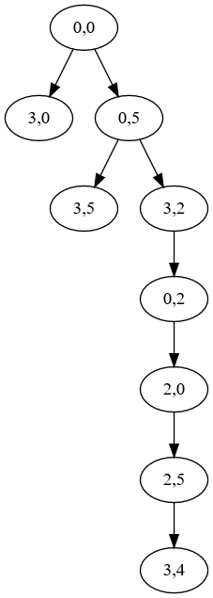

Enter capacities of jug1 and jug2:3 5

Enter Volume to make:4

Open List--Closed List

[(0, 0)]--[]

[(3, 0), (0, 5)]--[(0, 0)]

[(0, 5)]--[(0, 0), (3, 0)]

[(3, 5), (3, 2)]--[(0, 0), (3, 0), (0, 5)]

[(3, 2)]--[(0, 0), (3, 0), (0, 5), (3, 5)]

[(0, 2)]--[(0, 0), (3, 0), (0, 5), (3, 5), (3, 2)]

[(2, 0)]--[(0, 0), (3, 0), (0, 5), (3, 5), (3, 2), (0, 2)]

[(2, 5)]--[(0, 0), (3, 0), (0, 5), (3, 5), (3, 2), (0, 2), (2, 0)]

[(3, 4)]--[(0, 0), (3, 0), (0, 5), (3, 5), (3, 2), (0, 2), (2, 0), (2, 5)]

**II.**

**GRAPH:**

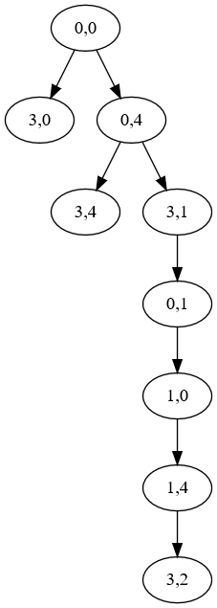

Enter capacities of jug1 and jug2:3 4

Enter Volume to make:2

Open List--Closed List

[(0, 0)]--[]

[(3, 0), (0, 4)]--[(0, 0)]

[(0, 4)]--[(0, 0), (3, 0)]

[(3, 4), (3, 1)]--[(0, 0), (3, 0), (0, 4)]

[(3, 1)]--[(0, 0), (3, 0), (0, 4), (3, 4)]

[(0, 1)]--[(0, 0), (3, 0), (0, 4), (3, 4), (3, 1)]

[(1, 0)]--[(0, 0), (3, 0), (0, 4), (3, 4), (3, 1), (0, 1)]

[(1, 4)]--[(0, 0), (3, 0), (0, 4), (3, 4), (3, 1), (0, 1), (1, 0)]

[(3, 2)]--[(0, 0), (3, 0), (0, 4), (3, 4), (3, 1), (0, 1), (1, 0), (1, 4)]

**2. b) Implement water jug problem with Search tree generation using DFS**

**Program:**

def fill(x,jug,i):

x=list(x)

x[i]=jug

return tuple(x)

def empty(x,i):

x=list(x)

x[i]=0

return tuple(x)

def transfer(x,jug1,jug2,i):

x=list(x)

if i==1:

available=jug2-x[1]

if x[0]>available:

x[0]-=available

x[1]+=available

else:

x[1]+=x[0]

x[0]=0

elif i==2:

available=jug1-x[0]

if x[1]>available:

x[1]-=available

x[0]+=available

else:

x[0]+=x[1]

x[1]=0

return tuple(x)

def make_tree(d,jug1,jug2,vol):

all_nodes=[(0,0)]

flag=1

while(flag):

if flag==2:

break

flag=0

source=all_nodes[0]

for i in [1,2]:

x=jug2

if i==1:

x=jug1

f=fill(source,x,i-1)

if f not in all_nodes:

all_nodes.insert(0,f)

d[source].append(f)

d[f]=[]

flag=1

if f[0]==vol or f[1]==vol:

break

f=empty(source,i-1)

if f not in all_nodes:

all_nodes.insert(0,f)

d[source].append(f)

d[f]=[]

flag=1

if f[0]==vol or f[1]==vol:

break

f=transfer(source,jug1,jug2,i)

if f not in all_nodes:

all_nodes.insert(0,f)

d[source].append(f)

d[f]=[]

flag=1

if f[0]==vol or f[1]==vol:

flag=2

break

jug1,jug2=map(int,input('Enter capacities of jug1 and jug2:').split())

vol=int(input('Enter Volume to make:'))

d={}

d[(0,0)]=[]

make_tree(d,jug1,jug2,vol)

final=[]

for i,j in d.items():

if j==[]:

if i[0]!=vol and i[1]!=vol:

pass

else:

final.append(i)

else:

final.append(i)

#DFS

open_list=[(0,0)]

closed_list=[]

print("Open List--Closed List")

print(''.join(str(open_list)),''.join(str(closed_list)),sep='--')

while open_list:

source=open_list.pop(0)

closed_list.append(source)

if source==final[-1]:

break

for i in d[source]:

if i not in closed_list and i not in open_list:

open_list.insert(0,i)

print(''.join(str(open_list)),''.join(str(closed_list)),sep='--',end='\n\n')

**OUTPUT:**

**I.**

**GRAPH:**



Enter capacities of jug1 and jug2:3 5

Enter Volume to make:4

Open List--Closed List

[(0, 0)]--[]

[(0, 5), (3, 0)]--[(0, 0)]

[(3, 2), (3, 5), (3, 0)]--[(0, 0), (0, 5)]

[(0, 2), (3, 5), (3, 0)]--[(0, 0), (0, 5), (3, 2)]

[(2, 0), (3, 5), (3, 0)]--[(0, 0), (0, 5), (3, 2), (0, 2)]

[(2, 5), (3, 5), (3, 0)]--[(0, 0), (0, 5), (3, 2), (0, 2), (2, 0)]

[(3, 4), (3, 5), (3, 0)]--[(0, 0), (0, 5), (3, 2), (0, 2), (2, 0), (2, 5)]

**II.**

**GRAPH:**



Enter capacities of jug1 and jug2:3 4

Enter Volume to make:2

Open List--Closed List

[(0, 0)]--[]

[(0, 4), (3, 0)]--[(0, 0)]

[(3, 1), (3, 4), (3, 0)]--[(0, 0), (0, 4)]

[(0, 1), (3, 4), (3, 0)]--[(0, 0), (0, 4), (3, 1)]

[(1, 0), (3, 4), (3, 0)]--[(0, 0), (0, 4), (3, 1), (0, 1)]

[(1, 4), (3, 4), (3, 0)]--[(0, 0), (0, 4), (3, 1), (0, 1), (1, 0)]

[(3, 2), (3, 4), (3, 0)]--[(0, 0), (0, 4), (3, 1), (0, 1), (1, 0), (1, 4)]

**3.a)Implement Missionaries and Cannibals problem with Search tree generation using BFS**

**Program:**

def travel(state,s): # TRAVEL FUNCTION RETURNS THE POSSIBLE STATE IF TRAVEL ACTION IS PERFORMED ELSE RETURNS A NULL STRING .

state=list(state)

state[0]=list(state[0])

state[1]=list(state[1])

if state[0][-1]==1:

for i in [0,1]:

state[0][i]-=s[i]

state[1][i]+=s[i]

state[0][-1]=0

state[1][-1]=1

state[0]=tuple(state[0])

state[1]=tuple(state[1])

state=tuple(state)

return state

elif state[1][-1]==1:

for i in [0,1]:

state[1][i]-=s[i]

state[0][i]+=s[i]

state[1][-1]=0

state[0][-1]=1

state[0]=tuple(state[0])

state[1]=tuple(state[1])

state=tuple(state)

return state

else:

return ""

def make_tree(start,end): # GENERATES STATE SPACE TREE

d={}

d[start]=[]

all_nodes=[start]

c=1

h=-1

source=start

while(h<c and source!=end):

h+=1

source=all_nodes[h]

for i in [0,1,2]: #EITHER 0,1 OR 2 MISSIONARIES

for j in [0,1,2]: # EITHER 0,1 OR 2 CANNIBALS

if i+j<=2 and i+j>0: # ATLEAST 1 ON BOAT OR ATMOST 2

state=travel(source,[i,j])

if state!="" and state not in all_nodes: # GENERATING ONLY NEW STATES.

if (state[0][0]>=state[0][1] or state[0][0]==0) and (state[1][0]>=state[1][1]or state[1][0]==0):

if state[0][0]>=0 and state[0][1]>=0 and state[1][0]>=0 and state[1][1]>=0:

all_nodes.append(state)

d[source].append(state)

d[state]=[]

if state==end:

break

c=len(all_nodes)

return d

m,n =map(int,input("Enter the number of missionaries and cannibals:").split()) #INPUT READING

start = ((m,n,1),(0,0,0))

end = ((0,0,0),(m,n,1))

key=end

state=start

d=make_tree(start,end) #FUNCTION CALL

#BFS

open_list=[start]

closed_list=[]

print("Open List--Closed List")

print(''.join(str(open_list)),''.join(str(closed_list)),sep='--')

while open_list:

source=open_list.pop(0)

closed_list.append(source)

if source==key:

print('Required node is found',key)

break

for i in d[source]:

if i not in closed_list and i not in open_list:

open_list.append(i)

print(''.join(str(open_list)),''.join(str(closed_list)),sep='--',end='\n\n')

**OUTPUT:**

**I.**

**GRAPH:**

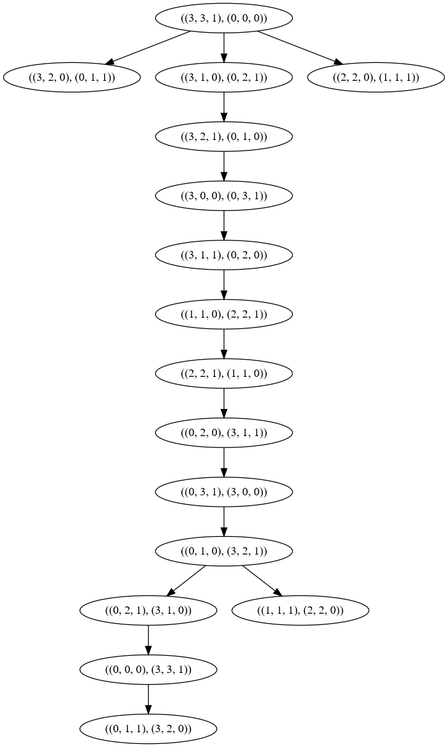

Enter the number of missionaries and cannibals:3 3

Open List--Closed List

[((3, 3, 1), (0, 0, 0))]--[]

[((3, 2, 0), (0, 1, 1)), ((3, 1, 0), (0, 2, 1)), ((2, 2, 0), (1, 1, 1))]--[((3, 3, 1), (0, 0, 0))]

[((3, 1, 0), (0, 2, 1)), ((2, 2, 0), (1, 1, 1))]--[((3, 3, 1), (0, 0, 0)), ((3, 2, 0), (0, 1, 1))]

[((2, 2, 0), (1, 1, 1)), ((3, 2, 1), (0, 1, 0))]--[((3, 3, 1), (0, 0, 0)), ((3, 2, 0), (0, 1, 1)), ((3, 1, 0), (0, 2, 1))]

[((3, 2, 1), (0, 1, 0))]--[((3, 3, 1), (0, 0, 0)), ((3, 2, 0), (0, 1, 1)), ((3, 1, 0), (0, 2, 1)), ((2, 2, 0), (1, 1, 1))]

[((3, 0, 0), (0, 3, 1))]--[((3, 3, 1), (0, 0, 0)), ((3, 2, 0), (0, 1, 1)), ((3, 1, 0), (0, 2, 1)), ((2, 2, 0), (1, 1, 1)), ((3, 2, 1), (0, 1, 0))]

[((3, 1, 1), (0, 2, 0))]--[((3, 3, 1), (0, 0, 0)), ((3, 2, 0), (0, 1, 1)), ((3, 1, 0), (0, 2, 1)), ((2, 2, 0), (1, 1, 1)), ((3, 2, 1), (0, 1, 0)), ((3, 0, 0), (0, 3, 1))]

[((1, 1, 0), (2, 2, 1))]--[((3, 3, 1), (0, 0, 0)), ((3, 2, 0), (0, 1, 1)), ((3, 1, 0), (0, 2, 1)), ((2, 2, 0), (1, 1, 1)), ((3, 2, 1), (0, 1, 0)), ((3, 0, 0), (0, 3, 1)), ((3, 1, 1), (0, 2, 0))]

[((2, 2, 1), (1, 1, 0))]--[((3, 3, 1), (0, 0, 0)), ((3, 2, 0), (0, 1, 1)), ((3, 1, 0), (0, 2, 1)), ((2, 2, 0), (1, 1, 1)), ((3, 2, 1), (0, 1, 0)), ((3, 0, 0), (0, 3, 1)), ((3, 1, 1), (0, 2, 0)), ((1, 1, 0), (2, 2, 1))]

[((0, 2, 0), (3, 1, 1))]--[((3, 3, 1), (0, 0, 0)), ((3, 2, 0), (0, 1, 1)), ((3, 1, 0), (0, 2, 1)), ((2, 2, 0), (1, 1, 1)), ((3, 2, 1), (0, 1, 0)), ((3, 0, 0), (0, 3, 1)), ((3, 1, 1), (0, 2, 0)), ((1, 1, 0), (2, 2, 1)), ((2, 2, 1), (1, 1, 0))]

[((0, 3, 1), (3, 0, 0))]--[((3, 3, 1), (0, 0, 0)), ((3, 2, 0), (0, 1, 1)), ((3, 1, 0), (0, 2, 1)), ((2, 2, 0), (1, 1, 1)), ((3, 2, 1), (0, 1, 0)), ((3, 0, 0), (0, 3, 1)), ((3, 1, 1), (0, 2, 0)), ((1, 1, 0), (2, 2, 1)), ((2, 2, 1), (1, 1, 0)), ((0, 2, 0), (3, 1, 1))]

[((0, 1, 0), (3, 2, 1))]--[((3, 3, 1), (0, 0, 0)), ((3, 2, 0), (0, 1, 1)), ((3, 1, 0), (0, 2, 1)), ((2, 2, 0), (1, 1, 1)), ((3, 2, 1), (0, 1, 0)), ((3, 0, 0), (0, 3, 1)), ((3, 1, 1), (0, 2, 0)), ((1, 1, 0), (2, 2, 1)), ((2, 2, 1), (1, 1, 0)), ((0, 2, 0), (3, 1, 1)), ((0, 3, 1), (3, 0, 0))]

[((0, 2, 1), (3, 1, 0)), ((1, 1, 1), (2, 2, 0))]--[((3, 3, 1), (0, 0, 0)), ((3, 2, 0), (0, 1, 1)), ((3, 1, 0), (0, 2, 1)), ((2, 2, 0), (1, 1, 1)), ((3, 2, 1), (0, 1, 0)), ((3, 0, 0), (0, 3, 1)), ((3, 1, 1), (0, 2, 0)), ((1, 1, 0), (2, 2, 1)), ((2, 2, 1), (1, 1, 0)), ((0, 2, 0), (3, 1, 1)), ((0, 3, 1), (3, 0, 0)), ((0, 1, 0), (3, 2, 1))]

[((1, 1, 1), (2, 2, 0)), ((0, 0, 0), (3, 3, 1))]--[((3, 3, 1), (0, 0, 0)), ((3, 2, 0), (0, 1, 1)), ((3, 1, 0), (0, 2, 1)), ((2, 2, 0), (1, 1, 1)), ((3, 2, 1), (0, 1, 0)), ((3, 0, 0), (0, 3, 1)), ((3, 1, 1), (0, 2, 0)), ((1, 1, 0), (2, 2, 1)), ((2, 2, 1), (1, 1, 0)), ((0, 2, 0), (3, 1, 1)), ((0, 3, 1), (3, 0, 0)), ((0, 1, 0), (3, 2, 1)), ((0, 2, 1), (3, 1, 0))]

[((0, 0, 0), (3, 3, 1))]--[((3, 3, 1), (0, 0, 0)), ((3, 2, 0), (0, 1, 1)), ((3, 1, 0), (0, 2, 1)), ((2, 2, 0), (1, 1, 1)), ((3, 2, 1), (0, 1, 0)), ((3, 0, 0), (0, 3, 1)), ((3, 1, 1), (0, 2, 0)), ((1, 1, 0), (2, 2, 1)), ((2, 2, 1), (1, 1, 0)), ((0, 2, 0), (3, 1, 1)), ((0, 3, 1), (3, 0, 0)), ((0, 1, 0), (3, 2, 1)), ((0, 2, 1), (3, 1, 0)), ((1, 1, 1), (2, 2, 0))]

Required node is found ((0, 0, 0), (3, 3, 1))

**II.**

**GRAPH:**

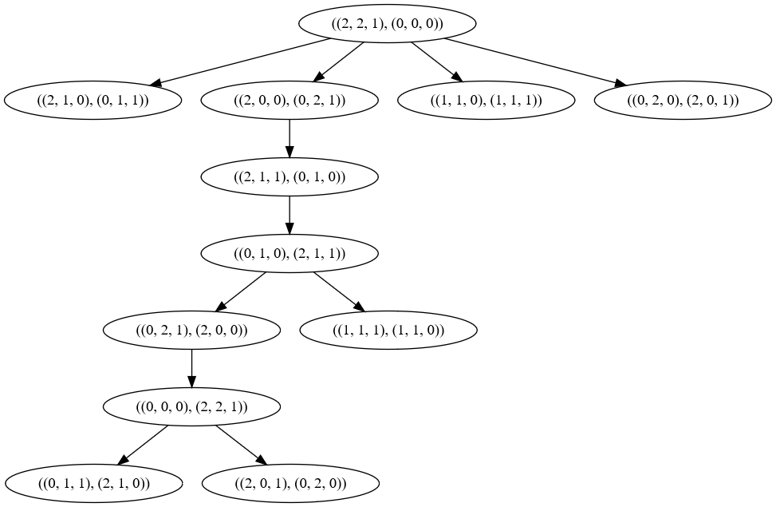

Enter the number of missionaries and cannibals:2 2

Open List--Closed List

[((2, 2, 1), (0, 0, 0))]--[]

[((2, 1, 0), (0, 1, 1)), ((2, 0, 0), (0, 2, 1)), ((1, 1, 0), (1, 1, 1)), ((0, 2, 0), (2, 0, 1))]--[((2, 2, 1), (0, 0, 0))]

[((2, 0, 0), (0, 2, 1)), ((1, 1, 0), (1, 1, 1)), ((0, 2, 0), (2, 0, 1))]--[((2, 2, 1), (0, 0, 0)), ((2, 1, 0), (0, 1, 1))]

[((1, 1, 0), (1, 1, 1)), ((0, 2, 0), (2, 0, 1)), ((2, 1, 1), (0, 1, 0))]--[((2, 2, 1), (0, 0, 0)), ((2, 1, 0), (0, 1, 1)), ((2, 0, 0), (0, 2, 1))]

[((0, 2, 0), (2, 0, 1)), ((2, 1, 1), (0, 1, 0))]--[((2, 2, 1), (0, 0, 0)), ((2, 1, 0), (0, 1, 1)), ((2, 0, 0), (0, 2, 1)), ((1, 1, 0), (1, 1, 1))]

[((2, 1, 1), (0, 1, 0))]--[((2, 2, 1), (0, 0, 0)), ((2, 1, 0), (0, 1, 1)), ((2, 0, 0), (0, 2, 1)), ((1, 1, 0), (1, 1, 1)), ((0, 2, 0), (2, 0, 1))]

[((0, 1, 0), (2, 1, 1))]--[((2, 2, 1), (0, 0, 0)), ((2, 1, 0), (0, 1, 1)), ((2, 0, 0), (0, 2, 1)), ((1, 1, 0), (1, 1, 1)), ((0, 2, 0), (2, 0, 1)), ((2, 1, 1), (0, 1, 0))]

[((0, 2, 1), (2, 0, 0)), ((1, 1, 1), (1, 1, 0))]--[((2, 2, 1), (0, 0, 0)), ((2, 1, 0), (0, 1, 1)), ((2, 0, 0), (0, 2, 1)), ((1, 1, 0), (1, 1, 1)), ((0, 2, 0), (2, 0, 1)), ((2, 1, 1), (0, 1, 0)), ((0, 1, 0), (2, 1, 1))]

[((1, 1, 1), (1, 1, 0)), ((0, 0, 0), (2, 2, 1))]--[((2, 2, 1), (0, 0, 0)), ((2, 1, 0), (0, 1, 1)), ((2, 0, 0), (0, 2, 1)), ((1, 1, 0), (1, 1, 1)), ((0, 2, 0), (2, 0, 1)), ((2, 1, 1), (0, 1, 0)), ((0, 1, 0), (2, 1, 1)), ((0, 2, 1), (2, 0, 0))]

[((0, 0, 0), (2, 2, 1))]--[((2, 2, 1), (0, 0, 0)), ((2, 1, 0), (0, 1, 1)), ((2, 0, 0), (0, 2, 1)), ((1, 1, 0), (1, 1, 1)), ((0, 2, 0), (2, 0, 1)), ((2, 1, 1), (0, 1, 0)), ((0, 1, 0), (2, 1, 1)), ((0, 2, 1), (2, 0, 0)), ((1, 1, 1), (1, 1, 0))]

Required node is found ((0, 0, 0), (2, 2, 1))

**3.b)Implement Missionaries and Cannibals problem with Search tree generation using DFS**

**Program:**

def travel(state,s):

state=list(state)

state[0]=list(state[0])

state[1]=list(state[1])

if state[0][-1]==1:

for i in [0,1]:

state[0][i]-=s[i]

state[1][i]+=s[i]

state[0][-1]=0

state[1][-1]=1

state[0]=tuple(state[0])

state[1]=tuple(state[1])

state=tuple(state)

return state

elif state[1][-1]==1:

for i in [0,1]:

state[1][i]-=s[i]

state[0][i]+=s[i]

state[1][-1]=0

state[0][-1]=1

state[0]=tuple(state[0])

state[1]=tuple(state[1])

state=tuple(state)

return state

else:

return ""

def make_tree(start,end):

d={}

d[start]=[]

all_nodes=[start]

c=1

h=-1

source=start

while(h<c and source!=end):

h+=1

source=all_nodes[h]

for i in [0,1,2]:

for j in [0,1,2]:

if i+j<=2 and i+j>0:

state=travel(source,[i,j])

if state!="" and state not in all_nodes:

if (state[0][0]>=state[0][1] or state[0][0]==0) and (state[1][0]>=state[1][1]or state[1][0]==0):

if state[0][0]>=0 and state[0][1]>=0 and state[1][0]>=0 and state[1][1]>=0:

all_nodes.append(state)

d[source].append(state)

d[state]=[]

if state==end:

break

c=len(all_nodes)

return d

m,n =map(int,input("Enter the number of missionaries and cannibals:").split())

start = ((m,n,1),(0,0,0))

end = ((0,0,0),(m,n,1))

key=end

state=start

d=make_tree(start,end)

#DFS

open_list=[start]

closed_list=[]

print("Open List--Closed List")

print(''.join(str(open_list)),''.join(str(closed_list)),sep='--')

while open_list:

source=open_list.pop(0)

closed_list.append(source)

if source==key:

print('Required node is found',key)

break

for i in d[source]:

if i not in closed_list and i not in open_list:

open_list.insert(0,i)

print(''.join(str(open_list)),''.join(str(closed_list)),sep='--',end='\n\n')

**OUTPUT:**

**I.**

**GRAPH:**



Enter the number of missionaries and cannibals:3 3

Open List--Closed List

[((3, 3, 1), (0, 0, 0))]--[]

[((2, 2, 0), (1, 1, 1)), ((3, 1, 0), (0, 2, 1)), ((3, 2, 0), (0, 1, 1))]--[((3, 3, 1), (0, 0, 0))]

[((3, 1, 0), (0, 2, 1)), ((3, 2, 0), (0, 1, 1))]--[((3, 3, 1), (0, 0, 0)), ((2, 2, 0), (1, 1, 1))]

[((3, 2, 1), (0, 1, 0)), ((3, 2, 0), (0, 1, 1))]--[((3, 3, 1), (0, 0, 0)), ((2, 2, 0), (1, 1, 1)), ((3, 1, 0), (0, 2, 1))]

[((3, 0, 0), (0, 3, 1)), ((3, 2, 0), (0, 1, 1))]--[((3, 3, 1), (0, 0, 0)), ((2, 2, 0), (1, 1, 1)), ((3, 1, 0), (0, 2, 1)), ((3, 2, 1), (0, 1, 0))]

[((3, 1, 1), (0, 2, 0)), ((3, 2, 0), (0, 1, 1))]--[((3, 3, 1), (0, 0, 0)), ((2, 2, 0), (1, 1, 1)), ((3, 1, 0), (0, 2, 1)), ((3, 2, 1), (0, 1, 0)), ((3, 0, 0), (0, 3, 1))]

[((1, 1, 0), (2, 2, 1)), ((3, 2, 0), (0, 1, 1))]--[((3, 3, 1), (0, 0, 0)), ((2, 2, 0), (1, 1, 1)), ((3, 1, 0), (0, 2, 1)), ((3, 2, 1), (0, 1, 0)), ((3, 0, 0), (0, 3, 1)), ((3, 1, 1), (0, 2, 0))]

[((2, 2, 1), (1, 1, 0)), ((3, 2, 0), (0, 1, 1))]--[((3, 3, 1), (0, 0, 0)), ((2, 2, 0), (1, 1, 1)), ((3, 1, 0), (0, 2, 1)), ((3, 2, 1), (0, 1, 0)), ((3, 0, 0), (0, 3, 1)), ((3, 1, 1), (0, 2, 0)), ((1, 1, 0), (2, 2, 1))]

[((0, 2, 0), (3, 1, 1)), ((3, 2, 0), (0, 1, 1))]--[((3, 3, 1), (0, 0, 0)), ((2, 2, 0), (1, 1, 1)), ((3, 1, 0), (0, 2, 1)), ((3, 2, 1), (0, 1, 0)), ((3, 0, 0), (0, 3, 1)), ((3, 1, 1), (0, 2, 0)), ((1, 1, 0), (2, 2, 1)), ((2, 2, 1), (1, 1, 0))]

[((0, 3, 1), (3, 0, 0)), ((3, 2, 0), (0, 1, 1))]--[((3, 3, 1), (0, 0, 0)), ((2, 2, 0), (1, 1, 1)), ((3, 1, 0), (0, 2, 1)), ((3, 2, 1), (0, 1, 0)), ((3, 0, 0), (0, 3, 1)), ((3, 1, 1), (0, 2, 0)), ((1, 1, 0), (2, 2, 1)), ((2, 2, 1), (1, 1, 0)), ((0, 2, 0), (3, 1, 1))]

[((0, 1, 0), (3, 2, 1)), ((3, 2, 0), (0, 1, 1))]--[((3, 3, 1), (0, 0, 0)), ((2, 2, 0), (1, 1, 1)), ((3, 1, 0), (0, 2, 1)), ((3, 2, 1), (0, 1, 0)), ((3, 0, 0), (0, 3, 1)), ((3, 1, 1), (0, 2, 0)), ((1, 1, 0), (2, 2, 1)), ((2, 2, 1), (1, 1, 0)), ((0, 2, 0), (3, 1, 1)), ((0, 3, 1), (3, 0, 0))]

[((1, 1, 1), (2, 2, 0)), ((0, 2, 1), (3, 1, 0)), ((3, 2, 0), (0, 1, 1))]--[((3, 3, 1), (0, 0, 0)), ((2, 2, 0), (1, 1, 1)), ((3, 1, 0), (0, 2, 1)), ((3, 2, 1), (0, 1, 0)), ((3, 0, 0), (0, 3, 1)), ((3, 1, 1), (0, 2, 0)), ((1, 1, 0), (2, 2, 1)), ((2, 2, 1), (1, 1, 0)), ((0, 2, 0), (3, 1, 1)), ((0, 3, 1), (3, 0, 0)), ((0, 1, 0), (3, 2, 1))]

[((0, 2, 1), (3, 1, 0)), ((3, 2, 0), (0, 1, 1))]--[((3, 3, 1), (0, 0, 0)), ((2, 2, 0), (1, 1, 1)), ((3, 1, 0), (0, 2, 1)), ((3, 2, 1), (0, 1, 0)), ((3, 0, 0), (0, 3, 1)), ((3, 1, 1), (0, 2, 0)), ((1, 1, 0), (2, 2, 1)), ((2, 2, 1), (1, 1, 0)), ((0, 2, 0), (3, 1, 1)), ((0, 3, 1), (3, 0, 0)), ((0, 1, 0), (3, 2, 1)), ((1, 1, 1), (2, 2, 0))]

[((0, 0, 0), (3, 3, 1)), ((3, 2, 0), (0, 1, 1))]--[((3, 3, 1), (0, 0, 0)), ((2, 2, 0), (1, 1, 1)), ((3, 1, 0), (0, 2, 1)), ((3, 2, 1), (0, 1, 0)), ((3, 0, 0), (0, 3, 1)), ((3, 1, 1), (0, 2, 0)), ((1, 1, 0), (2, 2, 1)), ((2, 2, 1), (1, 1, 0)), ((0, 2, 0), (3, 1, 1)), ((0, 3, 1), (3, 0, 0)), ((0, 1, 0), (3, 2, 1)), ((1, 1, 1), (2, 2, 0)), ((0, 2, 1), (3, 1, 0))]

Required node is found ((0, 0, 0), (3, 3, 1))

**II.**

**GRAPH:**



Enter the number of missionaries and cannibals:2 2

Open List--Closed List

[((2, 2, 1), (0, 0, 0))]--[]

[((0, 2, 0), (2, 0, 1)), ((1, 1, 0), (1, 1, 1)), ((2, 0, 0), (0, 2, 1)), ((2, 1, 0), (0, 1, 1))]--[((2, 2, 1), (0, 0, 0))]

[((1, 1, 0), (1, 1, 1)), ((2, 0, 0), (0, 2, 1)), ((2, 1, 0), (0, 1, 1))]--[((2, 2, 1), (0, 0, 0)), ((0, 2, 0), (2, 0, 1))]

[((2, 0, 0), (0, 2, 1)), ((2, 1, 0), (0, 1, 1))]--[((2, 2, 1), (0, 0, 0)), ((0, 2, 0), (2, 0, 1)), ((1, 1, 0), (1, 1, 1))]

[((2, 1, 1), (0, 1, 0)), ((2, 1, 0), (0, 1, 1))]--[((2, 2, 1), (0, 0, 0)), ((0, 2, 0), (2, 0, 1)), ((1, 1, 0), (1, 1, 1)), ((2, 0, 0), (0, 2, 1))]

[((0, 1, 0), (2, 1, 1)), ((2, 1, 0), (0, 1, 1))]--[((2, 2, 1), (0, 0, 0)), ((0, 2, 0), (2, 0, 1)), ((1, 1, 0), (1, 1, 1)), ((2, 0, 0), (0, 2, 1)), ((2, 1, 1), (0, 1, 0))]

[((1, 1, 1), (1, 1, 0)), ((0, 2, 1), (2, 0, 0)), ((2, 1, 0), (0, 1, 1))]--[((2, 2, 1), (0, 0, 0)), ((0, 2, 0), (2, 0, 1)), ((1, 1, 0), (1, 1, 1)), ((2, 0, 0), (0, 2, 1)), ((2, 1, 1), (0, 1, 0)), ((0, 1, 0), (2, 1, 1))]

[((0, 2, 1), (2, 0, 0)), ((2, 1, 0), (0, 1, 1))]--[((2, 2, 1), (0, 0, 0)), ((0, 2, 0), (2, 0, 1)), ((1, 1, 0), (1, 1, 1)), ((2, 0, 0), (0, 2, 1)), ((2, 1, 1), (0, 1, 0)), ((0, 1, 0), (2, 1, 1)), ((1, 1, 1), (1, 1, 0))]

[((0, 0, 0), (2, 2, 1)), ((2, 1, 0), (0, 1, 1))]--[((2, 2, 1), (0, 0, 0)), ((0, 2, 0), (2, 0, 1)), ((1, 1, 0), (1, 1, 1)), ((2, 0, 0), (0, 2, 1)), ((2, 1, 1), (0, 1, 0)), ((0, 1, 0), (2, 1, 1)), ((1, 1, 1), (1, 1, 0)), ((0, 2, 1), (2, 0, 0))]

Required node is found ((0, 0, 0), (2, 2, 1))

**4.a) Implement Vacuum World problem with Search tree generation using BFS**

**Program:**

def move(state): #FUNCTION TO PERFROM LEFT TO RIGHT OR RIGHT TO LEFT MOVE.

state=list(state)

temp=state[1]

state[1]=state[-1]

state[-1]=temp

return ''.join(state)

def clean(state): #FUNCTION TO CLEAN THE DIRT IF EXISTS.

state=list(state)

if state[0]=='1' and state[1]=='1':

state[0]='0'

if state[2]=='1' and state[3]=='1':

state[2]='0'

return ''.join(state)

def make_tree(start,final): # GENERATE STATE SPACE TREE.

d={}

d[start]=[]

all_nodes=[start]

c=1

h=-1

source=start

while(h<c and source not in final):

h+=1

source=all_nodes[h]

state=move(source)

if state not in all_nodes:

all_nodes.append(state)

d[source].append(state)

d[state]=[]

if state in final:

break

state=clean(source)

if state not in all_nodes:

all_nodes.append(state)

d[source].append(state)

d[state]=[]

if state in final:

break

c=len(all_nodes)

return d,state

start=input(“Enter start state:”) #READING INPUT

final=['0100','0001']

d,st=make_tree(start,final)

print(d)

#BFS

open_list=[(0,0)]

closed_list=[]

print("Open List--Closed List")

print(''.join(str(open_list)),''.join(str(closed_list)),sep='--')

while open_list:

source=open_list.pop(0)

closed_list.append(source)

if source==final[-1]:

break

for i in d[source]:

if i not in closed_list and i not in open_list:

open_list.append(i)

print(''.join(str(open_list)),''.join(str(closed_list)),sep='--',end='\n\n')

**OUTPUT:**

**I.**

**GRAPH:**

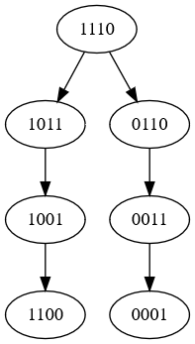

Enter start state:1110

{'1110': ['1011', '0110'], '1011': ['1001'], '0110': ['0011'], '1001': ['1100'], '0011': ['0001'], '1100': [], '0001': []}

Open List--Closed List

['1110']--[]

['1011', '0110']--['1110']

['0110', '1001']--['1110', '1011']

['1001', '0011']--['1110', '1011', '0110']

['0011', '1100']--['1110', '1011', '0110', '1001']

['1100', '0001']--['1110', '1011', '0110', '1001', '0011']

['0001']--['1110', '1011', '0110', '1001', '0011', '1100']

**II.**

**GRAPH:**

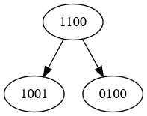

Enter start state:1100

{'1100': ['1001', '0100'], '1001': [], '0100': []}

Open List--Closed List

['1100']--[]

['1001', '0100']--['1100']

['0100']--['1100', '1001']

**4.b) Implement Vacuum World problem with Search tree generation using DFS**

**Program:**

def move(state):

state=list(state)

temp=state[1]

state[1]=state[-1]

state[-1]=temp

return ''.join(state)

def clean(state):

state=list(state)

if state[0]=='1' and state[1]=='1':

state[0]='0'

if state[2]=='1' and state[3]=='1':

state[2]='0'

return ''.join(state)

def make_tree(start,final):

d={}

d[start]=[]

all_nodes=[start]

c=1

h=-1

source=start

while(h<c and source not in final):

h+=1

source=all_nodes[h]

state=move(source)

if state not in all_nodes:

all_nodes.append(state)

d[source].append(state)

d[state]=[]

if state in final:

break

state=clean(source)

if state not in all_nodes:

all_nodes.append(state)

d[source].append(state)

d[state]=[]

if state in final:

break

c=len(all_nodes)

return d,state

start=input("Enter start state:")

final=['0100','0001']

d,st=make_tree(start,final)

print(d)

#DFS

open_list=[start]

closed_list=[]

print("Open List--Closed List")

print(''.join(str(open_list)),''.join(str(closed_list)),sep='--')

while open_list:

source=open_list.pop(0)

closed_list.append(source)

if source in final:

break

for i in d[source]:

if i not in closed_list and i not in open_list:

open_list.insert(0,i)

print(''.join(str(open_list)),''.join(str(closed_list)),sep='--',end='\n\n')

**OUTPUT:**

**I.**

**GRAPH:**



Enter start state:1110

{'1110': ['1011', '0110'], '1011': ['1001'], '0110': ['0011'], '1001': ['1100'], '0011': ['0001'], '1100': [], '0001': []}

Open List--Closed List

['1110']--[]

['0110', '1011']--['1110']

['0011', '1011']--['1110', '0110']

['0001', '1011']--['1110', '0110', '0011']

**II.**

**GRAPH:**



Enter start state:1100

{'1100': ['1001', '0100'], '1001': [], '0100': []}

Open List--Closed List

['1100']--[]

['0100', '1001']--['1100']

**5.Implement the following**

**a)Greedy Best First Search**

**Program:**

n=int(input("Enter number of nodes in the graph:")) #INPUT READING

cost = [[0] * n for i in range(n)]

for i in range(n):

print(i+1,end=' ')

print("are the names of nodes")

print("Enter path costs as follows for each node accordingly and x to quit reading costs:")

print("<from_node> <to_node> <cost>")

while True:

s=input("Enter:")

if s=='x' or s=='X':

break

s=s.split()

cost[int(s[0])-1][int(s[1])-1]=int(s[2])

h= list(map(int,input("Enter heuristic values in order:").split()))

source=int(input("Enter source node:"))-1

destination=int(input("Enter destination node:"))-1

def greed(cost,h,source,destination):

op=[] #OPEN LIST

c=[0] # CLOSED LIST

while source!=destination:

op.append(source)

children=[]

children_f=[]

for i in range(len(cost[0])):

if cost[source][i]>0: # TO CHECK IF CHILD EXISTS

children.append(i)

children_f.append(h[i])

if len(children)>0:

index=children_f.index(min(children_f)) #FINDING CHEAPEST PATH AVAILABLE

source=children[index] #UPDATING SOURCE

op.append(source)

return op,c

op,c=greed(cost,h,source,destination)

print('Nodes travelled are:')

for i in op[:-1]:

print(i+1,end='->')

print(op[-1]+1)

**OUTPUT:**

**I.**

**GRAPH:  
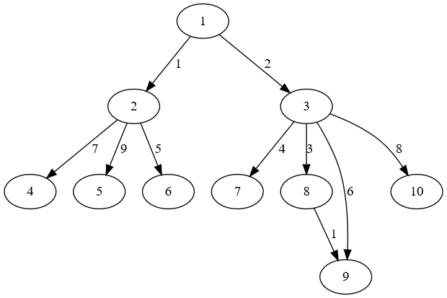**

Enter number of nodes in the graph:10

1 2 3 4 5 6 7 8 9 10 are the names of nodes

Enter path costs as follows for each node accordingly and x to quit reading costs:

<from_node> <to_node> <cost>

Enter:1 2 1

Enter:1 3 2

Enter:2 4 7

Enter:2 5 9

Enter:2 6 5

Enter:3 7 4

Enter:3 8 3

Enter:3 9 6

Enter:3 10 8

Enter:8 9 1

Enter:x

Enter heuristic values in order:8 10 4 15 14 12 7 2 0 4

Enter source node:1

Enter destination node:9

Nodes travelled are:

1->3->9

**II.**

**GRAPH:**

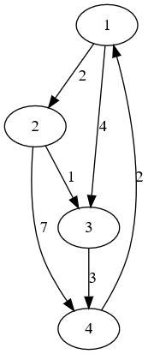

Enter number of nodes in the graph: 4

1 2 3 4 are the names of nodes

Enter path costs as follows for each node accordingly and x to quit reading costs:

<from_node> <to_node> <cost>

Enter: 1 2 2

Enter: 1 3 4

Enter: 2 3 1

Enter: 2 4 7

Enter: 3 4 3

Enter: 4 1 2

Enter: x

Enter heuristic values in order: 5 3 2 0

Enter source node: 1

Enter destination node: 4

Nodes travelled are:

1->2->3->4**b)A* algorithm**

**Program:**

n=int(input("Enter number of nodes in the graph:")) #INPUT READING

cost = [[0] * n for i in range(n)]

for i in range(n):

print(i+1,end=' ')

print("are the names of nodes")

print("Enter path costs as follows for each node accordingly and x to quit reading costs:")

print("<from_node> <to_node> <cost>")

while True:

s=input("Enter:")

if s=='x' or s=='X':

break

s=s.split()

cost[int(s[0])-1][int(s[1])-1]=int(s[2])

h= list(map(int,input("Enter heuristic values in order:").split()))

source=int(input("Enter source node:"))-1

destination=int(input("Enter destination node:"))-1

def Astar(cost,h,source,destination):

op=[]

c=[0]

while source!=destination:

op.append(source)

if len(op)>1:

c.append(cost[op[-2]][op[-1]])

children=[]

children_f=[] #F(N) VALUES

for i in range(len(cost[0])):

if cost[source][i]>0:

children.append(i)

children_f.append(sum(c)+h[i]+cost[source][i]) #F(N)=G(N)+H(N)

if len(children)>0:

index=children_f.index(min(children_f)) #SLECTING CHILD BASED ON F(N) VLAUES

source=children[index]

op.append(source)

c.append(cost[op[-2]][op[-1]])

return op,c

op,c=Astar(cost,h,source,destination)

print('Nodes travelled are:')

for i in op[:-1]:

print(i+1,end='->')

print(op[-1]+1)

print("Cost to traverse is ",sum(c))

**OUTPUT:**

**I.**

**GRAPH:**



Enter number of nodes in the graph:10

1 2 3 4 5 6 7 8 9 10 are the names of nodes

Enter path costs as follows for each node accordingly and x to quit reading costs:

<from_node> <to_node> <cost>

Enter:1 2 1

Enter:1 3 2

Enter:2 4 7

Enter:2 5 9

Enter:2 6 5

Enter:3 7 4

Enter:3 8 3

Enter:3 9 6

Enter:3 10 8

Enter:8 9 1

Enter:x

Enter heuristic values in order:8 10 4 15 14 12 7 2 0 4

Enter source node:1

Enter destination node:9

Nodes travelled are:

1->3->8->9

Cost to traverse is 6

**II.**

**GRAPH:**



**Enter number of nodes in the graph: 4**

**1 2 3 4 are the names of nodes**

**Enter path costs as follows for each node accordingly and x to quit reading costs:**

**<from_node> <to_node> <cost>**

**Enter: 1 2 2**

**Enter: 1 3 4**

**Enter: 2 3 1**

**Enter: 2 4 7**

**Enter: 3 4 3**

**Enter: 4 1 2**

**Enter: x**

**Enter heuristic values in order: 5 3 2 0**

**Enter source node: 1**

**Enter destination node: 4**

**Nodes travelled are:**

**1->2->3->4**

**Cost to traverse is 66. Implement 8-puzzle problem using A* algorithm.**

**Program:**

print("If the puzzle is \n1 2 3\n4 6\n7 5 8\ninput shall be given as 1234_6758")

start=input("Enter puzzle start state:")

final=input("Enter puzzle expected end state:")

def allpossible(state):

l=[]

index=state.index("_")

if index in [0,1,3,4,6,7]: # MOVE RIGHT

source=state[:]

source[index],source[index+1]=source[index+1],source[index]

l.append(''.join(source))

if index in [1,2,4,5,7,8]: #MOVE LEFT

source=state[:]

source[index],source[index-1]=source[index-1],source[index]

l.append(''.join(source))

if index in [3,4,5,6,7,8]: #MOVE UP

source=state[:]

source[index],source[index-3]=source[index-3],source[index]

l.append(''.join(source))

if index in [0,1,2,3,4,5]: #MOVE DOWN

source=state[:]

source[index],source[index+3]=source[index+3],source[index]

l.append(''.join(source))

return l

def heuristics(state,final): #HEURISTIC FUNCTION FINDS NUMBER OF WRONG TILES.

state=list(state)

final=list(final)

c=0

for i in range(len(state)):

if state[i]!=final[i]:

c+=1

return c

def EightPuzzle(source,final):

all_nodes=[source]

closed_list=[]

d={}

cost=0

while source!=final:

closed_list.append(source)

l=allpossible(list(source))

heur=[]

for i in l:

heur.append(heuristics(i,final))

index=heur.index(min(heur))

d[source]=l

source=l[index]

cost=cost+1

closed_list.append(source)

return d,closed_list

EightPuzzle(start,final) #FUNCUTION CALL

**OUTPUT:**

**I.**

**GRAPH:**

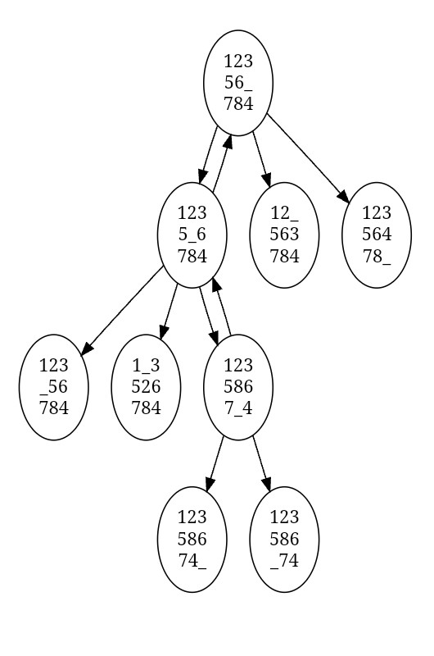

If the puzzle is

1 2 3

4 6

7 5 8

input shall be given as 1234_6758

Enter puzzle start state:12356_784

Enter puzzle expected end state:123586_74

({'12356_784': ['1235_6784', '12_563784', '12356478_'],

'1235_6784': ['12356_784', '123_56784', '1_3526784', '1235867_4'],

'1235867_4': ['12358674_', '123586_74', '1235_6784']},

['12356_784', '1235_6784', '1235867_4', '123586_74'])

**II.**

**GRAPH:**

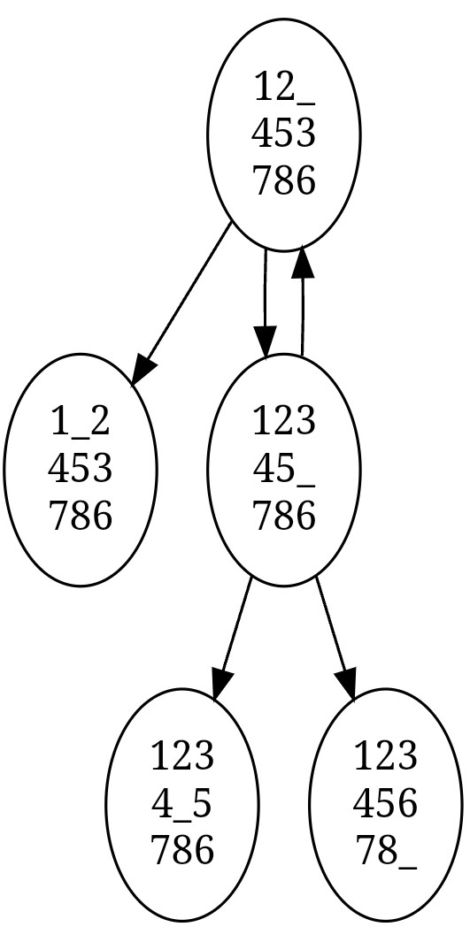

If the puzzle is

1 2 3

4 6

7 5 8

input shall be given as 1234_6758

Enter puzzle start state:12_453786

Enter puzzle expected end state:12345678_

({'12_453786': ['1_2453786', '12345_786'],

'12345_786': ['1234_5786', '12_453786', '12345678_']},

['12_453786', '12345_786', '12345678_'])

**7. Implement AO* algorithm for General graph problem.**

**Program:**

def cost(H, condition, weight=1):

costs = {}

if 'AND' in condition:

AND_nodes = condition['AND']

Path_A = ' AND '.join(AND_nodes)

PathA = sum(H[node] + weight for node in AND_nodes)

costs[Path_A] = PathA

if 'OR' in condition:

OR_nodes = condition['OR']

Path_B = ' OR '.join(OR_nodes)

PathB = min(H[node] + weight for node in OR_nodes)

costs[Path_B] = PathB

return costs

def update_cost(H, Conditions, weight=1):

main_nodes = list(Conditions.keys())

main_nodes.reverse()

least_cost = {}

for key in main_nodes:

condition = Conditions[key]

print(key, ':', Conditions[key], '>>>', cost(H, condition, weight))

c = cost(H, condition, weight)

H[key] = min(c.values())

least_cost[key] = cost(H, condition, weight)

return least_cost

def shortest_path(Start, Updated_cost, H):

Path = Start

if Start in Updated_cost.keys():

Min_cost = min(Updated_cost[Start].values())

key = list(Updated_cost[Start].keys())

values = list(Updated_cost[Start].values())

Index = values.index(Min_cost)

Next = key[Index].split()

if len(Next) == 1:

Start = Next[0]

Path += '<--' + shortest_path(Start, Updated_cost, H)

else:

Path += '<--(' + key[Index] + ') '

Start = Next[0]

Path += '[' + shortest_path(Start, Updated_cost, H) + ' + '

Start = Next[-1]

Path += shortest_path(Start, Updated_cost, H) + ']'

return Path

H = eval(input('Enter nodes with heuristic costs: '))

Conditions = eval(input('Enter graph: '))

weight = 1

print('Updated Cost:')

Updated_cost = update_cost(H, Conditions, weight=1)

print('Shortest Path:\n', shortest_path('A', Updated_cost, H))

**OUTPUT:**

**I.**

**GRAPH:**

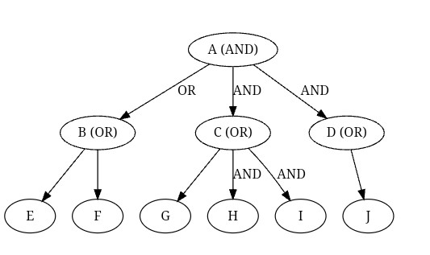

Enter nodes with heuristic costs: {'A': -1, 'B': 5, 'C': 2, 'D': 4, 'E': 7, 'F': 9, 'G': 3, 'H': 0, 'I': 0, 'J': 0}

Enter graph: {'A': {'OR': ['B'], 'AND': ['C', 'D']}, 'B': {'OR': ['E', 'F']}, 'C': {'OR': ['G'], 'AND': ['H', 'I']}, 'D': {'OR': ['J']}}

Updated Cost:

D : {'OR': ['J']} >>> {'J OR': 0}

C : {'OR': ['G'], 'AND': ['H', 'I']} >>> {'G OR': 3, 'H AND I': 2}

B : {'OR': ['E', 'F']} >>> {'E OR F': 6}

A : {'OR': ['B'], 'AND': ['C', 'D']} >>> {'B OR': 5, 'C AND D': 6}

Shortest Path:

A<--(B OR) [F + E] + (C AND D) [I + H]

**II.**

**GRAPH:**

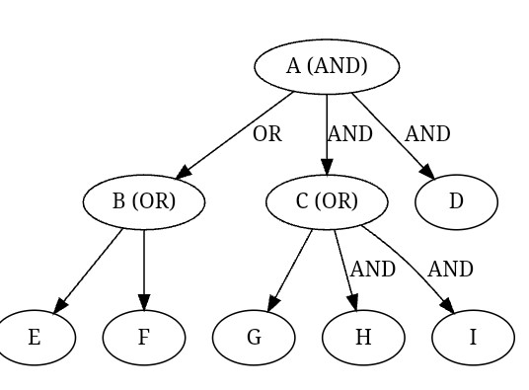

Enter nodes with heuristic costs: {'A': -1, 'B': 5, 'C': 2, 'D': 4, 'E': 7, 'F': 9, 'G': 3, 'H': 0, 'I': 0, 'J': 0}

Enter graph: {'A': {'OR': ['B'], 'AND': ['C', 'D']}, 'B': {'OR': ['E', 'F']}, 'C': {'OR': ['G'], 'AND': ['H', 'I']}}

Updated Cost:

C : {'OR': ['G'], 'AND': ['H', 'I']} >>> {'H AND I': 2, 'G': 4}

B : {'OR': ['E', 'F']} >>> {'E OR F': 8}

A : {'OR': ['B'], 'AND': ['C', 'D']} >>> {'C AND D': 8, 'B': 9}

Shortest Path:

A<--(C AND D) [C<--(H AND I) [H + I] + D]

**8. Implement Game trees using**

**a)MINIMAX algorithm**

**Program:**

import math

def minimax(curDepth, nodeIndex, maxTurn, scores, targetDepth):

if curDepth == targetDepth:

return scores[nodeIndex]

if maxTurn:

return max(minimax(curDepth + 1, nodeIndex * 2, False, scores, targetDepth),

minimax(curDepth + 1, nodeIndex * 2 + 1, False, scores, targetDepth))

else:

return min(minimax(curDepth + 1, nodeIndex * 2, True, scores, targetDepth),

minimax(curDepth + 1, nodeIndex * 2 + 1, True, scores, targetDepth))

scores = list(map(int,input("Enter scores:").split()))

treeDepth = int(math.log(len(scores), 2))

print("The optimal value is:", minimax(0, 0, True, scores, treeDepth))

**OUTPUT:**

**I.**

**GRAPH:**

3

9

5

2

3

Enter scores:3 5 2 9

The optimal value is: 3

**II.**

**GRAPH:**

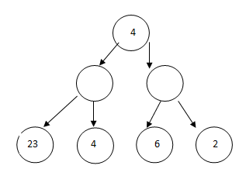

Enter scores:23 4 6 2

The optimal value is: 4

**b) Alpha-Beta pruning**

**Program:**

MAX, MIN = 1000, -1000

def minimax(depth, nodeIndex, maximizingPlayer, values, alpha, beta):

if depth == 3:

return values[nodeIndex]

if maximizingPlayer:

best = MIN

for i in range(2):

val = minimax(depth + 1, nodeIndex * 2 + i, False, values, alpha, beta)

best = max(best, val)

alpha = max(alpha, best)

if beta <= alpha:

break

return best

else:

best = MAX

for i in range(2):

val = minimax(depth + 1, nodeIndex * 2 + i, True, values, alpha, beta)

best = min(best, val)

beta = min(beta, best)

if beta <= alpha:

break

return best

values = list(map(int,input("Enter scores:").split()))

print("The optimal value is:", minimax(0, 0, True, values, MIN, MAX))

**OUTPUT:**

**I.**

**GRAPH:**

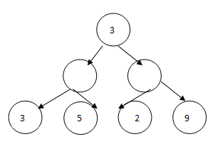

Enter scores:3 5 2 9

The optimal value is: 12

**II.**

**GRAPH:**

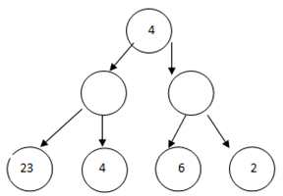

Enter scores: 23 4 6 2

The optimal value is: 6

**9. Implement Crypt arithmetic problems.**

**Program:**

import itertools

def number(word, digit_map):

return int(''.join(str(digit_map[letter]) for letter in word))

def solve_cryptarithmetic(puzzle): # TRYING ALL POSSIBLE MOVES WITH CONSTRIANTS

words = puzzle.split()

unique_characters = set(''.join(words))

if len(unique_characters) > 10: #NO MORE THAN 10 UNIQUE CHARS (0-9)

return "Invalid puzzle: More than 10 unique characters"

leading_characters = set(word[0] for word in words)

if len(leading_characters) > 2:

return "Invalid puzzle: More than 2 words start with the same character"

for digits in itertools.permutations(range(10), len(unique_characters)):

digit_map = dict(zip(unique_characters, digits))

if all(digit_map[word[0]] != 0 for word in leading_characters):

if sum(number(word, digit_map) for word in words[:-1]) == number(words[-1], digit_map):

return digit_map

return "No solution found"

puzzle = input("Enter the cryptarithmetic puzzle (words separated by spaces): ")

solution = solve_cryptarithmetic(puzzle)

print("Solution:", solution)

**OUTPUT:**

**I.**

Enter the cryptarithmetic puzzle (words separated by spaces): send more money

Solution: {'s': 9, 'e': 5, 'n': 6, 'd': 7, 'm': 1, 'o': 0, 'r': 8, 'y': 2}

**II.**

Enter the cryptarithmetic puzzle (words separated by spaces): TWO TWO FOUR

Solution: {'O': 4, 'R': 8, 'T': 7, 'U': 6, 'F': 1, 'W': 3}