Ministerul Educației și Cercetării al Republicii Moldova
Universitatea Tehnică a Moldovei
Facultatea Calculatoare, Informatică și Microelectronică
Departamentul Ingineria Software și Automatică
Program: Software Engineering
Report on laboratory work no. 4
Course: Operating Systems
Topic: The xv6 Shell from the Outside
Track B: build your own small OS, xv6
Done by:
st. gr. FAF-241,
Serghei Barladean
Checked by:
Dumitrascu Marius
Chișinău – 2026

Contents
Purpose of the Work 3
Part 1. Fix sleep for the Current xv6 3
1.1. Work Done 3
Part 2. bash versus the xv6 Shell 4
2.1. Comparison Table 4
2.2. Figures 5
2.3. Observations 7
Part 3. Who Expands *? Printing argv 7
3.1. Work Done 7
3.2. Observations 8
Part 4. Read the Shell 9
4.1. Work Done 9
4.2. Observations 10
Conclusions 11

Purpose of the Work
The purpose of this laboratory work is to use the xv6 shell side by side with bash and to find out, by experiment, what a shell must do and what bash adds on top of it. A small program that prints its arguments shows who expands * and who removes the quotes. At the beginning the sleep program from Laboratory Work 2 is checked on the current xv6.
The work was done on Ubuntu 24.04 (aarch64) in a Multipass virtual machine on macOS. xv6 (RISC-V) was built in ~/xv6-riscv and run in the QEMU emulator; the Linux part was run in bash. The figures are taken from the recorded terminal sessions.

Part 1. Fix sleep for the Current xv6

1.1. Work Done
In August 2025 the xv6 authors renamed the system call sleep() to pause(). The name used by the tree was checked with:
cd ~/xv6-riscv
grep -n "pause\|sleep" user/user.h
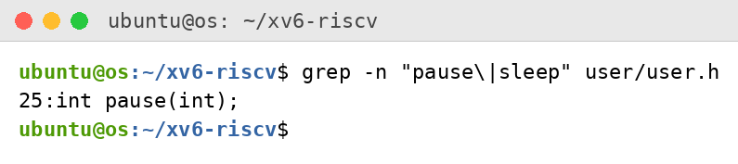
Figure 1.1 – The grep result in user.h
The only match is 25:int pause(int);: the tree declares pause and no sleep, so the call in user/sleep.c must be pause(). The updated program and the line $U/_sleep\ in the UPROGS list of the Makefile (a tab at the start, nothing after the backslash) are shown below:
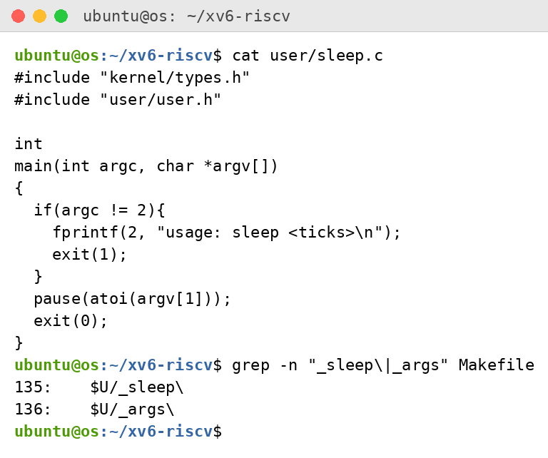
Figure 1.2 – The updated sleep.c and the UPROGS lines in the Makefile
After make qemu the program was tested inside xv6. With the argument 20 it waited for 20 clock ticks and returned to the prompt; without an argument it printed the usage message:
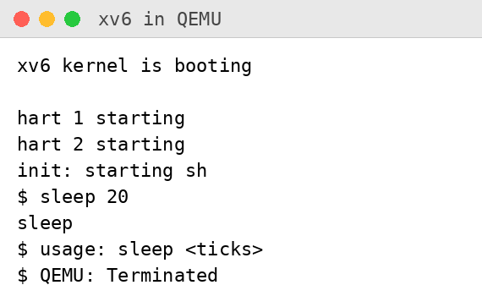
Figure 1.3 – sleep running in xv6, with and without an argument
The second line sleep in the figure was typed while sleep 20 was still running; the usage message appears after it finished.

Part 2. bash versus the xv6 Shell

2.1. Comparison Table
Every command was run once in bash, in the empty test folder ~/shtest that contains a file named README, and once at the xv6 prompt:
Command | Tests | bash | xv6 | Why
echo hello > f ; cat < f | redirection | hello | hello | Both shells implement < and > and the sequence operator ;.
ls | grep READ | pipe | README | README 2 2 2441 | Both support pipes. xv6 ls prints the type, inode number and size of each file.
(echo a; echo b) | wc | grouping, list | 2 2 4 (padded with spaces) | 2 2 4 | Both support parentheses and pipes. GNU wc pads the numbers, the xv6 wc does not.
echo one ; echo two | sequence | one  two | one  two | Both run the commands one after another.
echo bg & | background | [1] 52386  bg  [1]+ Done echo bg | bg | Both run the command in the background. Only bash does job control and prints job numbers and status.
ls * | globbing | README f | ls: cannot open * | bash expands * into file names; xv6 passes the literal * to ls, which has no file of that name.
echo $HOME | variables | /home/ubuntu | $HOME | xv6 shell has no variables; the text is printed as it is.
echo "a b" | quotes | a b | "a b" | bash removes the quotes; xv6 does not know quotes: echo receives the two words "a and b" with the quote characters.
mkdir d ; cd d ; ls .. | PATH | README d f  (and the shell is now in d) | exec cd failed  (listing of the root directory) | In xv6 cd is recognised only when it is the whole line, so inside a list it is run as a program and fails. The ls .. then ran in the old directory.
arrow up, Tab, Ctrl+R | history, completion | arrow up repeated the previous command; Tab on "ec" listed ec2metadata and echo | arrow up: exec ^[[A failed; Tab: exec ec failed | bash has line editing and history (readline); xv6 reads raw characters, so the keys are passed to the shell as text. Ctrl+R was not run.

2.2. Figures
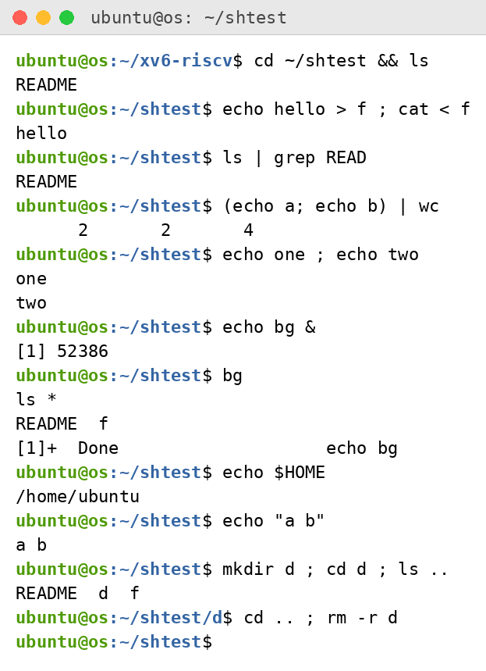
Figure 2.1 – The commands run in bash
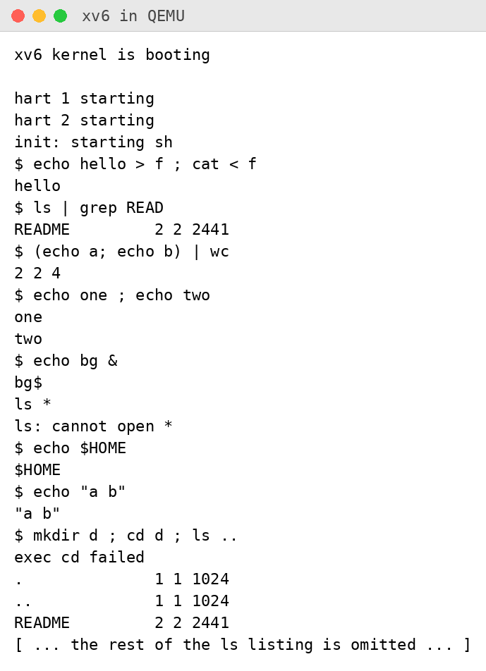
Figure 2.2 – The same commands run in xv6 (the long ls listing is shortened)
In xv6 the program ls was found after cd d only when it was started by a path. The commands and the result were:
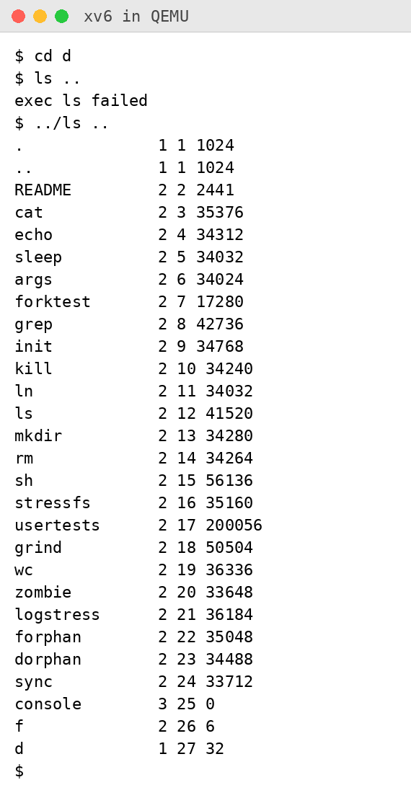
Figure 2.3 – ls failing after cd d, and the working alternative
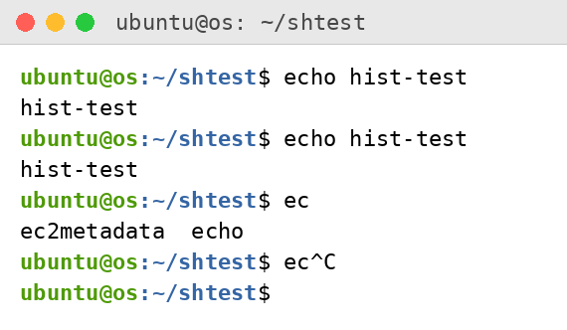
Figure 2.4 – Arrow up and Tab in bash
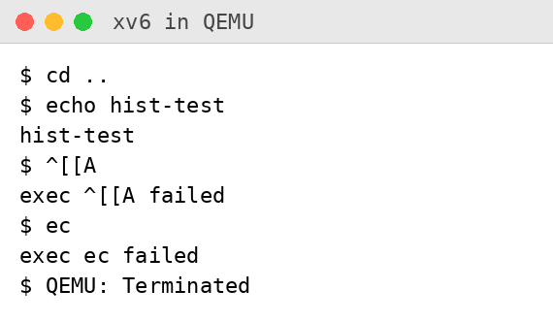
Figure 2.5 – Arrow up and Tab in xv6

2.3. Observations
- Both shells can run programs, redirect input and output (<, >), build pipes (|), run commands one after another (;), group commands with parentheses and run a command in the background (&). Only bash has globbing (*), variables ($HOME), quote processing, a PATH to search for programs, job control messages, command history, completion and line editing, and it recognises cd inside a list of commands.
- ls stops working after cd d because the xv6 shell has no PATH: it runs exec with the name as typed, and exec looks for that name in the current directory. The xv6 programs live in the root directory of the xv6 file system, so after cd d there is no file called ls there ("exec ls failed"). It works when the program is started by a path, ../ls .. (or /ls ..), as in Figure 2.3.
- In daily work I would miss command history and completion most: without the arrow keys every command has to be typed again, and a typing mistake means retyping the whole line. The easiest feature to add would be a simple search for programs: when exec of a name fails, the shell can try the same name in the root directory (a few lines in the function that runs a command).

Part 3. Who Expands *? Printing argv

3.1. Work Done
The program user/args.c prints the number of arguments and each argument in square brackets, so that spaces and quotes are visible. The line $U/_args\ was added to UPROGS:
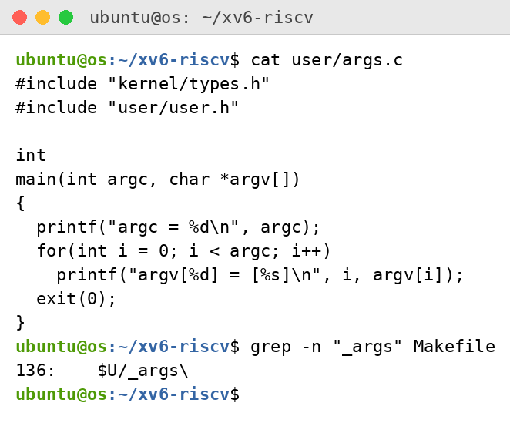
Figure 3.1 – args.c and the UPROGS line
The same program for Linux, args_linux.c, uses <stdio.h> and return 0 and was compiled with gcc -o args args_linux.c. Both programs were run with the same four lines, in bash in a folder that contains a.c and b.c, and in xv6:
args one two three
args *.c "x y"
args $HOME
args 'single quoted'
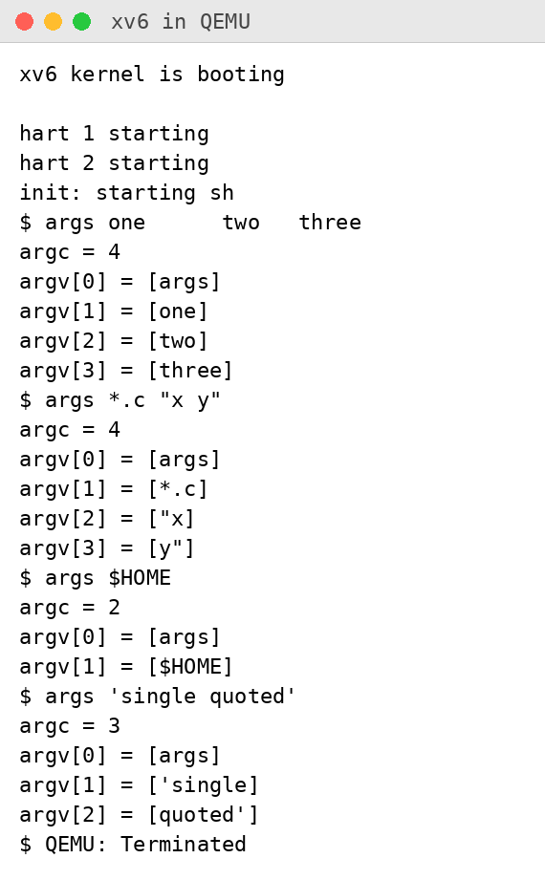
Figure 3.2 – args output in xv6
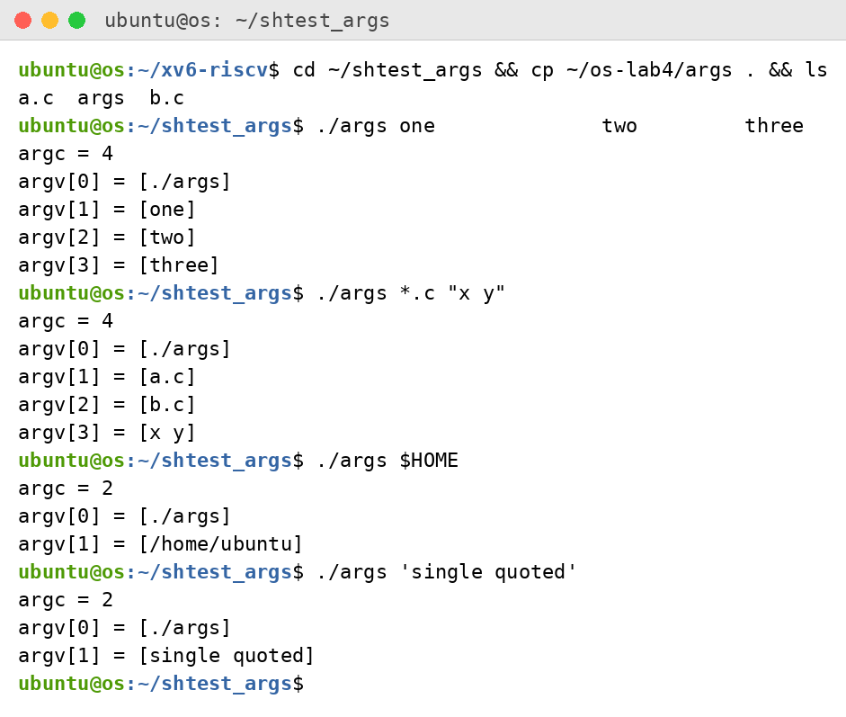
Figure 3.3 – args_linux output in bash

3.2. Observations
- args *.c "x y": in bash the output was argc = 4 with argv = [./args], [a.c], [b.c], [x y]. In xv6 the output was argc = 4 with argv = [args], [*.c], ["x], [y"]. Both programs received 4 arguments, but not the same ones: bash replaced *.c by the two file names and kept "x y" as one argument, xv6 passed *.c unchanged and split "x y" into two words that still contain the quote characters.
- The shell does both. It expands *.c into file names and removes the quotes before it calls exec; the kernel only copies the argument list to the new program, and the program just prints what it received. This is also why the same program gives different results in the two shells.
- The extra spaces in one two three disappeared in both shells: the shell uses runs of spaces only as separators between words, so the program received the three arguments one, two and three (argc = 4, counting the program name).

Part 4. Read the Shell

4.1. Work Done
The file user/sh.c has 499 lines. The kinds of commands, the places where each kind is handled and the handling of cd were found with grep:
wc -l user/sh.c
grep -n "#define" user/sh.c
grep -n "case " user/sh.c
grep -n "cd" user/sh.c | head
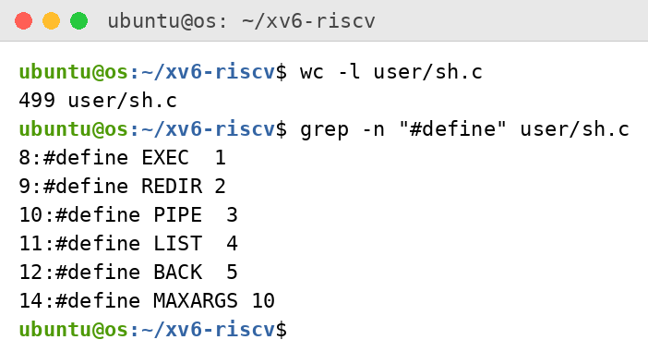
Figure 4.1 – The command kinds defined in sh.c
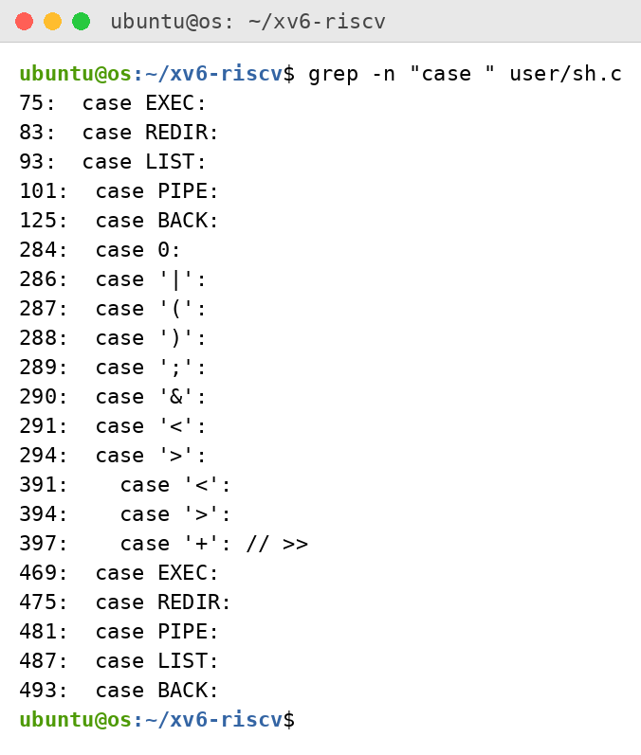
Figure 4.2 – Where each kind is run
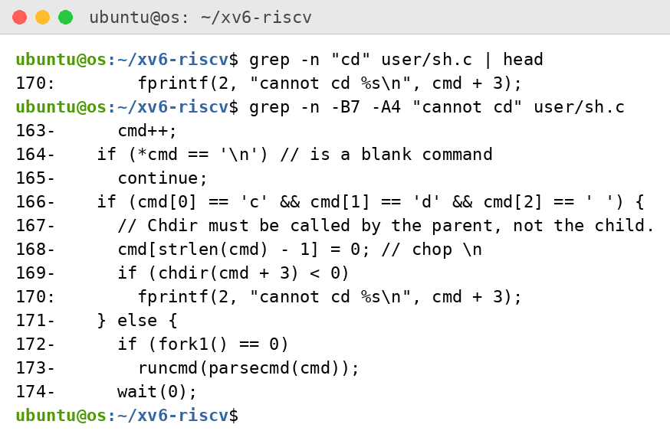
Figure 4.3 – The code that handles cd
A search for the characters * and $ in the source gave no result:
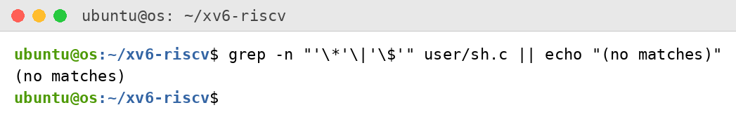
Figure 4.4 – Search for code that handles * or $ (no matches)

4.2. Observations
- The xv6 shell knows five kinds of commands (lines 8–12 of sh.c): EXEC, a simple command, a program with its arguments (plain words); REDIR, redirection, produced by < , > and >> ; PIPE, produced by | ; LIST, two commands one after another, produced by ; (parentheses are used to group them); BACK, a command in the background, produced by & . The case labels at lines 75–125 and 469–493 handle these five kinds.
- cd is handled in the main loop of the shell (lines 166–170), before a child process is created: if the line starts with "cd ", the shell calls chdir itself in the parent process. It is not run as a separate program because the working directory belongs to the process: a child that called chdir would change only its own directory and then exit, and the shell would stay in the old one. The same check also explains "exec cd failed" in Part 2: it works only when the whole line starts with cd; in mkdir d ; cd d ; ls .. the part cd d is run by a child as a program, and no such program exists.
- The search for the characters * and $ in sh.c found nothing ("no matches"). The xv6 shell therefore has no code for globbing or variables, which explains Part 2 and Part 3: ls * passed a literal * to ls, echo $HOME printed $HOME, and args received *.c and $HOME unchanged. The quote characters also reached the programs unchanged, so the shell does no quote processing either.

Conclusions
The xv6 shell is a very small program that does only what a shell must do: start programs, redirect their input and output, connect them with pipes, run lists of commands and background commands, and handle cd itself. Everything else that was seen in bash, globbing, variables, quotes, PATH, job control and history, is an addition made by bash.
The args program showed the division of work: the shell builds the argument list (expands * and removes the quotes in bash, does neither in xv6), the kernel passes this list to the program through exec, and the program only prints what it received.
The sleep program from Laboratory Work 2 was fixed for the current xv6, where the system call sleep() is called pause(), and it was tested inside xv6.

