**APPLICATION NAME:** MediTrans

**Problem or issue that app is going to address:**

It is an application which is useful for Drug distributors to update/add available drugs for customers. Customer can view/search for the availability of drugs from different drugstores.

This application helps customers to search for a drugstore along with availability of the desired drugs in stores up to date in Real. In addition, it also specifies if a store has delivery availability.

Customers search for exactly needed medicine or they can explore given categories and options and can select any product or medicine from there which reduces a lot of effort.

**Activities:**

* Medico Button (Drug Store) - Sign-in / Register / sign out pages
* We are storing data using firebase.
* A registered drug store can log into the application. If it is a new drug store, it has to register by providing necessary fields (examples: Shop Name, User Id, Address, Mobile Number, Open and Closing times, Location, Delivery Availability, … ) .Drug Store can add new drugs , update the availability of existing drugs and also view the list of the drugs that are fetched from the database we will use(firebase).
* A registered drug store can also view the request that are requested by the customer and when a requested drug is delivered, it will be removed through the button (Delivered).
* Customer can search for stores and they will be able to see the available drugs in that particular drug stores. They could request for a drug by adding prescription and other details (Ex: Name, Mobile Number, upload Prescription, …).
* If a customer searches for a particular drug it will list out all the drug stores in which a requested drug available.
* Drug store will be able to see the requests from customers. After reviewing the prescriptions, they delivers(if delivery is available for particular store) the drugs after confirming it on a call by pressing a “call” button which redirects to placing a call to that particular customer.

**Drugstore Activities:**

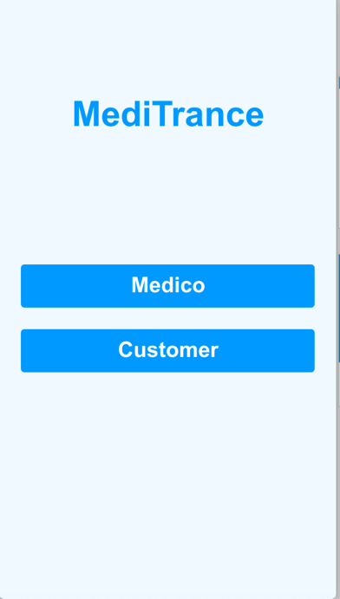 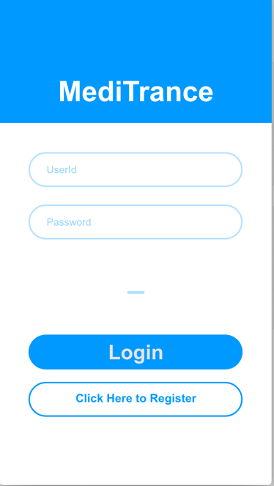 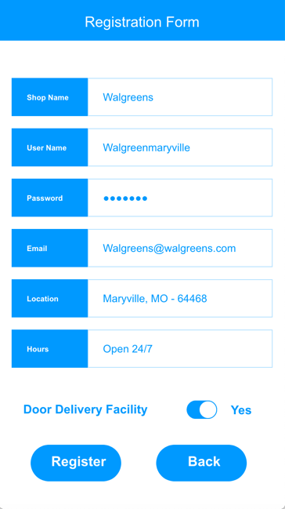

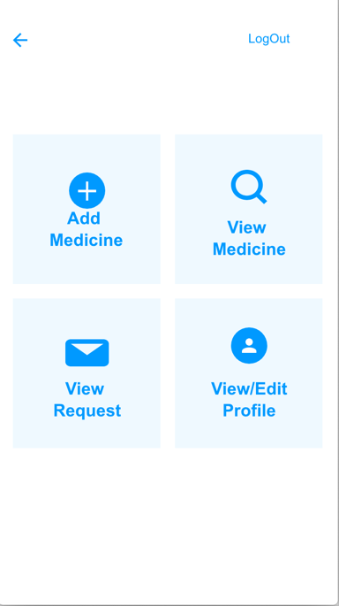 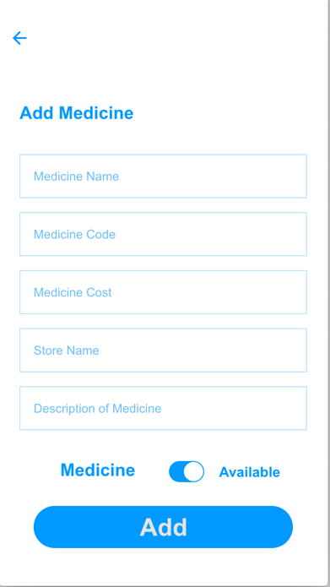 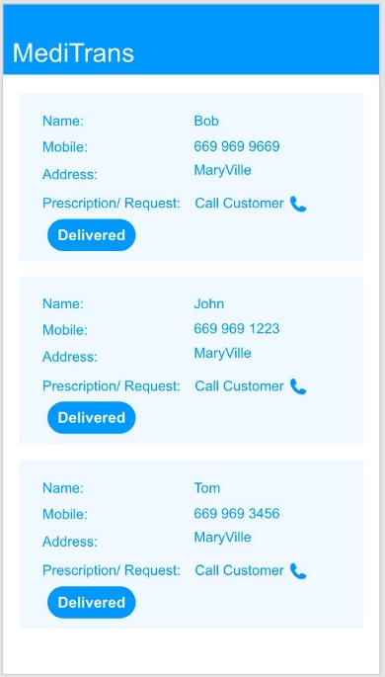

**Customer Activities:**

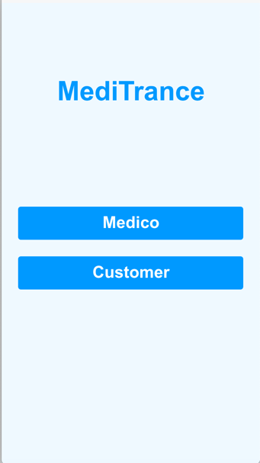 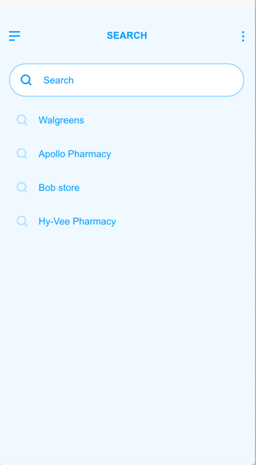 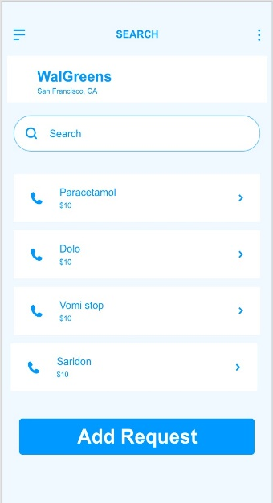

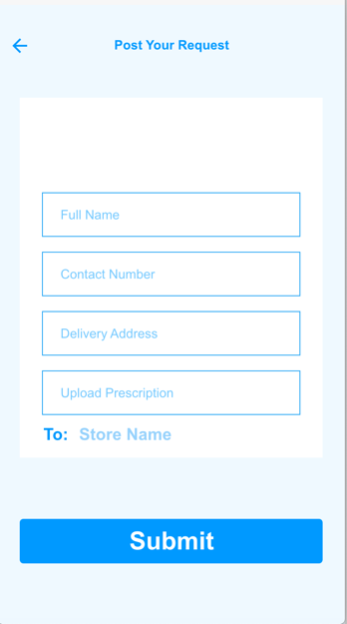

(Note: Activity Layouts are created using Adobe XD)