

BACHELOR THESIS

Ekaterina Kurysheva

Home alarm system

Department of Distributed and Dependable Systems

Supervisor of the bachelor thesis: doc. RNDr. Petr Hnětynka, Ph.D.
Study programme: Computer Science
Specialization: Software and Data Engineering

Prague year 2018

I declare that I carried out this bachelor thesis independently, and only with the cited sources, literature and other professional sources.

I understand that my work relates to the rights and obligations under the Act No. 121/2000 Coll., the Copyright Act, as amended, in particular the fact that the Charles University has the right to conclude a license agreement on the use of this work as a school work pursuant to Section 60 paragraph 1 of the Copyright Act.

In…...... date............ signature
Title: Home alarm system.
Author: Ekaterina Kurysheva.

Department / Institute: Department of Distributed and Dependable Systems
Supervisor of the bachelor thesis: doc. RNDr. Petr Hnětynka, Ph.D., Department of Distributed and Dependable Systems
Abstract: [abstract of 80-200 words in English, but not a copy of the assignment of the bachelor thesis]

Keywords: [3-5 keywords in English]
Thanks

Contents

Introduction
Technologies are developing at a high rate during the last century. Computers become smaller, and their potential, on the other hand, grows more prominent each day. As a result, there is a massive movement towards automation in all areas of our lives. This movement has played a vital role in the formation of the Internet of things (IoT) concept, which became the main inspiration for this thesis.
The Internet of things is a concept of connecting physical devices to a network, where they can exchange data and assist, automate or even manage processes. The system usually includes sensors, electronic devices, the network for communication between the parts and the managing software. This concept is applied or is developing in such fields as environment monitoring, optimisation in manufacturing or energy management. It brings the advantage of remote control over processes, which allows an increase of efficiency and minimisation of the human factor in the area.
One of the biggest concerns for people always was the safety of their belongings and privacy of their living and working space. The modern solutions to this problem are approaching it from angles that vary from using advanced door locks to complicated automatic systems with multi-level authentication, all of which are supposed to prevent illegal access to the private territory. Security has become a giant industry and success factor in many businesses, and developing hardware and software technologies find their application in the field.
The evolution of modern technologies has brought a vast amount of affordable and portable devices to the market, which can be used to provide custom security solutions. Motion sensors, sound alarms, identification cards and card readers are easy to purchase and use. Thanks to the availability of learning materials it became possible to create an automatic security system without any complicated prerequisites. Moreover, the own solution brings the advantage of building the unique application, which would meet individuals’ needs.
The mentioned trends in the Computer technologies field had a significant influence on the idea of the project. It appeared with the intention to create a custom application for monitoring private space, independent of any commercial services and usable in everyday life.

Thesis goals
This thesis’s goal is to create a home alarm system based on widely available and affordable components, which allow easy adjusting of the solution architecture. The system’s primary functionalities are to detect an intrusion, to notify the users of the event and to take pictures of the space upon the alert. We call it Safe Home.
Safe Home’s other functionalities are to identify the users with tokens, which trigger switching of the system and to provide a user management interface. The system is set to be accessible from the local network and the Internet.

Structure of the thesis
This thesis goes through project requirements and limitations, and problem analysis in the Analysis chapter. Then the detailed discussion of the software and hardware solution follows in chapter Solution. The evaluation of the work and comparison with the existing systems is described in chapter Evaluation. Finally, we discuss future perspectives in the Conclusion chapter.

Analysis
Safe Home project is a custom home alarm system for private spaces. Its goal is to detect an intrusion, collect data about the intrusion, such as time of the event and pictures from the place at the time, and to notify the user, so he or she can take actions. The discussion of the expectations and their possible implementation follows in this chapter.

Functional requirements

Intrusion alert
There are several ways to detect intrusion into a private space with simple hardware. It can be done with infra-red motion sensors, which react to people moving in the room, with door or window opening detectors, which are based on magnets or with detectors, which react on sharp noises, such as window breaking. The most appropriate method for making the system flexible and usable for a large variety of room layouts is an infra-red motion sensor since the monitored space does not have to have doors or windows.
To take pictures upon the motion detection, we can use an IP-camera, which has a built-in motion detector, or a separate camera, which can be controlled by a computer. IP-cameras usually use the manufacturer’s cloud storage and mobile applications, which eliminates the idea of creating a custom solution. Therefore the separate camera fits the criteria best.
The system needs to have the active and standby modes for hours when security is required to be on or off. The modes switching must be protected against illegal access. After putting together the motion sensor and the camera, the Safe Home system intrusion alert functionality involves detecting the motion in the monitored space and taking pictures upon the detection when the application is active. Then this component is set to deliver the information to the module responsible for notifications and access to pictures.

User identification
A user is a person who has the authority to access the monitored space and is interested in keeping it from intrusion. One space can have multiple users attached to it, for example, family members.
Hardware options of user identifications may be radio-frequency identification tokens read by RFID reader, fingerprint scanners or pin code entering. Fingerprint scanners are expensive, and the biometric data are sensitive. Pin code entering, on the other hand, does not provide any data about the user, who entered it. The RFID tokens are widely used, affordable and allow the system to identify the user, which makes them the best option from listed above.
To prevent illegal access to the system, the users and their identification tokens need management. The management interface must provide the opportunity to add and delete accepted tokens.
The user also needs to get notifications from the system and access to pictures taken by the camera remotely. This means the need for the remote access interface for browsing the pictures, and identification of the user in some additional way other than RFID token to deliver notifications and pictures outside of the local network.

Remote access
The common ways to deliver notifications to the users remotely are by SMS, e-mail or in a mobile application. SMS sending requires usage of a SIM-card or a paid third-party SMS service. Sending e-mail does not require paid services, but it lacks flexibility and a possibility of interactions with the user
Remote access to the pictures can be implemented as an e-mail attachment, on a website or in a mobile application. E-mail attachments' flaw is that pictures are not collected at one place. A mobile application offers a possibility to combine notifications delivery with picture browsing, which is why we choose it as a mean of remote access.

Analysis of the environment
The application is meant for usage at home with no particular equipment or predispositions for the security enhancements. However, the minimum requirement is access to the Internet from the monitored place since Safe Home is supposed to deliver notifications of the events.
To connect the motion sensor, camera and RFID reader into one system, which is capable of communication with a mobile application, we need to control them via single-board computer. When using them together, it is possible to create an independent security unit, which is capable of user identification and detecting intrusion.
There are various single-board computer options on the market, which are capable of reading the input from the hardware parts we want to use. Those include but not limited to Raspberry Pi, Arduino, Orange Pi, ODROID computers. Some of them have a complete operating system, and their performance is comparable with modern mobile devices, others read and write programmes directly to microcontrollers. The functional requirements for the project imply that the computer for controlling the hardware must be able to run multiple tasks with different hardware concurrently. The layered logic of the hardware controlling leads us to a decision to use a computer with an operating system.

Raspberry Pi
The Raspberry Pi [1] is a name of single-board computers produced by the Raspberry Pi Foundation [3]. It is the best-selling computer of its kind, the third after Apple Macintosh and Microsoft Windows PCs [18], highly affordable and widely distributed.
The computers are small in size, which varies from the size of a credit card to the size of a smartphone. It contains system on a chip (SoC), which is an integrated circuit broadly used in mobile computing, which ensures low power consumption. The SoC includes the CPU with a frequency of 700 MHz brought by the Broadcom Corporation [4] free from any license control. It also includes graphics processing unit (GPU) and RAM. Raspberry Pi Model B also has Ethernet circuitry, USB hub and GPIO (general-purpose input/output) pins. The USB ports on Raspberry Pi provide the option of connecting mice, keyboards or USB cameras, which extends the available functionality.
The Model B of Raspberry Pi has 26 GPIO pins including 3.3V and 5V power supply pins. Other pins can be configured to different pin-dependent settings like level-sensitive or edge-sensitive interrupt, or to the I2C bus. This variety of settings allows using the computer as a control unit in robotics and other embedded systems.
Raspberry Pi is also equipped with the Serial Peripheral Interface bus (SPI), which is used for the full duplex communication between devices on a short distance using master-slave architecture, which enables connecting of RFID reader to the computer.
The Raspberry Pi Foundation officially supports Raspbian operating system [5], however other third-party operating systems are available too. Raspbian is Debian-based and has pre-installed software for programming like Python, Java or Mathematica.

Card Reader
The card reader RFID-RC522 is a communication device for contactless reading of and writing to the MIFARE [6] cards and tags. It uses voltage 3.3V for the power supply and SPI interface to communicate with the master CPU, hence acts as a slave. It is capable of error detection and supports encryption algorithm.
The MIFARE series cards and tags is a registered technology for the radio-frequency identification (RFID). The tags contain memory structure and perform authentication of a reader and are broadly used in all areas where the electronic tagging is appropriate. The examples of cards containing RFID tag include payments cards, ISIC (International Student Identity Card).

Motion sensor
The motion sensor available for this project is a passive infrared sensor which detects the motion based on infrared radiation level changing. Its sensitivity range is up to 6 meters of distance and up to 110º x 70º of width depending on the lens. It cannot detect how far the moving object is nor how many objects there are. It has low power consumption and doesn’t wear out over the time.

Limitations for Raspberry Pi
As was mentioned at the beginning of this chapter, the minimum requirement for the place of Safe Home installation is access to the Internet. Most of Raspberry Pi models support connection to the Internet via Ethernet or Wi-Fi. We can suppose, that access to the Internet available at the place is protected by the firewall, and Raspberry Pi cannot be accessed directly from outside of the network. This means that we cannot consider direct remote access to the security module as a solution.

Design concept
The Safe Home application concept consists of two major parts. The first is security module on Raspberry Pi which controls hardware. The second is the user interface with its supporting components. We make this fundamental division because of the limitation that Raspberry Pi cannot be accessed directly from the Internet. Therefore, there must be a part of the application available to the user outside of Raspberry Pi.
We choose to implement application’s primary user interface as a mobile application. That is because mobile devices are reported to share more than 50% of the market of computers in 2017 11, winning over desktops. The mobility of the smartphones also provides the means to notify the user of the intrusion “on the go” whenever the device connects to the Internet, and mobile applications, in general, are more versatile and adjustable than simple e-mail notifications.
The decision to implement the user interface as a mobile application still does not provide a solution for fetching the information from Raspberry Pi security module. In this situation, a client-server pattern fits the concept.

Client-server model
The client-server model [12] is a design of communication between the server and usually multiple clients. The server stands for a communication party that provides data or service to clients upon requests. Clients are the other party; they do not usually share their resources. Clients initiate a connection. The communication has to have a template or protocol to allow interpreting requests and responses.
In case of Safe Home, Raspberry Pi security module and mobile application are clients, and the server is the new component responsible for passing relevant data between them, as illustrated in Figure 1. This solution solves the problem of Raspberry Pi being inaccessible because no direct access to the client from the server is required in this model since security module is to establish the communication.
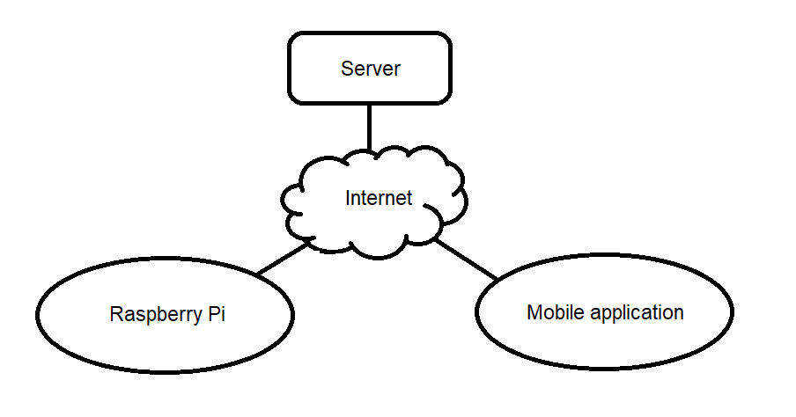
Figure 1. Design concept illustration.

Tools for the implementation

Java
“The Java programming language is a general-purpose, concurrent, class-based, object-oriented language.” [13]. According to the TIOBE index of programming languages popularity [14], Java has been the most used programming language for the majority of years of its existence, as presented on the diagram in Figure 2. Java programs can run on a significant number of platforms and have an enormous number of third-party libraries. It has predefined interfaces for development of web applications with various implementations. Also, this language has strong support on the Raspbian operating system. Those factors together make Java language a perfect match for the project development.
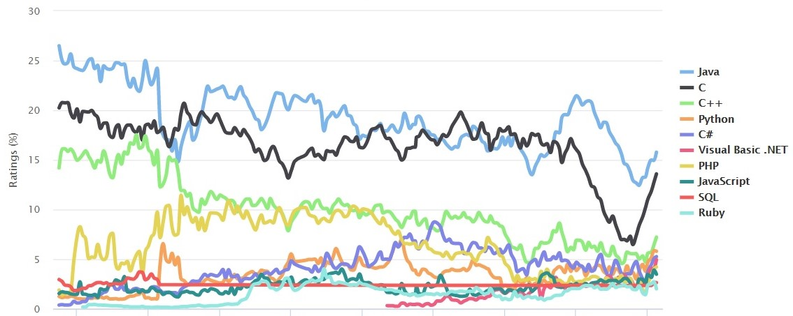
Figure 2. TIOBE Programming Community Index. [14]

Android
Android [2] is a name of the operating system for mobile devices based on Linux kernel. It is designed primarily for interactions via touchscreen with limited power supply and memory available.
Each Android application runs independently on other processes in its virtual machine (VM), which decreases security risks. Applications also have the minimum possible access to the device memory and functionalities, and they have to request the corresponding permissions to perform interactions which may be misused. The source code and all the resources of the application for Android are compiled into Android package (APK) file, which can be then installed on Android-powered devices.
Choosing to implement the user client for Android is beneficial in the following ways. Firstly, according to Gartner, Inc. [10], smartphones with Android operating system share over 86% of the market by the first quarter of the year 2017. The table with supporting data is presented in Figure 3. Secondly, the operating system supports [8] programming in Java [9] language, which was chosen for the implementation of the project. Finally, Android platform provides the means for non-trivial interaction with the user, which can be explicitly customised for the project, and that is impossible when using e-mails or other third-party applications for delivering data from Raspberry Pi.
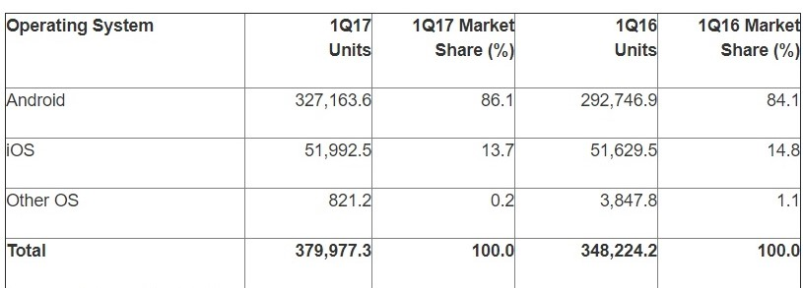
Figure 3. “Worldwide smartphone sales to end users by operating system in 1Q17 (thousands of units).” [10]

Server implementation
Java Enterprise Edition provides technology for easy Web server implementation: Java Servlet [19]. Java Servlet is platform-independent and has access to entire Java APIs. It is mostly used for implementing client-server communication based on HTTP protocol [7]. A servlet is an object, which gets a request and produces a response. Servlets need servlet containers to manage the interactions, URL mapping and servlet lifecycle.
There are several servlet containers, open-source and commercial, to choose from. Apache Tomcat, GlassFish or WildFly (former JBoss) are the most common and actively supported. From those three, Apache Tomcat is the most light-weight and compact, while the other two are instead considered mainly as application servers with a servlet container support as a feature.
The Apache Tomcat is an open source project which represents servlet container. It implements Java technologies such as JavaServer Page (JSP), Java Expression Language (JEL), Java WebSocket and Java Servlet interface. Tomcat provides the environment for deployment and running dynamic web applications. The technologies provided by Tomcat make it possible to implement different types of internet communication based on client-server architecture, including RESTful web services, SOAP (Simple Object Access Protocol) and others. Furthermore, JSP and JEL technologies deliver tools for the creation of rich HTML content, which makes Tomcat sufficient for server development.

Client-server communication
The communication between the parts is going via the Internet or local network. We are going to use HTTP protocol [7] since it is the most convenient when implementing Java Servlets and is supported by all browsers. The content of the HTTP requests can be further specified by communication protocols or approaches like SOAP (Simple Object Access Protocol), JSON-RPC (remote procedure call protocol encoded in JSON) or REST (Representational state transfer) to unify and make it more robust to changes.
SOAP is a platform-independent communication protocol. It uses XML message encoding with predefined SOAP namespaces. The server endpoints have strict descriptions which all requests and responses accessing the endpoints must follow. Any changes to those descriptions lead to the necessity of client application updates, but the communication goes through a robust validation process, which increases the security aspect.
JSON-RPC is another platform-independent communication protocol, which messages are encoded in JSON (JavaScript Object Notation). It has a simple predefined structure for the requests, but the endpoint requests and responses do not have descriptions for validation like in SOAP. However, clients have to call specific methods, which leads to tight coupling between server and client.
REST, on the other hand, is an architectural solution, which has no strictly specified standard, except that the RESTful API is based on specific URI construction. The clients do not call specified endpoints, they fill the request URI with documented parameters and get data. The key feature of REST is using stateless unified requests, which is very flexible and easily modifiable solution. The RESTful communication service usually uses HTTP methods GET, POST, PUT and DELETE consistently, where GET requests are meant to fetch the required information without changing it, POST requests initiate the creation of a new entry, PUT requests are used for changing existing data and therefore DELETE requests for deleting data.
For communication between parts of Safe Home, we choose to use RESTful API. That is due to its maintainability and flexibility, since the application has the potential for large extensions in the future, and we would like to avoid strong dependence of clients on server methods.

Concerns over the implementation
The suggested design approach and tool choice for the project implies several concerns which must be treated during implementation.
Firstly, the components must behave consistently regardless whether they are connected to the Internet or not. That means that the security module, for example, must be able to detect motions and take pictures independently from the server. The behaviour of RFID card registration interface also must be defined to prevent the module inaccessibility.
Secondly, the data from Raspberry Pi must not be lost due to an unstable Internet connection. Thus, there should be a mechanism of data exchange and storage that is designed for this environmental condition.
Finally, data exchange must be clear and well-defined for the components to communicate correctly and efficiently. It is also required to be modifiable since communication between a client and a server is one of the most likely areas of this application’s future extensions.

Solution
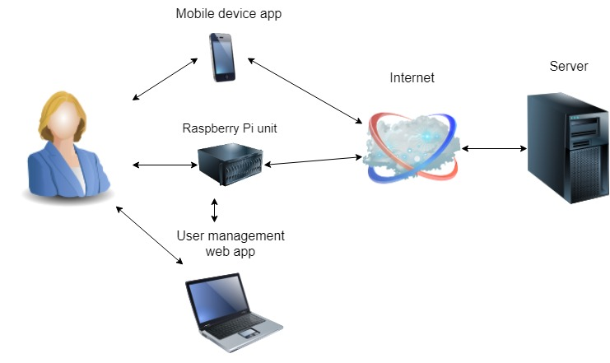
Figure 4. Safe Home components illustration.
The solution architecture for the project consists of four major units: Raspberry Pi unit, user management web application, Android application and server. Raspberry Pi unit is responsible for controlling USB camera, motion sensor and RFID reader. It holds the state of the program and contains the security logic. The user management web application is an implementation of the user interface for registering RFID tokens. It runs on Raspberry Pi and is accessible from the local network. The Android application gets the notifications about events registered by Raspberry Pi unit and allows the user to browse pictures taken by the USB camera. The server stores the event information and pictures from Raspberry Pi unit and shares the data with the Android application. Figure 5 and Figure 6 illustrate how the parts interact in two use-cases.
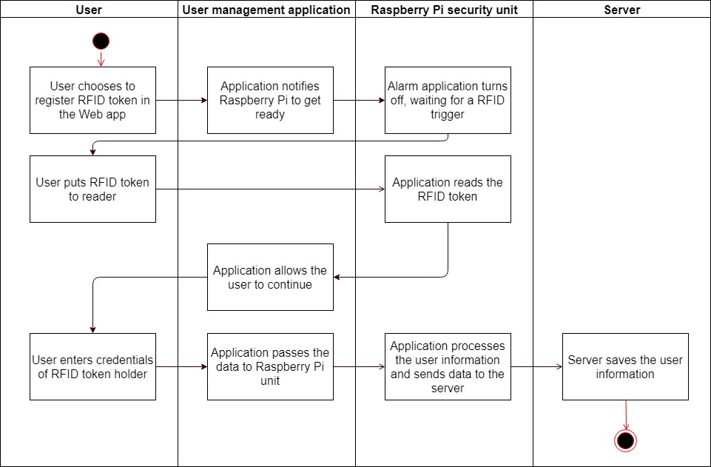
Figure 5. Components interactions during user registration.
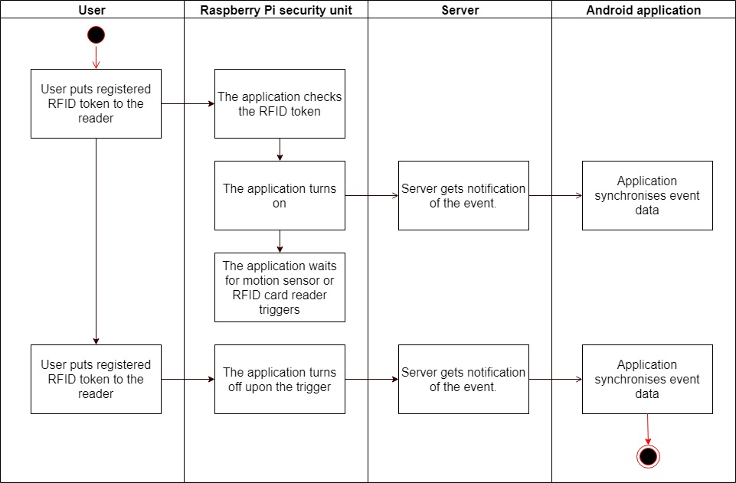
Figure 6. Components interactions while turning the application on and off.

Raspberry Pi module
Raspberry Pi module includes Raspberry Pi security unit and user management application. Its responsibilities can be divided into three categories. The first category is hardware management. The security logic of the application has RFID card reader, motion sensor and USB camera under control. The second category is user registration and management. It includes a user interface for registering RFID tokens and sharing data about the users. The third category is data exchange with the server. It consists of a communication interface and a communication policy.
Since those three parts of Raspberry Pi security module have a certain level of independence from each over, it is reasonable to apply the division to the module architecture to keep the model clear. The parts will apparently have to communicate with each other, and our goal is to make them loosely coupled to improve the quality of the code [17]. For coordination of these parts, we choose the mediator pattern [15] as a solution for cases, when there are many-to-many dependencies in the application.

Mediator pattern
Mediator pattern in software development is a type of encapsulation of interactions between objects of the application. When there are many classes with complex logic and several communication cases, a mediator is an object responsible for the interactions. The classes or objects do not communicate directly with each other but access the mediator, which coordinates the requests and channels them.
This approach decreases dependencies between the objects, which leads to easier future maintenance and applying of modifications and overall improves reusability of the code. This pattern also enables to develop and test the subsystems independently, which helps to reduce the number of flaws in the application [16].

Raspberry Pi module architecture
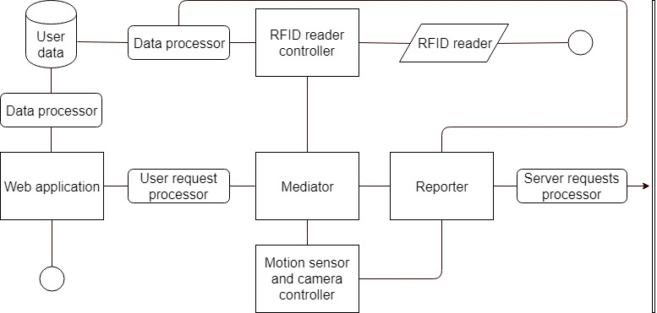
Figure 7. Raspberry Pi application architecture.
Raspberry Pi module communicates with the user and the server. The user can access it from two endpoints: the web application and by using registered RFID token on the RFID reader. The server gets data about events from Raspberry Pi via HTTP.
The web application allows the user to register RFID token as was illustrated earlier in Figure 5. The registration process includes filling the credentials of the user, which are later associated with the token. The web application also offers the interface for deleting registered users or changing their credentials. The data from this component stay in a local data storage and are processed by the main submodule.
The RFID reader endpoint reacts to reading a known RFID token and triggers the change of the application to the state “on” or “off” as was also illustrated in Figure 6. It accesses the local storage with the user data to identify the user and does not depend on the server. It accesses the local storage via a data processor, which watches changes in user information and reports it to the server. The RFID controller component performs simple tasks passed through the mediator and the change of state trigger goes through the mediator to the motion sensor and camera controller.
Communication with the server consists of the following parts. Raspberry Pi module sends the information about user credentials to the server in case of registering a new user, change in credentials or deleting of an existing user. The information about the associated RFID tokens is not shared with the server and stays inside the module to prevent the module inaccessibility in case of missing Internet connection. The module also notifies the server about turning the application on or off by the user and about detected motions. Moreover, the module sends the pictures taken by the USB camera to the server, and it sends the pictures separately from sending information about an intrusion to prevent the notification delivery failure in case camera is not available.
Coordination of the communication between the parts of the module goes through the mediator and sending information about the events on Raspberry Pi module goes through the reporter. The reporter is not a part of the mediator since its task is specific and does not include communication between the other parts, which does not fit into the idea of the mediator pattern. Its role is to collect the event information from the submodules and to pass it in a required format to the server, and the rest of the module does not depend on it. This architecture decision helps to fulfil the requirement for the parts of Safe Home to be available despite possible Internet connection issues.
The web application and the RFID reader controller do not share data access and the data processor, because the web application is separated from the rest of the module to a different application, which runs on a local server on Raspberry Pi. This decision has the benefit of the possible future extension of the web application with the user interface from the local network to the Internet. It also implies less dependency on the other components, easier component testing and better modifiability and maintainability.
The user data storage is implemented as a file containing all the information in JSON format. There is no database since the available memory on our Raspberry Pi is limited, and the expected number of users for one household is low enough for this data storage solution to work. This decision is a topic for future enhancements to the system.
The RFID controller is separate from the motion sensor, and USB camera controller since the RFID controller part needs the access to the user data and has its logic for cases of a regular turn on or off operations and the new user registration part. Moreover, both components listen to different triggers (for RFID token and the motion detection), hence need to run concurrently. USB camera usage, on the other hand, depends on the motion detection and does not follow any other specific logic, therefore becomes a part of the motion sensor controller. The motion sensor controller also holds the information about the current state of the application (“on” or “off”). The communication between the components is illustrated in Figure 8.
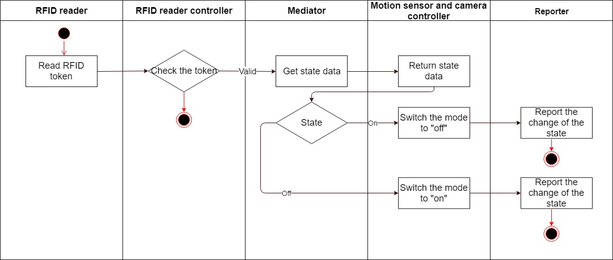
Figure 8. Communication inside Raspberry Pi module upon RFID token usage.

Server module
Servlet module of Safe Home has two types of clients. The first type is a security module, which sends data about clients and events in a monitored space. The second type is a user application, which we decided to implement as an Android application, but it can be extended to other platforms potentially. This type of the client needs to get information about the events and pictures to notify the user and provide access to the pictures. In this clients definition, the data flow goes from the security module to the application via the server, which role is to store data and control access to them, as illustrated in Figure 9.
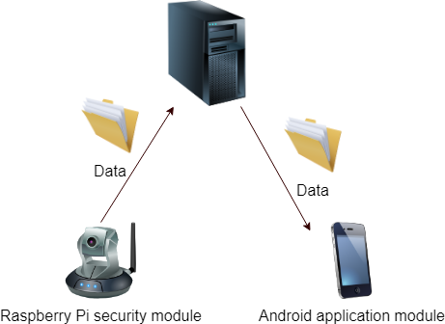
Figure 9. Data flow illustration
This strict division of the clients to the categories implies that the server’s communication with them needs to be separated into different interfaces, and the data shared between the two clients need to be stored. In Java Servlet technology we can easily implement two different servlets for the two clients respectively and to configure a database for our server.

Server module architecture
Figure
Server module of Safe Home consists of two Java Servlets and a database layer. The servlets respond to requests from Raspberry Pi module and Android application respectively. Database layer exists inside the module and cannot be accessed from other modules of the application.
Servlet for communication with the security module has its’ REST API. This API has a set of accepted URI parameters, which tell the server what action to perform. In the defined data flow, all data are sent as HTTP POST requests. The server then accesses the database to store events, time of events and photo in tables. It also saves the information about users to identify them, when they try to log in via the mobile application.
Servlet for communication with the mobile application has a similar REST API. The majority of requests from the application are HTTP GET requests. Those requests contain identification tokens for authentication of the user, which the server validates before providing any data. The application requests dates of the latest events, the event information and pictures.
The database layer consists of the database tables, functions and procedures and an interface for the database access from servlets. It watches the data consistency and saves the updates from the user profiles. The interactions between the components of the module are illustrated in the following figures.
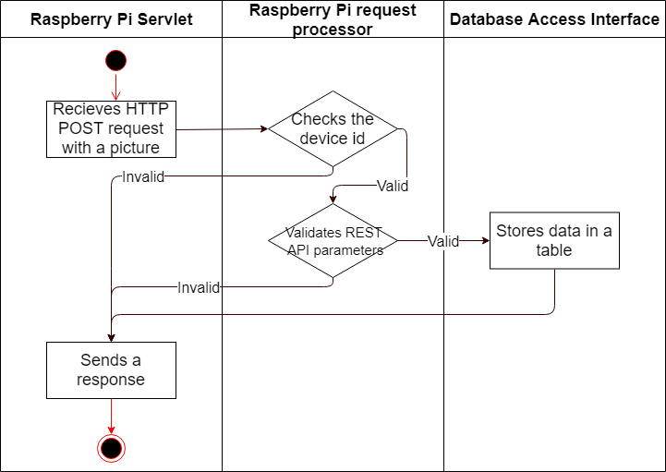
Figure 10. Communication inside the server module components when receiving a picture.
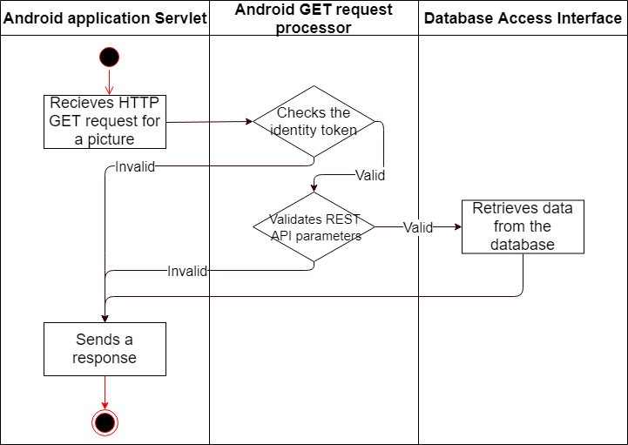
Figure 11. Communication inside the server module components when requested the picture.

Android application module
Android application module identifies the users to associate them with the security module. It also displays the notifications and provides an interface for the user to watch what happens at home.
There are several methods for the user identification in applications. The user can log in with a combination of username and password, which can be unique for the system or connected with a third-party profile like Facebook or Google account. Alternatively, the two modules can create a pair with an identification token (barcode, for example). We decided to use a combination of username and password, which the user sets during registration of the RFID token to avoid dependency on other systems and to make the logging in process available even if the web application is not accessible for displaying the pairing token.
We considered different options for providing access to the events information to the user. The Android operating system allows the applications to store data in the cache, which is not shared between different applications, but has small capacity and can be cleared by the system. There is also an option to store data in internal or external memory. The internal memory for the application is private and has more space than the cache. The Android operating system allows the applications to have a database in internal memory. The external memory, on the other hand, can be accessed by all applications on the device.
We decided to store pictures as media files in external storage in this module to allow the user to access them as regular files, which is not possible when using other methods. We store other text information delivered by the server in the cache memory since the application’s primary role is to display the latest events and not to store the whole history of Safe Home, which is available on the server.

Android application module architecture
Components diagram
The application’s entry point from the user view is a login page. The user types his or her username and password set during the RFID token registration there and the data from the associated Raspberry Pi are loaded if the user is authorised. When the user is identified, the component with pictures and text information from the security module becomes the entry point for the user.
The other entry point of the module is for the server. The Android application always initialises the connection. It validates the user with the server method, gets pictures and event information with separate requests.
The application’s notifications service runs in the background and synchronises updates with the server. The application communicates with the server over HTTP and is fully responsible for fetching the data at the right time.

The solution for the analysis concerns
The Safe Home project implementation fulfils all the requirements mentioned in the analysis of the problem. It is a complete application, which is capable of monitoring private space and sending an alarm message to the user.
The intrusion alert requirement is satisfied within Raspberry Pi security module, where the hardware components are connected to Raspberry Pi computer and are organised to switch between standby and active modes and to react on motions when in the active state.
The user identification is provided with the usage of RFID tokens and associated user profiles in the Android application. Only authenticated users can switch the states of the alarm systems and get an access to the pictures from the security module.
The design of the modules makes them reasonably independent on the possible Internet issues. The security module and the user management are available with no connection to the internet and all other parts behave correctly when not connected.
The pictures from the security module stay on Raspberry Pi until the server does not accept them, therefore the data cannot be lost due to an unstable Internet connection. The Internet communication itself is flexible and modifiable thanks to the REST API architecture solution. The implementation answers the concerns from the analysis with the listed solutions.

Evaluation and related work
Safe Home application is a system providing security monitoring for the user’s home. It consists of Raspberry Pi component, which belongs to space, where we want the monitoring, the server on the Internet and the Android application.
The installation and usage of Safe Home are straightforward. Hardware components include Raspberry Pi computer, RFID RC-522 reader, a PIR motion sensor, a LED, a resistor, a USB camera, jumping wires, breadboard and an Ethernet cable. After the hardware is connected and the operating system on Raspberry Pi is up and running, the installation script loads and configures the security module.
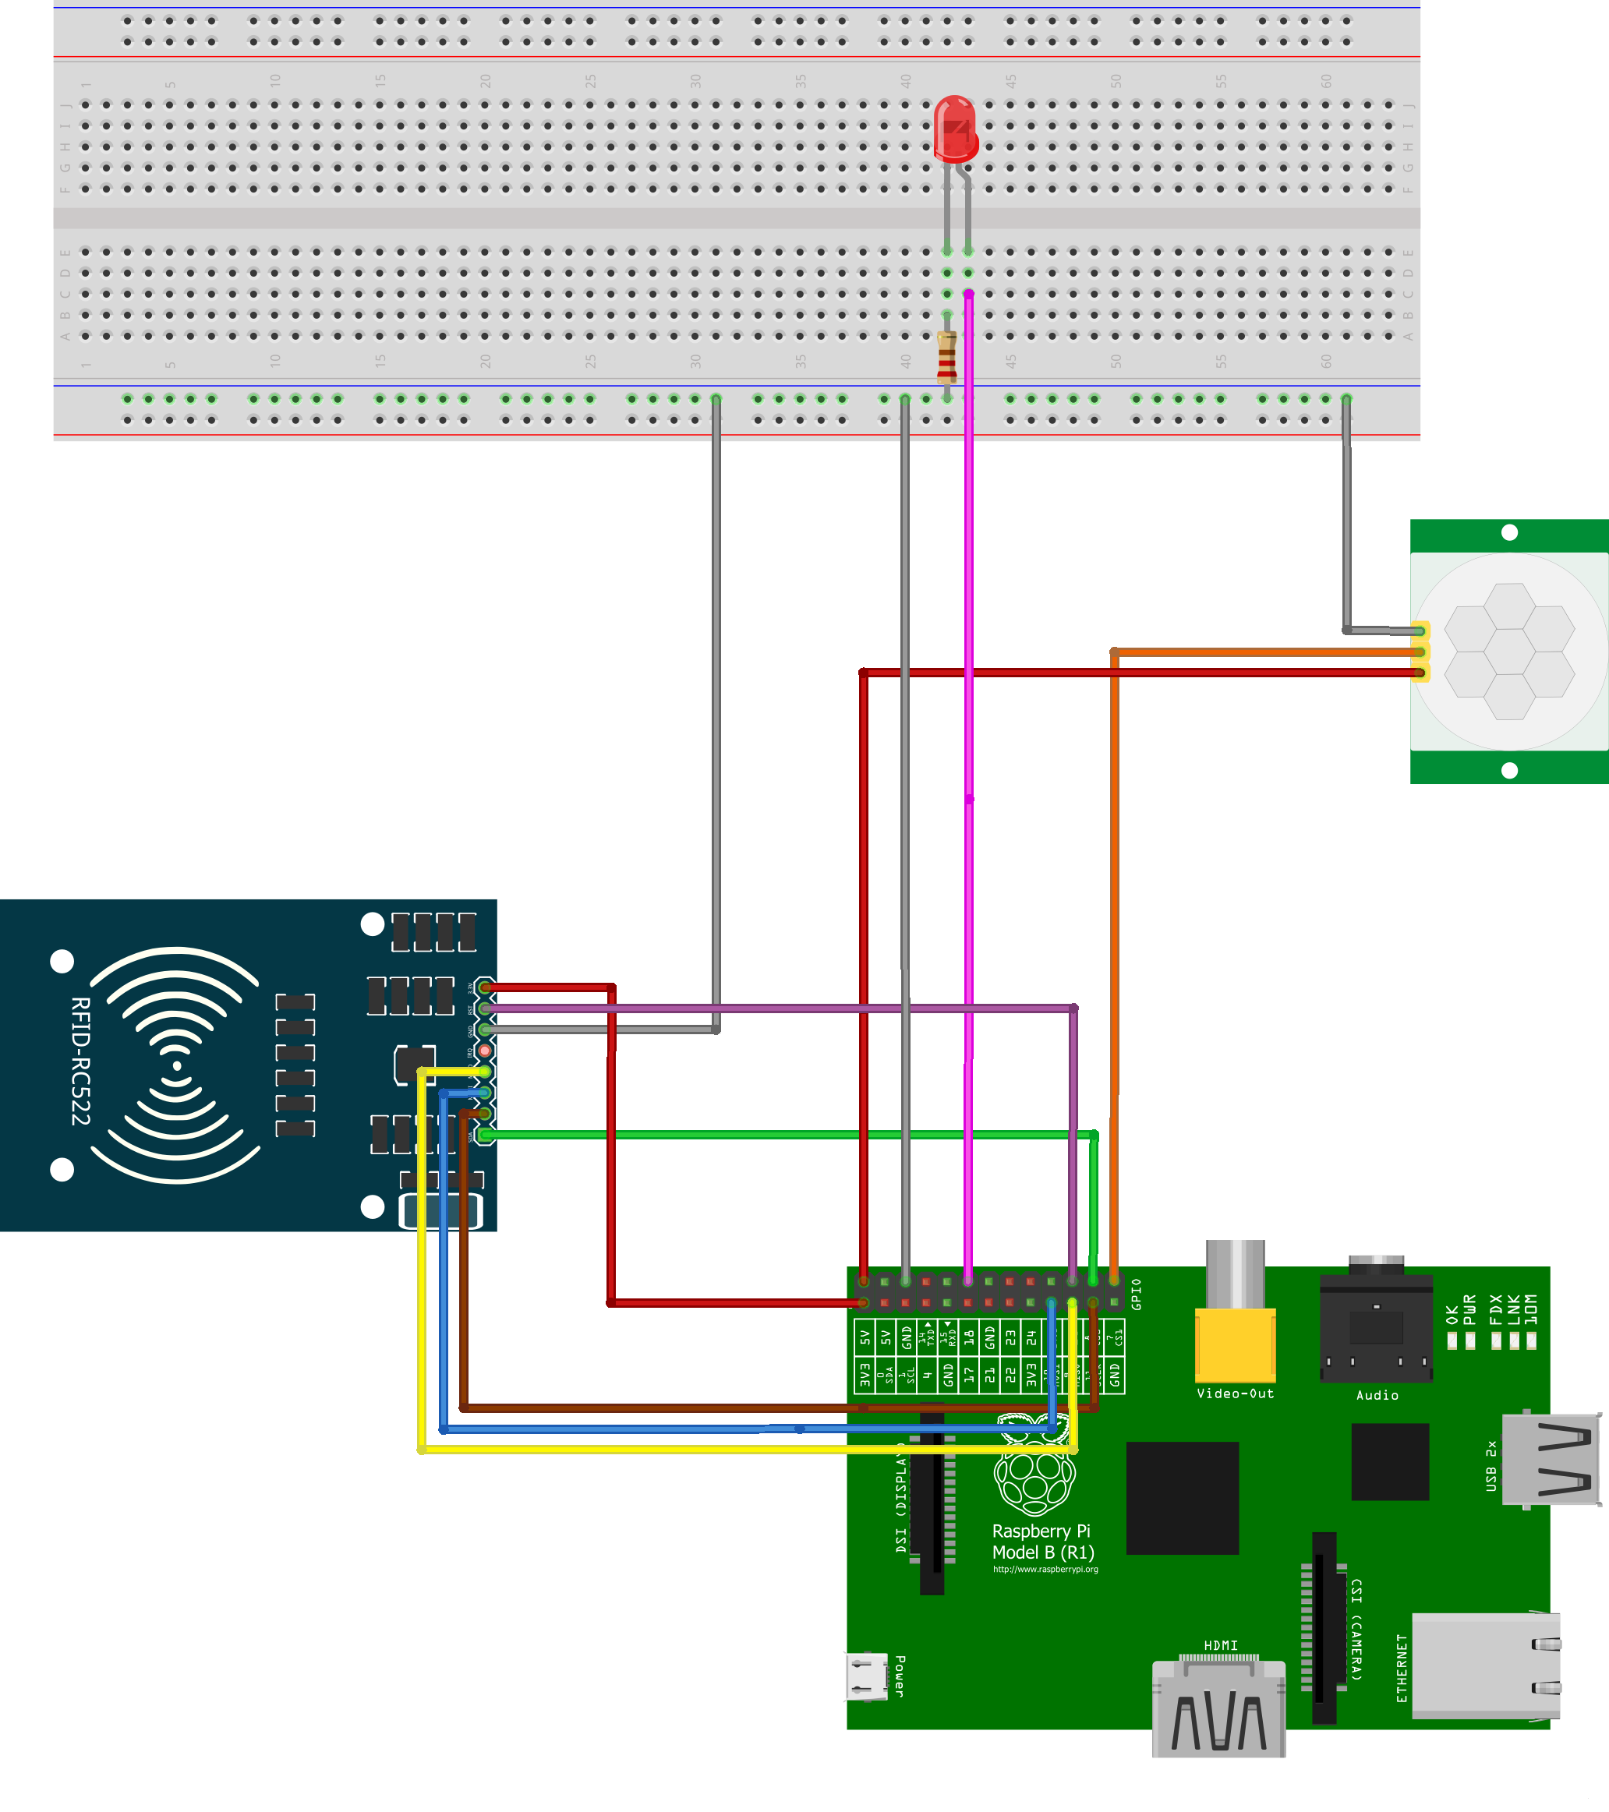
Figure 12. The hardware circuit scheme
The server and the database are also easily put together with a quick deployment and a database script run on a computer devoted to this task, and the Android application gets to the mobile device with the standard installation file.

How to use the application
To start with Safe Home usage, a user needs to register an RFID token, which is going to be used for the alarm switching. The token can be in a form of an RFID key, an ISIC card, a debit or credit card or any other card, which contains an RFID chip. The data read by the RFID reader stay exclusively on Raspberry Pi device and are only used to identify the registered card.
So, the first step is to open a website on the Raspberry Pi’s IP address, log in as admin and follow the instructions for registering a new user. After the process is finished, the user can log in to the Android application with the credentials, entered during the registration process. The user can only register the card to one user, but one user can have multiple tokens for identification.
Figure registration screenshot
The user can test the application with turning the security module on and off with his or her RFID token for a period of at least half a minute. Blinking LED means that the application recognizes the token. The notifications from the Android applications mean, that the user was successfully logged in the device, and the whole system was installed correctly. Now the user can get the information about detected intrusions in his or her mobile device.
Figure Android application screenshot

Comparison with commercial systems
The idea to connect the camera, motion sensor and a mobile application has been implemented by a large number of commercial companies by the year 2018. The implementation has got the name of an IP camera or a network camera. The first network camera was invented in 1996 by Axis Communications [20]. At that time, there was no mobile application, but the camera and its pictures could be accessed from the internet.
Today’s
Why my solution is better

Conclusion and future work

Bibliography
- Raspberry Pi. Retrieved July 8, 2017, from https://www.raspberrypi.org/
- Android. Retrieved July 8, 2017, from https://www.android.com/
- The Raspberry Pi Foundation. Retrieved July 8, 2017, from https://www.raspberrypi.org/about/
- Broadcom Corporation. Retrieved July 8, 2017, from https://www.broadcom.com/
- Raspbian operating system. Retrieved July 8, 2017, from https://www.raspbian.org/
- MIFARE. Retrieved July 8, 2017, from http://www.nxp.com/
- HTTP protocol. Retrieved July 10, 2017, from https://tools.ietf.org
- Android applications development. Retrieved April 3, 2018, from https://developer.android.com/
- Java. Retrieved April 3, 2018, from https://www.java.com
- Gartner, Inc. Retrieved April 4, 2018, from https://www.gartner.com
- “Desktop vs Mobile vs Tablet Market Share Worldwide.” Retrieved April 3, 2018, from http://gs.statcounter.com/
- “Introduction to Client/Server Architecture.” Retrieved April 3, 2018, from https://docs.oracle.com/
- Gosling, James; Joy, Bill; Steele, Guy; Bracha, Gilad; Buckley, Alex (2014). “The Java® Language Specification (Java SE 8 ed.)” PDF.
- “TIOBE Index for April 2018.” Retrieved April 4, 2018, from https://www.tiobe.com/
- “Mediator design pattern.” Retrieved April 11, 2018, from https://sourcemaking.com/design_patterns/mediator
- Jones, Capers. 1996. “Software Defect-Removal Efficiency”, IEEE Computer, April 1996.
- McConnell, Steve. 2004. “Code Complete, Second Edition”. Redmond, WA: Microsoft Press.
- Miller, Paul. 2017. “Raspberry Pi sold over 12.5 million boards in five years.” Retrieved April 15, 2018, from https://www.theverge.com/
- “Java Servlet Technology.” Retrieved April 16, 2018, from http://www.oracle.com
- “The Axis Story.” Retrieved May 5, 2018, from https://www.axis.com/about-axis/history

