**EMPLOYMENT DECLARATION**

I am the undersigned **George C. Arcangel**, holder of Philippine Passport No. P9083055B, presently residing at 113-2715 De La Gare Avenue Mascouche, Quebec, Canada J7K 0M8.

I have been employed in **PPI Holdings Inc.** – Araneta Center, Cubao Quezon City, Philippines as **Shift Manager** from March 6, 2017, to September 9, 2021 with a monthly salary of 18,000 **PHP** and 48 hours’ duty per week.

Duties and Responsibilities:

* Responsible for maximizing Sales and Profitability.
* Responsible for ensuring optimal level of Sanitation and Safety Standards in work area.
* Manage Control of the Restaurant Standards.
* Responsible for running an individual trading shift perfectly.
* Facilitate Maintenance concerns.

This is to certify that the above information is true and correct to the best of my knowledge.

Signed this 13th day of October 2024 at Quebec, Canada.

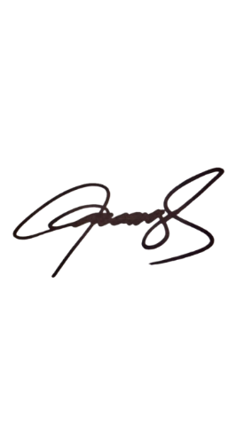Sincerely,

George Arcangel

Passport No. P9083055B

Reference

Marilou Catan- Area Manager

+63 998-591-4928

Rey Mabbayad-Restaurant Manager

+63 999-693-4672

