# Luna Design

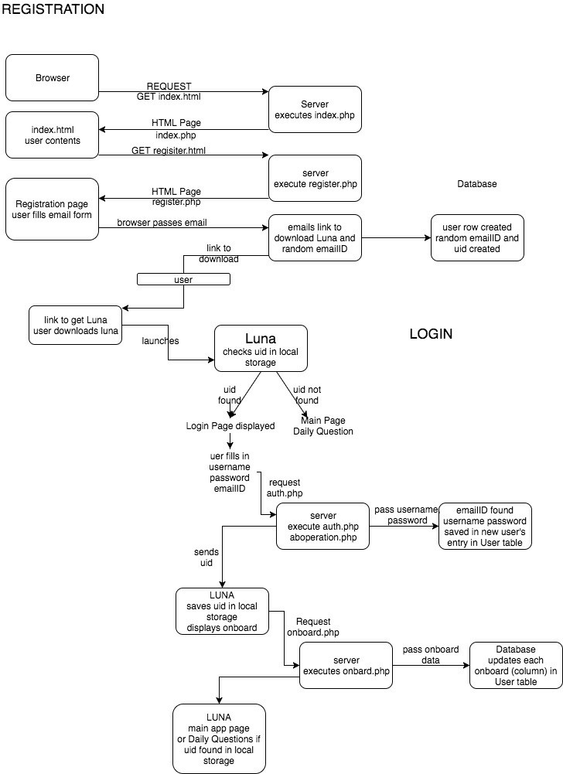

## New User

Fields in the user table created during the new user process:

emailID: random string sent to new user email address (done in register.php)

username/password: supplied by new user in logon screen, stored in the user's row. Only used when user wants to access personal data in tables.

uid: user ID, random number created by register.php for new user, when new user row created in user

table.

The uid is identifier that the app sends to the server for this user to change data in the tables.

1. New user uses browser to access Luna page: https://luna-app.000webhostapp.com(executes index.php)
2. Consent form displayed, new user must agree. New user enters age (must be between 18-25)
3. New user fills in email address, presses submit. If UK email adderess, continue with step 4. 4. Server: register.php executed. User row added to user table, random emailID,

random uid created, saved in new user table row

1. Random ID sent to email address (emailID column in user table)
2. Page displays instructions on how to get app
3. New user gets app, executes it on iPhone, or iPad
4. App checks if User ID (uid) has been saved in its local storage. If not, this is new user,

continue with step 9. If saved, displays main app page.

1. App displays logon page that asks for username, password, emailID
2. New user fills in emailID from email, username, password requested, presses submit

(sends request to server auth.php)

1. auth.php searches user table for emailID, if found continues
2. auth.php saves username, password in this new user's entry in user table, sets active flag

true

1. auth.php sends uid to app in message field of reply to app
2. app saves uid in local storage, displays page for new user to enter onBoard questions
3. After onboard questions answered, they are sent to server (onBoard.php), main app page

## Onboard questions

1. The new user is directed to answer the onboard questions. The user can view or change the answers toonboard questions via the settings tab.
2. The user must supply answers to all of the onboard questions. If not, when submit is pressed, the an alertmessage is displayed with the name of the first answer not supplied.
3. When all onboard questions answered, and submit is pressed, the answers are sent tochangeOnboard.php.

## Daily questions

1. When user executes the app, it looks up the user's uid stored in the app's local storage.
2. If the local storage uid contains the user's uid, the main screen is displayed.
3. When the user presses the tracker tab, tracker.ts is executed. The first daily question is displayed.
4. The user answers questions d, and e (see the entry table structure in the Data Base Documentationbelow).
5. If the user responds positively to question f, the remaining daily questions are displyed.
6. When the user presses submit, the tracker.ts function sends the answers to addDaily.php in the server.
7. addDaily.php creates a new row in the entry table for this user's daily questions.

## Settings

1. The user can display and change onboard questions and answers by pressing the settings

tab. The onBoarding.ts function is executed.

1. The user is asked for her username and password. If they match the variables in local

storage, the onboard questions are displayed.

1. The user can change any of them.
2. The app sends all the onboard questions to the server (onboard.php). onboard.php updates

the onboard columns in the user's row (identified by uid) in the user table.

## Calendar

The calendar page is displayed at the end of the new user steps, and when the app is started for the daily questions. The user is prompted to press the tracker tab to answer the daily questions. Currently the calendar is not used to display any user information.

# Database Documentation

Only the user table, and entry table are used by Luna. The period table and image table were created for possible future use. The incident table is used by the Sara app.

## 1. User Table

There is one row for each user. It is created during the "new user" activity. User rows It is flagged active when t the new user logs on for the first time. User rows are never deleted. The active flag can be set off, however this function is currently not provided.

1. uid - user identifier (primary key)
2. username - MD5 hashed username
3. password - MD5 hashed password
4. active - activity status (0 is inactive - can't log in)
5. onboard_status - onboarding status (1 is completed)
6. birthday: users birthdate
7. cycleLength: the number of days from one period until the next
8. periodLength: the number of days menstruating
9. birthControlType: hormonal or non-hormonal
10. lastPeriod: date of user’s last menstruation
11. status: current relationship status, single, casual, married, and long-term
12. time: time of activity on Luna
13. pregnant: whether or no user is pregnant
14. reproductiveDisorder: Answers to onboarding questions- ‘have you been

diagnosed with a reproductive disorder’

## 2. Entry Table

The entry table contains a row for each user's daily questions.

1. eid - entry identifier (primary key, auto increment)
2. uid - user identifier (foreign key)
3. entry_date - date of entry
4. onPeriod - - answer to daily question,menstruating status
5. sexualInterest - answer to daily question, rating of sexual desire or interest
6. sexualAcitvityNumber- answer to daily question, describe frequency of sexual

activity or intercourse

1. emotionalCloseness- answer to daily question, describes user satisfaction with

the amount of emotional closeness during sexual activity with partner

1. sexualRelationship- answer to daily question, describes user satisfaction with

their sexual relationship

1. sexualLife- answer to daily question, describes user’s overall satisfaction withtheir sexual life
2. sexualArousal- answer to daily question, describes how a user would rate their

level of sexual arousal

1. sexualArousalConfidence- answer to daily question, describes confidence in

sexual arousal

1. lubrication- answer to daily question, decribes how difficult it was to become

lubricated

1. lubricationMaintain- answer to daily question, describes difficulty to maintain

lubrication until completion of intimacy

1. difficulty - answer to daily question, describes difficulty reaching orgasm
2. satisfaction- answer to daily question, describes satisfaction with ability to

orgasm(climax)

1. discomfort- answer to daily question describes comfortability during intercourse

## 3. Period Table

Period dates for a specific user. Not currently used.

1. pid - period identifier (primary key, auto increment)
2. uid - user identifier (foreign key)
3. mens_start - menstrual cycle (or period) start date
4. mens_end - menstrual cycle (or period) end date

## 4. Image Table

Image information for uploaded photos. Not currently used.

1. iid - image identifier (primary key, auto increment)
2. uid - user identifier (foreign key)
3. upload_date - date of image upload
4. file_name - file name of image
5. image - image stored as a hex long blob

## 5. Incident Table

Basic sexual assault incident information. Used by the Sara app. Not used by Luna.

1. incident_id - incident identifier (primary key, auto increment)
2. user_hash - MD5 hashed username
3. incident_loc - location of incident
4. incident_date - date of incident