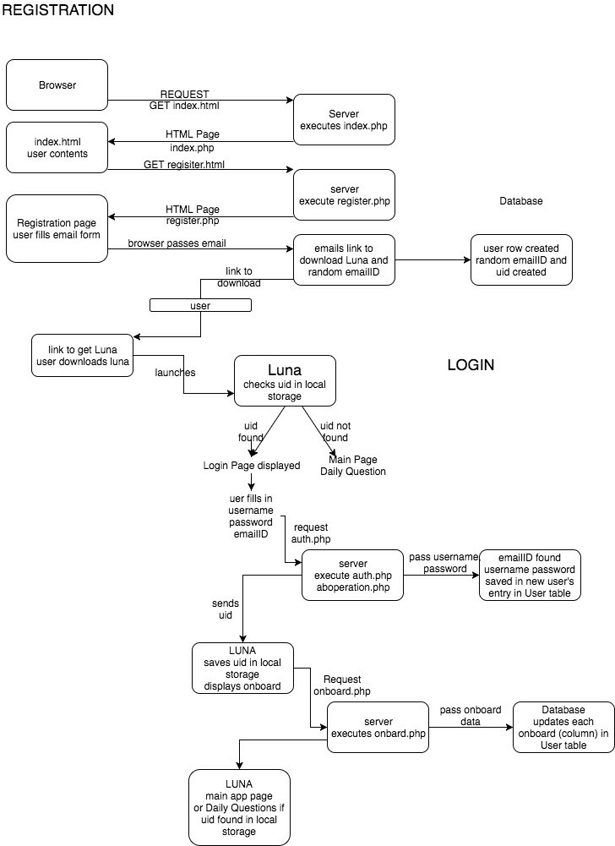
Luna Summer 2017
University of Kentucky
CS485: Special Topics Class
Introduction

Requirements
Design
Screens
User scenarios
Testing Joshua (Dillon) Pulliam

Future dpu225@g.uky.edu
Enhancements
Danyse Hickman
Conclusions drh223@g.uky.edu Installation Instructor:
Paul Piwowarski
References
paulp@cs.uky.edu Sponsor/Client:
Kaylynne Glover

kaylynnemglover@gmail.com

