Stabilizer – Initial Data Analysis Notes

Started with trying to understand how to best use oscilloscope to capture waveforms
Oscilloscope I am using can only export CSV via front USB panel to external drive – Using USB stick
Each time I am capturing a png of waveform alongside with csv

To start with I wanted to capture just the throughput – In this case the IIR filter applied is set to through
There are no harmonic parameters added
I am applying a current 0.1A and voltage 5.0V from PSU
Since I am aiming to hopefully see 50Hz and maybe some harmonic peaks – I have taken a time period of waveform resolution to be 200ms
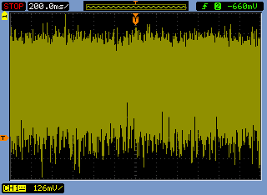
I have also done some with shorter time periods – which would look at the higher frequency noise
