|  |  |  |  |
| --- | --- | --- | --- |
| Junctons | Protein / gene | Phenotype | Reference |
| Cell adhesion | Amelotin (AMTN) | hypomineralize | (Nakayama 2015) |
| AMTN / KEK4 | hypominerlaize | (Núñez et al. 2016) |

**Figure**

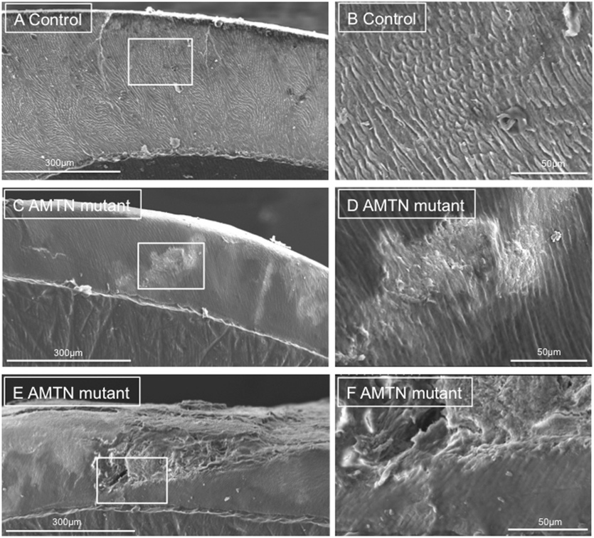(a) (b)

(a) (Smith et al. 2016)

(b) (Nakayama et al., 2015)

**Reference**

Nakayama, Y., J. Holcroft, and B. Ganss. 2015. “Enamel Hypomineralization and Structural Defects in Amelotin-Deficient Mice.” *Journal of Dental Research* 94 (5): 697–705.

Núñez, Stephanie M., Yong-Hee P. Chun, Bernhard Ganss, Yuanyuan Hu, Amelia S. Richardson, James E. Schmitz, Roberto Fajardo, Jie Yang, Jan C-C Hu, and James P. Simmer. 2016. “Maturation Stage Enamel Malformations in Amtn and Klk4 Null Mice.” *Matrix Biology: Journal of the International Society for Matrix Biology* 52–54: 219–33.

Smith, Claire E. L., Gina Murillo, Steven J. Brookes, James A. Poulter, Sandra Silva, Jennifer Kirkham, Chris F. Inglehearn, and Alan J. Mighell. 2016. “Deletion of Amelotin Exons 3-6 Is Associated with Amelogenesis Imperfecta.” *Human Molecular Genetics* 25 (16): 3578–87.