.Net 用の C# ライブラリィ

CoreLib

1.ダイヤログ

ChkListDialog

List<CheckBoxListItem> mChkList = new List<CheckBoxListItem>() {
new CheckBoxListItem(true, "TEST1"),
new CheckBoxListItem(false, "TEST2"),
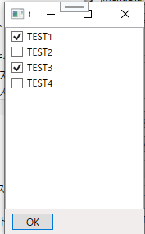
new CheckBoxListItem(true, "TEST3"),
new CheckBoxListItem(false, "TEST4"),
};
ChkListDialog mChkListDlg = null;

if (mChkListDlg != null)
mChkListDlg.Close();
mChkListDlg = new ChkListDialog();
mChkListDlg.mChkList = mChkList;
mChkListDlg.mCallBackOn = true;
mChkListDlg.callback = getchk;
mChkListDlg.Show();

public void getchk()
{
string buf = "";
foreach (CheckBoxListItem item in mChkList) {
if (item.Checked == true)
buf += item.Text + ",";
}
tbChkListDialog.Text = buf;
}

ColorDialog
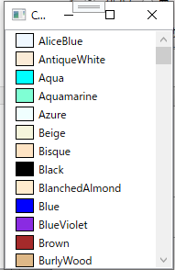

DiffFolder

FileCopyDialog

FileDeleteDialog

FullView

ImageView

InputBox
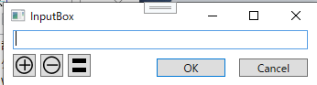

InputBox2
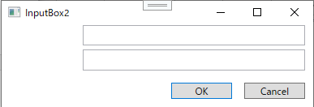

InputBoxMulti

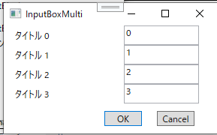

int count = 4;
InputBox inputBox = new InputBox();
if (inputBox.ShowDialog() == true) {
count = ylib.intParse(inputBox.mEditText);
}
List<string[]> dataList = new List<string[]>();
for (int i = 0; i < count; i++) {
string[] data = new string[2] { "タイトル "+ i.ToString(), i.ToString() };
dataList.Add(data);
}
InputBoxMulti dlg = new InputBoxMulti();
dlg.mDataList = dataList;
if (dlg.ShowDialog() == true) {
foreach (string[] data in dlg.mDataList)
System.Diagnostics.Debug.WriteLine(data[0] + " " + data[1]);
}

InputSelect
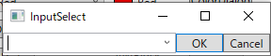

InputSelect dlg = new InputSelect();
dlg.Title = "フォルダ選択テスト";
dlg.mInputType = InputSelect.InputType.FOLDER;
dlg.mTextList = ylib.loadListData("InputSelect.csv");
dlg.ShowDialog();
tbInputSelect.Text = dlg.mText;
ylib.saveListData("InputSelect.csv", dlg.mTextList);

InputSelect2
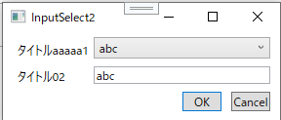

List<string> listData = new List<string>() {
"abc", "bcd", "cde", "defg"
};
InputSelect2 dlg = new InputSelect2();
dlg.Owner = this;
dlg.WindowStartupLocation = WindowStartupLocation.CenterOwner;
dlg.Title = "InputSelect2";
dlg.mSelectList = listData;
dlg.mTitle1 = "タイトルaaaaa1";
dlg.mTitle2 = "タイトル02";
if (dlg.ShowDialog() == true) {
tbInputSelect.Text = dlg.mSelectText;
tbInputSelect2.Text = dlg.mEditText;
}

MenuDialog

List<string> menu = new List<string>() { "メニュー1", "メニュー2", "メニュー3" };
MenuDialog dlg =new MenuDialog();
dlg.mMainWindow = this;
dlg.mHorizontalAliment = 1;
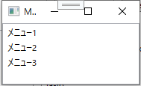
dlg.mVerticalAliment = 1;
dlg.mOneClick = true;
dlg.mMenuList = menu;
dlg.ShowDialog();
tbMenuDialog.Text = dlg.mResultMenu;

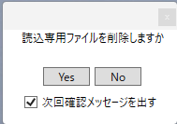
MessageBoxEx

MessageBoxEx dlg = new MessageBoxEx();
dlg.mMessage = "読込専用ファイルを削除しますか";
dlg.mButton = MessageBoxButton.YesNo;
dlg.mContinueMessageDisp = true;
dlg.ShowDialog();
tbMessageBox.Text = $"Continue: [{dlg.mContinueMessage}]";
tbMessageBox.Text += $" Result: [{dlg.mResult == MessageBoxResult.Yes}]";

SelectMenu
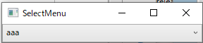

SelectMenu2
