Intuit DEV Op’s Specializing in GIT & Jenkins CI/CD

Pre-Assignment Craft Demonstration

**Overview: EBS WEBS (Worldwide Enterprise Billing Services) needs to be migrated to GIT from PERFORCE in order to take advantage of GIT’s branching/merging best practices, as well as Continuous Integration on Jenkins using GIT.**

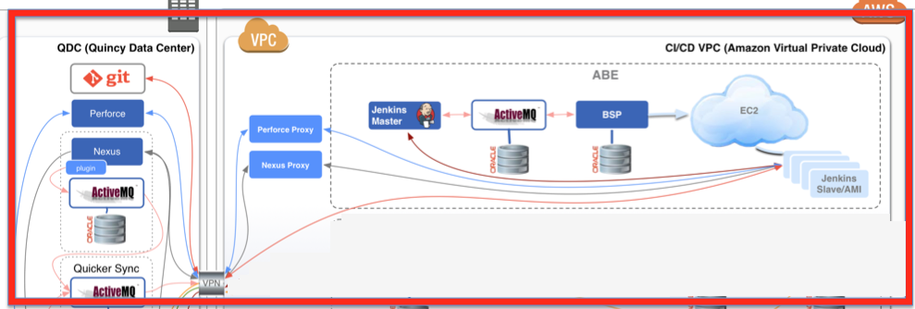

***Continuous Integration on Jenkins using GIT***

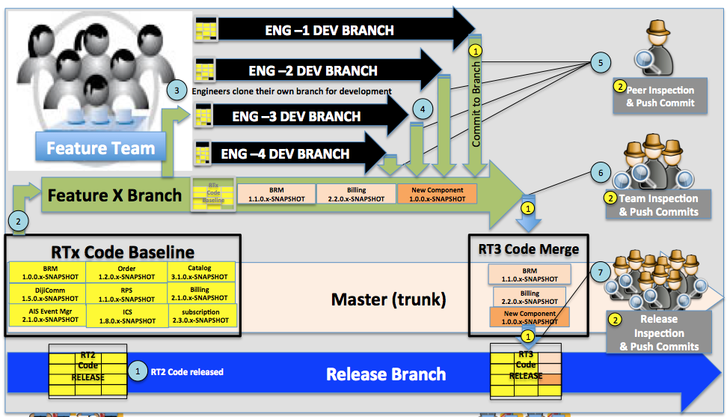

***Branching and merging best practices***

**Requirements for migration to GIT are:**

1. Migration from Perforce to GIT
2. Creating Maven pom Hierarchy (parent/child) for a nested project.
3. Jenkins jobs for Creating GIT Branches (Feature and Release)
4. Changing pom versioning

**All the Craft demonstrations will require pre-work**

1. Provide your own laptop
2. Must have at least Java JDK 1.7
3. Local running Jenkins

**Demo Project**

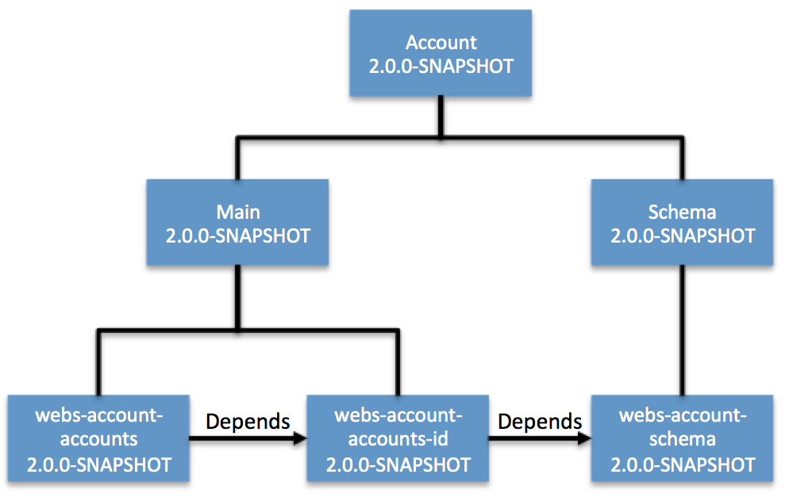

**Craft Demonstration #1**

Document the commands or process to be used to migrate a project from PERFORCE to GIT.

***Demonstration artifact:*** WORD, PPT or PDF

**Craft Demonstration #2**

Using provided source code project ZIP, create Maven hierarchy and demonstrate that it will build successfully. Result will be project1/target WAR file, project2/target JAR file and project3/target JAR file.

***Demonstration artifact:*** Command shell live demonstration of mvn build

**Craft Demonstration #3**

Using project from above demonstrate the run a maven command to revision pom files from 1.0.0-SNAPSHOT to 2.0.0.0-SNAPSHOT

***Demonstration artifact***: Command shell live demonstration

**Craft Demonstration #4**

Create & Demonstrate a Jenkins Job (freestyle software project) that would branch a project within GIT.

Job will have the following build parameters

1. Branch Name string
2. *Branch Choice* containing: **Feature** and **Release**
3. 2 text boxes to accept version numbers (Major, Minor)
4. Execute Shell will do 2 things
   1. Revision pom files using Major. Minor.BranchName-SNAPSHOT
   2. Execute a GIT command to create a branch

***Demonstration artifact:*** Display of Jenkins Job configuration