**Prerequisites:**

* **Java**
* **Ant**

**Additional Features Incorporated**

* Arbitrarily Sized Grids
* Loops through States
* Improved Result Display
* Good Performance

**Steps for the Executions**

1. Extract the Zip file and you can find 2 folders **lib** and **src** along with build.xml file
2. Open command prompt and enter in to the folder where these files resides.

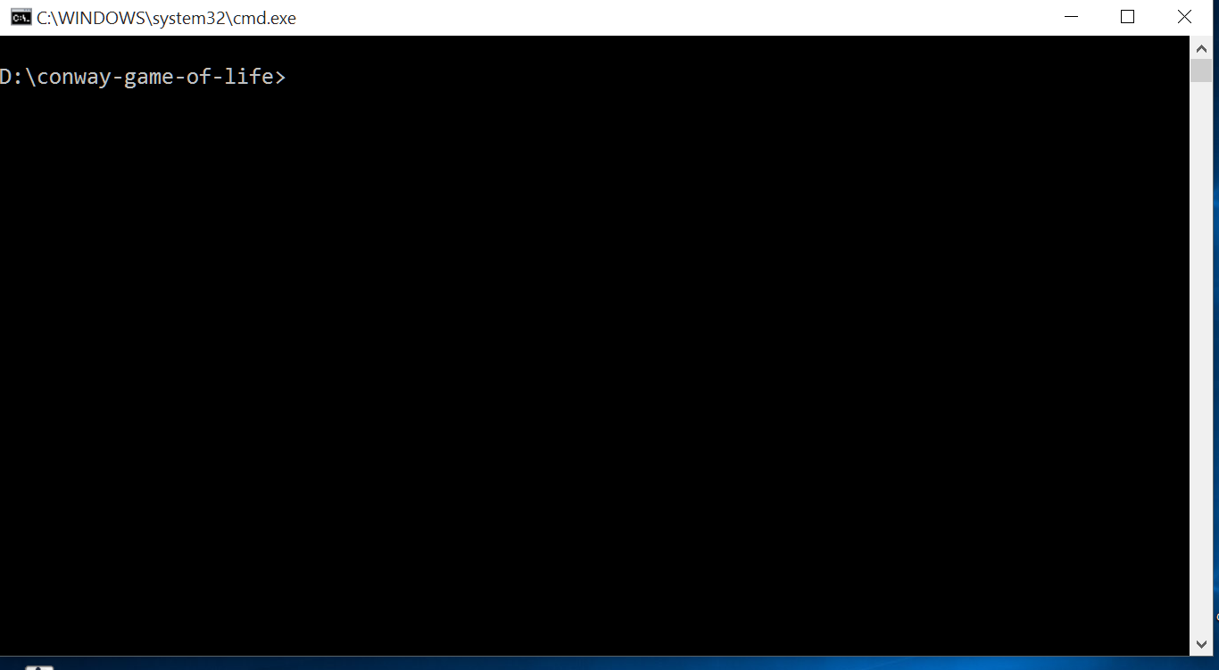

1. Type the command **ant** and it will run the default test cases. Ant Default task will do the compilation and execution of unit test cases.

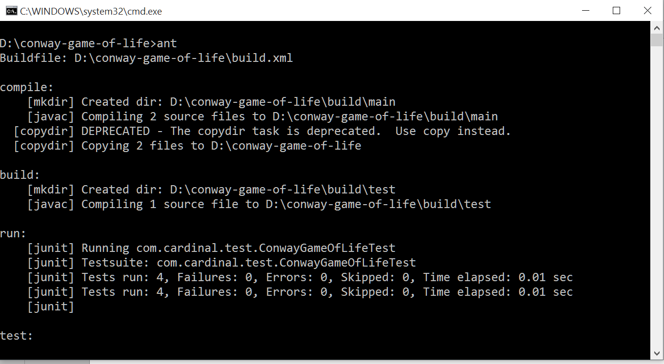

1. Type the command **java com.cardinal.SampleTest** and there comes the execution and follow the instructions on the screen

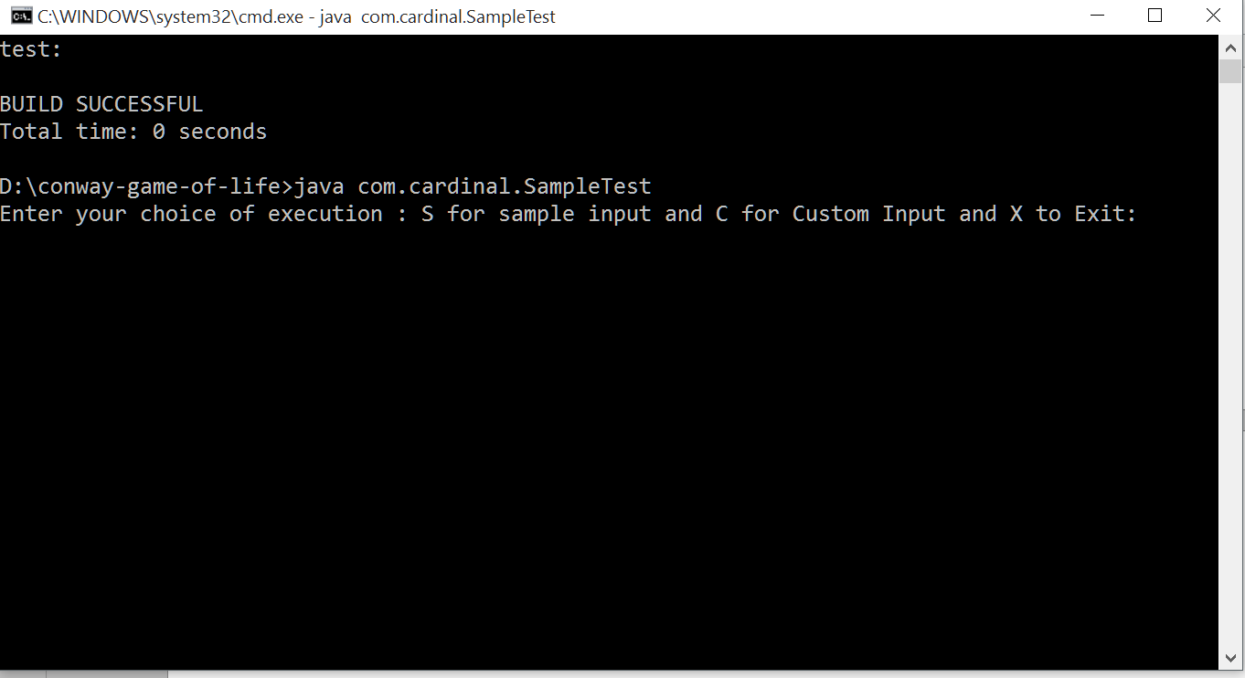

1. Enter **S** for Sample input which already defined in code which is specified in the requirement specification document.

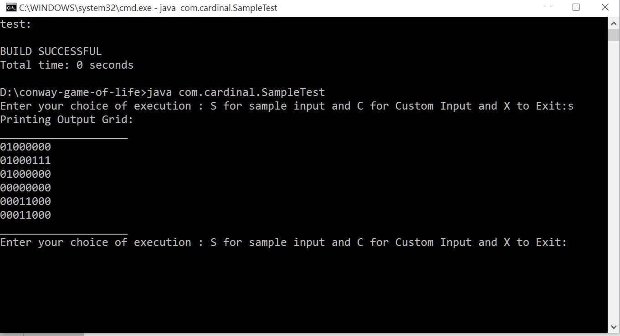

1. Enter **C** for custom grid creation and for manually give input to the cells, Input should be provided with **“ ,”** separated values.

* **0** for dead cell
* **1** for Live cell

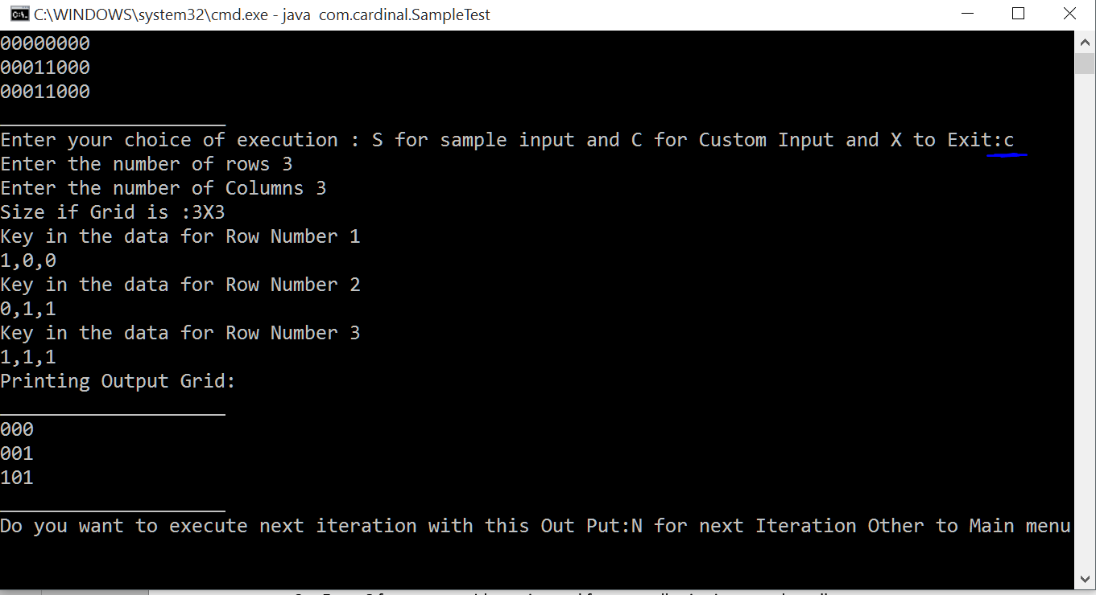

1. Give command **N** for next iteration with current output as input

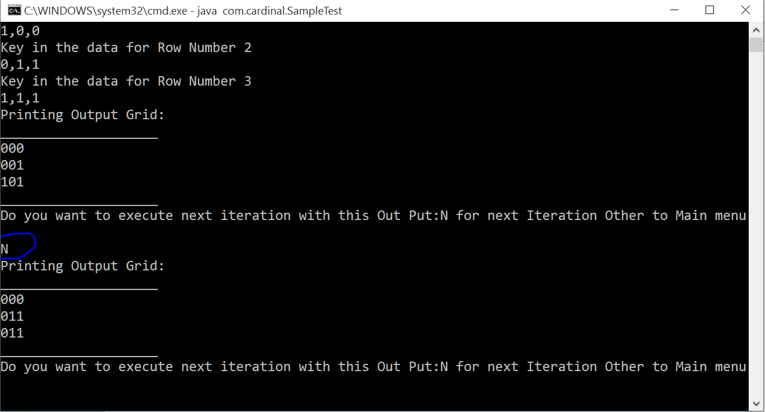

1. Type any character to return to main menu

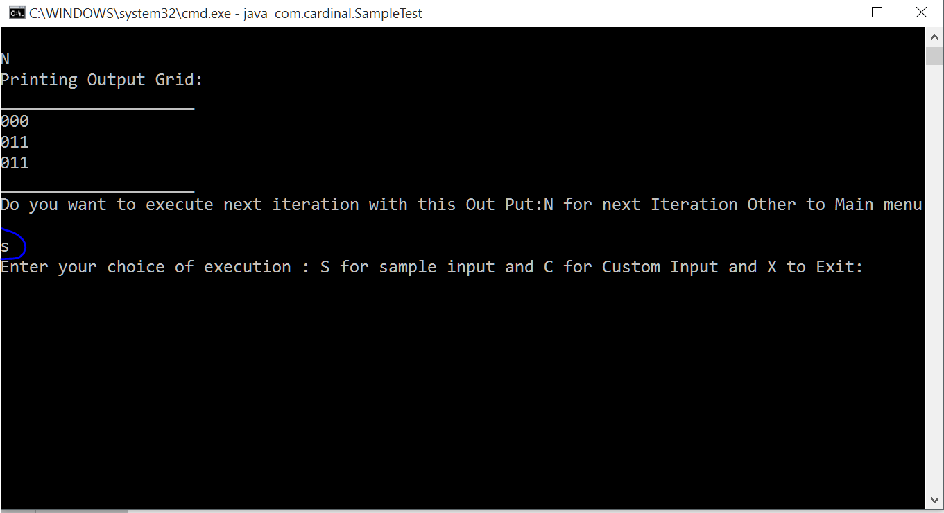

1. Type **X** to exit the screen.