<https://dotnettutorials.net/lesson/viewdata-asp-net-core-mvc/>

,

# ViewData in ASP.NET Core MVC

Back to: [ASP.NET Core Tutorials For Beginners and Professionals](https://dotnettutorials.net/course/asp-net-core-tutorials/)

## ****ViewData in ASP.NET Core MVC Application****

In this article, I am going to discuss the use of **ViewData in ASP.NET Core MVC** application with examples. Please read our previous article before proceeding to this article where we discussed [**Views in ASP.NET Core MVC**](https://dotnettutorials.net/lesson/views-asp-net-core-mvc/) application.

In ASP.NET Core MVC application, we can pass the data from a controller action method to a view in many different ways such as by using **[ViewBag](https://dotnettutorials.net/lesson/viewbag-asp-net-core-mvc/)**, **[ViewData](https://dotnettutorials.net/lesson/viewdata-asp-net-core-mvc/)**, and using a [**strongly typed model**](https://dotnettutorials.net/lesson/strongly-typed-view-asp-net-core-mvc/). In this article, I will show you how to use **ViewData** to pass the data from the controller action method to a view. The rest techniques i.e. [ViewBag](https://dotnettutorials.net/lesson/viewbag-asp-net-core-mvc/), and [strongly typed model](https://dotnettutorials.net/lesson/strongly-typed-view-asp-net-core-mvc/) are going to be discussed in our upcoming articles.

##### ****What is ViewData in ASP.NET Core MVC Application?****

The ViewData in ASP.NET Core MVC is a dictionary of weakly typed objects which is derived from the ViewDataDictionary class.

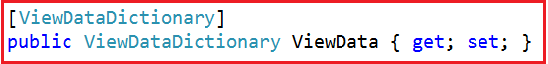

Now, look at the definition of ViewDataDictionary as shown below.



As you can see in the above image, the ViewDataDictionary implements ICollection, IEnumerable, and IDictionary interfaces where it will store the data in the form of key-value pairs. Here, the key is of type String and the value is of type object i.e. we can store any type of data.

##### ****What is the use of ViewData?****

1. ViewData is used to pass the data from the controller action method to a view and we can display this data on the view.
2. The ViewData is work on the principle of Key-value pairs. This type of binding is known as loosely binding.
3. We can pass any type of data in ViewData like normal integer, string, even though you can pass objects.
4. ViewData uses the ViewDataDictionary type.

##### ****How to use ViewData?****

First, we need to create a new key in ViewData and then assign some data to it. The key should be in string format and you can give any name to it and then you can assign any data to this key.

**ViewData[“KeyName”] = “Some Data”;**

Since ViewData is a server-side code, hence to use it on view, we need to use the razor syntax i.e. @

**@ViewData[“KeyName”]**

You can access the string data from the ViewData dictionary without casting the data to string type. But if you are accessing data other than the string type then you need to explicitly cast the data to the type you are expecting.

##### ****Example: Accessing string data****

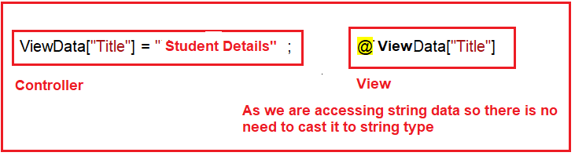

##### ****Example: Accessing Student Data:****

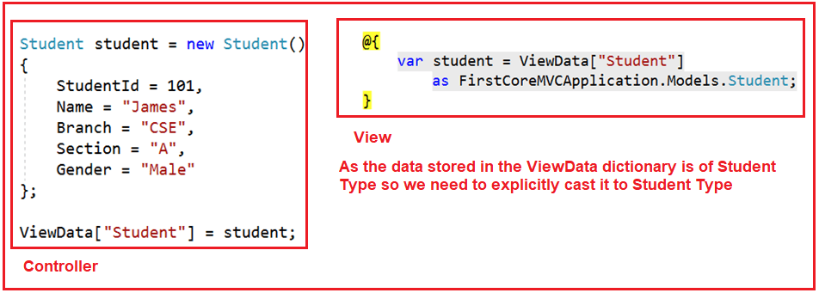

**Note**: We can use n number of ViewData on a single view. ViewData can also be used to pass data from view to its layout view.

##### ****ViewData Example in ASP.NET Core MVC Application:****

Let us see an example to understand how to use ViewData to pass data from a controller action method to a view. In our example, we want to pass three pieces of information to the view from the controller action method. One is the Title of the page, the second is the Header of the Page and the third one is the Student data that we want to display on the page.

First, create an ASP.NET Core Web Application with MVC (Model-View-Controller) project template. Once you create the project then add a class file with the name **Student.cs** in the Models folder. And then copy and paste the below code in it.

**namespace** *FirstCoreMVCWebApplication.Models*

**{**

**public** **class** Student

**{**

**public** **string** StudentId **{** **get**; **set**; **}**

**public** **string** Name **{** **get**; **set**; **}**

**public** **string** Branch **{** **get**; **set**; **}**

**public** **string** Section **{** **get**; **set**; **}**

**public** **string** Gender **{** **get**; **set**; **}**

**}**

**}**

##### ****Modifying the HomeController:****

Now, modify the Home Controller class as shown below. Here, we are removing the existing code and adding one action method i.e. Details.

**using** *Microsoft.AspNetCore.Mvc;*

**using** *FirstCoreMVCWebApplication.Models;*

**namespace** *FirstCoreMVCWebApplication.Controllers*

**{**

**public** **class** HomeController : Controller

**{**

**public** ViewResult Details**()**

**{**

//String string Data

ViewData**[**"Title"**]** = "Student Details Page";

ViewData**[**"Header"**]** = "Student Details";

Student student = new Student**()**

**{**

StudentId = "STD101",

Name = "James",

Branch = "CSE",

Section = "A",

Gender = "Male"

**}**;

//storing Student Data

ViewData**[**"Student"**]** = student;

**return** View**()**;

**}**

**}**

**}**

##### ****Creating Details.cshtml view:****

In our previous article, we discussed the different ways to create Views in ASP.NET Core Application. Let us add a view with the name Details.cshtml within the Home Folder which is present inside the View Folder as shown below.

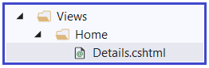

Now open Details.cshtml and then copy and paste the below code in it. As you can see in the below code, we directly access the string data from the ViewData without typecasting. But while accessing the Student data from the ViewData, we are typecasting it to the appropriate type.

@{

Layout = null;

}

<!DOCTYPE html>

**<html>**

**<head>**

**<meta** name="viewport" content="width=device-width" **/>**

**<title>**@ViewData["Title"]**</title>**

**</head>**

**<body>**

**<h1>**@ViewData["Header"]**</h1>**

@{

var student = ViewData["Student"]

as FirstCoreMVCWebApplication.Models.Student;

}

**<div>**

StudentId : @student.StudentId

**</div>**

**<div>**

Name : @student.Name

**</div>**

**<div>**

Branch : @student.Branch

**</div>**

**<div>**

Section : @student.Section

**</div>**

**<div>**

Gender : @student.Gender

**</div>**

**</body>**

**</html>**

Now run the application and navigate to the “**/Home/Details**” URL and you will see the data as expected as shown below.

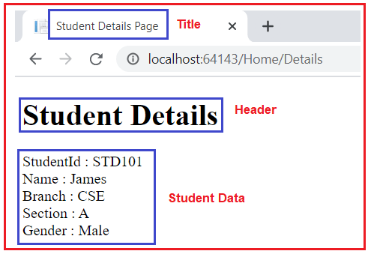

##### ****Points to Remember:****

The ViewData is dynamically resolved at runtime, as a result, it does not provide any compiles time error checking as well as we do not get any intelligence. For example, if we miss-spell the key names then we wouldn’t get any compile-time error. We get to know about the error only at runtime.

The ViewData only transfers the data from the controller action method to a view, but not vice-versa. That means it is valid only during the current request.

In the next article, I will discuss **[ViewBag in ASP.NET Core MVC](https://dotnettutorials.net/lesson/viewbag-asp-net-core-mvc/)** with an example. In this article, I try to explain **ViewData in ASP.NE**

# ViewBag in ASP.NET Core MVC

Back to: [ASP.NET Core Tutorials For Beginners and Professionals](https://dotnettutorials.net/course/asp-net-core-tutorials/)

## ****ViewBag in ASP.NET Core MVC Application****

In this article, I am going to discuss the use of **ViewBag in ASP.NET Core MVC** application with examples. Please read our previous article before proceeding to this article where we discussed **[ViewData in ASP.NET Core MVC](https://dotnettutorials.net/lesson/viewdata-asp-net-core-mvc/)** application. As we already discussed in the ASP.NET Core MVC application, we can pass the data from a controller to a view using ViewData, ViewBag, and strongly typed view model. As part of this article, we are going to discuss the following pointers.

1. **What is ViewBag in ASP.NET Core MVC?**
2. **How to Pass and Retrieve data From ViewBag in ASP.NET Core MVC?**
3. **Example to understand ViewBag in ASP.NET Core MVC**
4. **Difference between ViewData and ViewBag in ASP.NET Core MVC**

##### ****What is ViewBag in ASP.NET Core MVC?****

The ViewBag in ASP.NET Core MVC is one of the mechanisms to pass the data from a controller action method to a view. If you go the Controller base class, then you will find the following signature of the ViewBag property.

ViewBag in ASP.NET Core MVC

So the ViewBag is a dynamic property of the Controller base class. The dynamic type is introduced in C# 4.0. It is very much similar to the var keyword that means we can store any type of value in it but the type will be decided at run time rather than compile-time.

The ViewBag transfers the data from the controller action method to a view only, the reverse is not possible.

##### ****How to Pass and Retrieve data From ViewBag in ASP.NET Core MVC?****

The point that you need to keep in mind is, ViewBag is operating on the dynamic data type. So we don’t require typecasting while accessing the data from a ViewBag. It does not matter whether the data that we are accessing is of type string or any complex type.

**ViewBag in ASP.NET Core MVC with String Type:**

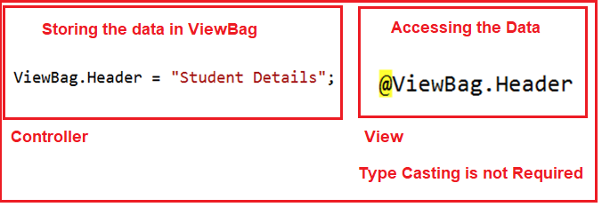

**ViewBag in ASP.NET Core MVC with Complex Type:**

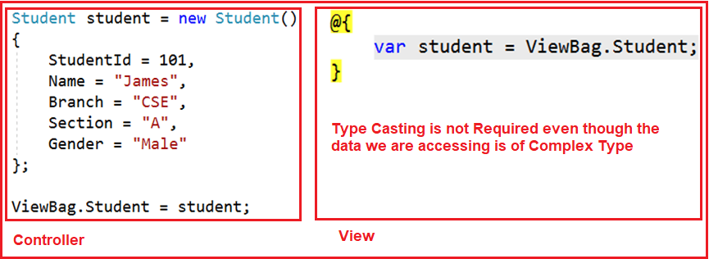

##### ****Example of ViewBag in ASP.NET Core MVC:****

Let us see an example to understand how to use ViewBag to pass data from a controller to a view. We are going to work with the same example that we worked in our previous article with ViewData. So, modify the Details action method of HomeController class as shown below.

**using** *FirstCoreMVCApplication.Models;*

**using** *Microsoft.AspNetCore.Mvc;*

**namespace** *FirstCoreMVCApplication.Controllers*

**{**

**public** **class** HomeController : Controller

**{**

**public** ViewResult Details**()**

**{**

ViewBag.Title = "Student Details Page";

ViewBag.Header = "Student Details";

Student student = new Student**()**

**{**

StudentId = 101,

Name = "James",

Branch = "CSE",

Section = "A",

Gender = "Male"

**}**;

ViewBag.Student = student;

**return** View**()**;

**}**

**}**

**}**

As you can see in the above example, here we are using the dynamic properties Title, Header, and Student on the ViewBag.

##### ****Accessing the ViewBag in a View in ASP.NET Core MVC****

Now we will see how to access the ViewBag data within an ASP.NET Core MVC view. So, modify the Details.cshtml view file as shown below.

**<html** xmlns="http://www.w3.org/1999/xhtml"**>**

**<head>**

**<title>**@ViewBag.Title**</title>**

**</head>**

**<body>**

**<h1>**@ViewBag.Header**</h1>**

@{

var student = ViewBag.Student;

}

**<div>**

StudentId : @student.StudentId

**</div>**

**<div>**

Name : @student.Name

**</div>**

**<div>**

Branch : @student.Branch

**</div>**

**<div>**

Section : @student.Section

**</div>**

**<div>**

Gender : @student.Gender

**</div>**

**</body>**

**</html>**

As you can see, here we are accessing the data from the ViewBag using the same dynamic properties Title, Header, and Student.  Now run the application and navigate to the “**/Home/Details**” URL and you will see the data as expected on the webpage as shown in the below image.

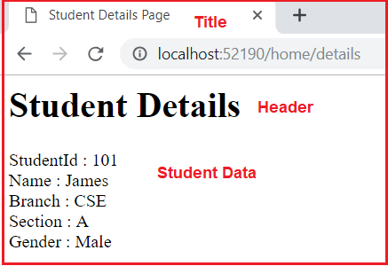

The ViewBag is a dynamic property that is resolved at runtime; as a result, here also it will not provide compile-time error checking as well as intelligence support. For example, if we miss-spell the property names of the ViewBag, then we wouldn’t get any compile-time error rather we came to know about the error at runtime.

##### ****Difference between ViewData and ViewBag in ASP.NET Core MVC****

1. In ASP.NET Core MVC, we can use both ViewData and ViewBag to pass the data from a Controller action method to a View.
2. The ViewData is a weakly typed dictionary object whereas the ViewBag is a dynamic property. Both ViewData and ViewBag are used to create a loosely typed view in MVC.
3. In ViewData, we use string keys to store and retrieve the data from the ViewData dictionary whereas in ViewBag we use the dynamic properties to store and retrieve data.
4. Both the ViewData keys and ViewBag dynamic properties are resolved only at runtime. As a result, both do not provide compile-time error checking and because of this, we will not get intelligence support.
5. So if we misspell the key names or dynamic property names then we will not get any compile-time error rather we came to know about the error only at run time. This is the reason why we rarely used ViewBag and ViewData in our application.

The best and preferred approach in MVC to pass data from a controller action method to a view is by using a strongly typed model object. When we use a strongly typed model object then only our view becomes a strongly typed view.

In the next article, I am going to discuss the [**Strongly Typed Views in ASP.NET Core MVC**](https://dotnettutorials.net/lesson/strongly-typed-view-asp-net-core-mvc/) application with an example. Here, in this article, I try to explain **ViewBag in ASP.NET Core MVC** application. I hope this article will help you with your needs.

# Strongly Typed View in ASP.NET Core MVC

Back to: [ASP.NET Core Tutorials For Beginners and Professionals](https://dotnettutorials.net/course/asp-net-core-tutorials/)

## ****Strongly Typed View in ASP.NET Core MVC Application****

In this article, I am going to discuss how to create a **Strongly Typed View in ASP.NET Core MVC** application with examples. Please read our previous article before proceeding to this article where we discussed **[ViewBag in ASP.NET Core MVC](https://dotnettutorials.net/lesson/viewbag-asp-net-core-mvc/)** application. As part of this article, we are going to discuss the following pointers.

1. **Why we need a Strongly Typed View in ASP.NET Core MVC?**
2. **How to create a strongly typed view in ASP.NET Core?**
3. **What are the advantages of using a strongly typed view?**

##### ****Why do we need Strongly Typed View in ASP.NET Core MVC?****

As we already discussed we can pass the model data to a view using many different ways such as ViewBag, ViewData, strongly typed model object, etc. When we passed the model data to a View using ViewBag or ViewData, then the view becomes a loosely typed view. In a loosely typed view, we will not get any intelligence as well as the compile-time error. With a strongly typed view, we will get both intelligence support as well as the compile-time error.

##### ****Implementing Strongly Typed View in ASP.NET Core MVC****

In order to create a strongly-typed view, from the action method of the controller, we need to pass the model object as a parameter to the View() extension method. The Controller base class provides us the following two overloaded versions of View() extension method which we can use to pass the model object from the controller action method to a view.

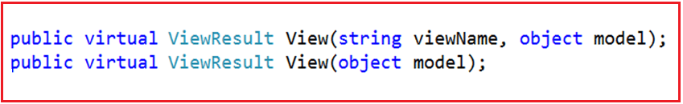

Here we are going to use the overloaded version which takes only the model object as an input parameter. So, modify the Details action method as shown below to pass the student object as a parameter to the View extension method.

**using** *FirstCoreMVCApplication.Models;*

**using** *Microsoft.AspNetCore.Mvc;*

**namespace** *FirstCoreMVCApplication.Controllers*

**{**

**public** **class** HomeController : Controller

**{**

**public** ViewResult Details**()**

**{**

ViewBag.Title = "Student Details Page";

ViewBag.Header = "Student Details";

Student student = new Student**()**

**{**

StudentId = 101,

Name = "James",

Branch = "CSE",

Section = "A",

Gender = "Male"

**}**;

**return** View**(**student**)**;

**}**

**}**

**}**

##### ****Changes in Details.cshtml View:****

In order to create a strongly-typed view in ASP.NET Core MVC, we need to specify the model type within the view by using the @model directive. As here, the Student class is going to be our model so we need to specify the model as shown below.

**@model FirstCoreMVCApplication.Models.Student**

The above statement will tell the view that we are going to use **FirstCoreMVCApplication.Models.Student** as the model for this view. The point that you need to remember is, here in the directive (**@model**), **m**is in lowercase and the statement should not be terminated with a semicolon.

Then in order to access the model object properties, you can simply use **@Model**, here the letter **M** is in uppercase. So, in our example, we can access the Student object properties such as Name, Gender, Branch, and Section by using **@Model.Name, @Model.Gender, @Model.Branch**, and **@Model.Section** respectively.

**Modify the Details.cshtml view file as shown below to make the view as strongly typed.**

@model FirstCoreMVCApplication.Models.Student

**<html** xmlns="http://www.w3.org/1999/xhtml"**>**

**<head>**

**<title>**@ViewBag.Title**</title>**

**</head>**

**<body>**

**<h1>**@ViewBag.Header**</h1>**

**<div>**

StudentId : @Model.StudentId

**</div>**

**<div>**

Name : @Model.Name

**</div>**

**<div>**

Branch : @Model.Branch

**</div>**

**<div>**

Section : @Model.Section

**</div>**

**<div>**

Gender : @Model.Gender

**</div>**

**</body>**

**</html>**

Now run the application and navigate to the “**/Home/Details**” URL and you will see the data as expected on the webpage.

##### ****Advantages of using Strongly Typed View in ASP.NET Core MVC Application:****

We will get the following advantages when we use a strongly typed view in the ASP.NET Core MVC application.

1. It will provide compile-time error checking, as a result, we will get the intelligence support.
2. With intelligence support, the chances of mis-spelling the properties and making typographical errors are almost zero.
3. If we misspell the property name, then it comes to know at compile time rather than at runtime.

The best and preferred approach in ASP.NET Core MVC to pass data from a controller action method to a view is by using a strongly typed model object.

In our example, we are still using ViewBag to pass the Header and Title from the Controller action method to the View. Then definitely the question that comes to your mind is how we will pass the Header and Title to a strongly typed view. Well, in such scenarios we need to use a view specific model which is called View Model.

In our next article, I am going to discuss the [**View Model in the ASP.NET Core MVC**](https://dotnettutorials.net/lesson/view-model-asp-net-core-mvc/) application with an example. Here, in this article, I try to explain the **Strongly Typed View in ASP.NET Core MVC** application. I hope you enjoy this article.

## ****ViewModel in ASP.NET Core MVC Application****

In this article, I am going to discuss **ViewModel in ASP.NET Core MVC** application with an example. Please read our previous article before proceeding to this article where we discussed [**Strongly Typed View in ASP.NET Core MVC**](https://dotnettutorials.net/lesson/strongly-typed-view-asp-net-core-mvc/) application. As part of this article, we are going to discuss the following pointers.

1. **What is a View Model in ASP.NET Core?**
2. **Why do we need the View Model?**
3. **How to implement the View Model in ASP.NET Core Application?**

##### ****What is a ViewModel in ASP.NET Core MVC?****

In real-time applications, a single model object may not contain all the data required for a view. In such situations, we need to use ViewModel in the ASP.NET Core MVC application. So in simple words, we can say that a ViewModel in ASP.NET Core MVC is a model that contains more than one model data required for a particular view. Combining multiple model objects into a single view model object provides us better optimization.

##### ****Understanding the ViewModel in ASP.NET Core MVC****:

The following diagram shows the visual representation of a view model in the ASP.NET Core MVC application.

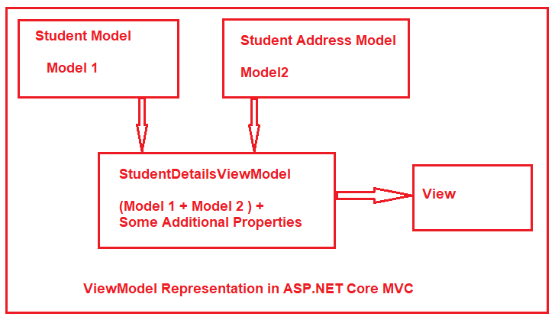

Let say we want to display the student details in a view. We have two different models to represent the student data. The Student Model is used to represent the student basic details where the Address model is used to represent the address of the student. Along with the above two models, we also required some static information like page header and page title in the view. If this is our requirement then we need to create a view model let say StudentDetailsViewModel and that view model will contain both the models (Student and Address) as well as properties to store the page title and page header.

##### ****Creating the Required Models:****

First, create a class file with the name **Student.cs** within the Models folder of your application. This is the model that is going to represent the basic information of a student such as a **name, branch, section**, etc. Once you create the **Student.cs** class file, then copy and paste the following code in it.

**namespace** *FirstCoreMVCApplication.Models*

**{**

**public** **class** Student

**{**

**public** **int** StudentId **{** **get**; **set**; **}**

**public** **string** Name **{** **get**; **set**; **}**

**public** **string** Branch **{** **get**; **set**; **}**

**public** **string** Section **{** **get**; **set**; **}**

**public** **string** Gender **{** **get**; **set**; **}**

**}**

**}**

Next, we need to create the Address model which is going to represent the Student Address such as **City, State, Country,** etc. So, create a class file with the name Address.cs within the Models folder and then copy and paste the following code in it.

**namespace** *FirstCoreMVCApplication.Models*

**{**

**public** **class** Address

**{**

**public** **int** StudentId **{** **get**; **set**; **}**

**public** **string** City **{** **get**; **set**; **}**

**public** **string** State **{** **get**; **set**; **}**

**public** **string** Country **{** **get**; **set**; **}**

**public** **string** Pin **{** **get**; **set**; **}**

**}**

**}**

##### ****Creating the View Model:****

Now we need to create the View Model which will store the required data that is required for a particular view. In our case its student’s Details view. This View Model is going to represent the Student Model + Student Address Model + Some additional data like page title and page header.

You can create the View Models anywhere in your application, but it is recommended to create all the View Models within a **folder** called **ViewModels** to keep the things organized.

So first create a folder at the root directory of your application with the name **ViewModels** and then create a class file with the name **StudentDetailsViewModel.cs** within the **ViewModels** folder. Once you create the **StudentDetailsViewModel.cs** class file, then copy and paste the following code in it.

**using** *FirstCoreMVCApplication.Models;*

**namespace** *FirstCoreMVCApplication.ViewModels*

**{**

**public** **class** StudentDetailsViewModel

**{**

**public** Student Student **{** **get**; **set**; **}**

**public** Address Address **{** **get**; **set**; **}**

**public** **string** Title **{** **get**; **set**; **}**

**public** **string** Header **{** **get**; **set**; **}**

**}**

**}**

We named the **ViewModel**class as **StudentDetailsViewModel**. Here the word **Student** represents the **Controller** name, the word **Details** represent the **action method name** within the Student Controller. As it is a view model so we prefixed the word **ViewModel**. Although it is not mandatory to follow this naming convention, I personally prefer it to follow this naming convention to organize view models.

##### ****Creating Student Controller:****

Right-click on the Controllers folder and then add a new class file with the name StudentController.cs and then copy and paste the following code in it.

**using** *FirstCoreMVCApplication.Models;*

**using** *FirstCoreMVCApplication.ViewModels;*

**using** *Microsoft.AspNetCore.Mvc;*

**namespace** *FirstCoreMVCApplication.Controllers*

**{**

**public** **class** StudentController : Controller

**{**

**public** ViewResult Details**()**

**{**

//Student Basic Details

Student student = new Student**()**

**{**

StudentId = 101,

Name = "Dillip",

Branch = "CSE",

Section = "A",

Gender = "Male"

**}**;

//Student Address

Address address = new Address**()**

**{**

StudentId = 101,

City = "Mumbai",

State = "Maharashtra",

Country = "India",

Pin = "400097"

**}**;

//Creating the View model

StudentDetailsViewModel studentDetailsViewModel = new StudentDetailsViewModel**()**

**{**

Student = student,

Address = address,

Title = "Student Details Page",

Header = "Student Details",

**}**;

//Pass the studentDetailsViewModel to the view

**return** View**(**studentDetailsViewModel**)**;

**}**

**}**

**}**

As you can see, now we are passing the view model as a parameter to the view. This is the view model that contains all the data required by the Details view. As you can notice, now we are not using any ViewData or ViewBag to pass the Page Title and Header to the view instead they are also part of the ViewModel which makes it a strongly typed view.

##### ****Creating the Details View:****

First, add a folder with the name **Student** within the **Views** folder your project. Once you add the Student Folder, then you need to add a razor view file with the name **Details.cshtml** within the Student folder. Once you add the **Details.cshtml** view then copy and paste the following code in it.

@model FirstCoreMVCApplication.ViewModels.StudentDetailsViewModel

**<html** xmlns="http://www.w3.org/1999/xhtml"**>**

**<head>**

**<title>**@Model.Title**</title>**

**</head>**

**<body>**

**<h1>**@Model.Header**</h1>**

**<div>**

StudentId : @Model.Student.StudentId

**</div>**

**<div>**

Name : @Model.Student.Name

**</div>**

**<div>**

Branch : @Model.Student.Branch

**</div>**

**<div>**

Section : @Model.Student.Section

**</div>**

**<div>**

Gender : @Model.Student.Gender

**</div>**

**<h1>**Student Address**</h1>**

**<div>**

City : @Model.Address.City

**</div>**

**<div>**

State : @Model.Address.State

**</div>**

**<div>**

Country : @Model.Address.Country

**</div>**

**<div>**

Pin : @Model.Address.Pin

**</div>**

**</body>**

**</html>**

Now, the Details view has access to the **StudentDetailsViewModel** object that we passed from the controller action method using the View() extension method. By using the **@model** directive, we set **StudentDetailsViewModel** as the Model for the **Details** view. Then we access **Student, Address, Title,**and **Header** using **@Model**property.

Now run the application, and navigate to the “**/Student/Details**” URL and you will see the output as expected on the webpage as shown in the below image.

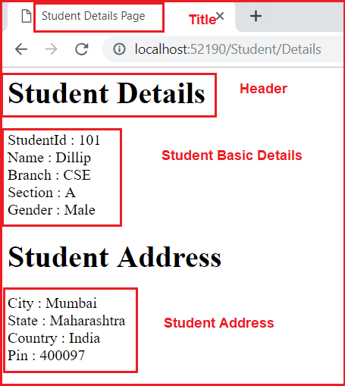

In the next article, I am going to discuss the [**Routing in ASP.NET Core MVC**](https://dotnettutorials.net/lesson/routing-asp-net-core-mvc/) application with an example. Here, in this article, I try to explain the **ViewModel in ASP.NET Core MVC** application with an example. I hope you understood the need and use of **ViewModel in ASP.NET Core MVC** Application.

# Routing in ASP.NET Core MVC

Back to: [ASP.NET Core Tutorials For Beginners and Professionals](https://dotnettutorials.net/course/asp-net-core-tutorials/)

## ****Routing in ASP.NET Core MVC Application****

In this article, I am going to discuss **Routing in ASP.NET Core MVC** application with examples. Please read our previous article where we discussed **[ViewModel in ASP.NET Core MVC Application](https://dotnettutorials.net/lesson/view-model-asp-net-core-mvc/)** with one real-time example. As part of this article, we are going to discuss the following pointers in detail.

1. **What is Routing in ASP.NET Core MVC?**
2. **What are the different types of Routing supported by ASP.NET Core MVC?**
3. **How Routing is working in ASP.NET Core?**
4. **Understanding Conventional based Routing.**

##### ****What is Routing in ASP.NET Core MVC?****

The Routing in ASP.NET Core MVC application is a mechanism in which it will inspect the incoming Requests (i.e. URLs) and then mapped that request to the controllers and their action methods. This mapping is done by the routing rules which are defined for the application. We can do this by adding the Routing Middleware to the request processing pipeline.

So, the ASP.NET Core Framework maps the incoming Requests i.e. URLs to the Controllers action methods based on the routes configured in your application. You can configure multiple routes for your application and for each route you can also set some specific configurations such as default values, constraints, message handlers, etc. If this is not clear at the moments then don’t worry we will discuss each and everything with examples.

##### ****What are the different types of Routing supported by ASP.NET Core MVC?****

In ASP.NET Core MVC application, you can define routes in two ways. They are as follows:

1. **Convention Based Routing**
2. **Attribute-Based Routing.**

##### ****What is Conventional Based Routing in ASP.NET Core MVC Application?****

In Conventional Based Routing, the route is determined based on the conventions defined in the route templates which will map the incoming Requests (i.e. URLs) to controllers and their action methods. In ASP.NET Core MVC application, the Convention based Routes are defined within the Configure method of the Startup.cs class file.

##### ****What is Attribute-Based Routing in ASP.NET Core MVC Application?****

In Attribute-Based Routing, the route is determined based on the attributes which are configured either at the controller level or at the action method level. We can use both Conventional Based Routing and Attribute-Based Routing in a single application.

In this article, we are going to discuss the Conventional Based Routing and in our upcoming article, we will discuss the Attribute-Based Routing.

##### ****Understanding Conventional Based Routing in ASP.NET Core MVC:****

In ASP.NET Core MVC application, it is the controller action method that is going to handle the incoming Requests i.e. URLs. For example, if we issue a request to the **“/Home/Index**” URL, then it is the Index action method of Home Controller class which is going to handle the request as shown in the below image.

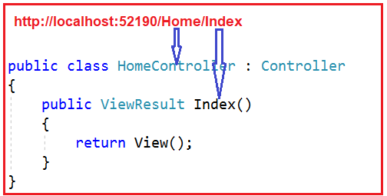

Similarly, if you issue a request to the **“/Home/Details/2**” URL, then it is the Details action method of the Home Controller class which is going to process that request as shown in the below image. Here the parameter value 2 is automatically mapped to the id parameter of the Details action method.

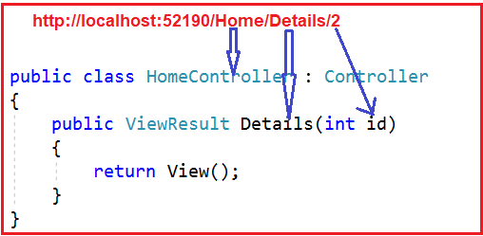

Now, the question that should come to your mind is, we have not explicitly defined any routing rules for the application, then how does this mapping is done i.e. how the “**/Home/Index**” URL is mapped to the Index action method and how “**/Home/Details/2**” URL is mapped to the Details action method of the Home Controller class.

This is actually done by the MVC Middleware which we registered in the application’s request processing pipeline.

##### ****Understanding the Default Route in ASP.NET Core MVC Application:****

As we already discussed in our previous article that we can add the required MVC middleware into the request processing pipeline either by calling the **UseMvcWithDefaultRoute()** method or by calling the **UseMvc()** method within in the Configure() method of the **Startup.cs** class file as shown in the below image. As of now, we are using the **UseMvcWithDefaultRoute()** middleware.

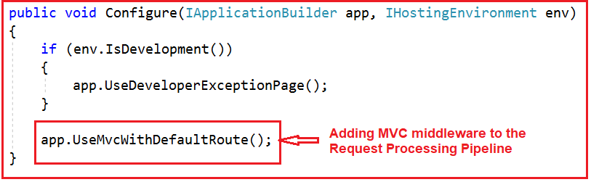

Let us have a look at the implementation of the **UseMvcWithDefaultRoute()** method by visiting the following GitHub URL.

<https://github.com/aspnet/Mvc/blob/release/2.2/src/Microsoft.AspNetCore.Mvc.Core/Builder/MvcApplicationBuilderExtensions.cs>

**The implementation is given as shown below.**

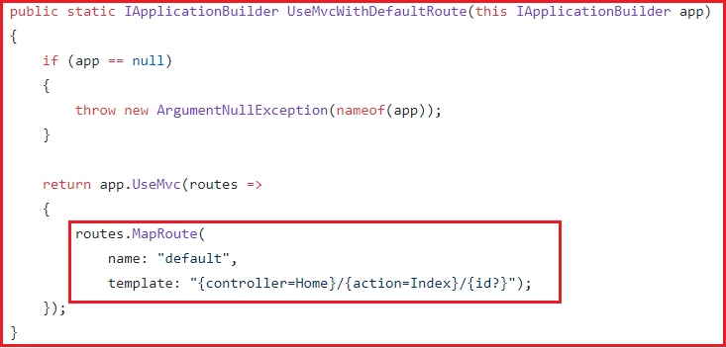

As you can see in the above implementation, this method internally calls the **UseMvc()** method which will add the default route into the application’s request processing pipeline. The default route is created with the following URL template:

**{controller=Home}/{action=Index}/{id?}**

##### ****Understanding The Route Template:****

The above default route template maps most URLs that have the following pattern.

**http://localhost:52190/Student/Details/2**

The first segment path of the URL i.e. “**/Student**” is mapped to the “**StudentController**“. As you can see in the URL we do not have the word Controller with the first segment path of the URL. But it maps to the StudentController, this is because when ASP.NET Core MVC Framework finds the word /Student as the first segment path of URL, then it internally appends the word Controller.

The second segment path of the URL i.e. “**/Details**” is mapped to the “**Details(int id)**” action method of the HomeController class and the third segment path of the URL i.e. “**2**” is mapped to the “**id**” parameter of the Details(int id) action method.

As you can see in the default route template **“{controller=Home}/{action=Index}/{id?}“**, we have a question mark at the end of the id parameter which makes the parameter id as optional. That means the following two requests now map to the same Details action method of the Home Controller class.

**/Home/Details/1**  
**/Home/Details**

In the default route template **“{controller=Home}/{action=Index}/{id?}“,**the value “**Home**” in **{controller=Home}** is the default value for the Controller. Similarly the value “**Index**” in **{action=Index}** is the default value for the action method.

That means if we navigate to the applications root URL then as shown, then that request is going to be handled by the Index action method of the Home Controller class.

###### **http://localhost:52190**

The following two URLs are also mapped to the Index action method of the HomeController class.

**http://localhost:52190/Home**

**http://localhost:52190/Home/Index**

For most of the ASP.NET Core MVC applications, the default route works fine. For example, create a controller with the name as StudentController and then copy and paste the following code in it.

**using** *Microsoft.AspNetCore.Mvc;*

**namespace** *FirstCoreMVCApplication.Controllers*

**{**

**public** **class** StudentController : Controller

**{**

**public** **string** Index**()**

**{**

**return** "Index() Action Method of StudentController";

**}**

**public** **string** Details**(string** id**)**

**{**

**return** "Details() Action Method of StudentController";

**}**

**}**

**}**

Now, the URL **“/student/index**” is mapped to the **Index()** action method of the **StudentController**class and the URL **“/student/details**” is mapped to the **Details()** action method of the **StudentController**.

In the next article, I am going to discuss how to define the [**custom route and Route Constraints, Optional Parameters, Default values**](https://dotnettutorials.net/lesson/custom-routing-inasp-net-core-mvc/) in the ASP.NET Core MVC application. Here, in this article, I try to explain the fundamental of **Routing in ASP.NET Core MVC** application. I hope you enjoy this article.

# Custom Routing in ASP.NET Core MVC

Back to: [ASP.NET Core Tutorials For Beginners and Professionals](https://dotnettutorials.net/course/asp-net-core-tutorials/)

## ****Custom Routing in ASP.NET Core MVC Application****

In this article, I am going to discuss **Custom Routing in the ASP.NET Core MVC** application. Please read our previous article before proceeding to this article where we discussed the basics of Routing as well as we also discussed the fundamental of [**Conventional based routing in ASP.NET Core MVC**](https://dotnettutorials.net/lesson/routing-asp-net-core-mvc/) Application. As part of this article, we are going to discuss the following pointers in detail.

1. **Creating Custom Routing in ASP.NET Core MVC Application.**
2. **Understanding Route Constraints?**
3. **How to define Optional Parameters in Route?**
4. **Providing Default Route Values.**

**Note:** We are going to work with the same example that we created in our previous article.

##### ****Custom Routing in ASP.NET Core MVC Application:****

If you want to define your own route then you need to the **UseMvc** middleware instead of **UseMvcWithDefaultRoute()**. Within the Configure method of the Startup class file use the **UseMVC** middleware and within that middleware make a call to the **MapRoute** method to define your own route as shown in the below image.

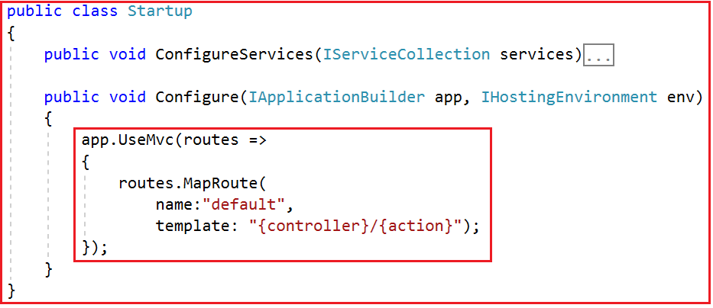

The above example is the simplest possible convention-based route for an ASP.NET Core MVC application. Now run the application and navigates to the following URLs and you will see the output as expected.

**http://localhost:52190/Student/Details**

**http://localhost:52190/Student/Index**

This is working fine. However, what if we wanted to have more specific routes? Say, something like:

**http://localhost:52190/Student/Details/20**

**http://localhost:52190/Student/Index/10**

If you want your controller action methods to match the above URLs, then you need to use a feature called Route Constraints in ASP.NET Core MVC Application.

##### ****Route Constraints in ASP.NET Core MVC Application:****

Let’s say we want to create a route that will match the following URL.

**http://localhost:52190/Student/Index/10**

**http://localhost:52190/Student/Details/20**

In order to achieve this, one of the simplest ways is to define a route as shown below:

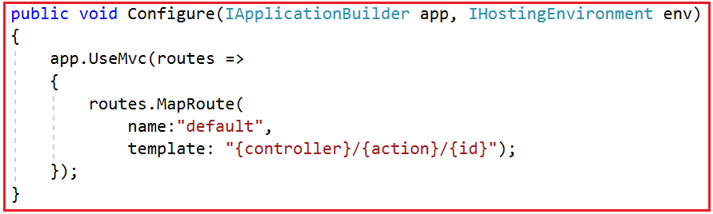

Now modify the StudentController as shown below.

**using** *Microsoft.AspNetCore.Mvc;*

**namespace** *FirstCoreMVCApplication.Controllers*

**{**

**public** **class** StudentController : Controller

**{**

**public** **string** Index**(string** count**)**

**{**

**return** "Index() Action Method of StudentController";

**}**

**public** **string** Details**(string** id**)**

**{**

**return** "Details() Action Method of StudentController";

**}**

**}**

**}**

Now run the application and navigate to the respective URLs and you will see that methods are executed as expected.

The problem with the above route is that it can accept any type of values. Here instead of an integer, if you pass string values then also it accepts and executes the action methods as shown below.

**http://localhost:52190/Student/Details/ABC**

If you want to restrict the id parameter value to be an integer only, then you need to use a concept called route constraint as shown below:

**using** *Microsoft.AspNetCore.Builder;*

**using** *Microsoft.AspNetCore.Hosting;*

**using** *Microsoft.Extensions.DependencyInjection;*

**namespace** *FirstCoreMVCApplication*

**{**

**public** **class** Startup

**{**

**public** **void** ConfigureServices**(**IServiceCollection services**)**

**{**

services.AddMvc**()**;

**}**

**public** **void** Configure**(**IApplicationBuilder app, IHostingEnvironment env**)**

**{**

app.UseMvc**(**routes =**>**

**{**

routes.MapRoute**(**

name:"default",

template: "{controller}/{action}/{id:int}"**)**;

**})**;

**}**

**}**

**}**

**Note:** The **{id:int}** in the template section specifies that whatever is in this part of the URL must be an integer, otherwise the URL does not map to this route.

With the above changes, now run the application and navigate to the following URL and you will see a 404 error. This is because here we are passing the Id parameter value as ABC.

**http://localhost:52190/Student/Details/ABC**

**http://localhost:52190/Student/index/ABC**

Now pass the id parameter value as an integer and you should get the output as expected. There are many route constraints are available that you can use. Some of them are as follows.

1. Int
2. Bool
3. Datetime
4. Decimal
5. Guid
6. length(min,max)
7. alpha
8. range(min,max)

For the list of all available route constraints, please find the following MSDN Article.

<https://docs.microsoft.com/en-us/aspnet/core/fundamentals/routing?view=aspnetcore-2.2#route-constraint-reference>

##### ****Optional Parameters:****

Before understanding the Optional Parameters, let us first change the StudentController as shown below.

**using** *Microsoft.AspNetCore.Mvc;*

**namespace** *FirstCoreMVCApplication.Controllers*

**{**

**public** **class** StudentController : Controller

**{**

**public** **string** Index**()**

**{**

**return** "Index() Action Method of StudentController";

**}**

**public** **string** Details**(string** id**)**

**{**

**return** "Details() Action Method of StudentController";

**}**

**}**

**}**

As you can see, the Index action method does not take any parameter while the Details action method takes one parameter. Now we need to invoke the Index action method without parameter. On the other hand, we need to make the id parameter of the Details action method as optional. It means the Details action method should be invoked using the following two URLs.

**http://localhost:52190/Student/Details**

**http://localhost:52190/Student/Details/10**

In order to achieve this, we need to use optional parameters in our convention-based routes by adding a question mark “**?**” to the optional parameter’s constraint as shown below.

**using** *FirstCoreMVCApplication.Models;*

**using** *Microsoft.AspNetCore.Builder;*

**using** *Microsoft.AspNetCore.Hosting;*

**using** *Microsoft.Extensions.DependencyInjection;*

**namespace** *FirstCoreMVCApplication*

**{**

**public** **class** Startup

**{**

**public** **void** ConfigureServices**(**IServiceCollection services**)**

**{**

services.AddMvc**()**;

**}**

**public** **void** Configure**(**IApplicationBuilder app, IHostingEnvironment env**)**

**{**

app.UseMvc**(**routes =**>**

**{**

routes.MapRoute**(**

name:"default",

template: "{controller}/{action}/{id:int?}"**)**;

**})**;

**}**

**}**

**}**

**Note:** You can define only one optional parameter per route, and that optional parameter must be the last parameter.

##### ****Providing Default Route Values in ASP.NET Core MVC Application:****

Using Default values we can specify what happens if parts of the route are not provided in the URL. For example, when we navigate to the following two URLs

**http://localhost:52190/**

**http://localhost:52190/Home**

We want to map the above two URLs to the Home Controller and Index action method of the Application. In order to achieve this, we need to provide default route values while defining the routes as shown below.

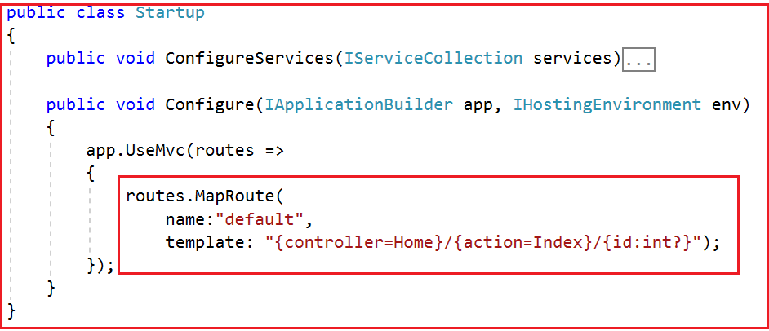

**Modify the Home Controller as shown below.**

**public** **class** HomeController : Controller

**{**

**public** **string** Index**()**

**{**

**return** "Index() Action Method of HomeController";

**}**

**}**

Now run the application and navigate to the following URLs and you will see the output as expected.

**http://localhost:52190/**

**http://localhost:52190/Home**

You can also map the default values by using the defaults property as shown below.

**public** **class** Startup

**{**

**public** **void** ConfigureServices**(**IServiceCollection services**)**

**{**

services.AddMvc**()**;

**}**

**public** **void** Configure**(**IApplicationBuilder app, IHostingEnvironment env**)**

**{**

app.UseMvc**(**routes =**>**

**{**

routes.MapRoute**(**

name: "default",

template: "{controller}/{action}/{id:int?}",

defaults: new **{** controller = "Home", action = "Index" **})**;

**})**;

**}**

**}**

In the next article, I am going to discuss [**Attribute Routing in ASP.NET Core MVC**](https://dotnettutorials.net/lesson/attribute-routing-in-asp-net-core-mvc/) Application. Here, in this article, I try to explain the Custom Routing in ASP.NET Core MVC Application with an example. I hope you enjoy this article.

# Attribute Routing in ASP.NET Core MVC

Back to: [ASP.NET Core Tutorials For Beginners and Professionals](https://dotnettutorials.net/course/asp-net-core-tutorials/)

## ****Attribute Routing in ASP.NET Core MVC Application****

In this article, I am going to discuss **Attribute Routing in ASP.NET Core MVC Application** with examples. Please read our previous article before proceeding to this article where we discussed the [**Conventional Based Custom Routing in ASP.NET Core MVC**](https://dotnettutorials.net/lesson/custom-routing-inasp-net-core-mvc/) Application. As part of this article, we are going to discuss the following pointers.

1. **Need and Use of Attribute Routing in ASP.NET Core MVC Application.**
2. **What is Attribute Routing in ASP.NET Core MVC?**
3. **Attribute Routing with Parameters in ASP.NET Core MVC Application**
4. **Attribute Routing with Optional Parameters in ASP.NET Core MVC Application**
5. **Controller and Action Method Names in Attribute Routing.**
6. **Attribute Routes at Controller Level**
7. **How to ignore the Route Template placed at the Controller Level?**

##### ****Need and Use of Attribute Routing in ASP.NET Core MVC Application****

Before understanding the **Attribute Routing in ASP.NET Core MVC** Application, let us first do some changes to our application. First, modify the Configure() method of the Startup.cs file as shown below. If you notice in the code, here we are using the **UseMvc()**method without passing the default route template as a parameter.

**public** **class** Startup

**{**

**public** **void** ConfigureServices**(**IServiceCollection services**)**

**{**

services.AddMvc**()**;

**}**

**public** **void** Configure**(**IApplicationBuilder app, IHostingEnvironment env**)**

**{**

app.UseMvc**()**;

**}**

**}**

With the above changes in the Configure method, now our application does not have any configured routes to handle the request and response.

**Now Modify the Home Controller as shown below.**

**public** **class** HomeController : Controller

**{**

**public** **string** Index**()**

**{**

**return** "Index() Action Method of HomeController";

**}**

**}**

Now, when you navigate to any of the following URLs, you will get the 404 errors. This is because at the moment we don’t have any configured route in our application to handle the request.

1. **http://localhost:52190**
2. **http://localhost:52190/home**
3. **http://localhost:52190/home/index**

Let us see how to use Attribute Routing to map the incoming URLs to the Index action method of Home Controller.

##### ****Attribute Routing in ASP.NET Core MVC:****

With the help of ASP.NET Core Attribute Routing, you can use the Route attribute to define routes for your application. You can use the Route attribute either at the Controller level or at the Controller Action Methods level. When you apply the Route attribute at the Controller level, then it is applicable for all the action methods of that controller.

Let us modify the Home Controller as shown below. Here we have applied the Route Attribute at the Action method.

**using** *Microsoft.AspNetCore.Mvc;*

**namespace** *FirstCoreMVCApplication.Controllers*

**{**

**public** **class** HomeController : Controller

**{**

**[**Route**(**""**)]**

**[**Route**(**"Home"**)]**

**[**Route**(**"Home/Index"**)]**

**public** **string** Index**()**

**{**

**return** "Index() Action Method of HomeController";

**}**

**}**

**}**

If you notice, here we applied the Route() attribute 3 times on the Index() action method of Home Controller. The point that you need to remember is, with each instance of the Route attribute we specified a different route template. With the above three Route attribute, now we can access the Index() action method of the HomeController using the following 3 URLs.

1. **http://localhost:52190**
2. **http://localhost:52190/home**
3. **http://localhost:52190/home/index**

Now run the application and navigate to the above three URLs and you will see the output as expected.

##### ****Attribute Routing with Parameters in ASP.NET Core MVC Application:****

As we already discussed, with conventional based routing, we can specify the route parameters as part of the route template. We can also do the same with attribute routing. That means we can also define Route Attribute with parameters. To understand this, modify the Home Controller as shown below.

**using** *Microsoft.AspNetCore.Mvc;*

**namespace** *FirstCoreMVCApplication.Controllers*

**{**

**public** **class** HomeController : Controller

**{**

**[**Route**(**""**)]**

**[**Route**(**"Home"**)]**

**[**Route**(**"Home/Index"**)]**

**public** **string** Index**()**

**{**

**return** "Index() Action Method of HomeController";

**}**

**[**Route**(**"Home/Details/{id}"**)]**

**public** **string** Details**(int** id**)**

**{**

**return** "Details() Action Method of HomeController, ID Value = " + id;

**}**

**}**

**}**

As you can see in the above code, the Details() action method has the id parameter. Notice in the route template, we also specified the id parameter. So the URL (/Home/Details/10) will execute the Details(int id) action method and maps the value “10” to the “id” parameter of the Details action method. This is done by a process called **Model binding**which will discuss in our upcoming articles. Now, run the application and navigate to the following URL and you will see the output as expected.

**http://localhost:52190/Home/Details/10**

##### ****Attribute Routing with Optional Parameters in ASP.NET Core MVC Application:****

Like conventional based routing, we can also make a parameter as optional in Attribute Routing. To make the Route parameter optional, simply add a question mark “**?**” at the end of the parameter.

In our example, at the moment, the Details(int id) action method of the HomeController is executed only if we pass the id parameter value. If we have not passed the id parameter value in the URL, then we will get 404. For example, at the moment if we navigate to the following URL we will get a 404 error.

**http://localhost:52190/Home/Details**  
Let us modify the Route attribute of the Details action method as shown below to make the route parameter **“id”** as optional by adding a **“?”** at the end.

**using** *Microsoft.AspNetCore.Mvc;*

**namespace** *FirstCoreMVCApplication.Controllers*

**{**

**public** **class** HomeController : Controller

**{**

**[**Route**(**""**)]**

**[**Route**(**"Home"**)]**

**[**Route**(**"Home/Index"**)]**

**public** **string** Index**()**

**{**

**return** "Index() Action Method of HomeController";

**}**

**[**Route**(**"Home/Details/{id?}"**)]**

**public** **string** Details**(int** id**)**

**{**

**return** "Details() Action Method of HomeController, ID Value = " + id;

**}**

**}**

**}**

Now run the application and navigate to the following URL and you will see the output as expected instead of 404 error.

**http://localhost:52190/Home/Details/**

##### ****Controller and Action Method Names in Attribute Routing:****

With attribute routing in ASP.NET Core MVC Application, the controller name and action method names do not play any role. To understand this, modify the Home Controller as shown below.

**using** *Microsoft.AspNetCore.Mvc;*

**namespace** *FirstCoreMVCApplication.Controllers*

**{**

**public** **class** HomeController : Controller

**{**

**[**Route**(**""**)]**

**[**Route**(**"MyHome"**)]**

**[**Route**(**"MyHome/Index"**)]**

**public** **string** StartPage**()**

**{**

**return** "StartPage() Action Method of HomeController";

**}**

**}**

**}**

As you can see, we have specified the Route attribute three times StartPage() action method of the HomeController. So, this StartPage action method is going to be executed for the following 3 URLs.

**/**  
**/MyHome**  
**/MyHome/Index**

##### ****Attribute Routes at Controller Level:****

In the ASP.NET Core MVC application, it is also possible to apply the Route() attribute on the Controller class as well as on individual action methods. If you want to make the attribute routing less repetitive, then you need to use the route attributes on the controller level as well as on the individual action methods level.

Let us understand this with an example. First, modify the Home Controller class as shown below.

**using** *Microsoft.AspNetCore.Mvc;*

**namespace** *FirstCoreMVCApplication.Controllers*

**{**

**public** **class** HomeController : Controller

**{**

**[**Route**(**""**)]**

**[**Route**(**"Home"**)]**

**[**Route**(**"Home/Index"**)]**

**public** **string** Index**()**

**{**

**return** "Index() Action Method of HomeController";

**}**

**[**Route**(**"Home/Details/{id?}"**)]**

**public** **string** Details**(int** id**)**

**{**

**return** "Details() Action Method of HomeController, ID Value = " + id;

**}**

**}**

**}**

With the above code in place, we can access the Index() action method using the following 3 URLs.  
**/**  
**/Home**  
**/Home/Index**  
Along the same line, we can also access the Details(int? id) action method using the following 2 URLs.   
**/Home/Details**  
**/Home/Details/2**

If you notice, we have repeated the word Home multiple times (four times in our example). In order to make these routes less repetitive, we need to apply the Route() attribute with the word Home at the HomeController class level as shown below.

**using** *Microsoft.AspNetCore.Mvc;*

**namespace** *FirstCoreMVCApplication.Controllers*

**{**

**[**Route**(**"Home"**)]**

**public** **class** HomeController : Controller

**{**

**[**Route**(**""**)]**

**[**Route**(**"Index"**)]**

**public** **string** Index**()**

**{**

**return** "Index() Action Method of HomeController";

**}**

**[**Route**(**"Details/{id?}"**)]**

**public** **string** Details**(int** id**)**

**{**

**return** "Details() Action Method of HomeController, ID Value = " + id;

**}**

**}**

**}**

**Note:** The Route template applied on the controller level is prepended to the route template applied to the action method level.

Now when you navigate to the following four URLs you will get the output as expected.

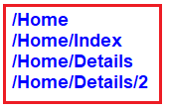

However, when you navigate to the root URL (**http://localhost:52190**) of the application, you will get a 404 error. In order to solve this, you need to include the route template that begins with **“/”** on the Index() action method as shown below.

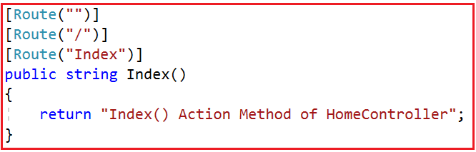

With the above changes in place, now run the application and navigate to the root URL and you will see the output as expected.

##### ****How to ignore the Route Template placed at the Controller Level?****

In order to ignore the Route Template placed at the Controller level, you need to use / or ~/ at the action method level. If the action method route template starts with **/ or ~/**, then the controller route template is not going to be combined with the action method route template.

To understand this let us modify the Home Controller class as shown below. In the following code, the About action method starts with ~/, so this action method is not going to be combined with the controller route template.

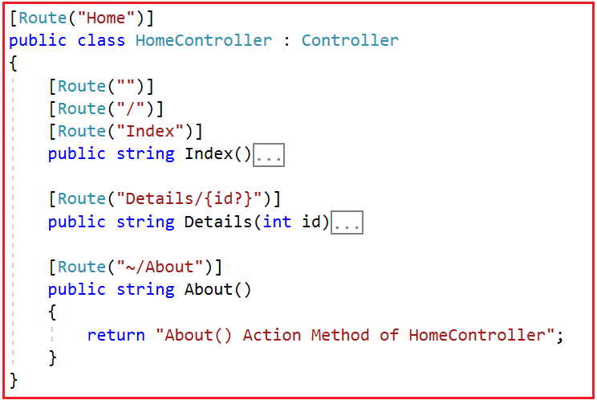

Now run the application and navigate to /About URL and you will see the output as expected.

That’s it for today. In the next article, I am going to discuss [**Tokens in Attribute Routing in ASP.NET Core MVC**](https://dotnettutorials.net/lesson/asp-net-core-attribute-routing-using-tokens/) Application. Here, in this article, I try to explain **Attribute Routing in ASP.NET Core MVC** Application. I hope you enjoy this article.

# ASP.NET Core Attribute Routing using Tokens

Back to: [ASP.NET Core Tutorials For Beginners and Professionals](https://dotnettutorials.net/course/asp-net-core-tutorials/)

## ****ASP.NET Core Attribute Routing using Tokens****

In this article, I am going to discuss the **ASP.NET Core Attribute Routing using Tokens** with examples. Please read our previous article before proceeding to this article as we are going to work with the same example that we worked in our previous article. In our previous article, we discussed [**Attribute Routing in ASP.NET Core MVC**](https://dotnettutorials.net/lesson/attribute-routing-in-asp-net-core-mvc/) Application. As part of this article, we are going to discuss the following pointers.

1. **Understanding Tokens in Attribute Routing.**
2. **Token Example in Attribute Routing.**
3. **Advantages of using Tokens in Attribute Routing.**
4. **Do we need to write the action token on each action method?**
5. **Attribute Routing vs Conventional Routing in ASP.NET Core.**

##### ****Tokens in Attribute Routing:****

In ASP.NET Core, the Route Attribute support token replacement. It means we can enclose the token (i.e. controller and action) within a pair of square-braces (**[ ]**). The tokens (i.e. **[controller]** and **[action]**) are then replaced with the values of controller and action method name where the route is defined.

##### ****Token Example in Attribute Routing:****

Let us understand this with an example. Please modify the Home Controller class as shown below. Here we are applying the token **[controller]** on the Home Controller and at the same time, we are applying the token **[action]** on all the action methods.

**using** *Microsoft.AspNetCore.Mvc;*

**namespace** *FirstCoreMVCApplication.Controllers*

**{**

**[**Route**(**"[controller]"**)]**

**public** **class** HomeController : Controller

**{**

**[**Route**(**"[action]"**)]**

**public** **string** Index**()**

**{**

**return** "Index() Action Method of HomeController";

**}**

**[**Route**(**"[action]"**)]**

**public** **string** Details**()**

**{**

**return** "Details() Action Method of HomeController";

**}**

**}**

**}**

With the above controller and action tokens in place, now you can access the Index action method of Home Controller with the URL **/Home/Index**. Similarly, you can access the Details action method using the URL **/Home/Details**. Now run the application and see everything is working as expected.

##### ****Advantages of Tokens in Attribute Routing:****

The main advantage is that in the future if you rename the controller name or the action method name then you do not have to change the route templates. The application is going to works with the new controller and action method names.

##### ****How to make the Index action method as the default action?****

With the controller and action tokens in place, if you want to make the Index action method of Home Controller as the default action, then you need to include the **Route(“”)** attribute with an empty string on the Index action method as shown below.

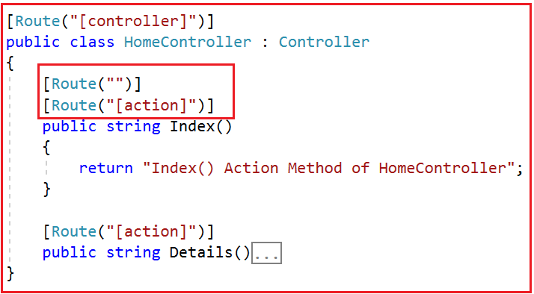

##### ****Do we need to write the action token on each action method?****

Not Really. If you want all your action methods to apply action token, then instead of including the [action] token on each and every action method, you can apply it only once on the controller as shown below.

**using** *Microsoft.AspNetCore.Mvc;*

**namespace** *FirstCoreMVCApplication.Controllers*

**{**

**[**Route**(**"[controller]/[action]"**)]**

**public** **class** HomeController : Controller

**{**

**public** **string** Index**()**

**{**

**return** "Index() Action Method of HomeController";

**}**

**public** **string** Details**()**

**{**

**return** "Details() Action Method of HomeController";

**}**

**}**

**}**

##### ****Attribute Routing vs Conventional Routing in ASP.NET Core:****

In Attribute Routing, we need to define the routes using the Route attribute within the controller and action methods. The Attribute routing offers a bit more flexibility than conventional based routing. However, in general, the conventional based routings are useful for controllers that serve HTML pages. On the other hand, the attribute routings are useful for controllers that serve RESTful APIs.

However, there is nothing stopping you from mixing conventional based routing with attribute routing in a single application.

In the next article, I am going to discuss [**Layout View in ASP.NET Core MVC**](https://dotnettutorials.net/lesson/layout-view-in-asp-net-core-mvc/) Application with one example. Here, in this article, I try to explain the need and use of **ASP.NET Core Attribute Routing using Tokens**. I hope you enjoy this article.

# Layout View in ASP.NET Core MVC

Back to: [ASP.NET Core Tutorials For Beginners and Professionals](https://dotnettutorials.net/course/asp-net-core-tutorials/)

## ****Layout View in ASP.NET Core MVC****

In this article, I am going to discuss the **Layout View in ASP.NET Core MVC** Application. Please read our previous article where we discussed the [**Attribute Routing in ASP.NET Core MVC**](https://dotnettutorials.net/lesson/attribute-routing-in-asp-net-core-mvc/) Application with examples. As part of this article, we are going to discuss the following pointers.

1. **Why do we need Layout View in ASP.NET Core MVC?**
2. **What is a Layout?**
3. **How to Create a Layout View in ASP.NET Core MVC Application?**
4. **How to use a Layout View in ASP.NET Core MVC Application?**

##### ****What is Layout?****

The layouts are like the master pages in Webforms applications.  The common UI code, which can be used in many views can go into a common view called layout.

##### ****Why do we need Layout View in ASP.NET Core MVC?****

Nowadays, almost all web applications have the following sections.

1. **Website Header**
2. **Website Footer**
3. **Navigation Menus**
4. **Main Content Area**

Please have a look at the following image which shows the above mentioned four areas on a website.

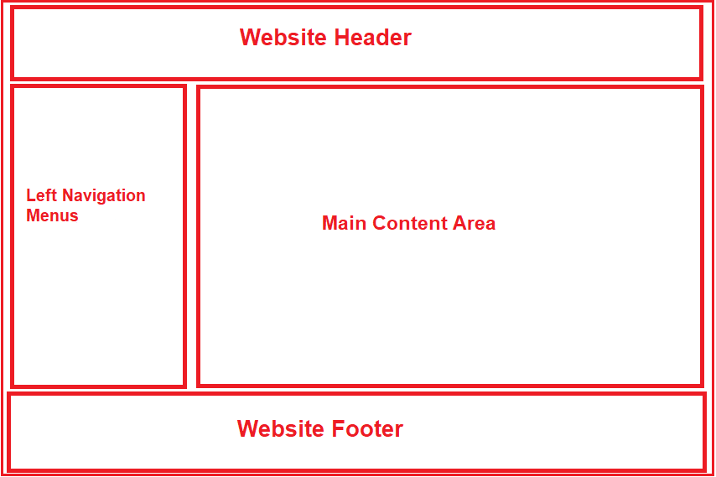

If you don’t have a layout view for your website, then you need to repeat the required HTML for the above-mentioned sections in each and every view of your application. This is violating the DRY (Don’t Repeat Yourself) principle as we are repeating the same code in multiple views. As a result, it is very difficult to maintain the application. For example, if you have to remove or add a menu item from the list of navigation menus or even if you want to change the header or footer of your website then you need to do this in each and every view which is tedious, time-consuming as well as error-prone.

Instead of putting all the sections (i.e. the HTML) in each and every view pages, it is always better and advisable to put them in a layout view and then inherit that layout view in each and every view where you want that look and feel. With the help of layout views, now it is easier to maintain the consistent look and feel of your application. This is because if you at all need to do any changes then you need to do it only at one place i.e. in the layout view and the changes will be reflected immediately across all the views which are inherited from the layout view.

##### ****Layout View in ASP.NET Core MVC Application:****

1. Like the regular view in ASP.NET Core MVC, the layout view is also a file with a .cshtml extension
2. If you are coming from ASP.NET Web Forms background, you can think the layout view as the master page in asp.net web forms application.
3. As the layout views are not specific to any controller, so, we usually place the layout views in a subfolder called “**Shared**” within the “**Views**” folder.
4. By default, in ASP.NET Core MVC Application, the layout view file is named **_Layout.cshtml**.
5. The leading underscore in the file name indicates that these files are not intended to be served directly by the browser.
6. In ASP.NET Core MVC, it is also possible to create multiple layout files for a single application. For example, you may have one layout file for the admin users and another layout file for non-admin users of your application.

**How to Create a Layout View in ASP.NET Core MVC Application?**In order to create a layout view in ASP.NET Core MVC, you need to follow the below steps.

1. Right-click on the “**Views**” folder and then add a new folder with the name “**Shared**“.
2. Next, Right-click on the “**Shared**” folder and then select the “**Add**” – “**New Item**” option from the context menu which will open the Add New Item window.
3. From the “**Add New Item**” window search for **Layout** and then select “**Razor Layou**t”, give a meaning full name (_Layout.cshtml) to your layout view and finally click on the “**Add**” button as shown below which should add **_Layout.cshtml** file within the Shared folder.

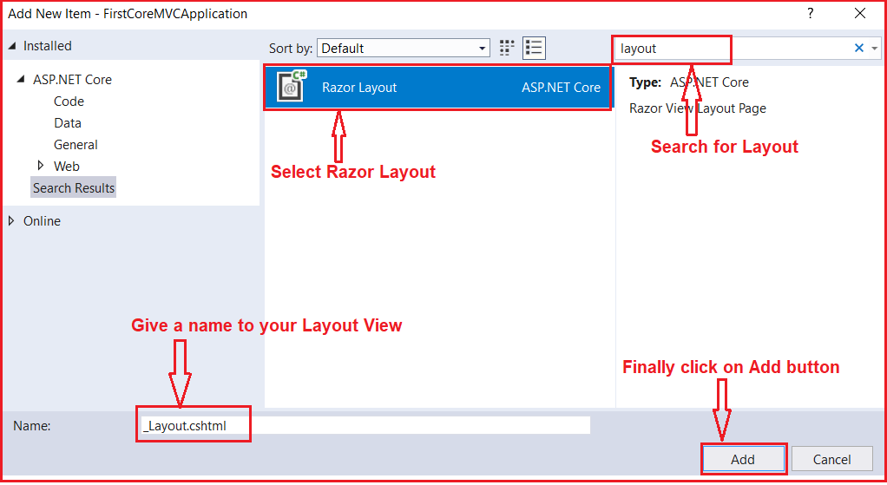

Note: In this article, I am going to show you how to create and use a layout file and in our upcoming articles, I will show you how to use website header, footer, and navigation menus.

##### ****Understanding the _Layout.cshtml file:****

Let us have a look at the auto-generated HTML code in the **_Layout.cshtml** file. The following HTML is auto-generated in the **_Layout.cshtml** file.

<!DOCTYPE html>

**<html>**

**<head>**

**<meta** name="viewport" content="width=device-width" **/>**

**<title>**@ViewBag.Title**</title>**

**</head>**

**<body>**

**<div>**

@RenderBody()

**</div>**

**</body>**

**</html>**

As you can see in the above layout file, it contains the standard Html, head, title and body elements. As the above elements are present in the layout file, so you don’t have to repeat all the above elements in each and every view.

The View or Page-specific title is retrieved by using the **@ViewBag.Title** expression. For example, when “**index.cshtml**” view is rendered using this layout view, then the **index.cshtml** view will set the Title property on the ViewBag. This is then retrieved by the Layout view using the expression **@ViewBag.Title** and set as the value for the <title> tag.

The **@RenderBody()** specifies the location where the view or page-specific content is injected. For example, if “**index.cshtml**” view is rendered using this layout view, then **index.cshtml** view content is injected at the location.

Let us modify the **_Layout.cshtml** page as shown below to include the header, footer, left navigation menus and main content area section.

<!DOCTYPE html>

**<html>**

**<head>**

**<meta** name="viewport" content="width=device-width" **/>**

**<title>**@ViewBag.Title**</title>**

**</head>**

**<body>**

**<table** border="1" style="width:800px; font-family:Arial"**>**

**<tr>**

**<td** colspan="2" style="text-align:center"**>**

**<h3>**Website Header**</h3>**

**</td>**

**</tr>**

**<tr>**

**<td** style="width:200px"**>**

**<h3>**Left Navigation Menus**</h3>**

**</td>**

**<td** style="width:600px"**>**

@RenderBody()

**</td>**

**</tr>**

**<tr>**

**<td** colspan="2" style="text-align:center; font-size:x-small"**>**

**<h3>**Website Footer**</h3>**

**</td>**

**</tr>**

**</table>**

**</body>**

**</html>**

##### ****Modifying the Startup class:****

Please modify the Startup class as shown below where we configure the required services for MVC.

**using** *Microsoft.AspNetCore.Builder;*

**using** *Microsoft.AspNetCore.Hosting;*

**using** *Microsoft.Extensions.DependencyInjection;*

**namespace** *FirstCoreMVCApplication*

**{**

**public** **class** Startup

**{**

**public** **void** ConfigureServices**(**IServiceCollection services**)**

**{**

services.AddMvc**()**;

**}**

**public** **void** Configure**(**IApplicationBuilder app, IHostingEnvironment env**)**

**{**

app.UseMvcWithDefaultRoute**()**;

**}**

**}**

**}**

##### ****Modifying the Home Controller:****

Please modify the Home Controller as shown below.

**using** *Microsoft.AspNetCore.Mvc;*

**namespace** *FirstCoreMVCApplication.Controllers*

**{**

**public** **class** HomeController : Controller

**{**

**public** ViewResult Index**()**

**{**

**return** View**()**;

**}**

**public** ViewResult Details**()**

**{**

**return** View**()**;

**}**

**}**

**}**

As you can see here we have created two action methods i.e. Index and View.

##### ****Using Layout view in ASP.NET Core MVC Application:****

Now we are going to create the Index and Details views using the Layout view. In order to render a view using the layout view (_Layout.cshtml), you need to set the Layout property.

###### **Index.cshtml:**

Please modify the Index view as shown below to use the layout view.

@{

ViewBag.Title = "Home Page";

Layout = "~/Views/Shared/_Layout.cshtml";

}

**<h1>**Home Page**</h1>**

###### **Details.cshtml:**

Please modify the Details view as shown below to use the layout view.

@{

ViewBag.Title = "Details Page";

Layout = "~/Views/Shared/_Layout.cshtml";

}

**<h1>**Details Page**</h1>**

Now run the application and navigate to the Home/Index URL which should display the page as shown below.

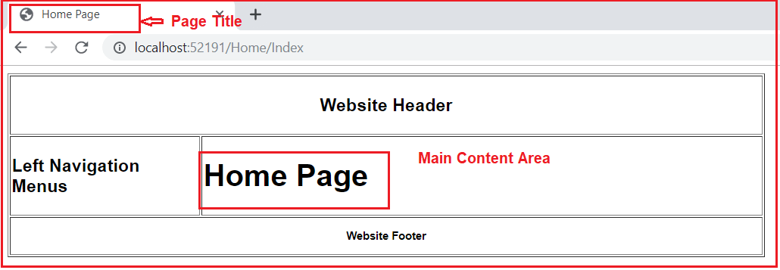

That’s it for today. In the next article, I am going to discuss [**Sections in the layout page in ASP.NET Core MVC**](https://dotnettutorials.net/lesson/sections-in-layout-view-in-asp-net-core-mvc/) Application. Here, in this article, I try to explain the need and how to create and use layout files in ASP.NET Core MVC Application.

1. **What are Sections?**
2. **What is the need for Sections in Layout View in ASP.NET Core MVC Application?**
3. **Understanding the RenderSection Method.**
4. **How to use the RenderSection Method in ASP.NET Core MVC?**
5. **How to Provide section Content in a View?**
6. **Understanding How to make the layout section optional in ASP.NET Core MVC?**

**Sections in Layout View in ASP.NET Core MVC Application:**

In ASP.NET Core MVC, the layout view contains one or more sections in it. The Sections in a layout view are used to organize where certain page elements should be placed. The sections in a layout view can be optional or mandatory.

**Understanding the need for Sections with an Example:**

In order to understand this, let us first create a custom javascript file. First, create a folder at the root level of the application with the name “**wwwroot”**. In generally all the static files we need to be placed within this folder. Once you created the “**wwwroot**” folder create a subfolder within this with the name **“js”** and then add a javascript file with the name **“CustomJavascript.js”** within the js folder as shown in the below image.

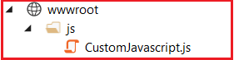

**Situation1:**

If we have a custom javascript file (i.e. CustomJavascript.js) and that file is being required by all the views of our application, then we need to place it in the Layout View of our application as shown below.

<!DOCTYPE html>

**<html>**

**<head>**

**<meta** name="viewport" content="width=device-width" **/>**

**<title>**@ViewBag.Title**</title>**

**</head>**

**<body>**

**<table** border="1" style="width:800px; font-family:Arial"**>**

**<tr>**

**<td** colspan="2" style="text-align:center"**>**

**<h3>**Website Header**</h3>**

**</td>**

**</tr>**

**<tr>**

**<td** style="width:200px"**>**

**<h3>**Left Navigation Menus**</h3>**

**</td>**

**<td** style="width:600px"**>**

@RenderBody()

**</td>**

**</tr>**

**<tr>**

**<td** colspan="2" style="text-align:center; font-size:x-small"**>**

**<h3>**Website Footer**</h3>**

**</td>**

**</tr>**

**</table>**

**<script** src="~/js/CustomJavascript.js"**></script>**

**</body>**

**</html>**

**Note:** It is always a good programming practice to put all the script files before the closing body tag.

**Situation2:**

If you have a custom javascript file (i.e. CustomJavascript.js) and you want that file in some specific views. Let assume you want that file in the Index view but not in the Details view of Home Controller. In such scenarios, you can make use of the section.

**Understanding the RenderSection Method:**

Let us have a look at the signature of the RenderSection() method which is shown below.

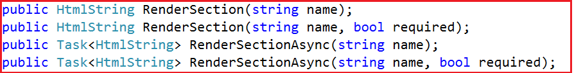

As you can see there are two overloaded versions of the **RenderSection** Method. The same is the case for the **RenderSectionAsync** method. The first version of the Render section method takes a single parameter (i.e. name) which specifies the name of the section. The second overloaded version takes two parameters. The first parameter (name) specifies the name of the section while the second parameter (required) specifies whether the section is required or optional.

**How to use the RenderSection Method in ASP.NET Core MVC?**

In your layout view, you need to call the **RenderSection()** method at the location where you want the section content to be rendered. In our example, we want the script file to be included just before the closing **</body>** tag. So, we are calling the **@RenderSection()** method just before the closing **</body>** tag as shown below.

<!DOCTYPE html>

**<html>**

**<head>**

**<meta** name="viewport" content="width=device-width" **/>**

**<title>**@ViewBag.Title**</title>**

**</head>**

**<body>**

**<table** border="1" style="width:800px; font-family:Arial"**>**

**<tr>**

**<td** colspan="2" style="text-align:center"**>**

**<h3>**Website Header**</h3>**

**</td>**

**</tr>**

**<tr>**

**<td** style="width:200px"**>**

**<h3>**Left Navigation Menus**</h3>**

**</td>**

**<td** style="width:600px"**>**

@RenderBody()

**</td>**

**</tr>**

**<tr>**

**<td** colspan="2" style="text-align:center; font-size:x-small"**>**

**<h3>**Website Footer**</h3>**

**</td>**

**</tr>**

**</table>**

@RenderSection("Scripts")

**</body>**

**</html>**

In the above code, we are using the first overloaded version of the RenderSection method which takes only the name parameter.

**How to Provide section Content in a View?**

In our layout view, we have created a section. Now let us understand how to provide section content in a view. Each and every view which wants to provide section content must include a section within the same. Here, you need to use the @section directive to include the section and provide the content.

In our example, we want to provide the section content from the Index view. So, modify the index view as shown below.

@{

ViewBag.Title = "Home Page";

Layout = "~/Views/Shared/_Layout.cshtml";

}

**<h1>**Home Page**</h1>**

@section Scripts {

**<script** src="~/js/CustomJavascript.js"**></script>**

}

**Modify the Startup class as shown below.**

**using** *Microsoft.AspNetCore.Builder;*

**using** *Microsoft.AspNetCore.Hosting;*

**using** *Microsoft.Extensions.DependencyInjection;*

**namespace** *FirstCoreMVCApplication*

**{**

**public** **class** Startup

**{**

**public** **void** ConfigureServices**(**IServiceCollection services**)**

**{**

services.AddMvc**()**;

**}**

**public** **void** Configure**(**IApplicationBuilder app, IHostingEnvironment env**)**

**{**

**if** **(**env.IsDevelopment**())**

**{**

app.UseDeveloperExceptionPage**()**;

**}**

app.UseMvcWithDefaultRoute**()**;

**}**

**}**

**}**

Now run the application and navigate to Home/Index URL and you will see the out as expected. But, when you navigate to Home/Details URL, you will get the following error page.

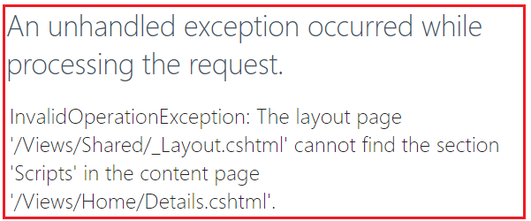

The reason for getting the above exception is the section is mandatory and we have not specified the section content in the Details view.

**How to make the layout section optional in ASP.NET Core MVC?**

We can make a layout section optional in ASP.NET Core MVC in two ways. They are as follows:

**Way1:**Use the RenderSection method which takes two parameters. Set the second parameter (i.e. the required) to false.

**@RenderSection(“Scripts”, required: false)**

**Way2:**Using the IsSectionDefined() method. This method returns a value that indicates whether the specified section is defined in the content page.

**@if (IsSectionDefined(“Scripts”))**  
**{**  
**@RenderSection(“Scripts”, required: false)**  
**}**

So, modify the **_Layout.cshtml** file as shown below to make the section as optional.

<!DOCTYPE html>

**<html>**

**<head>**

**<meta** name="viewport" content="width=device-width" **/>**

**<title>**@ViewBag.Title**</title>**

**</head>**

**<body>**

**<table** border="1" style="width:800px; font-family:Arial"**>**

**<tr>**

**<td** colspan="2" style="text-align:center"**>**

**<h3>**Website Header**</h3>**

**</td>**

**</tr>**

**<tr>**

**<td** style="width:200px"**>**

**<h3>**Left Navigation Menus**</h3>**

**</td>**

**<td** style="width:600px"**>**

@RenderBody()

**</td>**

**</tr>**

**<tr>**

**<td** colspan="2" style="text-align:center; font-size:x-small"**>**

**<h3>**Website Footer**</h3>**

**</td>**

**</tr>**

**</table>**

@RenderSection("Scripts", false)

**</body>**

**</html>**

With the above changes in place, run the application and navigate to both the URL and you should get the output as expected.

In the next article, I am going to discuss the [**_ViewStart.cshtml in ASP.NET Core MVC**](https://dotnettutorials.net/lesson/viewstart-in-asp-net-core-mvc/) Application. Here, in this article, I try to explain the **Sections in the Layout Page in ASP.NET Core MVC** Application.

<https://dotnettutorials.net/lesson/sections-in-layout-view-in-asp-net-core-mvc/>