T-[VENKATESHWARI1@cognizant.com](mailto:VENKATESHWARI1@cognizant.com)

YOUR BANK ACCOUNT MANAGEMENT & TRANSATIONS

# INTEGRATED CASE STUDY

|  |  |
| --- | --- |
| Introduction |  |
| Project OverView |  |
| Scope |  |
| Traget Audience |  |
| SOFTWARE & HARDWARE REQUIREMENTS |  |
| 🡪HARDWARE |  |
| 🡪SOFTWARE |  |
| DATA SPECIFICATIONS |  |
| -🡪Data Design |  |
| 🡪Components required |  |
| 🡪Use Cases |  |
| 🡪Design Constraints |  |
| SUBMISSION |  |

# INTRODUCTION:

ENJOY CREATING AN ACCOUNT IN YOUR BANK APP.

PERFORM TASK LIKE DEPOSIT,WITHDRAWLS,

BALANCE ENQUIRY

# PROJECT OVERVIEW:

This project captures the various concepts, techniques and skills learned and help to put them into practice using ASP.NET MVC . Admittedly, this would be at a scaled-down level since the purpose is to let the associate experience the conceptsDATA BASE TABLES,ASP.NET MVC FORMS learned in .NET as an individual. The individual associate is expected to carry out the knock out challenge and complete it within 3 hours.

# SCOPE:

🡪ASP.NET MVC

🡪MS SQL SERVER

🡪HTML,CSS,JAVASCRIPT

# TARGET AUDIENCE

🡪Beginer Level

# Hardware and Software Requirements

### Hardware Requirements

|  |  |  |
| --- | --- | --- |
| # | Item | Specification/Version |
|  | PROCESSOR | I5 |
|  | RAM | 8GB |
|  | OS | WINDOWS 10 |
|  |  |  |

### Software Requirements

|  |  |  |  |
| --- | --- | --- | --- |
| # | Item | Specification/Version | |
| 1. | Visual Studio2017 | Enterprise Edition | |
|  | | |
|  |  |  | |

# Functional Requirements

## Functional Requirements

|  |  |  |  |  |
| --- | --- | --- | --- | --- |
| Req. # | Req. Name | Req. Description | Actors / Users | Comments |
| 1 | ADD ACCOUNT | ADD ACCOUNT, will automatically adds minimum amount of 500/rs | Users |  |
| 2 | DEPOSIT | Will take account number to deposit specified amount, to corresponding account. |  | Will add amount to existing amount |
| 3 | WITHDRAWLS | Will take account number to withdraw from specified ac no |  | Will substract from existing amount of the specified ac.  Withdrawl amont should not be more than existing amount. |
| 4 | BALANCE ENQUIRY | Takes account number and displays available balance in ac. |  | -- |
| 5 | Exit | --------- |  |  |
|  |  |  |  |  |

=🡺 AFTER EACH TRANSATION IT SHOULD ASK FOR “WISH TO CONTINUE” ‘Y’ & ‘N’

# USE CASE:

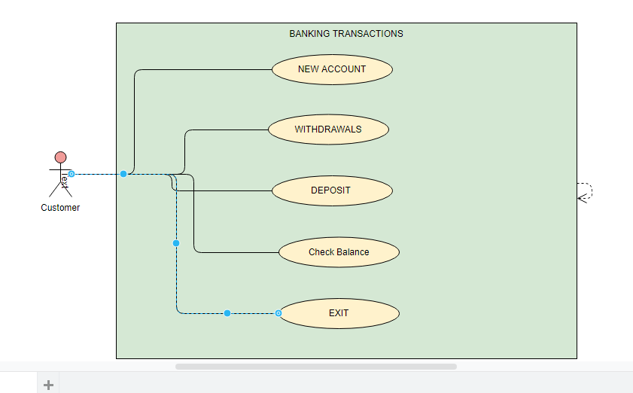

## Data Design

TABLE STRUCTURE

|  |  |
| --- | --- |
| Table name: BANK_USER | |
| Column Name | **Data type** |
| ID | Int (PK) IDENTITY |
| NAME | varchar(25) |
| Adress | varchar(25) |
| PhoneNumber | Int |
| AccountType | Varchar(25) |
| BalanceAmount | Double |

## Component Design for identified Use cases

|  |  |  |
| --- | --- | --- |
| Component Name(Class) | Method  (OR)  Property | Desc |
| BANKCLASS | Accountno, Accountholdername, Accountholderaddress, Accountholderphonenumber,  Accounttype, Balanceamount,  public long balanceamountdump = 500; |  |
|  | PARAMETER CONSTRUCTOR WITH above properties |  |
| INTERFACE ALLMETHODS | --string mainmenu();  --void addnewaccount();  -- void balanceenquiry(allmethodsdetails allmethoddetailsbalanceobj);  --void withdrawamount(allmethodsdetails allmethoddetailswithdrawobj);  --void depositamount(allmethodsdetails allmethoddetailsdepositobj);  --void exit(); |  |
| class allmethodsdetails : allmethods | This class implements methods of allmethods interface |  |
|  |  |  |

