**USE [pubs]**

**GO**

**/****** Object: Table [dbo].[Bank_Admin] Script Date: 1/30/2020 2:52:03 PM ******/**

**SET ANSI_NULLS ON**

**GO**

**SET QUOTED_IDENTIFIER ON**

**GO**

**SET ANSI_PADDING ON**

**GO**

**CREATE TABLE [dbo].[Bank_Admin](**

**[User_ID] [char](10) NOT NULL,**

**[Pwd] [int] NOT NULL**

**) ON [PRIMARY]**

**GO**

**SET ANSI_PADDING OFF**

**GO**

**USE [pubs]**

**GO**

**/****** Object: Table [dbo].[Bank_Master] Script Date: 1/30/2020 2:52:35 PM ******/**

**SET ANSI_NULLS ON**

**GO**

**SET QUOTED_IDENTIFIER ON**

**GO**

**SET ANSI_PADDING ON**

**GO**

**CREATE TABLE [dbo].[Bank_Master](**

**[AcTypeID] [int] IDENTITY(1,1) NOT NULL,**

**[AcType] [char](20) NOT NULL,**

**[Description] [varchar](500) NOT NULL,**

**CONSTRAINT [PK_Bank_Master] PRIMARY KEY CLUSTERED**

**(**

**[AcTypeID] ASC**

**)WITH (PAD_INDEX = OFF, STATISTICS_NORECOMPUTE = OFF, IGNORE_DUP_KEY = OFF, ALLOW_ROW_LOCKS = ON, ALLOW_PAGE_LOCKS = ON) ON [PRIMARY]**

**) ON [PRIMARY]**

**GO**

**SET ANSI_PADDING OFF**

**GO**

**USE [pubs]**

**GO**

**/****** Object: Table [dbo].[CustomerDetails] Script Date: 1/30/2020 2:52:49 PM ******/**

**SET ANSI_NULLS ON**

**GO**

**SET QUOTED_IDENTIFIER ON**

**GO**

**SET ANSI_PADDING ON**

**GO**

**CREATE TABLE [dbo].[CustomerDetails](**

**[AccountNo] [int] IDENTITY(1,1) NOT NULL,**

**[CustomerName] [char](50) NOT NULL,**

**[Address] [varchar](100) NOT NULL,**

**[PhoneNo] [int] NULL,**

**[BalanceAmount] [money] NOT NULL,**

**[AccountType] [char](15) NOT NULL,**

**[AcTypeID] [int] NULL,**

**CONSTRAINT [PK_CustomerDetails] PRIMARY KEY CLUSTERED**

**(**

**[AccountNo] ASC**

**)WITH (PAD_INDEX = OFF, STATISTICS_NORECOMPUTE = OFF, IGNORE_DUP_KEY = OFF, ALLOW_ROW_LOCKS = ON, ALLOW_PAGE_LOCKS = ON) ON [PRIMARY]**

**) ON [PRIMARY]**

**GO**

**SET ANSI_PADDING OFF**

**GO**

**ALTER TABLE [dbo].[CustomerDetails] WITH CHECK ADD FOREIGN KEY([AcTypeID])**

**REFERENCES [dbo].[Bank_Master] ([AcTypeID])**

**GO**

PIC-1

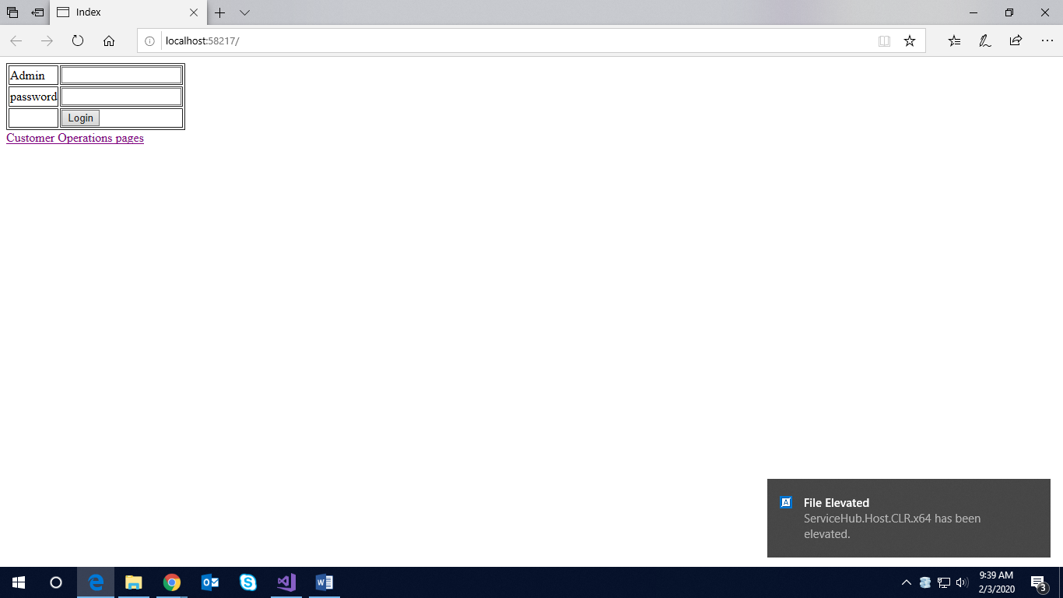

PIC-2

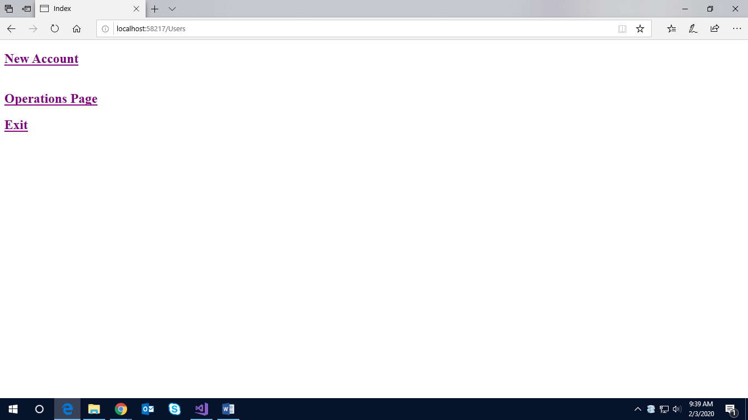

PIC-3 Search by ID

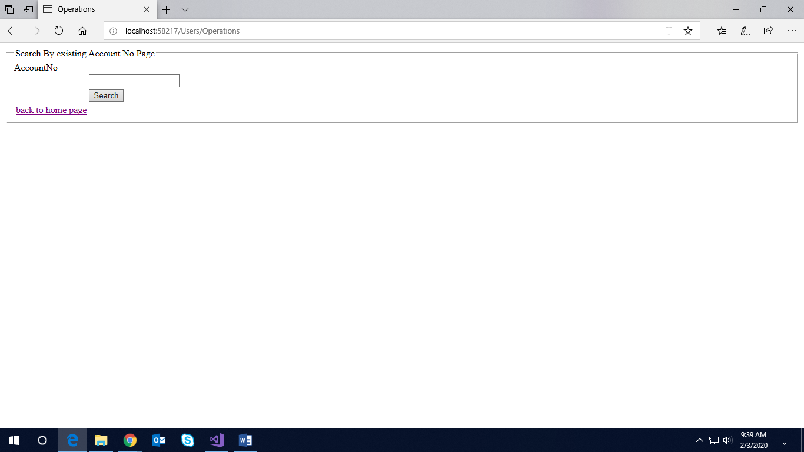

PIC-4

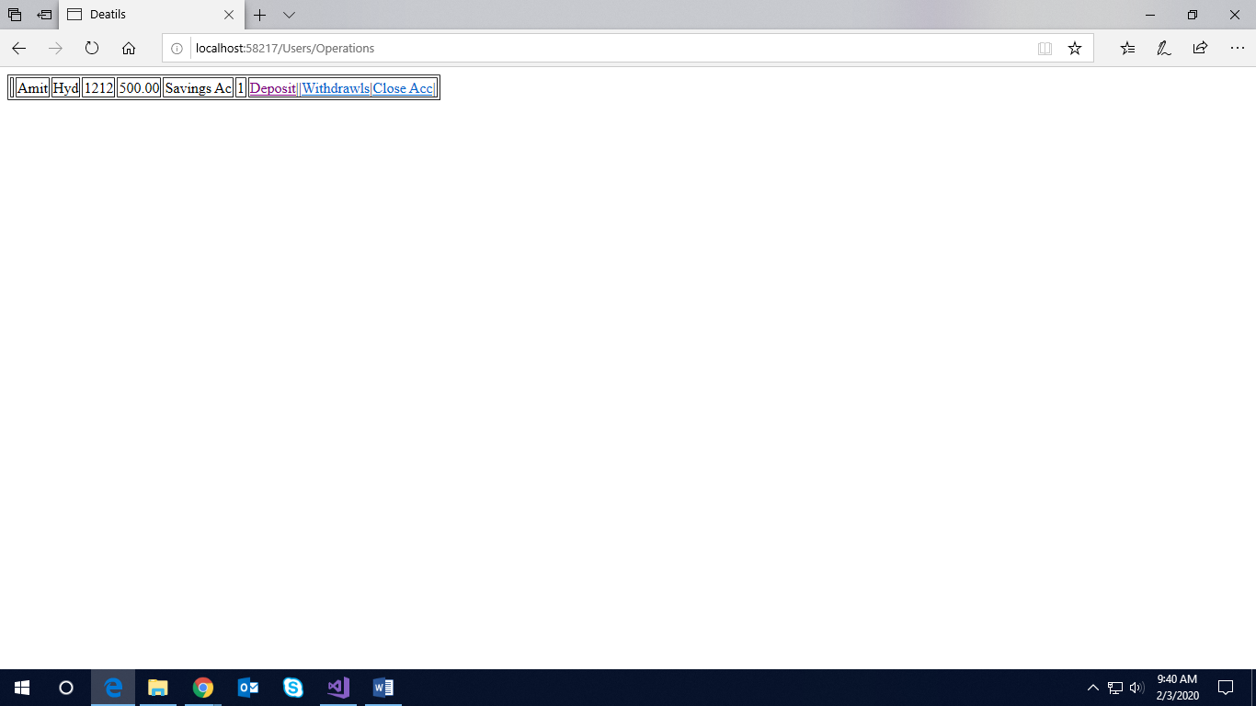

PIC-5

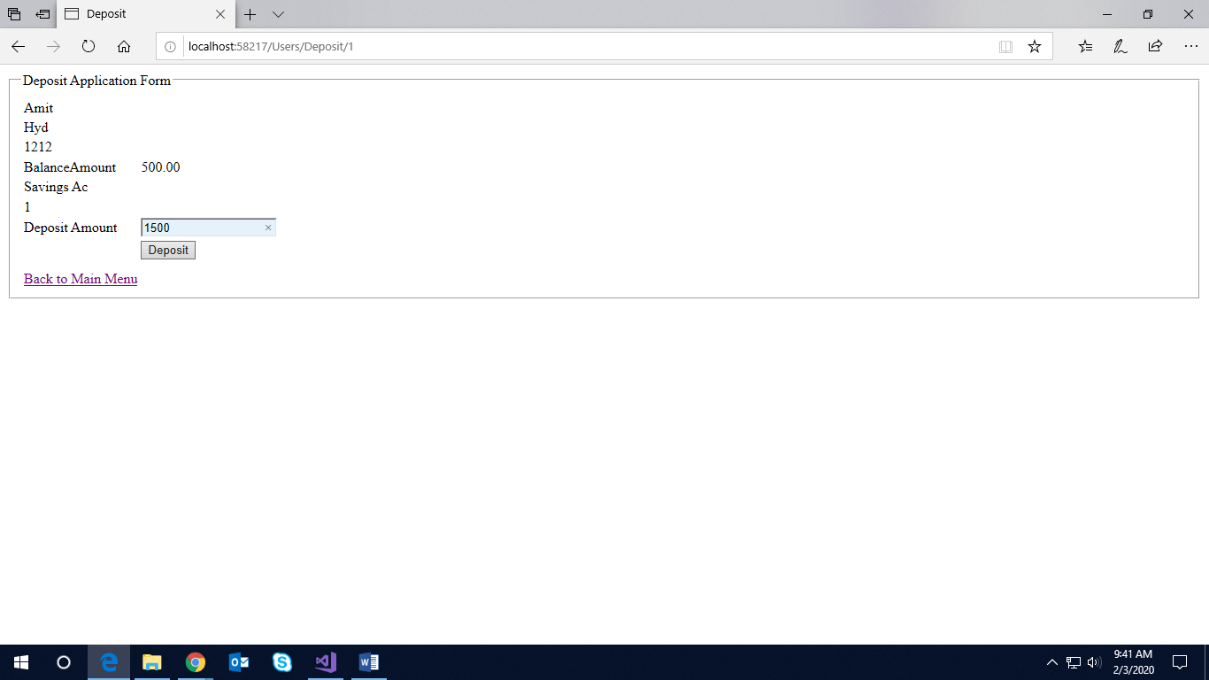

PIC-6

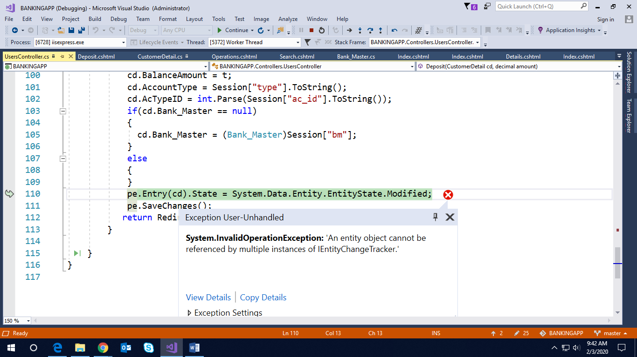

MODELS🡪

BANK_ADMIN.cs

//------------------------------------------------------------------------------

// <auto-generated>

// This code was generated from a template.

//

// Manual changes to this file may cause unexpected behavior in your application.

// Manual changes to this file will be overwritten if the code is regenerated.

// </auto-generated>

//------------------------------------------------------------------------------

namespace BANKINGAPP.Models

{

using System;

using System.Collections.Generic;

public partial class Bank_Admin

{

public string User_ID { get; set; }

public int Pwd { get; set; }

}

}

//------------------------------------------------------------------------------

// <auto-generated>

// This code was generated from a template.

//

// Manual changes to this file may cause unexpected behavior in your application.

// Manual changes to this file will be overwritten if the code is regenerated.

// </auto-generated>

//------------------------------------------------------------------------------

namespace BANKINGAPP.Models

{

using System;

using System.Collections.Generic;

using System.ComponentModel.DataAnnotations;

public partial class Bank_Master

{

[System.Diagnostics.CodeAnalysis.SuppressMessage("Microsoft.Usage", "CA2214:DoNotCallOverridableMethodsInConstructors")]

public Bank_Master()

{

this.CustomerDetails = new HashSet<CustomerDetail>();

}

[Key]

public int AcTypeID { get; set; }

[Required(ErrorMessage ="pl give account type")]

[StringLength(100,ErrorMessage ="string to be 5-100 characters")]

public string AcType { get; set; }

[Required(ErrorMessage = "pl give Description for type")]

[StringLength(100, ErrorMessage = "string to be 5-100 characters")]

public string Description { get; set; }

[System.Diagnostics.CodeAnalysis.SuppressMessage("Microsoft.Usage", "CA2227:CollectionPropertiesShouldBeReadOnly")]

public virtual ICollection<CustomerDetail> CustomerDetails { get; set; }

}

}

//------------------------------------------------------------------------------

// <auto-generated>

// This code was generated from a template.

//

// Manual changes to this file may cause unexpected behavior in your application.

// Manual changes to this file will be overwritten if the code is regenerated.

// </auto-generated>

//------------------------------------------------------------------------------

namespace BANKINGAPP.Models

{

using System;

using System.Collections.Generic;

using System.ComponentModel.DataAnnotations;

using System.ComponentModel.DataAnnotations.Schema;

public partial class CustomerDetail

{

//[Key]

public int AccountNo { get; set; }

[Required(ErrorMessage ="Pl Enter Customer name ")]

[StringLength(25)]

//[DataType (ErrorMessage = "pl name should contain only characters"]

public string CustomerName { get; set; }

[Required(ErrorMessage ="pl enter address")]

public string Address { get; set; }

[Required(ErrorMessage ="pl enter only numbers")]

public Nullable<int> PhoneNo { get; set; }

public decimal BalanceAmount { get; set; }

public string AccountType { get; set; }

public Nullable<int> AcTypeID { get; set; }

[ForeignKey("AcTypeID")]

public virtual Bank_Master Bank_Master { get; set; }

}

}

HOMEController.cs

using System;

using System.Collections.Generic;

using System.Linq;

using System.Web;

using System.Web.Mvc;

using BANKINGAPP.Models;

namespace BANKINGAPP.Controllers

{

public class HomeController : Controller

{

// GET: Home

public ActionResult Index()

{

return View();

}

public ActionResult CheckLogin(FormCollection fc)

{

using (pubsEntities pe = new pubsEntities())

{

Bank_Admin ba = new Bank_Admin();

string ur = fc["Ad"].ToString();

string pd = fc["pwd"].ToString();

if (ur == "Admin" && pd == "123")

{

return RedirectToAction("Index", "Admins");

}

else

{

return RedirectToAction("Index", "Users");

}

}

}

}

}

AdminsController

using System;

using System.Collections.Generic;

using System.Linq;

using System.Web;

using System.Web.Mvc;

using BANKINGAPP.Models;

namespace BANKINGAPP.Controllers

{

public class AdminsController : Controller

{

// GET: Admins

pubsEntities pe = new pubsEntities();

public ActionResult Index()

{

return View();

}

[HttpPost]

public ActionResult Index(Bank_Master bm)

{

if (ModelState.IsValid)

{

pe.Entry(bm).State = System.Data.Entity.EntityState.Added;

pe.SaveChanges();

return RedirectToAction("Index", "Admins");

}

else

{

return View("Index");

}

}

public ActionResult Logout()

{

Session.Clear();

return RedirectToAction("Index", "Home");

}

}

}

UsersController

using System;

using System.Collections.Generic;

using System.Linq;

using System.Web;

using System.Web.Mvc;

using BANKINGAPP.Models;

using System.Data.SqlClient;

using System.Data;

using System.Configuration;

namespace BANKINGAPP.Controllers

{

public class UsersController : Controller

{

// GET: Users

pubsEntities pe = new pubsEntities();

public ActionResult Index()

{

return View();

}

[HttpGet]

public ActionResult Create()

{

string mysql = ConfigurationManager.ConnectionStrings["Mycon"].ConnectionString;

SqlConnection conn = new SqlConnection(mysql);

conn.Open();

string query = "select * from Bank_Master";

SqlCommand cmd = new SqlCommand(query, conn);

SqlDataAdapter da = new SqlDataAdapter(cmd);

DataSet ds = new DataSet();

da.Fill(ds);

ViewBag.AcType = ds.Tables[0];

List<SelectListItem> getType = new List<SelectListItem>();

foreach (System.Data.DataRow item in ViewBag.AcType.Rows)

{

getType.Add(new SelectListItem { Text = @item["AcType"].ToString(), Value = @item["AcType"].ToString() });

ViewBag.type1 = getType;

}

return View();

}

[HttpPost]

public ActionResult Create(CustomerDetail cd)

{

if (ModelState.IsValid)

{

pe.Entry(cd).State = System.Data.Entity.EntityState.Added;

cd.BalanceAmount = 500;//default amount to added while creating new ac

pe.SaveChanges();

return RedirectToAction("Index", "Users");

}

else

{

return RedirectToAction("Index", "Users");

}

}

public ActionResult Signout()

{

return RedirectToAction("Index", "Users");

}

[HttpGet]

public ActionResult Operations()

{

return View();

}

[HttpPost]

public ActionResult Operations(int id)

{

CustomerDetail cd = pe.CustomerDetails.Find(id);

return View("Details",cd);

}

public ActionResult Details()

{

return View();

}

[HttpGet]

public ActionResult Deposit(int id)

{

CustomerDetail cd = pe.CustomerDetails.Where(x => x.AccountNo == id).FirstOrDefault();

Session["i"] = cd.AccountNo;

Session["cu_name"] = cd.CustomerName;

Session["a"] = cd.Address;

Session["ba"] = cd.BalanceAmount;

Session["p"] = cd.PhoneNo;

Session["type"] = cd.AccountType;

Session["ac_id"] = cd.AcTypeID;

Session["bm"] = cd.Bank_Master;

return View(cd);

}

[HttpPost]

public ActionResult Deposit(CustomerDetail cd,decimal amount)

{

cd.AccountNo = int.Parse(Session["i"].ToString());

cd.CustomerName = Session["cu_name"].ToString();

cd.Address = Session["a"].ToString();

cd.PhoneNo = int.Parse(Session["p"].ToString());

decimal t = decimal.Parse(Session["ba"].ToString());

decimal x = amount;

t = t + x;

cd.BalanceAmount = t;

cd.AccountType = Session["type"].ToString();

cd.AcTypeID = int.Parse(Session["ac_id"].ToString());

if(cd.Bank_Master == null)

{

cd.Bank_Master = (Bank_Master)Session["bm"];

}

else

{

}

pe.Entry(cd).State = System.Data.Entity.EntityState.Modified;

pe.SaveChanges();

return RedirectToAction("Operations");

}

}

}

Views🡪

Home🡪Index.cshtml

@model BANKINGAPP.Models.Bank_Admin

@{

Layout = null;

}

<!DOCTYPE html>

<html>

<head>

<meta name="viewport" content="width=device-width" />

<title>Index</title>

</head>

<body>

<div> @using (Html.BeginForm("CheckLogin","Home"))

{

<table border="1">

<tr><td>@Html.Label("Admin")</td><td>@Html.TextBox("Ad")</td></tr>

<tr><td>@Html.Label("password")</td><td>@Html.TextBox("pwd")</td></tr>

<tr><td></td><td><input type="submit" value="Login" /></td></tr>

</table>

}</div>

<div></div><div></div>

<div></div><div>@Html.ActionLink("Customer Operations pages","Index","Users")</div>

</body>

</html>

Admins🡪Index.cshtml

@model BANKINGAPP.Models.Bank_Admin

@{

Layout = null;

}

<!DOCTYPE html>

<html>

<head>

<meta name="viewport" content="width=device-width" />

<title>Index</title>

</head>

<body>

<div> @using (Html.BeginForm("CheckLogin","Home"))

{

<table border="1">

<tr><td>@Html.Label("Admin")</td><td>@Html.TextBox("Ad")</td></tr>

<tr><td>@Html.Label("password")</td><td>@Html.TextBox("pwd")</td></tr>

<tr><td></td><td><input type="submit" value="Login" /></td></tr>

</table>

}</div>

<div></div><div></div>

<div></div><div>@Html.ActionLink("Customer Operations pages","Index","Users")</div>

</body>

</html>

Users🡪

Index.cshtml

@{

Layout = null;

}

<!DOCTYPE html>

<html>

<head>

<meta name="viewport" content="width=device-width" />

<title>Index</title>

</head>

<body>

<div>

<h2>@Html.ActionLink("New Account", "Create", "Users")</h2>

<table><tr><td></td><td></td></tr></table>

<h2>@Html.ActionLink("Operations Page", "Operations", "Users")</h2>

@*<h2>@Html.ActionLink("WithDrawls", "Withdraw", "Users")</h2>

<h2>@Html.ActionLink("Check Balance", "CheckingBal", "Users")</h2>*@

<h2>@Html.ActionLink("Exit", "Signout", "Users")</h2>

</div>

</body>

</html>

Create.cshtml🡪

@model BANKINGAPP.Models.CustomerDetail

@{

Layout = null;

}

<!DOCTYPE html>

<html>

<head>

<meta name="viewport" content="width=device-width" />

<title>Create</title>

</head>

<body>

<div> @using (Html.BeginForm())

{

<fieldset><legend>Creating New Customer Application Form</legend>

<table>

<tr>

<td>@Html.LabelFor(x => x.CustomerName)</td>

<td>@Html.TextBoxFor(x => x.CustomerName)</td>

<td>

@Html.ValidationMessageFor(x => x.CustomerName)

</td>

</tr>

<tr>

<td>@Html.LabelFor(x => x.Address)</td>

<td>@Html.TextBoxFor(x => x.Address)</td>

<td>

@Html.ValidationMessageFor(x => x.Address)

</td>

</tr>

<tr>

<td>@Html.LabelFor(x => x.PhoneNo)</td>

<td>@Html.TextBoxFor(x => x.PhoneNo)</td>

<td>

@Html.ValidationMessageFor(x => x.PhoneNo)

</td>

</tr>

<tr>

<td>@Html.LabelFor(x => x.AccountType)</td>

<td>@Html.DropDownList("type1", "Select Existing Ac type ")</td>

<td>

@Html.ValidationMessageFor(x => x.AccountType)

</td>

</tr>

<tr><td><input type="submit" value="New Account" /></td></tr>

</table>

</fieldset>

}

</div>

<div></div>

<div></div>

<div>@Html.ActionLink("Back to Home Page","Index","Users")</div>

</body>

</html>

Deposit.cshtml🡪

@model BANKINGAPP.Models.CustomerDetail

@{

Layout = null;

}

<!DOCTYPE html>

<html>

<head>

<meta name="viewport" content="width=device-width" />

<title>Deposit</title>

</head>

<body>@using (Html.BeginForm())

{

<div>

<fieldset><legend>Deposit Application Form</legend>

<table>

<tr><td>@Html.HiddenFor(x=>x.AccountNo)</td></tr>

<tr><td>@Html.DisplayFor(x=>x.CustomerName)</td><td></td></tr>

<tr><td>@Html.DisplayFor(x=>x.Address)</td></tr>

<tr><td>@Html.DisplayFor(x=>x.PhoneNo)</td></tr>

<tr>

<td>@Html.DisplayNameFor(x=>x.BalanceAmount)</td>

<td>@Html.DisplayFor(x=>x.BalanceAmount)</td>

</tr>

<tr><td>@Html.DisplayFor(x=>x.AccountType)</td></tr>

<tr><td>@Html.DisplayFor(x=>x.AcTypeID)</td></tr>

<tr><td>@Html.Label("Deposit Amount")</td><td>@Html.TextBox("amount")</td></tr>

<tr><td></td><td><input type="submit" value="Deposit" /></td></tr>

<tr><td>@if (Session["bm"] == null)

{

<td>Hello</td>

}</td></tr>

<tr></tr>

<tr></tr>

<tr><td>@Html.ActionLink("Back to Main Menu", "Index", "Users")</td></tr>

</table>

</fieldset>

</div>

}

</body>

</html>

Details.cshtml

@model BANKINGAPP.Models.CustomerDetail

@{

Layout = null;

}

<!DOCTYPE html>

<html>

<head>

<meta name="viewport" content="width=device-width" />

<title>Deposit</title>

</head>

<body>@using (Html.BeginForm())

{

<div>

<fieldset><legend>Deposit Application Form</legend>

<table>

<tr><td>@Html.HiddenFor(x=>x.AccountNo)</td></tr>

<tr><td>@Html.DisplayFor(x=>x.CustomerName)</td><td></td></tr>

<tr><td>@Html.DisplayFor(x=>x.Address)</td></tr>

<tr><td>@Html.DisplayFor(x=>x.PhoneNo)</td></tr>

<tr>

<td>@Html.DisplayNameFor(x=>x.BalanceAmount)</td>

<td>@Html.DisplayFor(x=>x.BalanceAmount)</td>

</tr>

<tr><td>@Html.DisplayFor(x=>x.AccountType)</td></tr>

<tr><td>@Html.DisplayFor(x=>x.AcTypeID)</td></tr>

<tr><td>@Html.Label("Deposit Amount")</td><td>@Html.TextBox("amount")</td></tr>

<tr><td></td><td><input type="submit" value="Deposit" /></td></tr>

<tr><td>@if (Session["bm"] == null)

{

<td>Hello</td>

}</td></tr>

<tr></tr>

<tr></tr>

<tr><td>@Html.ActionLink("Back to Main Menu", "Index", "Users")</td></tr>

</table>

</fieldset>

</div>

}

</body>

</html>

Operations.cshtml🡪

@model BANKINGAPP.Models.CustomerDetail

@{

Layout = null;

}

<!DOCTYPE html>

<html>

<head>

<meta name="viewport" content="width=device-width" />

<title>Operations</title>

</head>

<body>

@using (Html.BeginForm())

{

<div>

<fieldset><legend>Search By existing Account No Page</legend>

<table><tr>@Html.LabelFor(x => x.AccountNo)<td></td><td>@Html.TextBox("id")</td></tr>

<tr><td></td><td><input type="submit" value="Search" /></td></tr>

@*<tr><td>@Html.ActionLink("Search rec","Details",new { id=Model.AccountNo})</td></tr>*@

<tr><td>@Html.ActionLink("back to home page","Index","Users")</td></tr></table></fieldset>

</div>

}

</body>

</html>

Web.Config

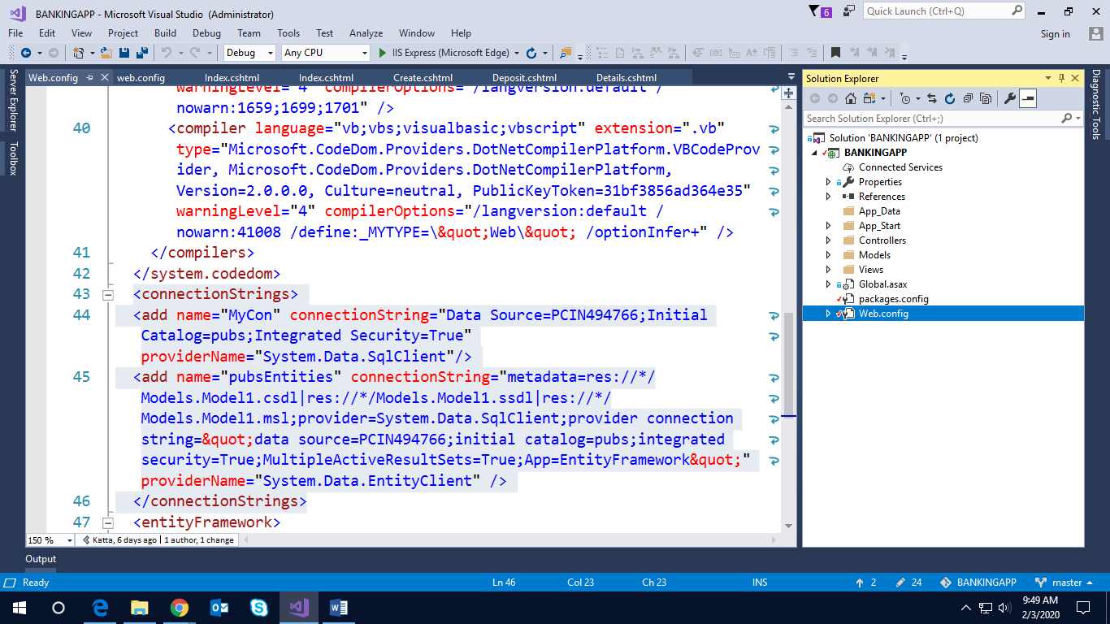

<connectionStrings>

<add name="MyCon" connectionString="Data Source=PCIN494766;Initial Catalog=pubs;Integrated Security=True" providerName="System.Data.SqlClient"/>

<add name="pubsEntities" connectionString="metadata=res://*/Models.Model1.csdl|res://*/Models.Model1.ssdl|res://*/Models.Model1.msl;provider=System.Data.SqlClient;provider connection string=&quot;data source=PCIN494766;initial catalog=pubs;integrated security=True;MultipleActiveResultSets=True;App=EntityFramework&quot;" providerName="System.Data.EntityClient" />

</connectionStrings>