**CSS**, stands for Cascading Style Sheet is a computer language to describe presentation (for example width, height, color, background color, alignment etc.) of HTML and XML (and XML based languages like XHTML, SVG) web documents. In all the examples of our tutorials, we have used HTML for implementing CSS.

**CSS** is a standard specified and maintained by **World Wide Web Consortium**.

|  |
| --- |
| * Home * CSS Home * CSS basics * CSS values * CSS assigning property values cascading inheritance * CSS Concepts * CSS Selectors * CSS background * CSS padding * CSS margin * CSS border * CSS Font * CSS Color * CSS User interface * CSS text align |

<section>

<aside>

Selectors:

Id

Class

Tag

Class selectors .classname

ID selectors #idname

Pseudo-elements:first-line | :first-letter | :before and :after

Pseudo-classes:first-child | :link and :visited | :hover, :active, and :focus | :lang

Box Model

In an HTML page, an element (it may contain other elements within it)generates a rectangular box. This is described as CSS Bo Model.

There are several CSS properties which work with respect to the CSS Box Model.

Dimensions

CSS Box Model has three dimensions: padding, border, and margin, in that order with respect to the actual content.

The following picture clarifies the concept of padding, border, and margin.

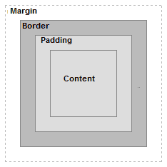

padding is the area next to the actual content.

The border is the area next to the padding. Alternatively, you can say that it is the area between padding and margin.

The margin is the area next to the border.

The properties padding, border and margin can be applied with respect to the top, left, bottom and right of the associated element. The following picture clarifies that :

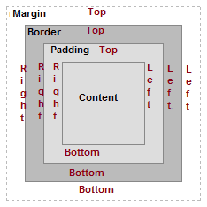

The following picture shows the content, padding, border and margin edges :

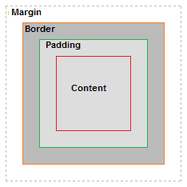

* CSS box model applies to block elements only, not to inline elements.
* When an element is displayed in the web browser, it's width / height is : (width|height) margin + border + padding. Remember that width is affected by left and right padding, border and margin, height is affected by top and bottom padding, border and margin.
* 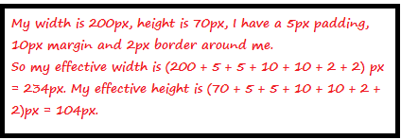
* When two block elements lie next to each other, and if their margin are greater that zero, the larger of the two margins is applied only. See the picture bellow :
* 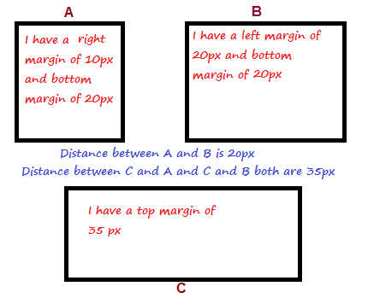

|  |
| --- |
| <!DOCTYPE HTML PUBLIC "-//W3C//DTD HTML 4.01//EN" "http://www.w3.org/TR/html4/strict.dtd">  <html>  <head>  <meta http-equiv="Content-Type" content="text/html; charset=iso-8859-1">  <title>CSS selector example</title>  <style type="text/css">  p {  width: 500px;  border: 1px solid silver;  color: maroon;  padding: 5px;  }  </style>  </head>  <body>  <h1>Example of CSS selector</h1>  <p>Lorem ipsum dolor sit amet, consectetur adipiscing elit. Pellentesque a interdum turpis. Sed viverra odio a leoaliquam porttitor. Duis sed sodales purus. Vestibulum lacus lorem, aliquam ut tincidunt a, pretium id ante.  <p>  Duis eget nisi sem, eu dignissim lorem. Suspendisse sit amet lorem leo. Nullam euismod posuere turpis, et sollicitudin elit hendrerit ac.Vestibulum sit amet mauris elit, vitae convallis neque. Vivamus at mattis ligula.</p>  <p>  Vestibulum ante ipsum primis in faucibus orci luctus et ultrices posuere cubilia Curae; Class aptent taciti sociosqu ad litora torquent per conubia nostra, per inceptos himenaeos. Nullam non magna nec ipsum pharetra posuere. Proin libero arcu, rutrum non convallis vitae, rutrumpulvinar eros. In hac habitasse platea dictumst></p>  </body>  </html> |

|  |  |
| --- | --- |
| .w3r_none {  border-top-style: none;  }  .w3r_hiddent {  border-top-style: hidden;  }  .w3r_dotted {  border-top-style: dotted;  }  .w3r_dashed{  border-top-style: dashed;  }  .w3r_solid {  border-top-style: solid;  }  .w3r_double {  border-top-style: double;  }  .w3r_groove {  border-top-style: groove;  }  .w3r_ridge {  border-top-style: ridge;  }  .w3r_inset {  border-top-style: inset;  }  .w3r_outset {  border-top-style: outset;  } | <!DOCTYPE HTML PUBLIC "-//W3C//DTD HTML 4.01//EN" "http://www.w3.org/TR/html4/strict.dtd">  <html>  <head>  <meta http-equiv="Content-Type" content="text/html; charset=iso-8859-1">  <title>CSS border-top-style example - w3resource</title>  <link rel='stylesheet' href='border-top-style.css' type='text/css' />  </head>  <body>  <p class="w3r_none">Duis aute irure dolor in reprehenderit in voluptate velit esse cillum dolore eu fugiat nulla pariatur. Excepteur sint occaecat cupidatat non proident, sunt in culpa qui officia deserunt mollit anim id est laborum.</p>  <p class="w3r_hidden">Duis aute irure dolor in reprehenderit in voluptate velit esse cillum dolore eu fugiat nulla pariatur. Excepteur sint occaecat cupidatat non proident, sunt in culpa qui officia deserunt mollit anim id est laborum.</p>  <p class="w3r_dotted">Duis aute irure dolor in reprehenderit in voluptate velit esse cillum dolore eu fugiat nulla pariatur. Excepteur sint occaecat cupidatat non proident, sunt in culpa qui officia deserunt mollit anim id est laborum.</p>  <p class="w3r_dashed">Duis aute irure dolor in reprehenderit in voluptate velit esse cillum dolore eu fugiat nulla pariatur. Excepteur sint occaecat cupidatat non proident, sunt in culpa qui officia deserunt mollit anim id est laborum.</p>  <p class="w3r_solid">Duis aute irure dolor in reprehenderit in voluptate velit esse cillum dolore eu fugiat nulla pariatur. Excepteur sint occaecat cupidatat non proident, sunt in culpa qui officia deserunt mollit anim id est laborum.</p>  <p class="w3r_double">Duis aute irure dolor in reprehenderit in voluptate velit esse cillum dolore eu fugiat nulla pariatur. Excepteur sint occaecat cupidatat non proident, sunt in culpa qui officia deserunt mollit anim id est laborum.</p>  <p class="w3r_groove">Duis aute irure dolor in reprehenderit in voluptate velit esse cillum dolore eu fugiat nulla pariatur. Excepteur sint occaecat cupidatat non proident, sunt in culpa qui officia deserunt mollit anim id est laborum.</p>  <p class="w3r_ridge">Duis aute irure dolor in reprehenderit in voluptate velit esse cillum dolore eu fugiat nulla pariatur. Excepteur sint occaecat cupidatat non proident, sunt in culpa qui officia deserunt mollit anim id est laborum.</p>  <p class="w3r_inset">Duis aute irure dolor in reprehenderit in voluptate velit esse cillum dolore eu fugiat nulla pariatur. Excepteur sint occaecat cupidatat non proident, sunt in culpa qui officia deserunt mollit anim id est laborum.</p>  <p class="w3r_outset">Duis aute irure dolor in reprehenderit in voluptate velit esse cillum dolore eu fugiat nulla pariatur. Excepteur sint occaecat cupidatat non proident, sunt in culpa qui officia deserunt mollit anim id est laborum.</p>  </body>  </html> |