Methodology
Participants
Forty nine native speakers of Spanish participated in this experiment (age range = 20-35yo). All participants were recruited based on the following language competence criteria (retrieved from the Participa database [link]): (a) acquisition of L1 Spanish started between 0-3yo, (b) a 5/5 mark in the Spanish interview conducted as an indicator of linguistic competence, (c) Spanish BEST score range 60-65, and (d) any other language than Spanish is at minimal proficiency. Further, participants were recruited based on the following typing speed and accuracy criteria: (a) typing 30 words per minute (wpm), and (b) typing accuracy > = N.

Stimuli
Forty-five di- and trisyllabic Spanish nouns, selected from the MultiPic database (Duñabeitia et al., 2018) are employed in the experiment. We selected words that are noncognates with Basque and/or English, have a high logarithmic frequency (mean = 4.12), are 4 to 7 letters long, are comprised by 4 to 7 phonemes and belong to specific semantic categories (animal, body part, clothes, food, job, object, person, place) (Duchon et al., 2013). The main aim was to include a similar number of stimuli for each semantic category. However, in order to manage to control for the previous variables as well and taking into account the limited number of words at our disposal, we included more stimuli in some semantic categories than in others. More specifically, the semantic category object includes the highest number of representative words (N = 15), followed by animal (N = 8), place (N = 5), body part, clothes, and job, each consisting of 4 words, food consisting of 3 words, and person consisting of 2 words (Appendix, Table N).
Also, we selected words for which mean bigram frequency (mean = 30850.56) and percentage of bimanual transitions (mean = 45%) are homogeneously distributed. Percentage of bimanual transitions demonstrates the rate of within or between hand movements to type a word on a keyboard. For instance, 0% of bimanual transitions indicates that only one of the hands is used to type a word (e.g. cabra, ‘goat’), while 100% bimanual transition applies to words like lengua ‘tongue’ for the typing of which fingers from one hand to the other interchange after every keystroke. Homogeneous distribution of mean bigram frequency and percentage of bimanual transition are important to ensure that the frequency of pairs of letters occuring together is the same across the words used and that the ease/difficulty with which a word is typed is also kept similar across words, respectively.
We also selected the pictures associated with the stimuli based on high imageability (mean = 6.09) (Duchon et al., 2013), low visual complexity (mean = 2.35), and high name agreement (≥ 90, mean = 98.07) measures (Duñabeitia et al., 2018). Three pictures did not include information about imageability (pulpo, bombero, muñeca), but were included nevertheless.

Table 1. Spanish nouns per semantic category included in the present research.
Design
We conducted a picture naming task (PNT) with response modality switch. The design included Condition (repeat, switch) and Response modality (speak, type) as within-subjects independent variables that provide a crossing of four conditions: repeat type, repeat speak, switch type to speak, switch speak to type. Reaction times (RTs), accuracy (%), and durations (ms) are the dependent variables. Response modality was cued by two different colours (yellow, blue) within each trial. This ensured that there would be no time for cue-based preparation. Participants had to attend to the colour cue in each trial and name a picture either by speaking or by typing. Repeat and switch trials were always stimulus repeat trials. Namely each picture appeared twice, in a pair, in which the second trial was the target item. Response modality of the first trial of each pair indicated whether the target item will be a repeat or a switch trial. Filler trials were included to ensure that participants would not predict the order of Condition and/or item appearance and that the probability of item repetition was kept around 50%. Fillers were modality-repetition but no item-repetition trial pairs in which the second trial was the target item. Repetition of fillers was used to calculate the baseline RTs for Response modality.

Experimental list
We used the Euler package in R (Larsson, 2022) to create the experimental list. Initially, we obtained four different balanced sequences of the four conditions of interest: repeat type and repeat speak (Figure 3), switch type to speak and switch speak to type (Figure 4). Every sequence consists of eight picture pairs (16 trials; the second item in each pair is the target one). We ordered these four sequences from the first to the fourth. This sums up to 64 trials (target = 32). We created four sets of eight different pictures (N = 32). Each set of pictures corresponds to one of the four sequences (Table 3). In order to ensure that each target item appears once in all four conditions of interest within each sequence, we shaffled the order in which the picture pairs were presented in each sequence three more times. This provided us with four different orders of stimuli presentation. The first part in the experimental list consists of the first order of stimuli presentation (for the four sequences), the second part consists of the second order of stimuli presentation, and so on for the third and fourth parts of the list. This sums up to 256 trials (target = 128). Not more than three items of the same response modality nor more than three picture pairs appear consecutively. Unless in a picture pair, the same picture is not repeated. Apart from the eight picture pairs, each of the four sequences includes eight fillers (N = 32) which multiplied by the four orders of stimuli presentation result in 128 filler trials. The same 32 pictures that were used for the picture pairs were also used as fillers. An extra 6 pictures (espejo, cadena, escoba, tronco, tenedor, columna) were included in the task to prevent modality repetition (not more than three times consecutively), but also as trials at the beginning of the list and at the beginning of blocks (24 trials). These were excluded from the analyses. Overall, the experimental list consisted of one block of 256 target trials and 152 filler trials (N = 408; 204 speak, 204 type). A break was provided at every 51 trials. We created a total of four versions of the experimental list for the PNT by shaffling the four parts of the list mentioned above. We also counterbalanced the colour-cue for Response modality which resulted in a total of eight versions of the experimental list for the PNT.

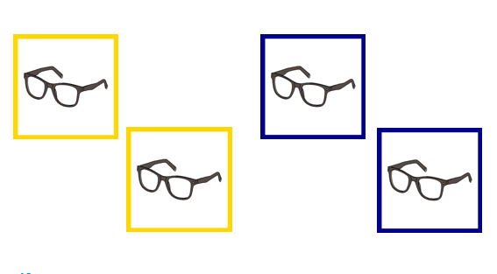
Figure 3. Experimental conditions: repeat speak (left), repeat type (right).
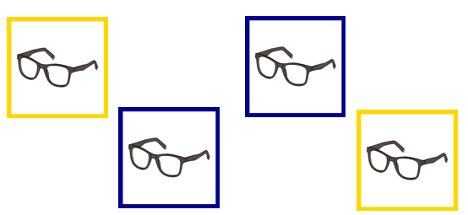
Figure 4. Experimental conditions: switch speak to type (left), switch type to speak (right).

Procedure
We conducted a picture naming task with response modality switch in PsychoPy (Peirce et al., 2022). The task was performed in a Dell computer (1920x1080pixel screen). Participants typed the response with a DirectIN PCB v2016 Empirisoft keyboard with millisecond accuracy. Vocal responses were recorded via an Audio Technica (ATH-PG1) gaming headset with an incorporated microphone. The total experiment consisted of one session that included a familiarisation phase, two practice sessions, and the main experimental task. The total duration of the experiment was approximately 45’.
In the familiarisation phase, participants were presented with all the pictures used in the experiment (target and fillers) in a randomised order and were asked to name each object (N = 45). Every picture appeared on screen for 7sec. The name of each picture appeared at 3.5sec in the middle below the picture and remained on screen until the end of the trial, thus participants were given 3.5sec to name each picture before the name appeared on screen. The intertrial interval (ITI) included a fixation cross with variable duation (1-1.5sec) preceding each picture. Oral feedback was provided when a different word than the one expected was used. Following the familiarisation phase, participants were asked to complete two short practice sessions in which they were trained in the colour-modality association. They viewed a small set of training pictures (N = 7), that were the same between the two practice sessions but different from the ones used in the experimental task, with different colour frames. The picture remained on screen for 3sec. Total trial duration was 4sec. No response was measured after 3sec. The ITI was the same as in the familiarisation phase. They were informed that colour A requires the word to be typed, while colour B requires for the word to be named orally. In the first practice session, they saw the response modality written above the picture and the colour-cued frame. In the second practice phase, they had to practice without the response-modality indication. Colour-modality associations were counter-balanced across participants. The main experimental task consisted of the picture naming task. Participants saw pictures of objects and were asked to either type or say the name of the object presented on the screen based on the colour associations mentioned above. As in the practice sessions, the total duration of each trial was 4sec and the picture remained on screen for 3sec. The ITI interal was the same as in the previous parts of the experimental session. All RTs were measured from the stimulus onset up to 3sec.

Questionnaires
Statistical analysis
We conducted our analyses using the R Statistical Language (R Core Team, 2021). Trials with RTs below 150ms and higher than 2500ms were excluded (% of total trials), as were incorrect trials (% of total trials). The following responses were treated as errors: (a) picture named in the wrong modality, (b) error in the name of the picture, (c) use of backspace in typing. A baseline for speak and type RTs was obtained from filler trials. To examine the effect of Condition (repeat, switch) and Response modality (speak, type) on RTs and on durations we conducted linear-mixed effects modelling (package lme4; Bates et al., 2015; package lmerTest; Kuznetsova et al., 2017). To investigate the effect of the same independent variables on accuracy we employed generalised mixed-effects modelling (ibid). Condition (repeat, switch) and Response modality (type, speak) are the main predictors. We also checked for random effects to control for unobserved homogeneity that is uncorrelated to our main predictors.

