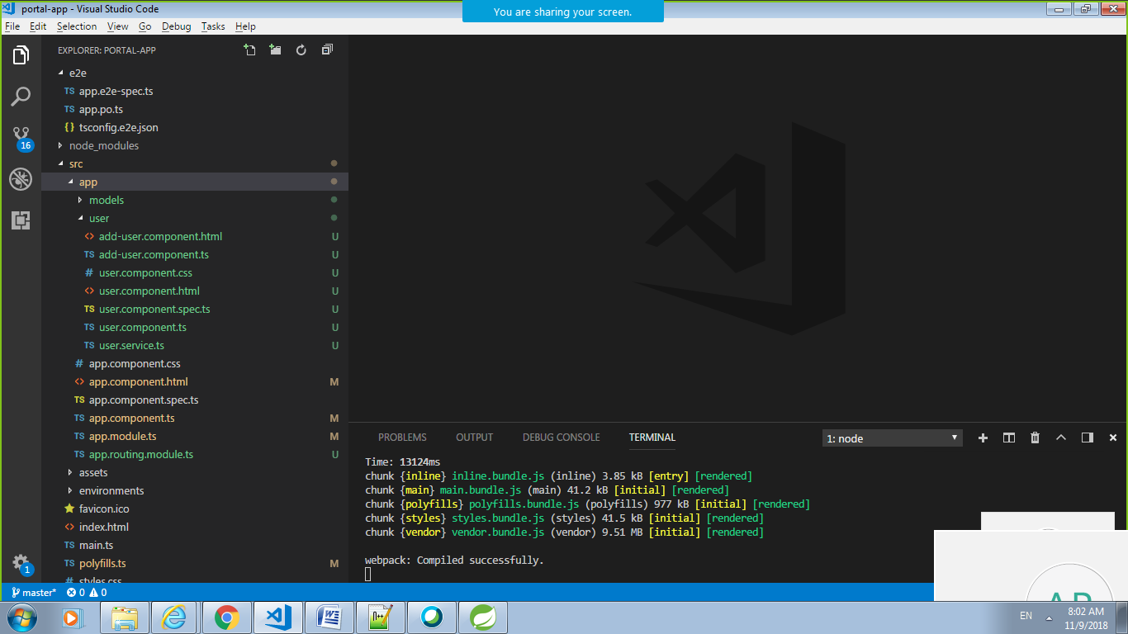

app.component.html

<div class="container-fluid">

<div class="col-md-offset-1">

<h1>

Welcome to {{title}}!

</h1>

</div>

<a routerLink="/users">List Users</a>

<a style="margin-left:10px" routerLink="/add">Add User</a>

<br/>

<router-outlet></router-outlet>

</div>

app.component.spec.ts

import { TestBed, async } from '@angular/core/testing';

import { AppComponent } from './app.component';

describe('AppComponent', () => {

beforeEach(async(() => {

TestBed.configureTestingModule({

declarations: [

AppComponent

],

}).compileComponents();

}));

it('should create the app', async(() => {

const fixture = TestBed.createComponent(AppComponent);

const app = fixture.debugElement.componentInstance;

expect(app).toBeTruthy();

}));

it(`should have as title 'app'`, async(() => {

const fixture = TestBed.createComponent(AppComponent);

const app = fixture.debugElement.componentInstance;

expect(app.title).toEqual('app');

}));

it('should render title in a h1 tag', async(() => {

const fixture = TestBed.createComponent(AppComponent);

fixture.detectChanges();

const compiled = fixture.debugElement.nativeElement;

expect(compiled.querySelector('h1').textContent).toContain('Welcome to app!');

}));

});

app.component.ts

import { Component } from '@angular/core';

@Component({

selector: 'app-root',

templateUrl: './app.component.html',

styleUrls: ['./app.component.css']

})

export class AppComponent {

title = 'User app';

}

app.module.ts

import { BrowserModule } from '@angular/platform-browser';

import { NgModule } from '@angular/core';

import { FormsModule } from '@angular/forms';

import { AppComponent } from './app.component';

import { UserComponent } from './user/user.component';

import { AppRoutingModule } from './app.routing.module';

import {UserService} from './user/user.service';

import {HttpClientModule} from "@angular/common/http";

import {AddUserComponent} from './user/add-user.component';

@NgModule({

declarations: [

AppComponent,

UserComponent,

AddUserComponent

],

imports: [

BrowserModule,

AppRoutingModule,

HttpClientModule,

FormsModule

],

providers: [UserService],

bootstrap: [AppComponent]

})

export class AppModule { }

app.routing.module.ts

import { NgModule } from '@angular/core';

import { RouterModule, Routes } from '@angular/router';

import { UserComponent } from './user/user.component';

import {AddUserComponent} from './user/add-user.component';

const routes: Routes = [

{ path: '', component: UserComponent },

{ path: 'users', component: UserComponent },

{ path: 'add', component: AddUserComponent }

];

@NgModule({

imports: [

RouterModule.forRoot(routes)

],

exports: [

RouterModule

],

declarations: []

})

export class AppRoutingModule { }

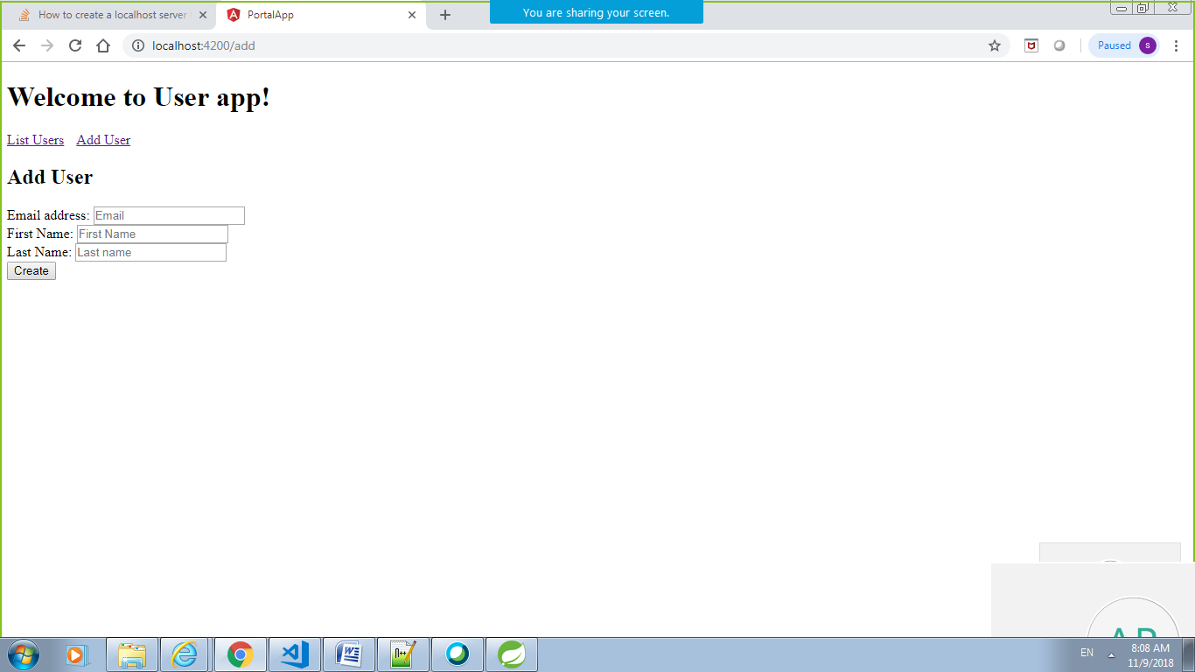

app-> models

user.model.ts;

export class User {

id: string;

firstName: string;

lastName: string;

email: string;

}

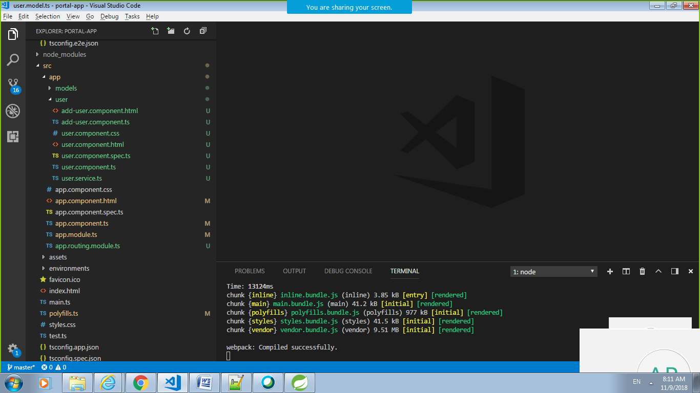

app-> models -> user

add-user.component.html

<div class="col-md-6">

<h2 class="text-center">Add User</h2>

<form>

<div class="form-group">

<label for="email">Email address:</label>

<input type="email" [(ngModel)]="user.email" placeholder="Email" name="email" class="form-control" id="email">

</div>

<div class="form-group">

<label for="firstName">First Name:</label>

<input [(ngModel)]="user.firstName" placeholder="First Name" name="firstName" class="form-control" id="firstName">

</div>

<div class="form-group">

<label for="lastName">Last Name:</label>

<input [(ngModel)]="user.lastName" placeholder="Last name" name="lastName" class="form-control" id="lastName">

</div>

<button class="btn btn-success" (click)="createUser()">Create</button>

</form>

</div>

app-> models -> user

add-user.component.ts

import { Component } from '@angular/core';

import { Router } from '@angular/router';

import { User } from '../models/user.model';

import { UserService } from './user.service';

@Component({

templateUrl: './add-user.component.html'

})

export class AddUserComponent {

user: User = new User();

constructor(private router: Router, private userService: UserService) {

}

createUser(): void {

this.userService.createUser(this.user)

.subscribe( data => {

alert("User created successfully.");

});

};

}

app-> models -> user

user.component.html

<div class="col-md-6">

<h2> User Details</h2>

<table class="table table-striped">

<thead>

<tr>

<th class="hidden">Id</th>

<th>FirstName</th>

<th>LastName</th>

<th>Email</th>

</tr>

</thead>

<tbody>

<tr \*ngFor="let user of users">

<td class="hidden">{{user.id}}</td>

<td>{{user.firstName}}</td>

<td>{{user.lastName}}</td>

<td>{{user.email}}</td>

</tr>

</tbody>

</table>

</div>

app-> models -> user

user.component.spec.ts

import { async, ComponentFixture, TestBed } from '@angular/core/testing';

import { UserComponent } from './user.component';

describe('UserComponent', () => {

let component: UserComponent;

let fixture: ComponentFixture<UserComponent>;

beforeEach(async(() => {

TestBed.configureTestingModule({

declarations: [ UserComponent ]

})

.compileComponents();

}));

beforeEach(() => {

fixture = TestBed.createComponent(UserComponent);

component = fixture.componentInstance;

fixture.detectChanges();

});

it('should create', () => {

expect(component).toBeTruthy();

});

});

app-> models -> user

user.component.ts

import { Component, OnInit } from '@angular/core';

import { Router } from '@angular/router';

import { User } from '../models/user.model';

import { UserService } from './user.service';

@Component({

selector: 'app-user',

templateUrl: './user.component.html',

styleUrls: ['./user.component.css']

})

export class UserComponent implements OnInit {

users: User[];

constructor(private router: Router, private userService: UserService) {

}

ngOnInit() {

this.userService.getUsers()

.subscribe( data => {

this.users = data;

});

};

}

app-> models -> user

user.service.ts

import {Injectable} from '@angular/core';

import { HttpClient, HttpHeaders } from '@angular/common/http';

import { User } from '../models/user.model';

const httpOptions = {

headers: new HttpHeaders({ 'Content-Type': 'application/json' })

};

@Injectable()

export class UserService {

constructor(private http:HttpClient) {}

private userUrl = 'http://localhost:8888/empmodule/emp/list';

//private userUrl = '/api';

public getUsers() {

alert("invoking getUsers");

return this.http.get<User[]>(this.userUrl);

}

public deleteUser(user) {

return this.http.delete(this.userUrl + "/"+ user.id);

}

public createUser(user) {

return this.http.post<User>(this.userUrl, user);

}

}