**Image Recognition with IBM Cloud Visual Recognition:**

**Problem Definition:**

The project involves creating an image recognition system using IBM Cloud Visual Recognition. The goal is to develop a platform where users can upload images, and the system accurately classifies and describes the image contents. This will enable users to craft engaging visual stories with the help of AI-generated captions, enhancing their connection with the audience through captivating visuals and compelling narratives.

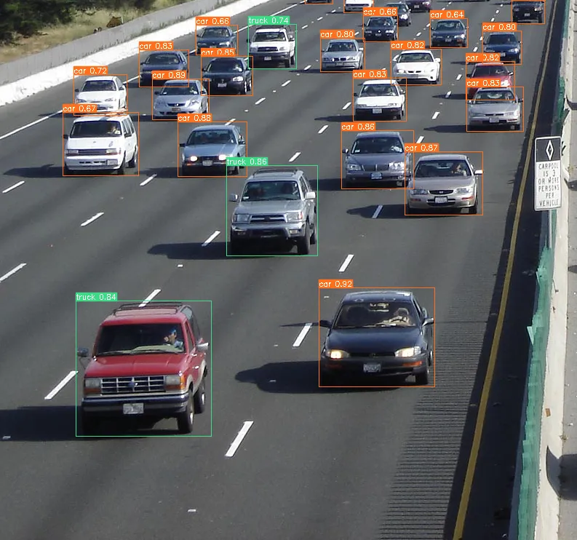

**User Interface:**

**1.Image Upload Section:**

* + Upload Button: Place a prominent "Upload Image" button.
  + Drag-and-Drop Area: Include a drag-and-drop area for users to drop images for recognition.
  + File Input: Alternatively, allow users to click and select images using a file input field.
  + Upload Progress: Display a progress bar or loading spinner during image upload.

**2.Image Display:**

* + After uploading, display the uploaded image prominently.
  + Allow users to zoom in/out or view the image in full-screen mode.

**3.Recognition Results:**

* + Recognized Objects: List the objects or concepts detected in the image.
  + Confidence Scores: Include confidence scores indicating the AI's confidence level for each recognition.

**4.Action Buttons:**

* + "Recognize" or "Analyze" Button: Trigger the image recognition process.
  + "Clear" Button: Allow users to remove the uploaded image and recognition results.

**AI-Generated Captions:**

1. In image recognition we use the Deep learning algorithm for detect the object.
2. Deep learning is a branch of machine Learning. It is an algorithm that attempts to perform high-level abstraction on data using multiple processing layers that contain complex structures or consist of multiple nonlinear transformations.
3. end-to-end (E2E) object detection can be performed without defining features, usually based on a convolutional neural network (CNN).
4. Deep learning-based object detection methods can be classified into one-stage methods and two-stage methods, as well as the RefineDet algorithm that inherits the benefits of the former algorithms.

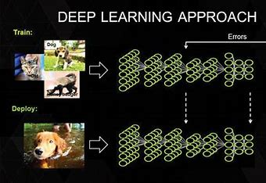

**Technical Implementation:**

1. Data Collection and Preprocessing
2. Splitting Data
3. Building a CNN Model
4. Model Training
5. Hyperparameter Tuning
6. Model Evaluation

**Design Of Image Recognition:**

1. Utilize IBM Cloud services, specifically IBM Watson Visual Recognition, to perform image recognition tasks. This service provides pre-trained models and the ability to create custom classifiers.
2. Collect and curate a dataset of images relevant to your recognition task. Ensure that the dataset is diverse and representative of the objects or concepts you want to recognize.
3. Preprocess the image dataset by resizing, normalizing, and augmenting images to improve model performance.
4. Choose between using pre-trained models provided by IBM Watson Visual Recognition or training a custom model. Pre-trained models are suitable for common recognition tasks, while custom models are ideal for specific requirements.
5. If creating a custom model, use the IBM Watson Visual Recognition service to train the model on your curated dataset. This process involves labeling images and specifying recognition classes.
6. Integrate the IBM Watson Visual Recognition API into your application or system. You'll need to use the API key and endpoint provided by IBM Cloud.
7. Design a user-friendly interface that allows users to upload images for recognition.
8. Display recognition results along with any additional information, such as confidence scores and recognized labels.
9. Implement error handling for cases where image recognition fails or returns unexpected results. Provide clear feedback to users in case of errors.

Implement security measures to protect user data and ensure compliance with data privacy regulations. Handle sensitive image data with care.

Design the system to be scalable to handle varying levels of image recognition requests. IBM Cloud offers scalability options to accommodate increased workloads.

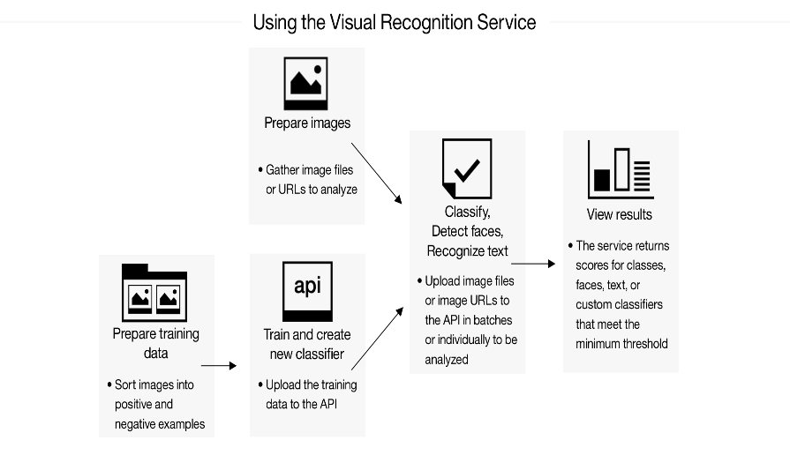

1. Optimize the system for performance by leveraging caching, parallel processing, and efficient image recognition model usage.
2. Decide whether the system will perform real-time image recognition as images are uploaded or batch processing for analyzing large collections of images.
3. Implement analytics and monitoring tools to track user engagement, system performance, and recognition accuracy. Use this data to make improvements.
4. Regularly update the system with new data to improve recognition accuracy and consider fine-tuning custom models as needed.
5. Provide documentation and user support to help users understand how to use the image recognition system effectively.
6. Monitor usage and manage costs effectively by optimizing API calls and resource usage on IBM Cloud.
7. Consider adding features for users to explore, save, and share AI-enhanced images, as discussed earlier in this conversation.

**Watson Visual Recognition:**

* Takes an image as an input and extract features based on models and classifiers.
* A model can be seen as a “taxonomy of related classes on a single domain”.
* Watson includes a standard classifier and some beta classifier(currently food and excplicit)
* Additionally you can create your own model with its classes

**MODELS AND CLASSES:**

Model is the high level classifier, while classes are the different tags that Watson extracts from your image content.

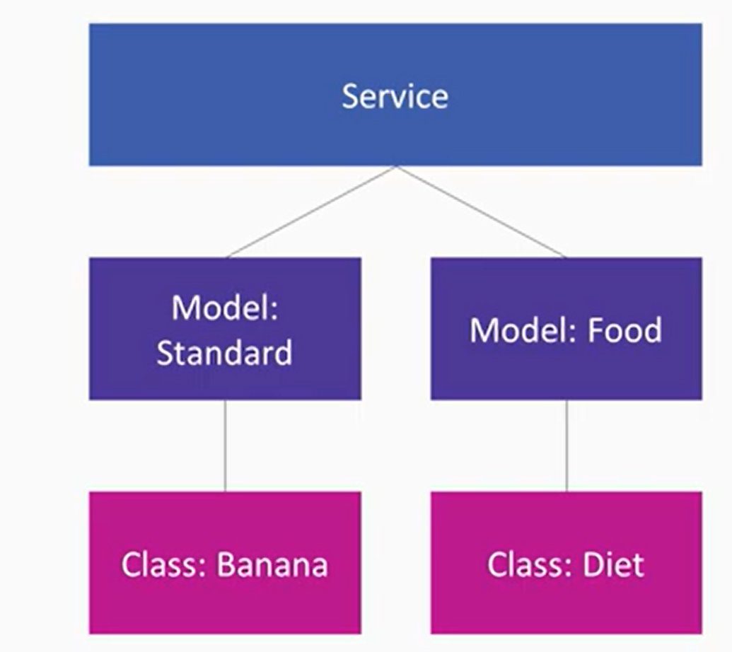

* **Pretrained models-** Models trained by IBM with a lot of tags.
* **Face Recognition-** Find faces inside images.
* **Core ML-** Include computer vision in apple devices.

While using IBM visual Recognition they will produce the name of the image or object present in the given image. There some example of the IBM visual recognition are

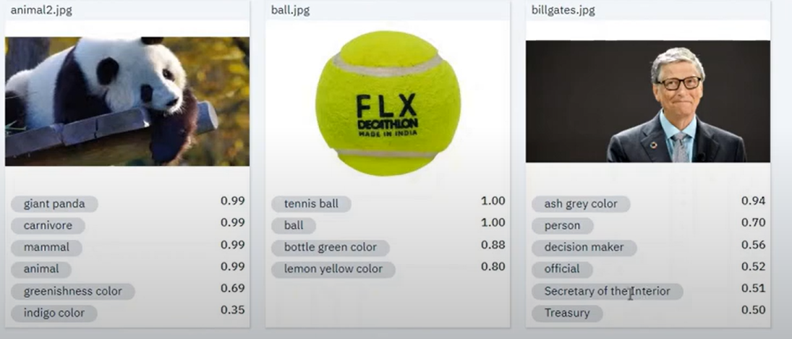

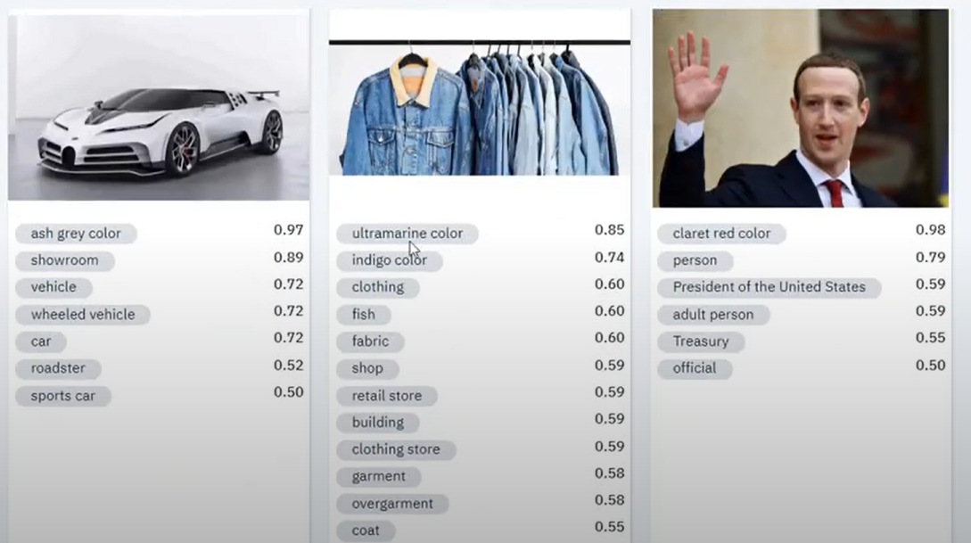

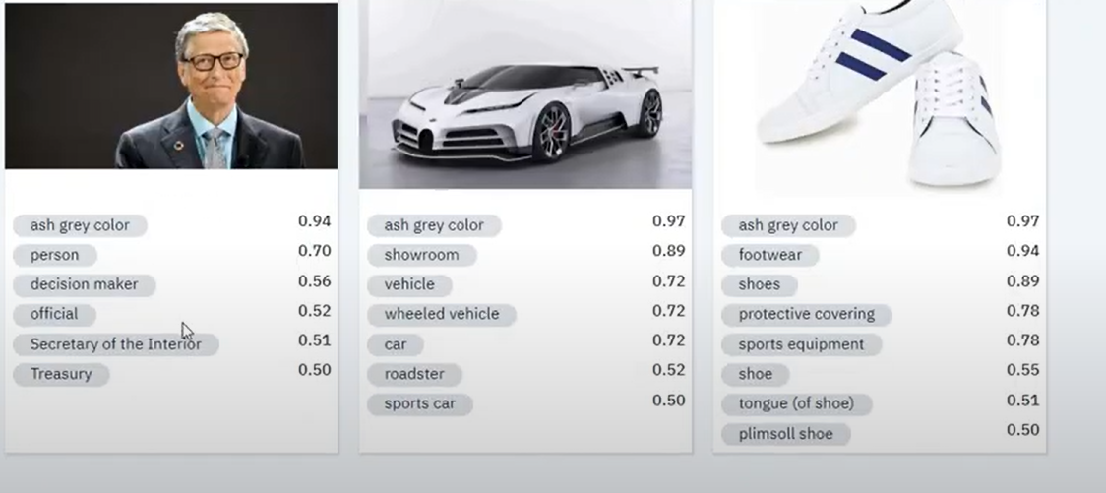

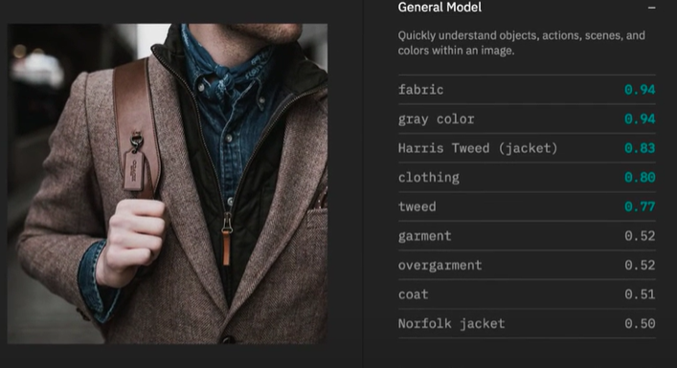

These are Output of the given image in the IBM cloud using the IBM visual recognition.

**SAMPLE CODES AND API KEY:**

Code for the image recognition using IBM cloud using the flask resources. There is some sample code for these project,

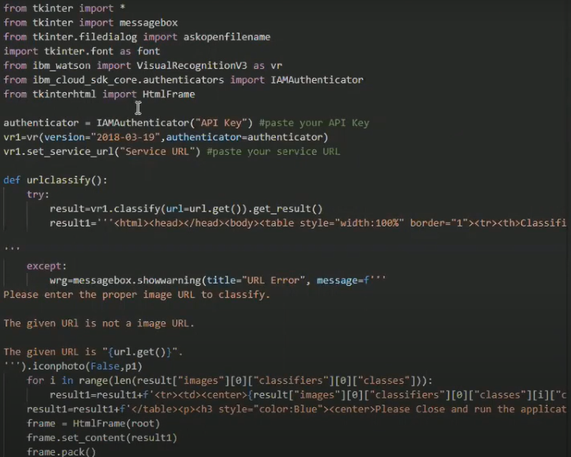

**API KEY:**

Sample API key for the given IBM visual recognition.

