**Image Recognition with IBM Cloud Visual Recognition:**

Image Recognition with IBM Cloud Visual Recognition allows developers to integrate AI-powered image analysis into their applications, identifying objects, scenes, and text within images with high accuracy using IBM's cloud-based service and API.

**DESGIN OF IMAGE RECOGINITION:**

**1. IBM Cloud Services:**

Utilize IBM Cloud services, specifically IBM Watson Visual Recognition, to perform image recognition tasks. This service provides pre-trained models and the ability to create custom classifiers.

**2. Image Data Collection:**

Collect and curate a dataset of images relevant to your recognition task. Ensure that the dataset is diverse and representative of the objects or concepts you want to recognize.

**3. Data Preprocessing:**

Preprocess the image dataset by resizing, normalizing, and augmenting images to improve model performance.

**4. Model Selection:**

Choose between using pre-trained models provided by IBM Watson Visual Recognition or training a custom model. Pre-trained models are suitable for common recognition tasks, while custom models are ideal for specific requirements.

**5. Training :**

If creating a custom model, use the IBM Watson Visual Recognition service to train the model on your curated dataset. This process involves labeling images and specifying recognition classes.

**6. API Integration:**

Integrate the IBM Watson Visual Recognition API into your application or system. You'll need to use the API key and endpoint provided by IBM Cloud.

**7. User Interface:**

* Design a user-friendly interface that allows users to upload images for recognition.
* Display recognition results along with any additional information, such as confidence scores and recognized labels.

**8. Error Handling:**

Implement error handling for cases where image recognition fails or returns unexpected results. Provide clear feedback to users in case of errors.

**9. Privacy and Security:**

Implement security measures to protect user data and ensure compliance with data privacy regulations. Handle sensitive image data with care.

**10. Scalability:**

Design the system to be scalable to handle varying levels of image recognition requests. IBM Cloud offers scalability options to accommodate increased workloads.

**11. Performance Optimization:**

Optimize the system for performance by leveraging caching, parallel processing, and efficient image recognition model usage.

**12. Real-time vs. Batch Processing:**

Decide whether the system will perform real-time image recognition as images are uploaded or batch processing for analyzing large collections of images.

**13. Analytics and Monitoring:**

Implement analytics and monitoring tools to track user engagement, system performance, and recognition accuracy. Use this data to make improvements.

**14. Continuous Improvement:**

Regularly update the system with new data to improve recognition accuracy and consider fine-tuning custom models as needed.

**15. Documentation and Support:**

Provide documentation and user support to help users understand how to use the image recognition system effectively.

**16. Cost Management:**

Monitor usage and manage costs effectively by optimizing API calls and resource usage on IBM Cloud.

**17. User Engagement Features:**

Consider adding features for users to explore, save, and share AI-enhanced images, as discussed earlier in this conversation.

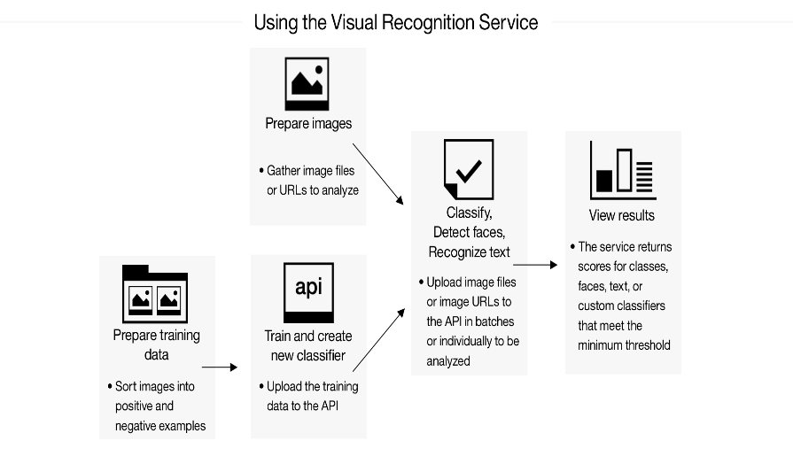

**NOVALTY:**

**1.AI Insights:**

The service provided insights into recognized images, including details about recognized objects, concepts, and visual characteristics. Users could leverage this information for data-driven decision-making.

**2.Integration with Watson Studio:**

Users could seamlessly integrate IBM Cloud Visual Recognition with IBM Watson Studio, a powerful platform for data science and machine learning. This integration facilitated more advanced analytics and model training.

**3.Text Extraction from Images:**

In addition to object recognition, the service had the ability to extract text from images. This feature was particularly useful for tasks like reading text from images for data entry or document analysis.

**4.Visual Recognition API:**

IBM Cloud Visual Recognition offered an API that allowed developers to incorporate image recognition capabilities into their own applications and services, expanding the reach of this technology across various industries.

**ADVANTAGE:**

* **Cost-Effective:**

IBM Cloud offers flexible pricing models, including pay-as-you-go and subscription options, allowing you to choose a pricing structure that fits your budget and usage patterns.

* **Developer-Friendly:**

IBM Cloud provides SDKs, APIs, and developer tools that simplify the integration of image recognition capabilities into your applications, reducing development time and effort.

* **Scalability:**

IBM Cloud provides scalable infrastructure, ensuring that your image recognition service can handle varying workloads, from small-scale applications to large enterprise-level solutions, without compromising performance.

* **Integration:**

IBM Cloud services are designed to integrate seamlessly with other IBM Cloud offerings, making it easier to build end-to-end solutions that combine image recognition with other cloud services like databases, AI, and IoT.

* **State-of-the-Art Technology:**

IBM Cloud's image recognition services are built on advanced technologies, including deep learning and convolutional neural networks (CNNs), which provide accurate and reliable recognition of objects, scenes, and concepts in images.

* **Customization:**

IBM Cloud Visual Recognition allows you to create custom classifiers tailored to your specific image recognition needs. This enables you to recognize and classify objects or concepts unique to your business or industry.

**DISADVANTAGE:**

* **Dependency on Third-Party Service:**

Relying on a third-party cloud service means your image recognition capabilities are dependent on the service's availability and reliability. Downtime or changes in service offerings can disrupt your application.

* **Model Bias:**

Like many machine learning models, image recognition models can exhibit biases based on the data they were trained on. It's important to consider and address potential biases, especially in applications involving sensitive or controversial content.

* **Latency:**

The speed at which IBM Cloud Visual Recognition processes images can vary based on factors like the size of the image, network latency, and the current load on the service. For real-time or low-latency applications, this delay can be a disadvantage.

**DEPENDENCY:**

**OPENCV:**

**A) Rich Functionality:**

OpenCV offers a wide range of functions for image processing, feature detection, object tracking, facial recognition, and more. It includes algorithms for image enhancement, filtering, edge detection, and geometric transformations.

**B) Machine Learning Integration:**

OpenCV seamlessly integrates with machine learning libraries like TensorFlow and PyTorch, allowing you to combine traditional computer vision techniques with deep learning models for image recognition tasks.

**C) Real-Time Capabilities:**

OpenCV is optimized for real-time image and video processing, making it suitable for applications like robotics, surveillance, and augmented reality.

**D) Image Recognition Techniques:**

OpenCV supports various image recognition techniques, including object detection, image classification, and feature matching. It includes pre-trained models for tasks like face detection and pedestrian detection.

**E) OpenCV DNN Module:**

The Deep Neural Networks (DNN) module in OpenCV allows you to load and use pre-trained deep learning models for image recognition tasks. It supports popular frameworks like TensorFlow and Caffe.

**WASTON:**

**1) Image Classification:**

IBM Watson Visual Recognition allows you to classify images into predefined categories or labels. You can train custom classifiers for specific recognition tasks, such as identifying products, animals, or objects.

**2) Custom Training:**

One of its key features is the ability to create custom classifiers. You can provide your own labeled training data to teach the system to recognize specific objects or concepts relevant to your application.

**3) Pre-Trained Models:**

Watson Visual Recognition provides pre-trained models for a wide range of common objects, scenes, and concepts. These models are ready to use out of the box for general-purpose image recognition.

**4) Object Detection:**

It can not only classify images but also locate and identify multiple objects within an image. This is useful for tasks like counting objects in a scene or detecting specific items within a larger image.