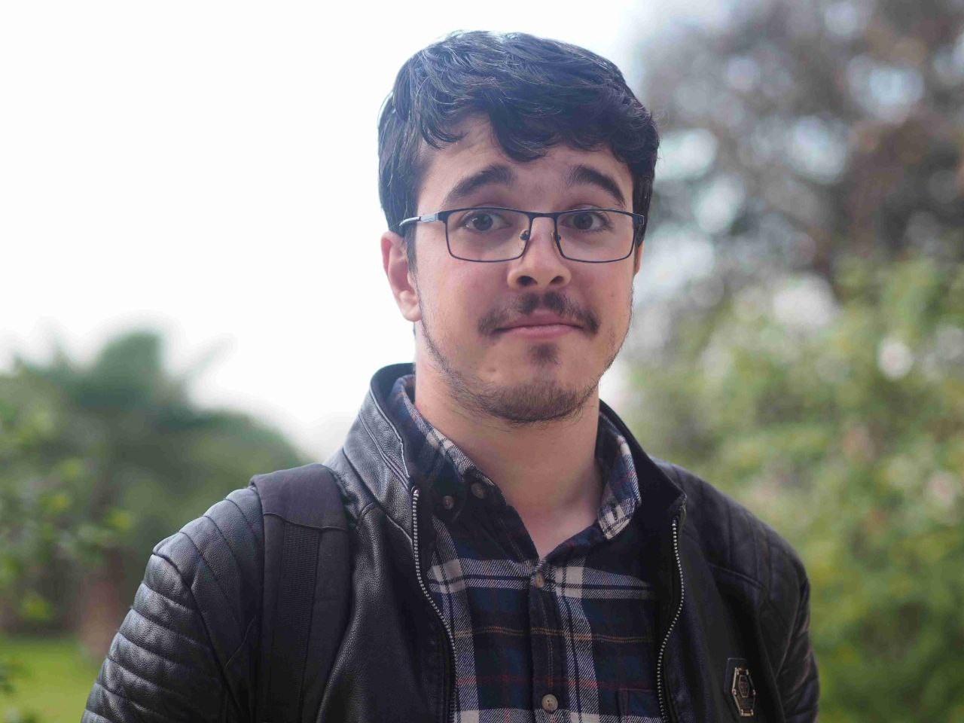

aminebourouba9@gmail.com

+213699154241

Amine Bourouba

**LANGUAGES**

**PERSONAL SKILLS**

**EXPERIENCE**

**DIPLOMAS Y HOBBIES**

**Formaciones :** Diplomados, Congresos, xxxxxxxxxx xxxxxx xxxxxxxxx xxxxxxxxxxxxxxxxx

**Hobbies:** xxxxxxxxxxxxxxxxxxxxxxxxxxxxxx





linkedin.com/in/aminebourouba



313, Cité Amirouch Hussein Dey, Algiers, Algeria

MAR/2021

Actual position

(Remote/Ireland)

JAN/2020

FEB/2021

(Algiers/Algeria)

APR/2019

DEC/2019

(Batna/Algeria)

NOV/2018

FEB/2019

(Batna/Algeria)

**PROFESSIONAL SKILLS**

**Evercam**

Software engineer

* + - * Designing, developing and debugging user interfaces using Vuejs, NuxtJs, Vuetify and consume the company’s REST API
      * Collaborating with other departments in order to define the future features
      * Working on adding new features on both user and admin

Dashboards

* + - * **Stack**: Vue, Vuetify, Nuxt, Javascript, Axios, Phoenix (Elixir)

**Oudekniss**

Software engineer

* + - * Worked on the latest company platform, including new UI and back-end microservices
      * Designed and built website’s comments Graphql API with Lighthouse
      * Designed and built user interfaces using Vuejs, Vuetify, this includes

the user’s dashboard (especially announcements/delivery management systems), some pages in the admin’s

* + - * Maintain and optimize communication between back-end and front-end using ApolloGraphql
      * **Stack**: Vue, Vuetify, Javascript, ApolloGraphQL, GraphQL, Laravel, Lighthouse

**Zorx Tech**

Fullstack developer

* + - * Working on the development of different projects:

- Enterprise Management System (EMS)

- Project Management System (PMS)

- Noukhba (pivate school management system)

* + - * **Stack**: VueJs, Vuetify, Javascript, NodeJs, Laravel, MySQL, MongoDB

**iCar Corporation**

Backend developer

Internship position, working as a backend developer in the design

and construction of the iControl project (enterprise HR/resources management system) using Laravel framework.

* + - * Programming: Vue.Js, NuxtJs GraphQL, Javascript, Laravel, PHP, Node.Js, Pheonix framwork, Python, Scrapy
      * Version control: Github, Gitlab
      * Databases: MySQL, MongoDB
      * Containers: Docker

* + - * Arabic: native
      * English: advanced
      * French: advanced
      * Spanish: beginner

**EDUCATION**

2016-2018

**MASTER, MAJOR IN INFORMATION SYSTEMS**

Department of Computer Science (University of Batna 2): | Batna, Algeria

2013-2016

**BACHLOR, MAJOR IN NETWORKING & DISTRBUTED SYSTEMS**

Department of Computer Science (University of Batna 2): | Batna, Algeria

**Academic Projects**

* + - * Realization of a robust and secure authentication solution based on virtualization, in a wireless sensor network (M.Sc. Thesis, Jun 2018)
      * Realization and implementation of a semantic indexing tool in Arabic language (B.Sc. Project, Jun2016)
      * Analytical skills
      * Problem-solving
      * Creativity
      * Critical-thinking
      * Resilience
      * Self-Motivation