Practical Work No. 10
Database source link: PostgreSQL Demo Database “Airlines” installation page (used as the source for the demo “bookings” database).
Direct demo files index: https://edu.postgrespro.ru/

1. Execution Screenshots and Commentary
Screenshot 1. Total amount for tickets above 7,000
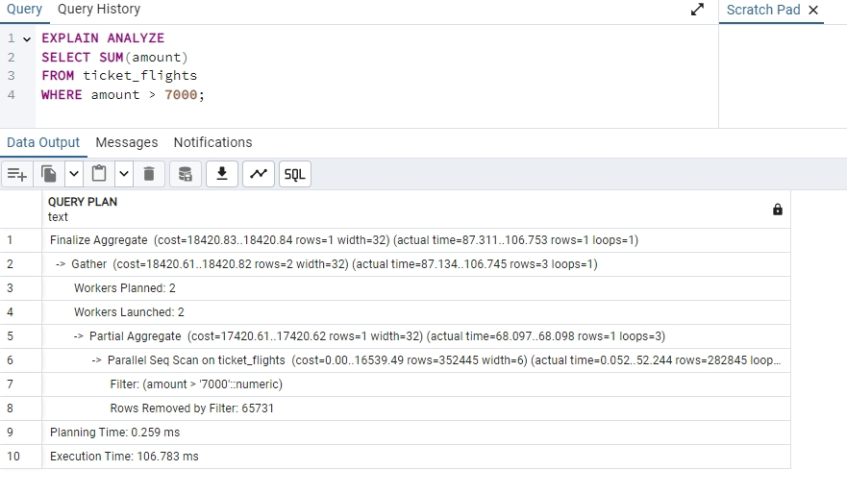
The query calculates the total amount for all records where amount > 7000. PostgreSQL chose a parallel aggregation plan with Gather, Partial Aggregate, and Finalize Aggregate nodes. The scan reads the ticket_flights table and filters rows by the amount condition.
Screenshot 2. MATERIALIZED CTE version of the same aggregation
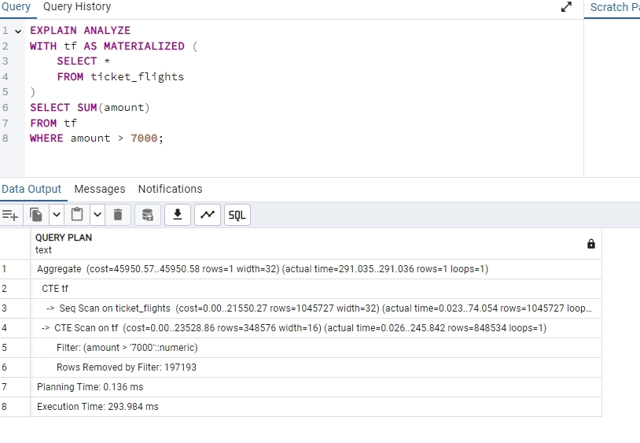
The same aggregation is executed through a MATERIALIZED common table expression. The plan includes a CTE Scan, which indicates that the intermediate result was materialized first and then scanned. This increases execution cost compared with the direct query.
Screenshot 3. Maximum ticket price using MAX(amount)
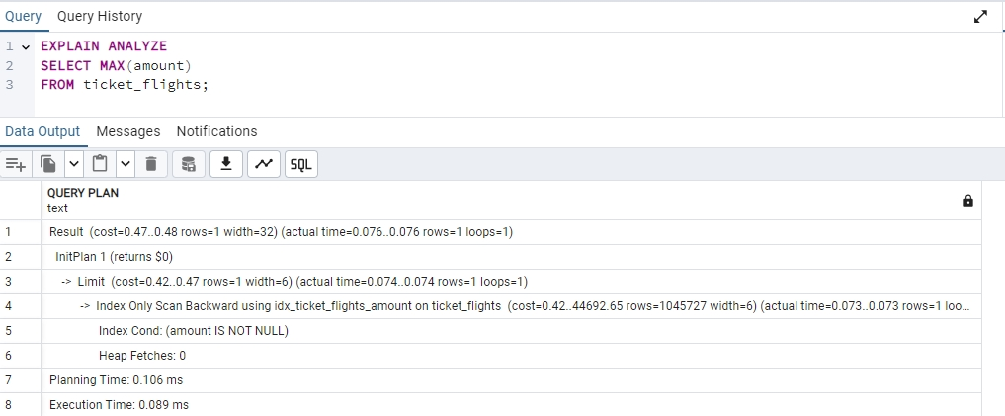
The maximum ticket price is obtained through an aggregate expression. After an index on amount is available, PostgreSQL can use an index-only access path and avoid scanning the full table.
Screenshot 4. Maximum ticket price using ORDER BY amount DESC LIMIT 1
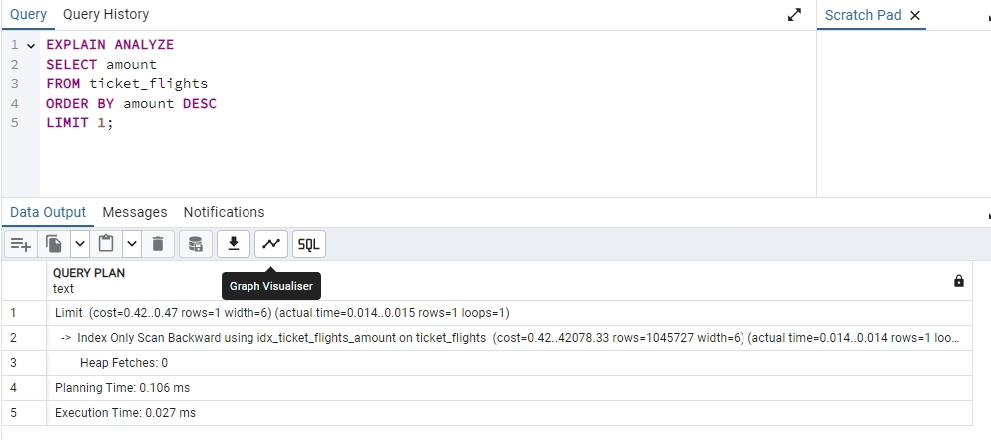
The alternative formulation retrieves the highest amount by reading the B-tree index backward and stopping after the first row. This is efficient because the requested value is located at the end of the ordered index.
Screenshot 5. Repeated MAX(amount) check after indexing
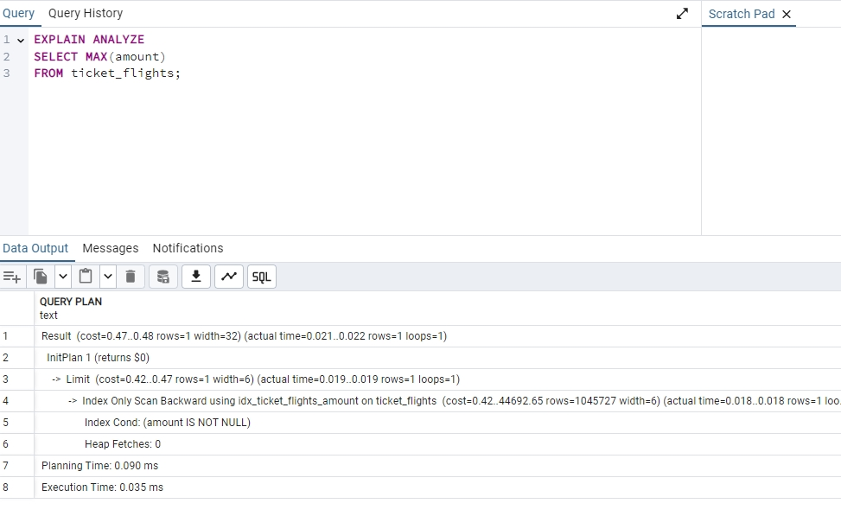
The plan confirms that the optimizer can use an index-only scan for the maximum value lookup. The execution time is significantly lower than a full sequential scan would require.
Screenshot 6. Repeated ORDER BY DESC LIMIT 1 check after indexing
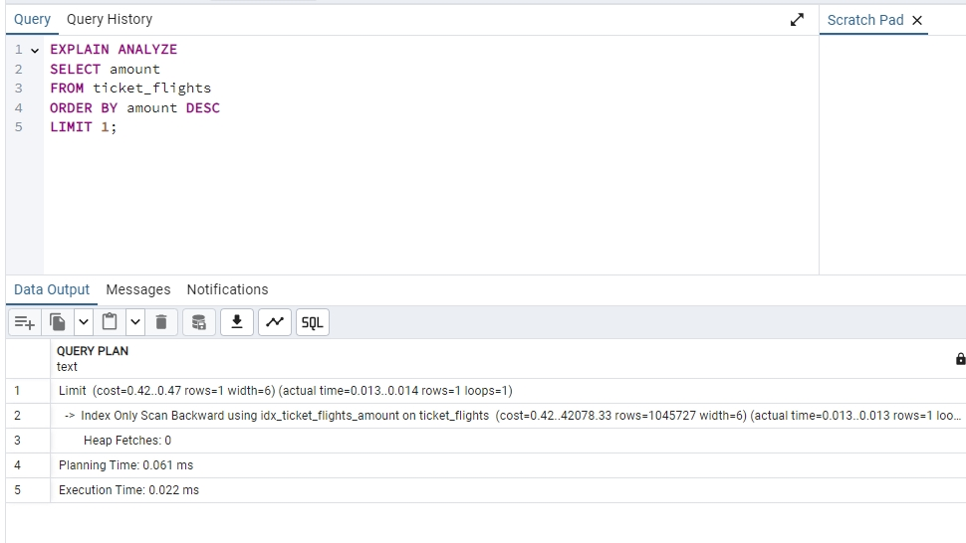
The backward index-only scan is used again. The LIMIT clause allows PostgreSQL to stop immediately after finding the first highest value.
Screenshot 7. INCLUDE index query on flights
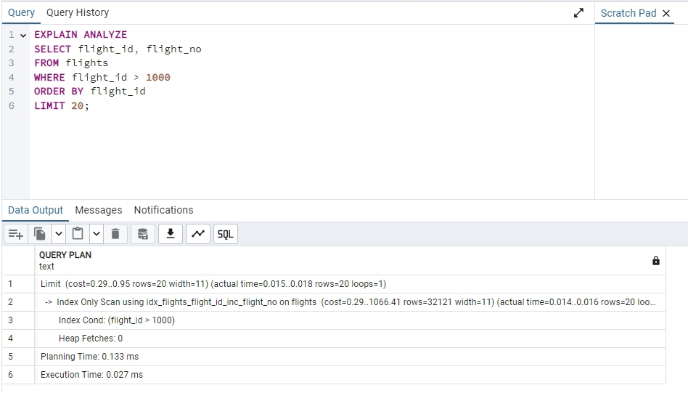
The query selects flight_id and flight_no from flights. The INCLUDE index allows flight_no to be stored as a non-key attribute, enabling an index-only scan for this access pattern.
Screenshot 8. Primary key constraint name check
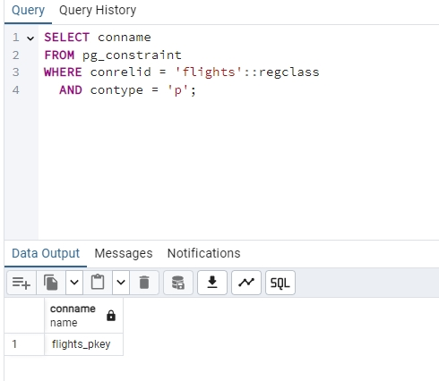
The query identifies the primary key constraint on flights as flights_pkey. This check was required before evaluating whether the primary key index could be replaced.
Screenshot 9. Index-only access with the INCLUDE index
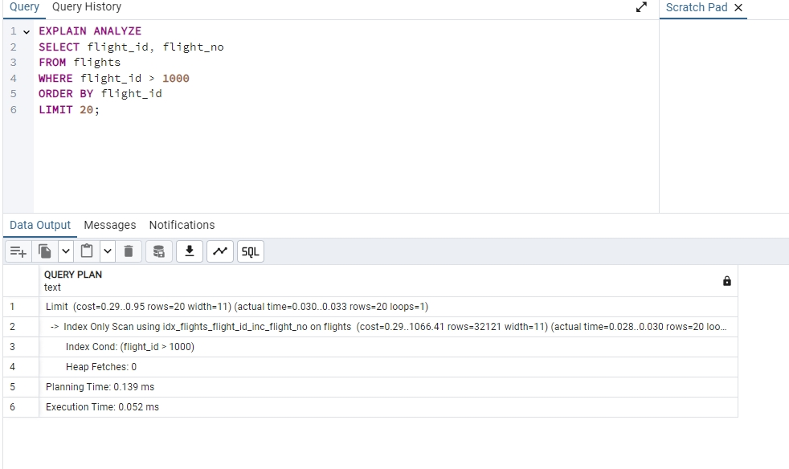
The execution plan confirms that the include index is used for the query against flights. The selected key and non-key columns are retrieved from the index without reading full table rows.
Screenshot 10. Filtering ticket_flights by amount above 200,000
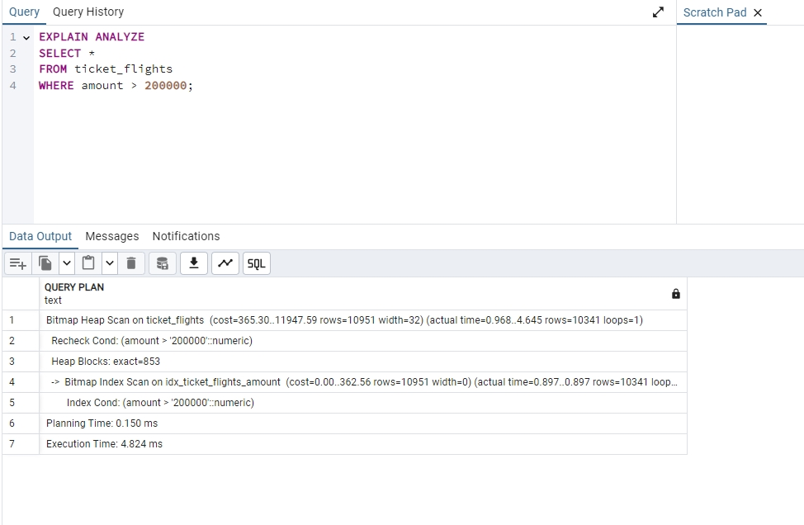
The optimizer selected Bitmap Index Scan followed by Bitmap Heap Scan for a highly selective condition. This method collects matching tuple locations through the index and then reads the required table pages.
Screenshot 11. Sequential scan disabled for comparison
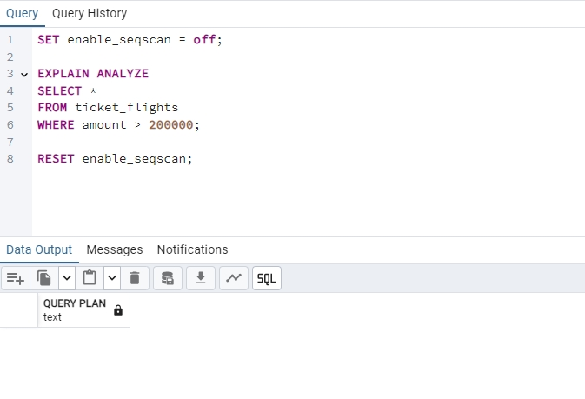
The enable_seqscan parameter is disabled to force PostgreSQL to consider alternative plans. This step is used to compare the optimizer-selected plan with a restricted planning environment.
Screenshot 12. Index and bitmap scans disabled for comparison
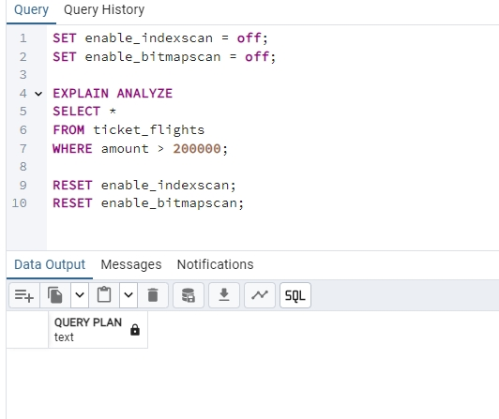
Index scan and bitmap scan methods are disabled to force a different access strategy. This experiment demonstrates how planner settings influence the selected execution plan and why manual disabling can reduce performance.

2. SQL Code Used in the Work
Preparation
SET search_path TO bookings;
ANALYZE ticket_flights;
ANALYZE flights;
1. Total amount for tickets above 7,000
EXPLAIN ANALYZE
SELECT SUM(amount)
FROM ticket_flights
WHERE amount > 7000;
2. The same task through a MATERIALIZED CTE
EXPLAIN ANALYZE
WITH tf AS MATERIALIZED (
SELECT *
FROM ticket_flights
)
SELECT SUM(amount)
FROM tf
WHERE amount > 7000;
3. Maximum ticket price through the aggregate function
EXPLAIN ANALYZE
SELECT MAX(amount)
FROM ticket_flights;
4. Maximum ticket price through sorting and LIMIT
EXPLAIN ANALYZE
SELECT amount
FROM ticket_flights
ORDER BY amount DESC
LIMIT 1;
5. Index creation for ticket price
CREATE INDEX IF NOT EXISTS idx_ticket_flights_amount
ON ticket_flights(amount);
ANALYZE ticket_flights;
6. Repeated MAX(amount) check after index creation
EXPLAIN ANALYZE
SELECT MAX(amount)
FROM ticket_flights;
7. Repeated ORDER BY DESC LIMIT 1 check after index creation
EXPLAIN ANALYZE
SELECT amount
FROM ticket_flights
ORDER BY amount DESC
LIMIT 1;
8. INCLUDE index for the flights table
CREATE INDEX IF NOT EXISTS idx_flights_flight_id_inc_flight_no
ON flights(flight_id) INCLUDE (flight_no);
ANALYZE flights;
9. Query using key and non-key columns from the INCLUDE index
EXPLAIN ANALYZE
SELECT flight_id, flight_no
FROM flights
WHERE flight_id > 1000
ORDER BY flight_id
LIMIT 20;
10. Primary key constraint name check
SELECT conname
FROM pg_constraint
WHERE conrelid = 'flights'::regclass
AND contype = 'p';
11. High-value ticket filter
EXPLAIN ANALYZE
SELECT *
FROM ticket_flights
WHERE amount > 200000;
12. Sequential scan disabled
SET enable_seqscan = off;
EXPLAIN ANALYZE
SELECT *
FROM ticket_flights
WHERE amount > 200000;
RESET enable_seqscan;
13. Index and bitmap scans disabled
SET enable_indexscan = off;
SET enable_bitmapscan = off;
EXPLAIN ANALYZE
SELECT *
FROM ticket_flights
WHERE amount > 200000;
RESET enable_indexscan;
RESET enable_bitmapscan;

3. Conclusion
The practical work demonstrated how PostgreSQL selects execution plans based on table statistics, available indexes, and planner cost estimates. The direct aggregation query was executed with a parallel plan, while the MATERIALIZED CTE introduced an additional scan of the intermediate result. The B-tree index on amount improved maximum-value retrieval by enabling backward index-only access. The INCLUDE index on flights allowed PostgreSQL to retrieve both key and non-key columns through the index. Planner settings such as enable_seqscan, enable_indexscan, and enable_bitmapscan were used to compare alternative access methods and confirm that forced plans are not always more efficient than the optimizer-selected plan.

