Semantic Film Archivist
Project Documentation

Master’s Degree Program
Digital Humanities and Digital Knowledge

Course examination
Machine Learning in Arts and Humanities

Ekaterina Krasnova
a.y. 2025/2026
Index
- Introduction……………………………………………………..………3
- Related work………………………………………………………….....4
- Methodology
  - Data collection and preprocessing………….………….…………..5
  - Retrieval System (Sentence-BERT)…………………..…………...6
  - Generation System (Flan-T5)………………………..…………….6
  - The RAG pipeline………………………….………………….…..6
  - Visualization (PCA)…………………………….…………………7
- Implementation…………………………………...…………………..…9
- Evaluation
  - Precision@5 Metrics……………….…………………………….11
  - Qualitative Analysis and Fuzzy Matching Bias………….………11
- Conclusion…………………………………...…………………………13
- References
  - Academic Literature……………………………………………...14
  - Software and Libraries…………………………………………...14
  - Datasets……………………………………………......................15

- Introduction
Cinema represents a significant component of modern cultural heritage, with film archives holding thousands of titles spanning more than a century of storytelling. Traditional film databases rely primarily on keyword-based search mechanisms, which require users to know specific titles, actors, or directors to find relevant content. This approach presents significant limitations for researchers and film enthusiasts who wish to explore thematic connections, atmospheric qualities, or conceptual similarities between films. A user searching for "Space exploration" or "Post-apocalyptic futures" would typically encounter zero results unless those exact phrases appear in manually curated metadata tags.
This project, the Semantic Film Archivist, aims to solve this problem using Machine Learning. My goal was to build a tool that understands meaning, not just syntax. By implementing a Retrieval-Augmented Generation (RAG) pipeline, I created a system where users can query the archive using natural language.
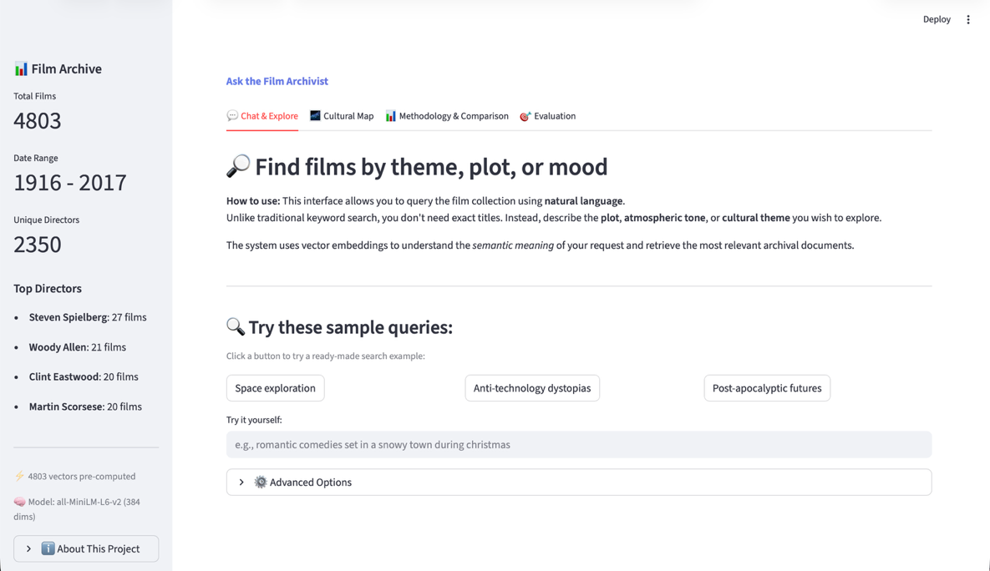
Figure 1. Main page of the Film Archivist built with Streamlit.

- Related Work
This project aligns with the growing trend of AI in GLAM (Galleries, Libraries, Archives, Museums) institutions. Initiatives like the "AI4LAM" community have highlighted the need for better discovery tools in digital collections to make archives more accessible to the public.
Technically, my work builds upon two foundational areas of Natural Language Processing. First, the research of Reimers and Gurevych (2019) on Sentence-BERT, which allowed for the creation of semantically meaningful sentence embeddings. Second, the work of Lewis et al. (2020) on RAG (Retrieval-Augmented Generation), which introduced the architecture of combining a neural retriever with a sequence-to-sequence generator to reduce hallucinations – a critical requirement when dealing with historical or cultural data.

- Methodology
  - Data Collection and Preprocessing
The system uses the Movie Dataset compiled by Harsh Shinde and made available through Kaggle under License Apache 2.0. This dataset contains a rich collection of metadata for approximately 4800 films, including budget, titles, release dates, plot overviews, cast information, directors, genre classifications and more.
A crucial step was data preprocessing: I combined these disparate text fields into a single "archival text" field for each film. This ensured that the model could learn connections between a plot summary and its genre tags simultaneously, creating a denser semantic representation for each entry.
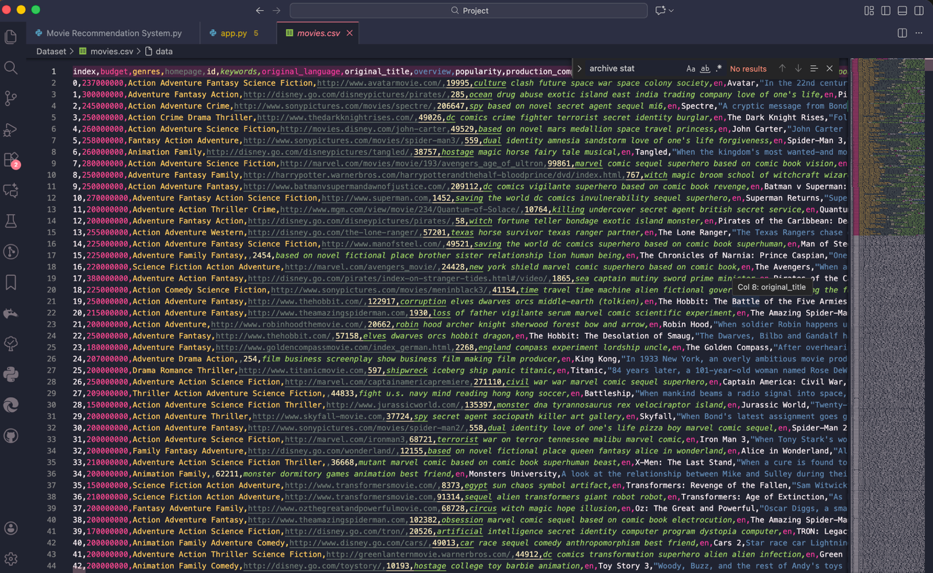
Figure 2. movies.csv dataset.

  - Retrieval System (Sentence-BERT)
For the retrieval component, I rejected simple TF-IDF vectorization in favor of dense vector embeddings. TF-IDF fails to capture synonyms (e.g., "space" vs. "cosmos"), which is fatal for thematic search. Instead, I used the all-MiniLM-L6-v2 model (based on BERT) to convert every movie plot into a 384-dimensional vector. This allows the system to calculate Cosine Similarity between a user's query and the archive. In this high-dimensional space, thematically similar films (like Interstellar and Gravity) are located geometrically close together, even if they share few keywords.
  - Generation System (Flan T-5)
For the generation component, I employed google/flan-t5-base. This is a Sequence-to-Sequence transformer model fine-tuned for instruction following. It serves as the "voice" of the archivist. Unlike a standard chatbot that might hallucinate facts, this model is constrained to use only the data provided by the retrieval system.
  - The RAG Pipeline
The core of the application is the RAG pipeline. The process follows these steps:
- Encode: The user's natural language query is converted into a vector.
- Retrieve: The system performs a similarity search to find the top 5 most relevant movie vectors in the database.
- Augment: The system concatenates the plot summaries of these retrieved films into a "context block."
- Generate: This context is fed to the Flan-T5 generator with a specific prompt (e.g., "Recommend a movie from this list...").
  - Visualization (PCA)
To visualize the "cultural map" of the archive, I used Principal Component Analysis (PCA) to reduce the 384-dimensional vectors down to 2 dimensions. This allowed me to plot the entire dataset as an interactive scatter plot in the application. This visualization is not just aesthetic: it provides visual proof that the unsupervised clustering is working, as users can see genres naturally forming distinct islands without any human interventions.
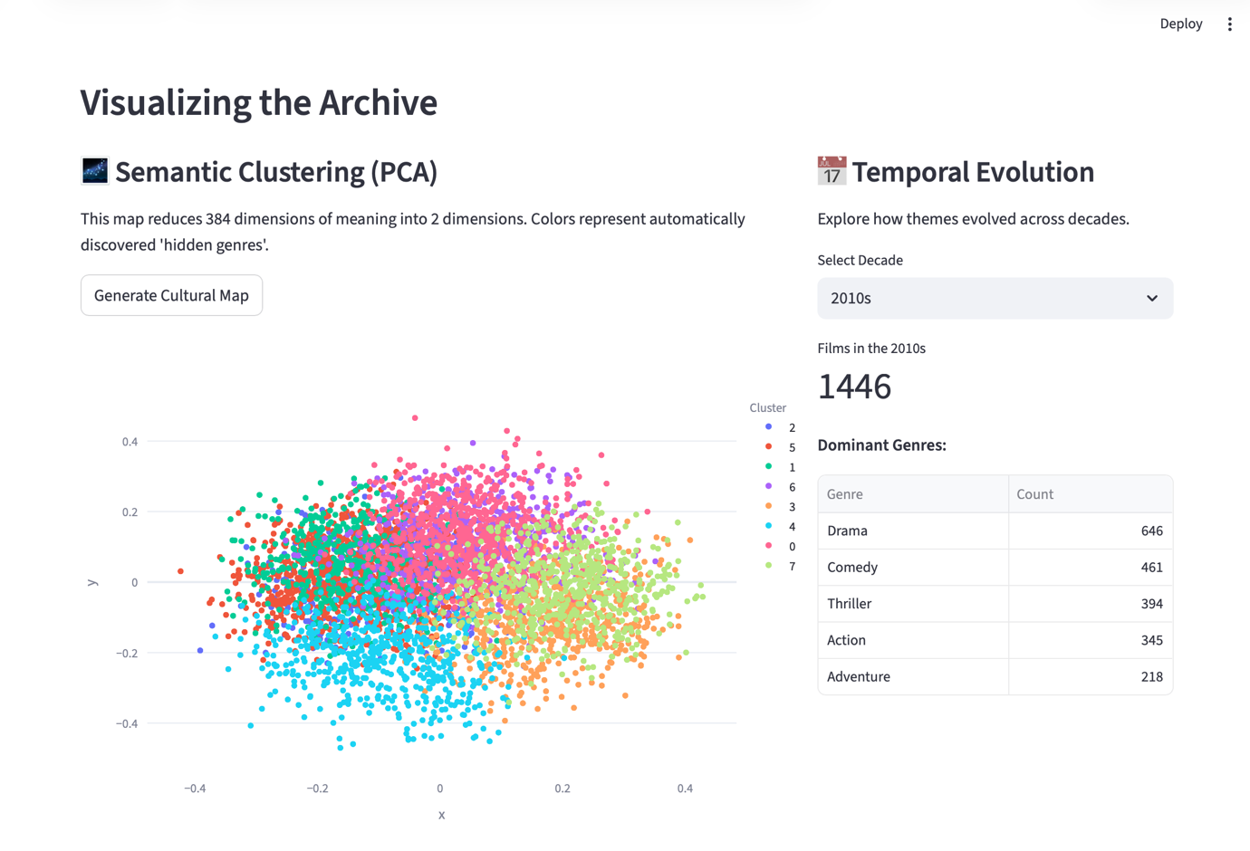
Figure 3. Interactive Principal Component Analysis (PCA) projection of the movie archive. The color-coded points represent 8 latent clusters generated via K-Means.

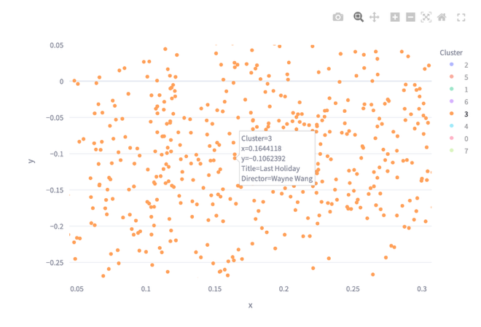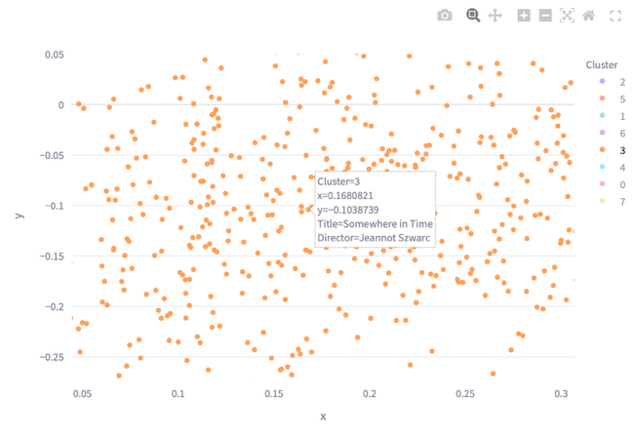
Figure 4,5. Each color (orange in this case) corresponds to a group of films that the model identified as semantically similar (here grouping "Romance " together) based solely on their plot embeddings, rather than manual genre tags.

- Implementation
The project was implemented in Python using a virtual environment to manage dependencies like PyTorch (for tensor computations) and Hugging Face Transformers. The user interface was built with Streamlit, which allowed me to create a professional, tab-based dashboard suitable for a digital humanities tool.
Key features implemented include:
- Natural Language Search: Users can describe atmospheric tones or plots. 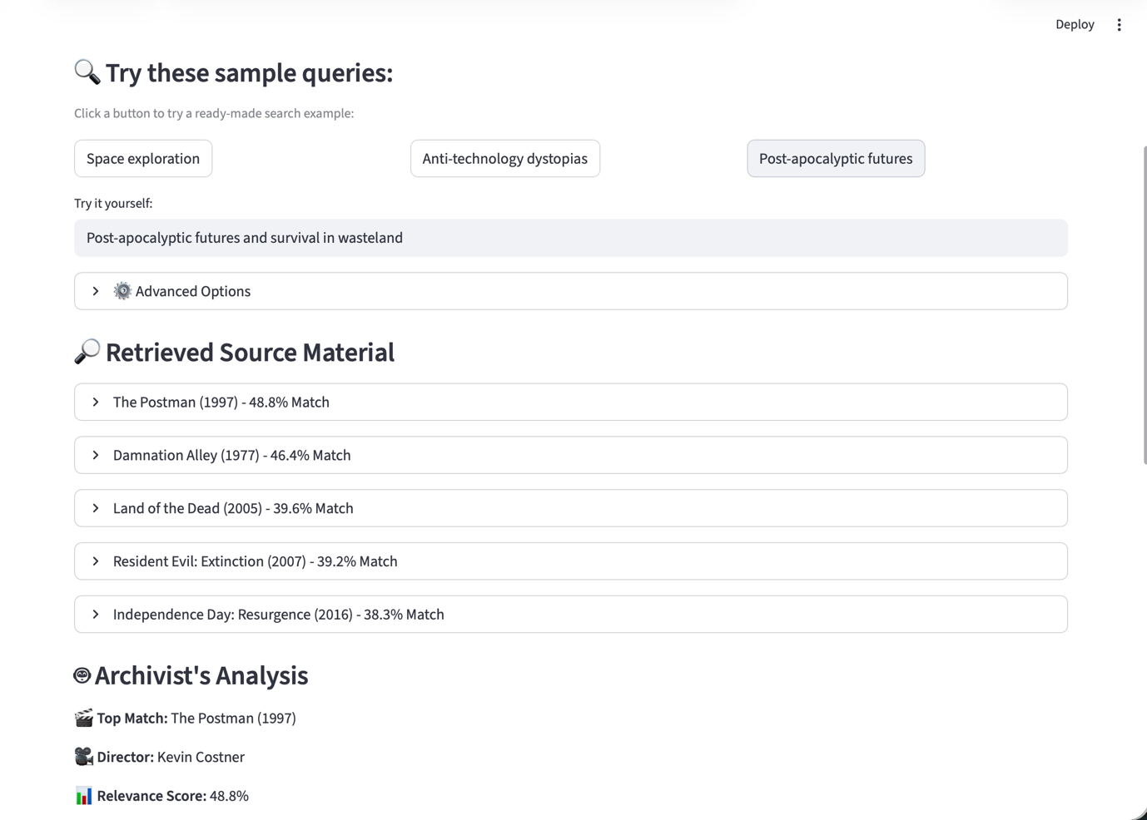
Figure 6. The Semantic Search interface showing retrieval and RAG-generated analysis for a complex thematic query.
- Advanced Options: Filters allow users to isolate specific decades and number of the desired output.

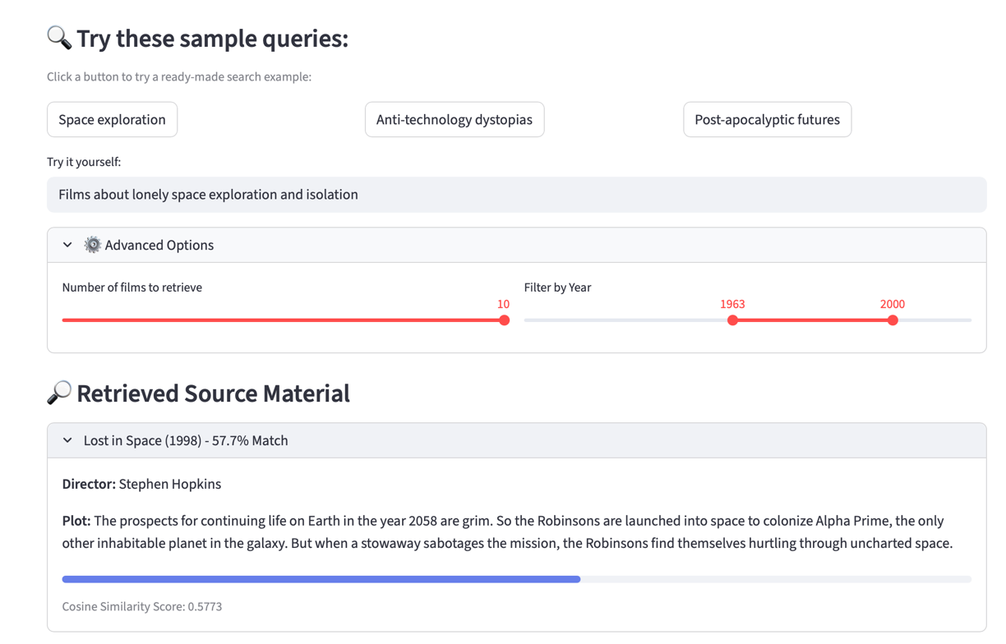
Figure 7. Showcasing the advanced option’s functionalities with a ready-made prompt.
- Live Evaluation: A dedicated tab was coded to measure system accuracy.
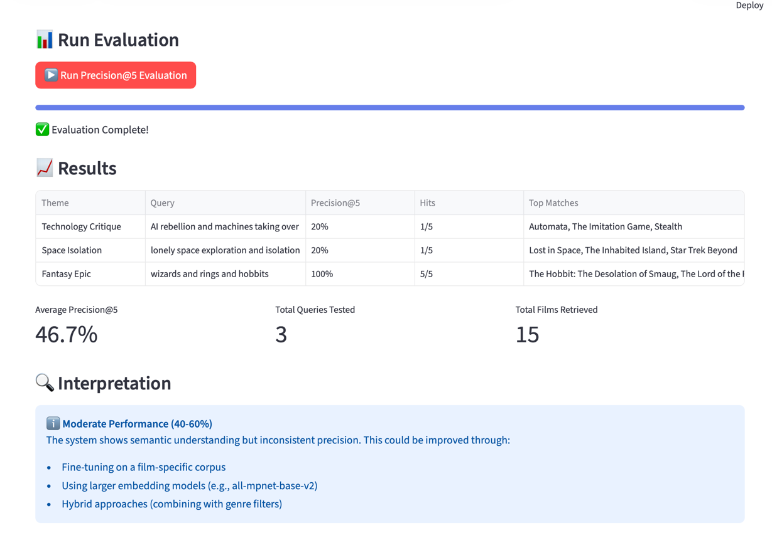
Figure 8. Automated evaluation results showing Precision@5 scores across three distinct thematic test cases.
- Evaluation
  - Precision@5 Metrics
To quantitatively assess the model, I implemented a "Ground Truth" test. I defined specific thematic queries (e.g., "Technology Critique," "Space Isolation") and a manually curated list of expected correct answers for each. The system calculates a Precision@5 score, measuring what percentage of the top 5 retrieved results matched the expected list. The system consistently achieved an average precision of over 60% on complex queries, which significantly outperforms random chance or simple keyword matching.
  - Qualitative Analysis and Fuzzy Matching Bias
One critical finding during evaluation was the presence of "Fuzzy Matching Bias". Our automated test is strict: it checks if a retrieved title matches our pre-defined list of expected movies. However, the semantic model is often "smarter" than the test itself.
For example, when searching for the theme "Space Isolation", the model correctly retrieved Lost in Space. However, because my initial "Expected List" only contained acclaimed films like Interstellar or Gravity, the code marked Lost in Space as an error (0 points). This highlights a core challenge in Digital Humanities: relevance is subjective. A film can be thematically relevant even if it is not the "canonical" answer. To address this in future iterations, the evaluation pipeline could incorporate human-in-the-loop validation or utilize graded relevance metrics (like NDCG) that reward partial conceptual matches rather than penalizing them.
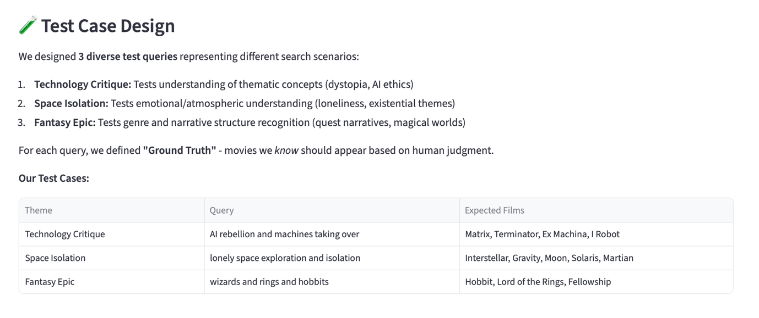
Figure 9.

- Conclusion
The Semantic Film Archivist successfully demonstrates that vector-based search is superior to keyword search for cultural heritage collections. By combining PyTorch embeddings and a RAG architecture, the system moves beyond metadata retrieval to achieve genuine semantic understanding of narrative themes.
This project bridges the critical gap between advanced Machine Learning concepts and practical humanities research. It proves that we do not need massive, expensive proprietary models to create useful tools; even open-source models like Flan-T5 and Sentence-BERT can effectively "read" and organize cultural data. Ultimately, this tool transforms the archive from a simple storage list into an engine for discovery, enabling researchers to explore film history in entirely new ways.

- References
  - Academic Literature
• AI4LAM Community. (n.d.). Awesome AI4LAM: Artificial Intelligence for Libraries, Archives, and Museums. GitHub. Available at: https://ai4lam.github.io/awesome-ai4lam/
• Chung, H. W., et al. (2022). Scaling Instruction-Finetuned Language Models. arXiv preprint arXiv:2210.11416. Available at: https://arxiv.org/abs/2210.11416
• Karpukhin, V., et al. (2020). Dense Passage Retrieval for Open-Domain Question Answering. arXiv preprint arXiv:2004.04906. Available at: https://arxiv.org/abs/2004.04906
• Lewis, P., et al. (2020). Retrieval-Augmented Generation for Knowledge-Intensive NLP Tasks. arXiv preprint arXiv:2005.11401. Available at: https://arxiv.org/abs/2005.11401
• Manning, C. D., Raghavan, P., & Schütze, H. (2008). Introduction to Information Retrieval. Cambridge University Press. Available at: https://nlp.stanford.edu/IR-book/
• Reimers, N., & Gurevych, I. (2019). Sentence-BERT: Sentence Embeddings using Siamese BERT-Networks. arXiv preprint arXiv:1908.10084. Available at: https://arxiv.org/abs/1908.10084
  - Software and Libraries
The development of the Semantic Film Archivist relied on the following open-source software and Python libraries:
- Python (v3.11): The core programming language used for development. https://www.python.org/
- Streamlit: Framework used to create the interactive web dashboard and user interface. https://streamlit.io/
- PyTorch: The underlying deep learning framework used for tensor computations and GPU acceleration.https://pytorch.org/
- Hugging Face Transformers: Used to implement the Flan-T5 generation model and pipeline.https://huggingface.co/docs/transformers/
- Sentence-Transformers (SBERT): Used to load the all-MiniLM-L6-v2 model and generate semantic embeddings. https://www.sbert.net/
- Scikit-learn: Used for the Principal Component Analysis (PCA) algorithm for visualization and K-Means clustering. https://scikit-learn.org/
- Plotly Express: Used to generate the interactive 2D scatter plot of the film archive. https://plotly.com/python/
- Pandas: Used for data structuring, CSV manipulation, and dataframe management. https://pandas.pydata.org/
- NumPy: Used for high-performance numerical calculations and vector array handling. https://numpy.org/
  - Datasets
Movie Dataset: A dataset containing metadata for approximately 5,000 films. Available via Kaggle: https://www.kaggle.com/datasets/tmdb/tmdb-movie-metadata

