Section 1 — Outlook Connection
This section explains how to connect your Microsoft Outlook calendar to TrackFlow so that calendar events can be pulled in directly as time entries.

Step 1 Click the Outlook Icon in TrackFlow
In TrackFlow, navigate to your integrations or settings panel and click on the Outlook icon in the Time Page to begin the connection process.
Time Page

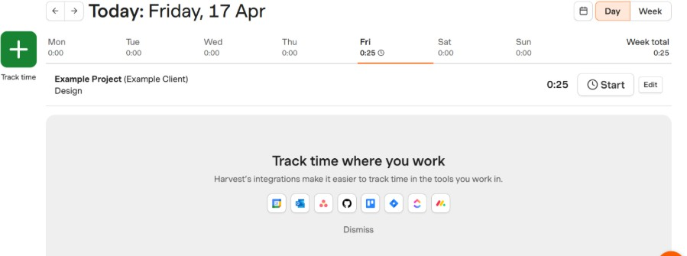

Settings -> Integration Option
Check Outlook.com option and click Connect button.
After successfully enabling the integration, Outlook will display a "Connected" status confirming the link between TrackFlow and your Outlook calendar is active.

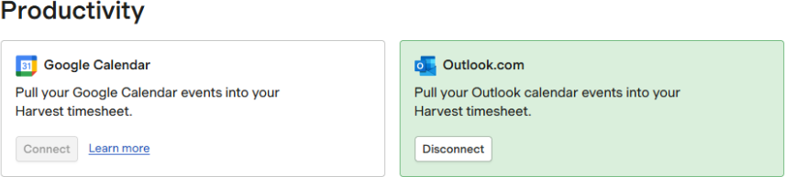

Step 2 Enable the Integration via Time Page
Click “Connect to Outlook” button visible on the left banner to allow TrackFlow to connect with your Outlook account. You may be prompted to sign in with your Microsoft credentials.

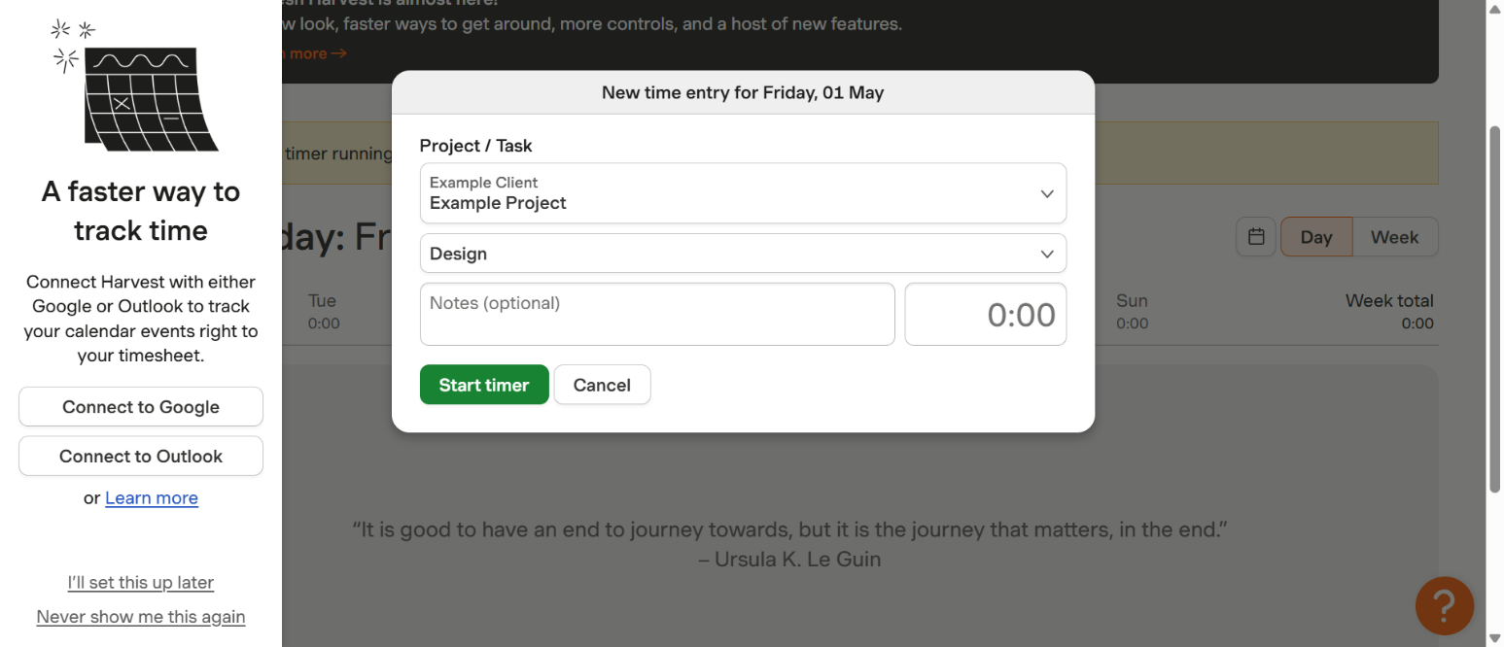

After successfully connection, the below page will show.

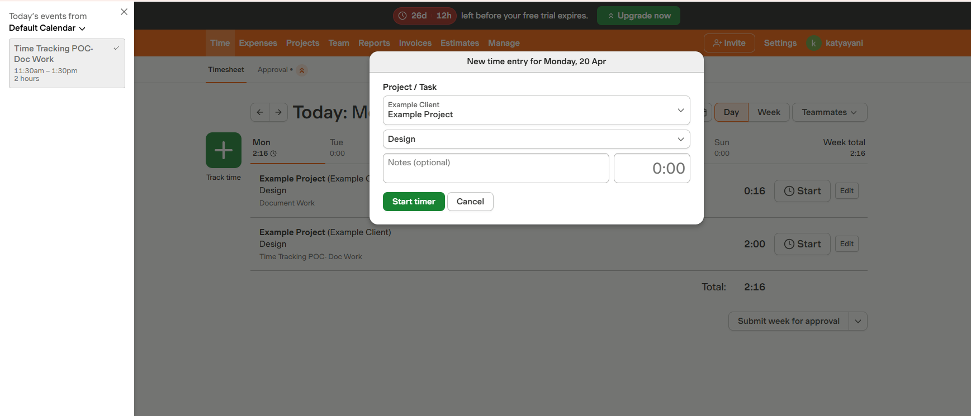

Step 4 Click "Pull in a Calendar Event" Option
Once connected, use the "Pull in a calendar event" option to import your Outlook calendar events directly into TrackFlow. This allows you to start a timer from any scheduled meeting or event.
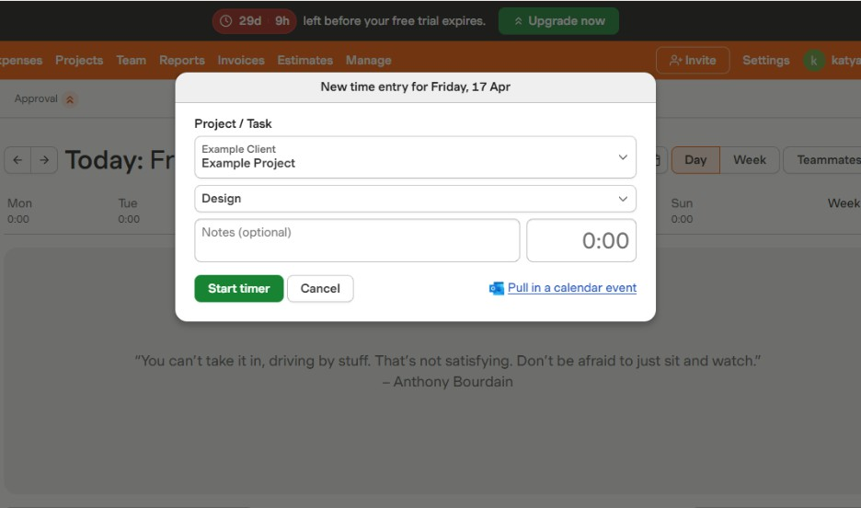
Step 5 Enter Time and Click Start Timer
After pulling in a calendar event, review the pre-filled time entry details, adjust the duration if needed, and click Start Timer to begin tracking time for that event in TrackFlow.
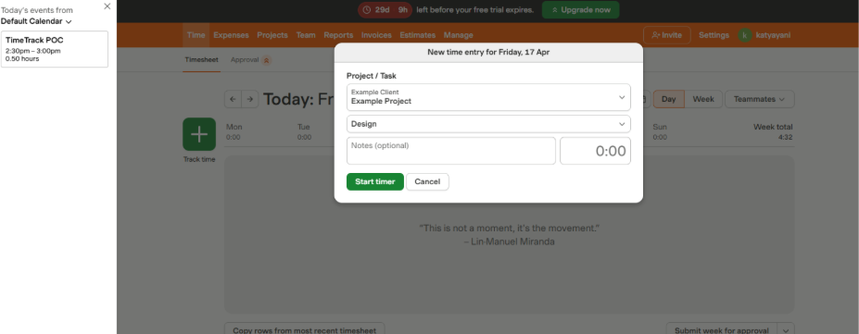
Note: Calendar events pulled from Outlook will appear with their event title and duration pre-filled. You can edit these details before starting the timer.

Click Calendar event from left banner and fill the Time on the popup..

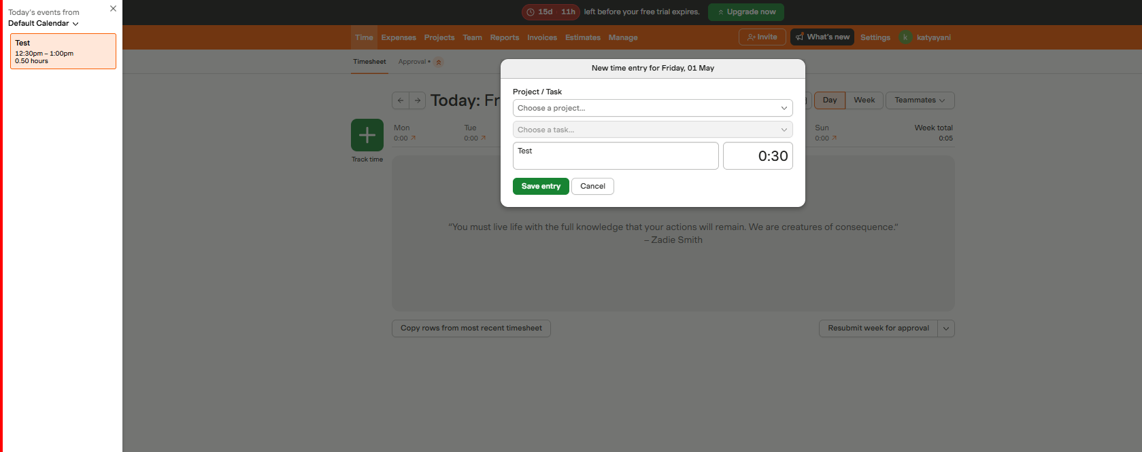

Click Save entry

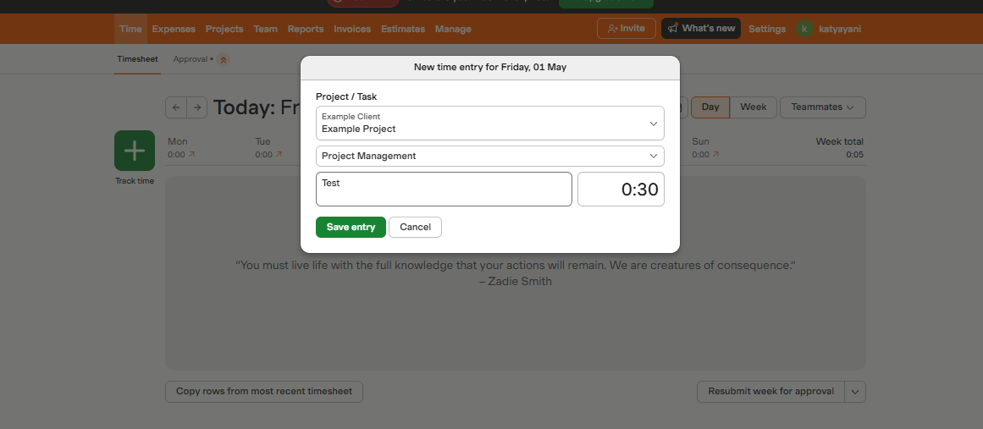

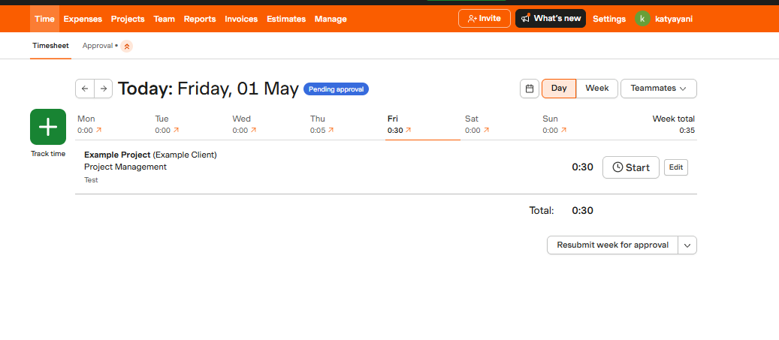
After creating and added time the event will show gray and Non-clickable.. New Entry will only be added.

