Integration Guide
Outlook & JIRA
with TrackFlow Time Tracking
Step-by-step setup and usage instructions

Section 1 — Outlook Connection
This section explains how to connect your Microsoft Outlook calendar to TrackFlow so that calendar events can be pulled in directly as time entries.

Step 1 Click the Outlook Icon in Trackflow
In TrackFlow, navigate to your integrations or settings panel and click on the Outlook icon to begin the connection process.
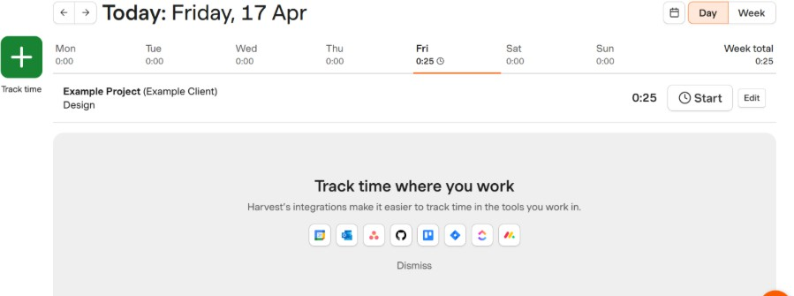

Step 2 Enable the Integration
Click “Connect to Outlook” button to allow TrackFlow to connect with your Outlook account. You may be prompted to sign in with your Microsoft credentials.

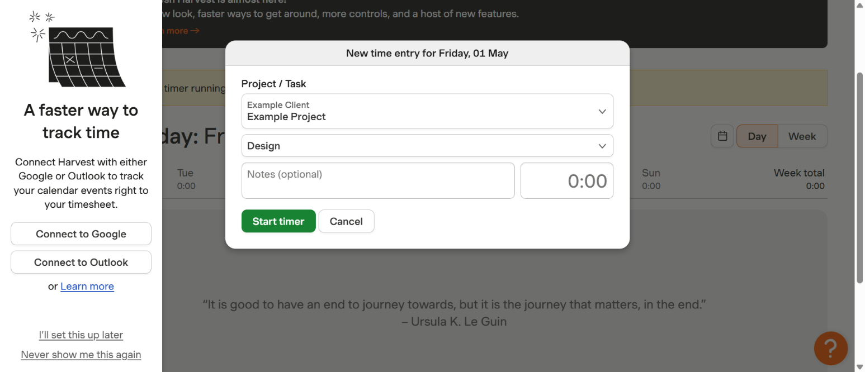
After successfully connection, the below page will show.
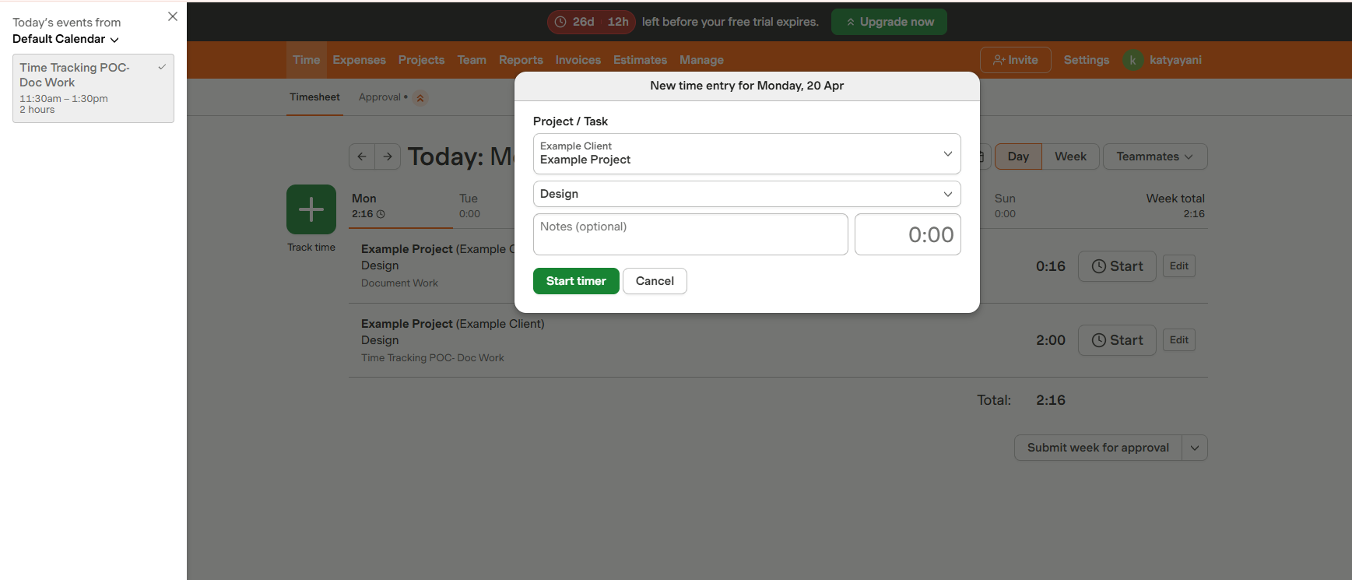

Step 3 OR we can also integrate Outlook through Settings -> Integrations page
After successfully enabling the integration, Outlook will display a "Connected" status confirming the link between TrackFlow and your Outlook calendar is active.
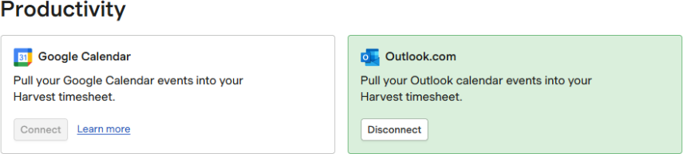
Step 4 Click "Pull in a Calendar Event" Option
Once connected, use the "Pull in a calendar event" option to import your Outlook calendar events directly into TrackFlow. This allows you to start a timer from any scheduled meeting or event.
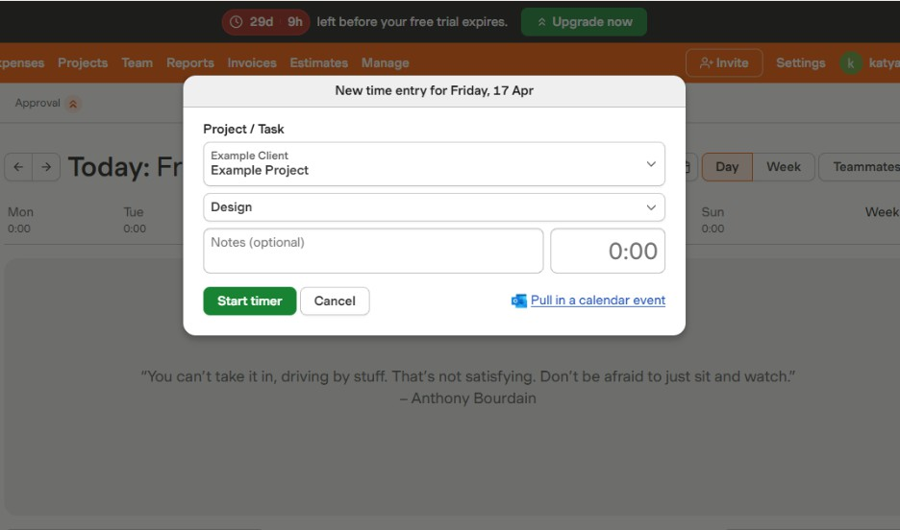
Step 5 Enter Time and Click Start Timer
After pulling in a calendar event, review the pre-filled time entry details, adjust the duration if needed, and click Start Timer to begin tracking time for that event in TrackFlow.
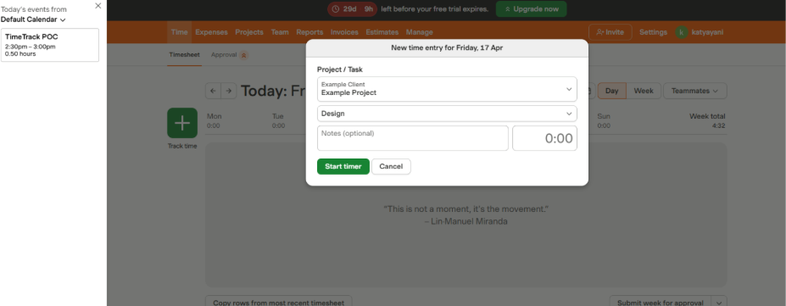
Note: Calendar events pulled from Outlook will appear with their event title and duration pre-filled. You can edit these details before starting the timer.

Click Calendar event from left banner and fill the Time on the popup..

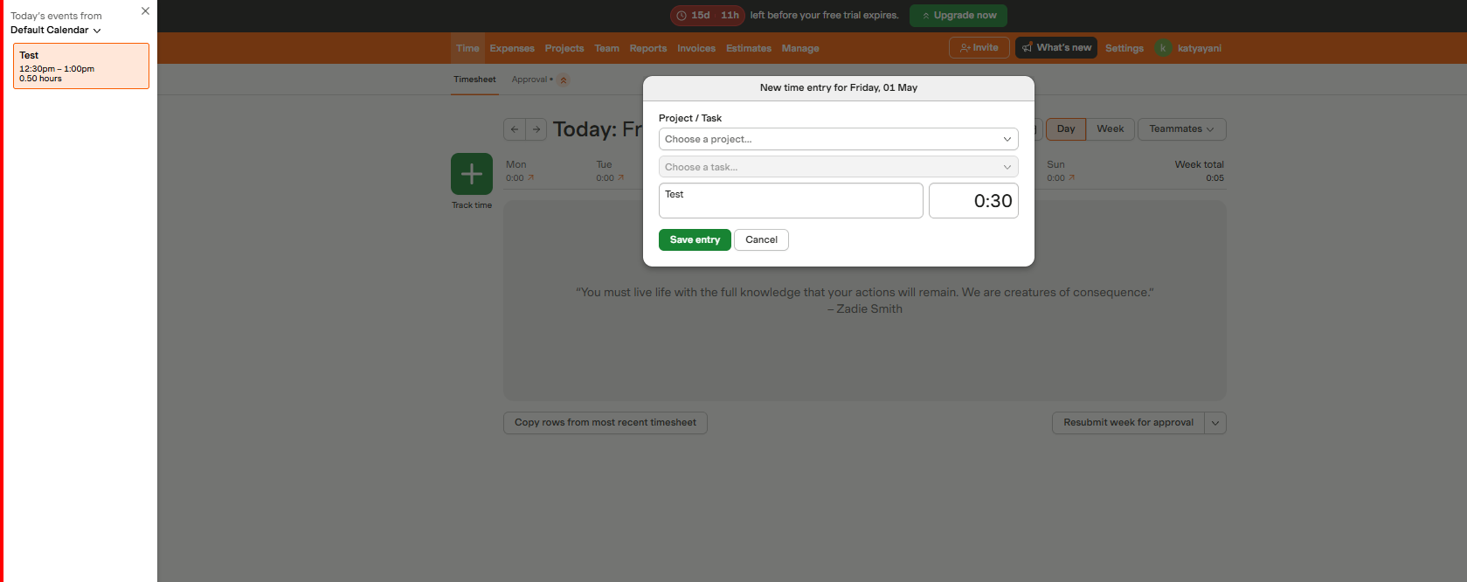

Click Save entry

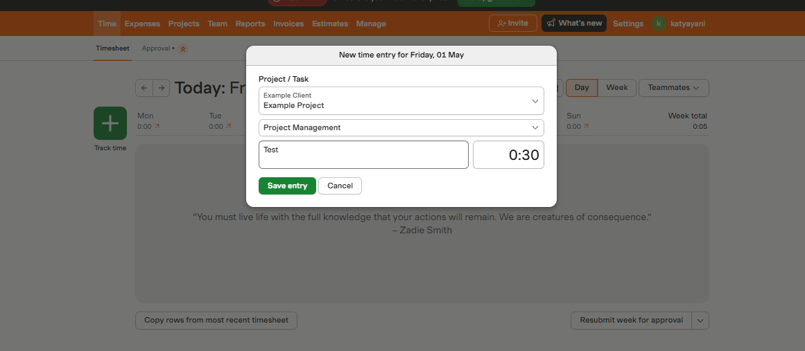

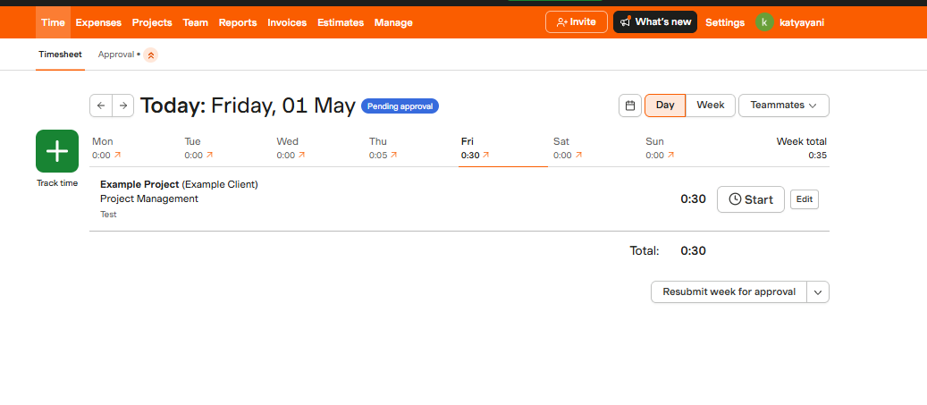
After creating and added time the event will show gray and Non-clickable.. New Entry will only be added.

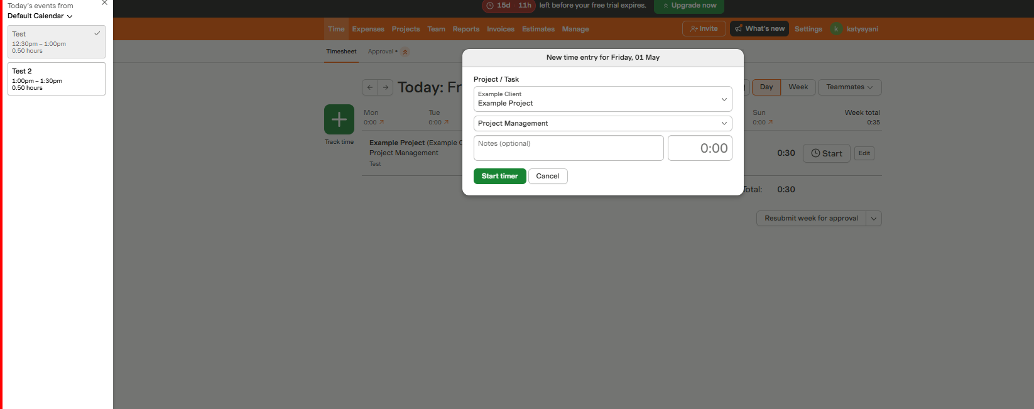

Section 2 — JIRA Connection
This section covers how to integrate JIRA with TrackFlow, enabling you to log time directly against JIRA issues/tasks without leaving JIRA.

Part A — Install the TrackFlow App in JIRA
Step 1 Click "Connect JIRA" in TrackFlow
In TrackFlow, go to Integrations and click the Connect JIRA option to initiate the integration setup from the TrackFlow side.
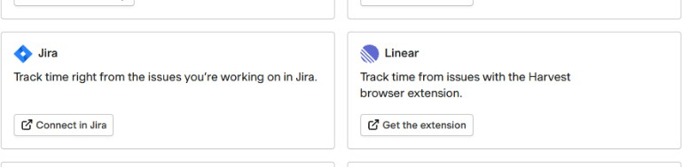
Step 2 Search for the TrackFlow App inside JIRA Marketplace
Create an account in JIRA (if you don't have one), then navigate to the Atlassian Marketplace from inside your JIRA instance. Search for "TrackFlow" to find the official TrackFlow time-tracking app for JIRA.
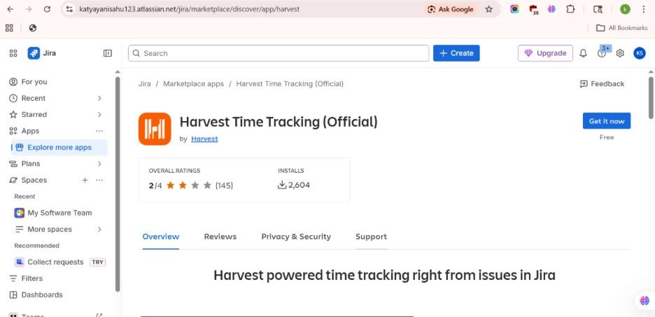
Step 3 Click "Get it Now"
On the TrackFlow app listing in the Atlassian Marketplace, click the "Get it Now" button to begin the installation process.
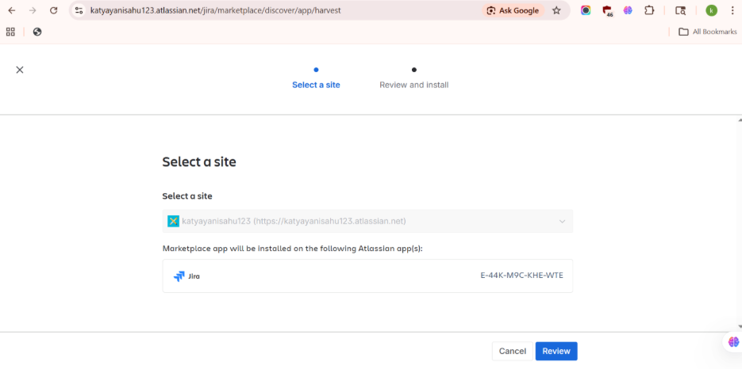
Step 4 Click "Review" to Confirm Permissions
Review the permissions that the TrackFlow app will require in your JIRA instance. Ensure all required access is acceptable, then proceed.
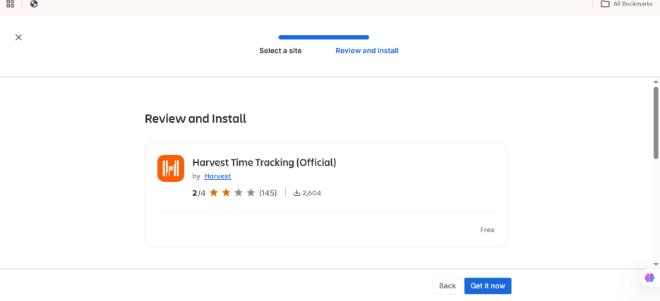
Step 5 Click "Get it Now" — Installation Confirmed
Click the "Get it Now" button again to confirm the installation. Once complete, JIRA will display a confirmation message showing the TrackFlow app is installed successfully.
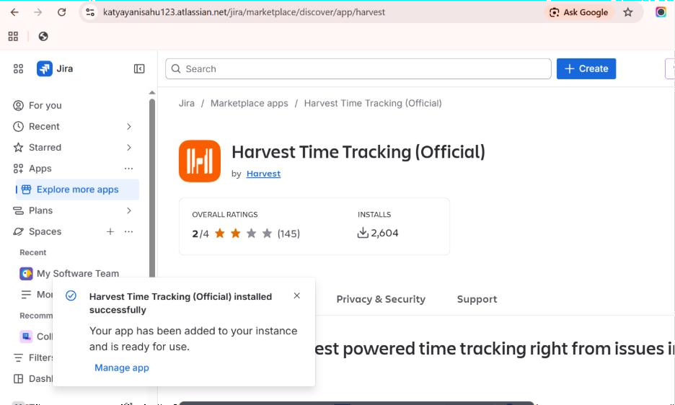
Note: After installation it may take a few moments for the TrackFlow panel to appear inside JIRA tasks. Refresh the page if the panel does not appear immediately.

Part B — Log Time from JIRA Tasks
Step 6 Go to a JIRA Task
Navigate to any JIRA project and open a task/issue on which you want to log time. The TrackFlow panel will be visible in the right-hand side panel of the issue.
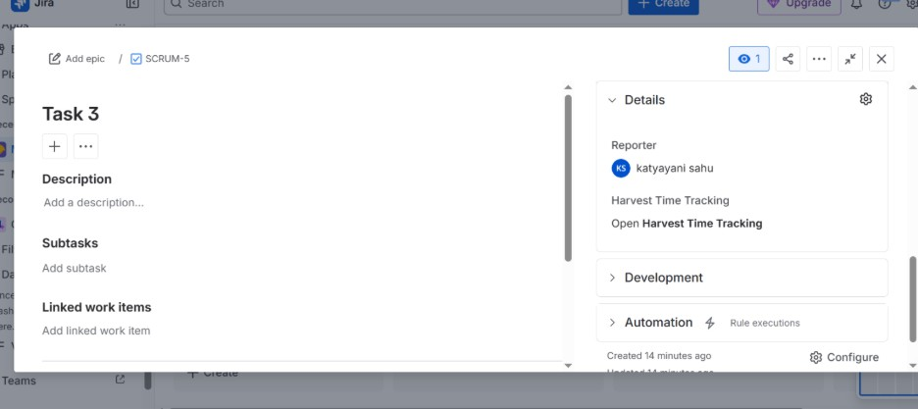
Step 7 Click "Open TrackFlow Time" Option
In the JIRA issue view, locate the TrackFlow panel on the right side and click the "Open TrackFlow Time" option to expand the time-tracking widget.
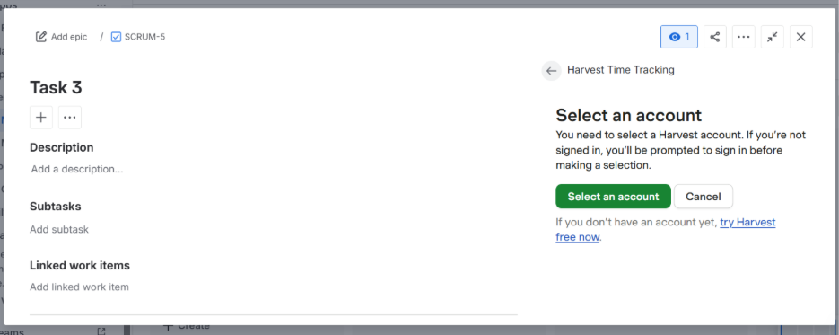
Step 8 Select an Account & View Time Entry Page
Select the relevant TrackFlow account from the dropdown list. The TrackFlow time entry page for that JIRA issue will then be displayed, showing existing time entries and an option to add a new one.
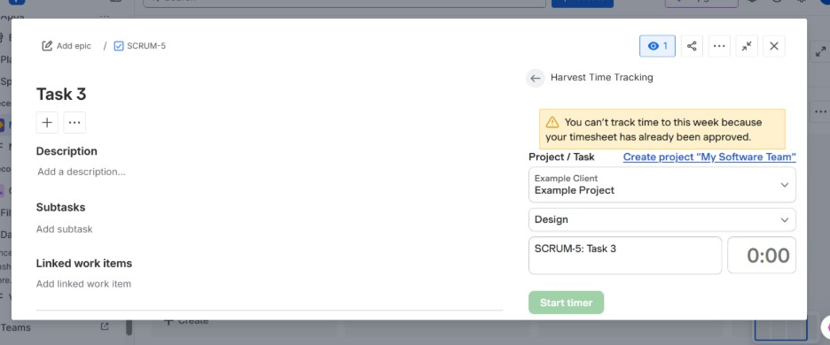
Step 9 Withdraw Approved Timesheet in TrackFlow (if Required)
If the timesheet for the relevant period has already been approved in TrackFlow, you will need to withdraw the approval first before new time entries can be added. After withdrawing, refresh the JIRA page — the time entry will then show as active and editable.
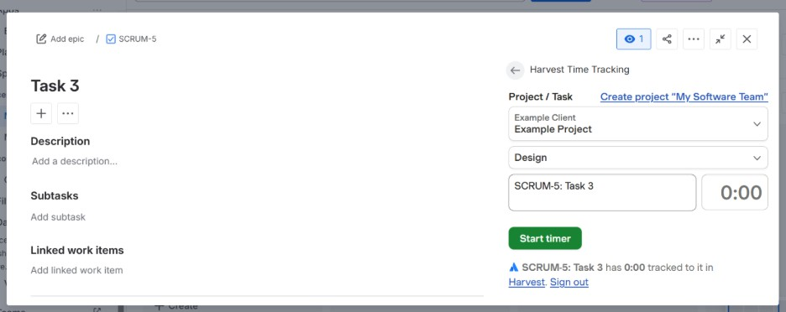
Note: Withdrawal of an approved timesheet must be done by an Admin or Owner in TrackFlow. Once withdrawn the timesheet status will change from "Approved" to "Active", allowing new time entries.

Step 10 Add Time and Click Start Timer
Enter the time details for the JIRA task and click "Start Timer". The time entry will immediately reflect in and update the corresponding TrackFlow timesheet, keeping your project tracking in sync across both tools.
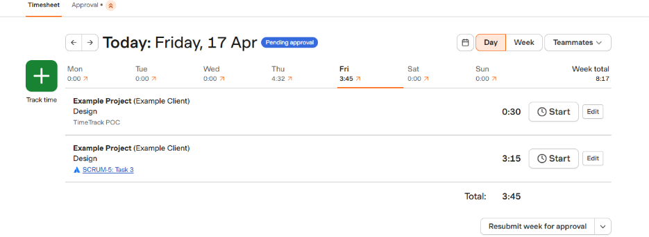
Note: Time entries started from JIRA will appear in TrackFlow under the project and task assigned to that JIRA issue. Ensure the correct project/task mapping is configured in your TrackFlow JIRA settings.

