**Table of Contents**

**I****. Proposal** **2**

**Introduction** **2**

**Scope:** **2**

**Goals:** **2**

**II. ERD** **3**

**III. Design** **4**

**IV.Appendix** **5**

**Relationship** **5**

**Data Dictionary****5**

**Screenshot from R Shiny****:** **10**

# Proposal

# Introduction

There is no doubt that buying a home is a significant life decision. Our company understands the importance of this endeavor and offers a comprehensive suite of services to ensure a smooth, efficient, and profitable transaction for all parties involved. This proposal outlines our services and the benefits of partnering with us for your home sales needs.

# Scope:

* ***Market Inventory***

Our project centers on developing a sophisticated app designed to revolutionize the home sale market in Dallas. This application aims to provide comprehensive support and insights to both buyers and realtors in the Dallas area. **The primary function of the app is to offer an extensive database of available properties, complete with detailed descriptions, pricing.** Users will have the ability to conduct refined searches based on specific criteria such as location, price range, property type, and more, ensuring a tailored and efficient home-buying experience. Besides being comprehensive, this application will also be time-saving. Our client would benefit from the compilation of live listings from popular sites in order to save valuable time and not miss out on any listings.

* ***Market Dynamics***

Moreover, our data-driven approach extends to providing real-time market analytics. This feature will offer users and professionals in the real estate sector insights into **Dallas's housing market trends, such as price fluctuations, for sale inventory dynamics, and new listings**. This information will be crucial for buyers in making informed decisions and for sellers and realtors in developing effective marketing and pricing strategies. Integrate a mortgage calculator which enables clients to better finance their options.

In summary, our app aims to be a comprehensive tool for the Dallas home sale market, facilitating easier and more informed buying and selling decisions through a combination of a rich property database and sophisticated data analytics. It promises to enhance the property search experience for buyers while offering realtors and sellers a valuable resource for understanding and adapting to market dynamics.

# Goals:

Our Dallas Home Sale Application is set to redefine the real estate landscape in Dallas. Designed with a meticulous blend of comprehensive property listings and cutting-edge analytics, the platform aims to be an indispensable tool for both potential home buyers and realtors. Users will benefit from a rich database offering detailed property descriptions, historical sales data, all presented within an intuitive interface that streamlines the search process. Meanwhile, real-time market analytics will equip realtors and sellers with the insights necessary to craft effective marketing strategies and set competitive prices. With a focus on user experience, informed decision-making, and continuous enhancement, the application aspires to become the paramount hub for Dallas's home sale market, simplifying property transactions and setting a new standard for digital real estate platforms. As we focus on the Dallas market, the app's scalable architecture is designed with the foresight to potentially expand to other regions, reinforcing our ambition to revolutionize the real estate market on a broader scale.

# ERD

In our database design, the E-R diagram reflects the relationships between houses, agents, listings, and sales contracts, tailored to the real estate market's needs:

* House-Listing: A one-to-many relationship allowing multiple listings per house, reflecting real-world scenarios of re-listing.
* Agent-Listing: A flexible zero or one-to-many relationship caters to the possibility of listings without agents.
* SalesContract-Agent: A many-to-one relationship acknowledges that an agent can manage multiple contracts.
* House-SalesContract: A one-to-zero/one relationship accounts for houses that may not always result in a sale.
* Listing-SalesContract: A one-to-zero/one relationship ensures each contract is linked to only one listing, though not all listings lead to a contract.

Transformation to Tables:

The E-R diagram was systematically converted into tables by creating a table for each entity and translating relationships into foreign keys. The relationships were straightforward, involving primary-foreign key mappings.

Normalization:

Our tables were normalized to 3NF to ensure data integrity and eliminate redundancy. This involved removing any attributes that were not dependent on the primary key, thus streamlining the data structure and improving database efficiency.

# III. Design

We designed the Shiny user interface and workflow for this real estate management application with an emphasis on user-friendliness and functional clarity. Utilizing the shiny dashboard package, we structured the layout into a header, a sidebar, and a main body.

**User interface design included:**

In the header, we placed the title "ITOM6265 Group 8" to impart a professional feel. The sidebar was equipped with menu items for various functions such as viewing market listings and adding new houses, each accompanied by an icon for easy identification.

In the main body, we adopted a tabbed structure where each tab, like "House On Market" or "Add New House", serves a specific purpose. This approach aids in neatly organizing the content. Within each tab, we used boxes to group related UI elements, thereby enhancing the user experience.

**Our user workflow design included:**

Data Viewing and Interaction: The application allows users to explore house listings through different tabs, featuring functionalities like interactive maps and agent-specific data.

Data Management: Users can add, update, or delete listings, facilitated by text inputs and action buttons, ensuring efficient data handling.

Data Filtering and Analysis: We included features for filtering listings based on various criteria and a separate tab for analytics, providing insights into Dallas real estate trends.

Feedback Mechanisms: We incorporated notifications for actions like adding or deleting houses to enhance interaction.

Our design philosophy is centered on creating a tool that is both informative and engaging for real estate professionals and enthusiasts, with a user-centric approach. We aimed to make the application intuitive and easily navigable, ensuring accessibility even for those with limited technical knowledge. Through clear labeling, logical grouping of elements, and a consistent theme, we ensured ease of use. Additionally, responsive and interactive elements enhance user engagement and provide immediate feedback based on user actions.

In summary, this Shiny application's design effectively merges functional complexity with user-friendly interfaces, tailored to facilitate the management and analysis of real estate data.

# IV.Appendix

* Relationship
* A house can have zero to many listings over time, a listing can list one house.
* An agent can manage zero or many listings, and a listing is managed by zero or one agent.
* A SalesContract can be managed by one agent and an agent can manage many SalesContract.
* A house can be included in zero or one SalesContract, a SalesContract can cover many houses.
* A listing leads to zero or one sales contract, a contract comes from one listing
* Data Dictionary
* Agent Table

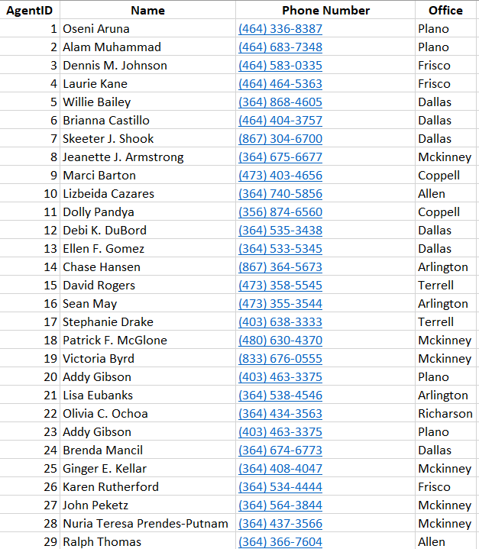

* House Table

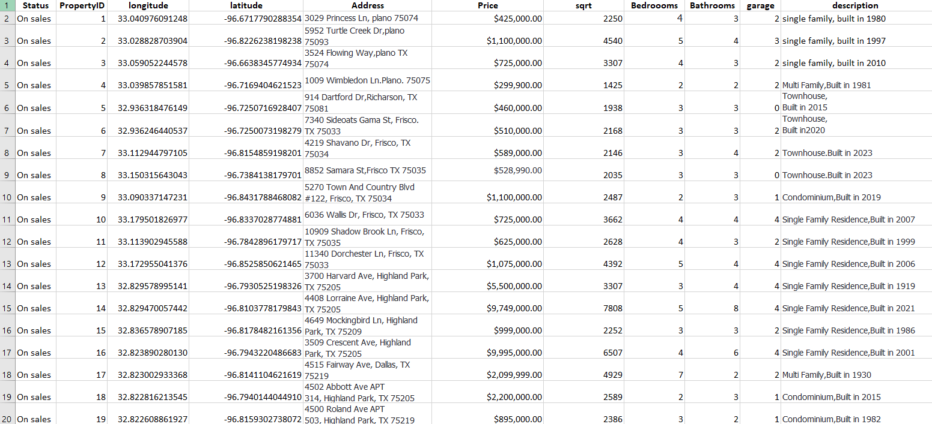

|  |
| --- |
|  |

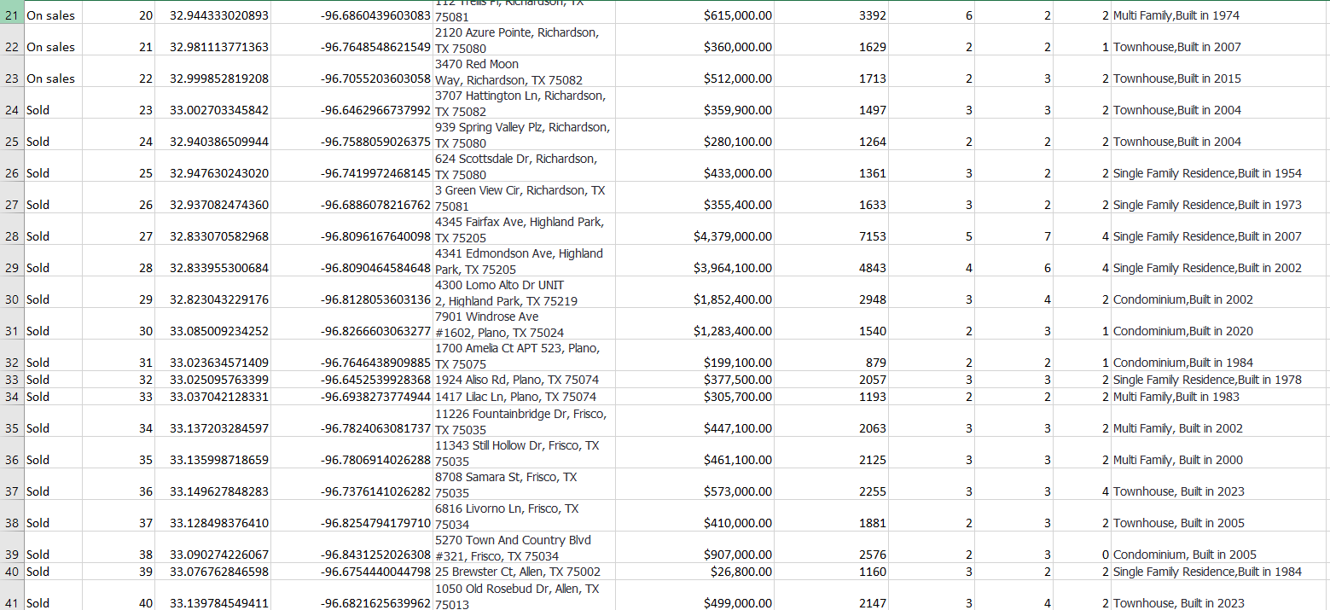

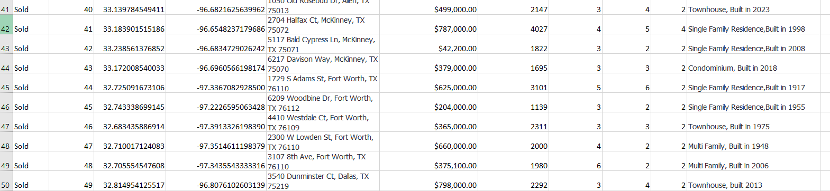

* Listing

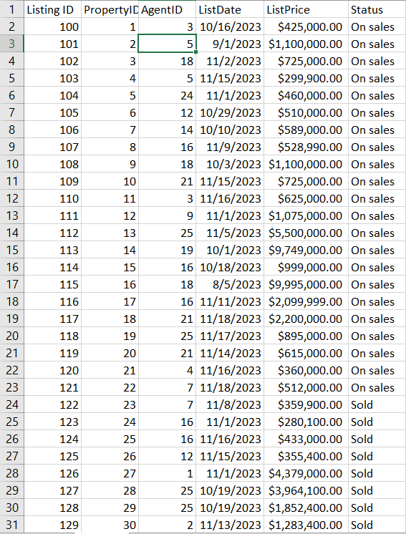

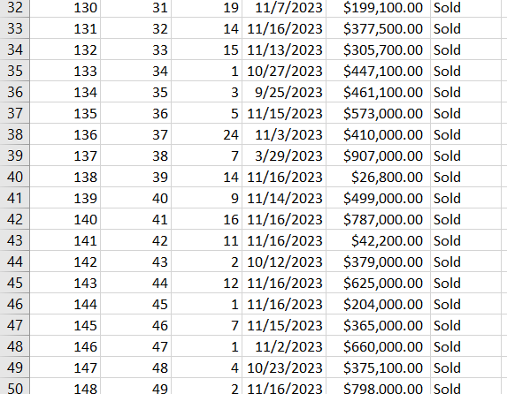

* Sales Contract

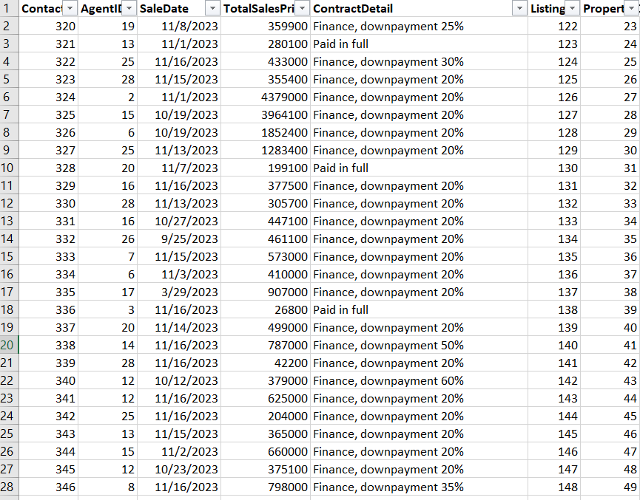

* Screenshot From R shiny

