**🧠 Behavioral Predictors of Infant Sleep: Summary of Findings**

**🔍 Overview of Analysis**

We examined how maternal behavioral and psychosocial factors during pregnancy predict infant sleep outcomes at 3 and 12 months postpartum. This was done using PCA-derived domain scores and original variables, followed by both linear regression and random forest modeling.

Outcomes analyzed:

* **Sleep duration at 3 months** (outcome_sleep_3mo)
* **Sleep duration at 12 months** (outcome_sleep_12mo)

📊 **Mental Health PCA Loadings Recap**

| **Variable** | **RC1 (Gen. Distress)** | **RC2 (COVID Distress)** | **RC3 (Preg. Anxiety)** | **RC4 (Noise)** |
| --- | --- | --- | --- | --- |
| **EPDS_T1** (Depression) | 0.965 |  |  |  |
| **Panx_t_T1** (Anxiety) | 0.965 |  |  |  |
| **PRAQ_T1** (Pregnancy Anxiety) |  |  | 0.955 |  |
| **Distress Thermometer (COVID)** |  | 0.998 |  |  |

**📊 Social Support PCA Summary**

| **Variable** | | **RC1** | **RC2** | **RC3** |
| --- | --- | --- | --- | --- |
| SSEQtotal_T1 | | **0.618** | 0.530 | 0.580 |
| TaskSupport | | **0.449** | 0.497 | **0.742** |
| InformSupport | | **0.518** | 0.513 | **0.676** |
| EmotSupport | | **0.612** | 0.533 | **0.583** |
| NegSupport | | **0.611** | 0.533 | **0.583** |
| CSI_T1 | | 0.400 | **0.803** | 0.441 |
|  | |  |  |  |
| **Component** | **Interpretation** | | | | | **Variance (%)** |
| **RC1** | Broad social support (SSEQ items) | | | | | 29.3% |
| **RC2** | **Couple satisfaction** + some SSEQ | | | | | 33.4% |
| **RC3** | **Task/informational/emotional support** | | | | | 37.0% |
| **RC4–6** | Noise | | | | | ~0% |

**📊 Health Behaviors PCA Interpretation**

This is a **classic “one-variable-per-component” pattern**, where each behavior loads almost exclusively on its own PC:

| **Variable** | **Strongest Loading** | **Interpretation** |
| --- | --- | --- |
| preg_demo_alch_while_week | RC4 = **0.97** | Alcohol use |
| preg_demo_tobac_during_week | RC3 = **0.97** | Tobacco use |
| preg_demo_cannab_during_week | RC5 = **0.97** | Cannabis use |
| preg_demo_drugs_while_week | RC2 = **0.97** | Other drug use |
| PA_T1 | RC1 = **0.93** | Physical activity |
| CDN_PA_met | RC7 = **0.89** | Physical activity (alt metric) |
| GodinT1 | RC6 = **0.93** | Physical activity (Godin) |

**📊 SES PCA Summary**

| **Variable** | **Strongest Loading** | **Interpretation** |
| --- | --- | --- |
| preg_demo_income | RC2 = **0.978** | Income |
| Education | RC4 = **1.000** | Education |
| preg_demo_food_scarcity | RC5 = **0.958** | Food insecurity |
| preg_demo_foodbank | RC1 = **0.972** | Food bank use |
| preg_demo_stablehome | RC3 = **0.982** | Housing stability |

**💤 Significant Correlates of Infant Sleep at 3 Months**

| **Predictor** | **Correlation** | ***p* value** |
| --- | --- | --- |
| COVID-specific distress (*mh_pc2_covid*) | –0.098 | 1.15 × 10⁻⁶ |
| Stable housing (*ses_stablehome*) | –0.090 | 2.25 × 10⁻⁵ |
| Prenatal anxiety (*hh_during_anxiety*) | –0.077 | 1.43 × 10⁻³ |
| Pre-pregnancy anxiety (*hh_pre_anxiety*) | –0.074 | 3.08 × 10⁻³ |
| Pre-pregnancy depression (*hh_pre_depression*) | –0.066 | 2.40 × 10⁻² |

**💤 Significant Correlates of Infant Sleep at 12 Months**

| **Predictor** | **Correlation** | ***p* value** |
| --- | --- | --- |
| Household income (*ses_income*) | +0.162 | 1.06 × 10⁻²¹ |
| Stable housing (*ses_stablehome*) | –0.118 | 4.84 × 10⁻¹¹ |
| COVID-specific distress (*mh_pc2_covid*) | –0.109 | 1.64 × 10⁻⁹ |
| Pre-pregnancy depression (*hh_pre_depression*) | –0.093 | 1.92 × 10⁻⁶ |
| Pregnancy-specific anxiety (*mh_pc3_preganx*) | –0.082 | 6.07 × 10⁻⁵ |
| Pre-pregnancy anxiety (*hh_pre_anxiety*) | –0.082 | 8.58 × 10⁻⁵ |
| Food scarcity (*ses_foodscarce*) | +0.073 | 1.59 × 10⁻³ |
| Physical activity (Godin score, *hb_pa_godin*) | +0.065 | 1.22 × 10⁻² |
| Prenatal depression (*hh_during_depression*) | –0.062 | 2.94 × 10⁻² |

**🧮 Model Overview**

* **Outcome variable:** outcome_sleep_3mo (infant sleep duration at 3 months)
* **Model type:** Linear regression
* **Sample size:** 3,510 complete cases
* **R² (explained variance):** 1.88%
* **Adjusted R²:** 1.74%
* **Model significance:** *F*(5, 3504) = 13.43, **p** < 0.001  
  → The model is statistically significant overall, but effect size is small.

**📊 Predictors of Infant Sleep at 3 Months**

| **Predictor** | **Estimate** | ***p* value** | **Interpretation** |
| --- | --- | --- | --- |
| **Intercept** | 75.99 | < .001 | Average sleep when all predictors = 0 (baseline) |
| **mh_pc2_covid** | –0.88 | < .001 ** | Higher COVID-specific distress is associated with **less sleep** |
| hh_during_anxiety | –0.63 | 0.267 | Not statistically significant |
| hh_pre_anxiety | –1.00 | 0.056 · | Not statistically significant |
| ses_income | –0.08 | 0.427 | Not significant |
| **ses_stablehome** | –4.99 | < .001 ** | Unstable housing is associated with **substantially less sleep** |

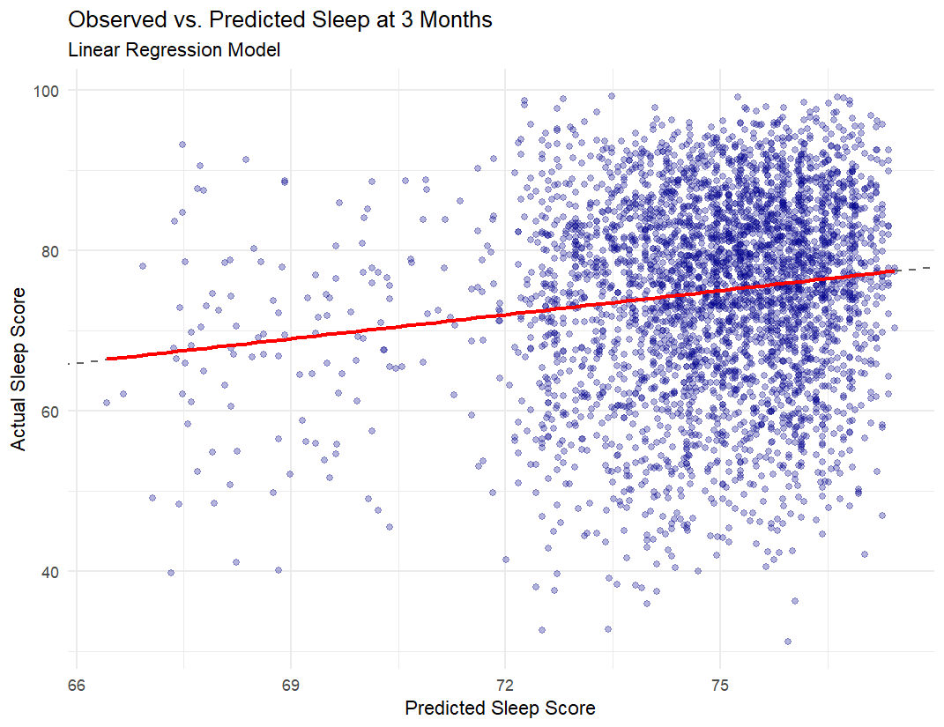

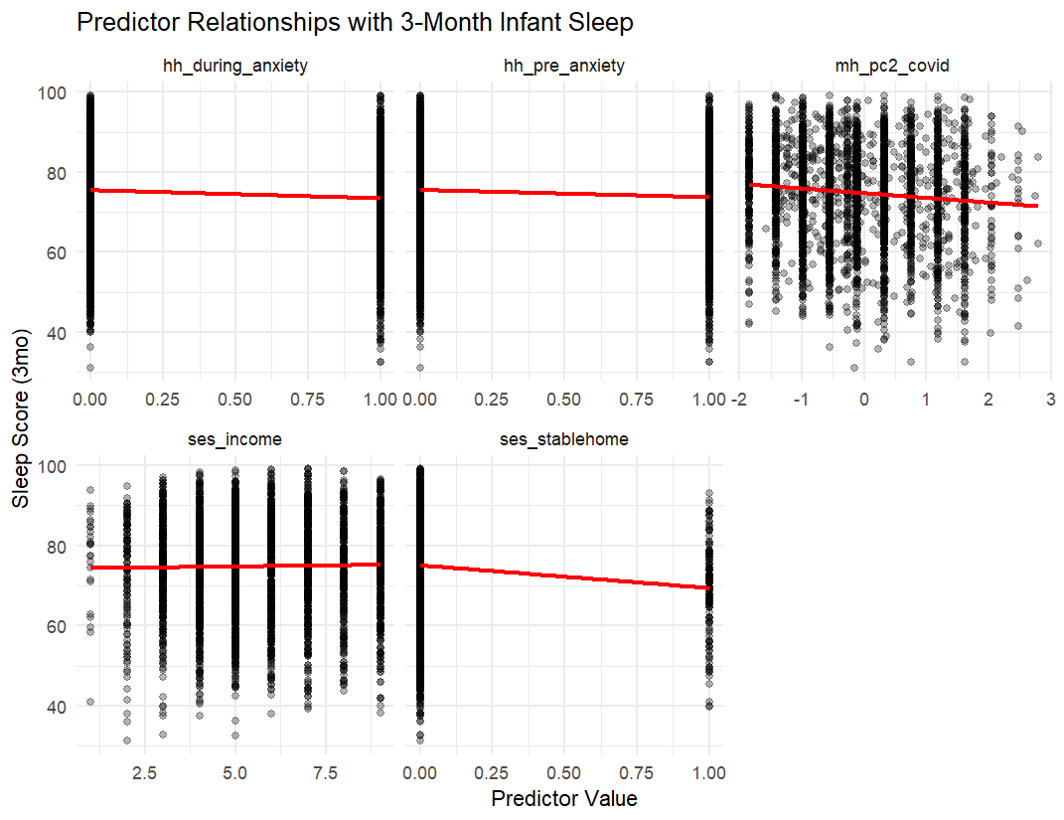

**🌲 Random Forest Summary: Infant Sleep at 3 Months**

**🧮 Model Overview**

* **Outcome variable:** outcome_sleep_3mo (infant sleep duration at 3 months)
* **Model type:** Random Forest (500 trees)
* **Performance metrics (on training data):**
  + **RMSE:** 11.90 (indicates the average error in predicting sleep duration)
  + **R²:** 0.059 → Model explains **5.9% of variance** in 3-month infant sleep

While the model captures **a small portion of the variability**, it performs slightly better than the linear regression (which had R² ≈ 1.9%).

**🔍 Variable Importance (%IncMSE)**

(*Higher values indicate stronger impact on model accuracy*)

| **Predictor** | **% Increase in MSE** | **Interpretation** |
| --- | --- | --- |
| **ses_stablehome** | **19.85** | Most important predictor — infants from unstable housing slept less |
| **hh_during_anxiety** | 13.07 | Prenatal anxiety impacts infant sleep duration |
| **hh_pre_anxiety** | 11.79 | Anxiety before pregnancy also relevant |
| **mh_pc2_covid** | 11.47 | Greater prenatal COVID-related distress reduces sleep |
| **ses_income** | 4.09 | Less predictive than housing or mental health |

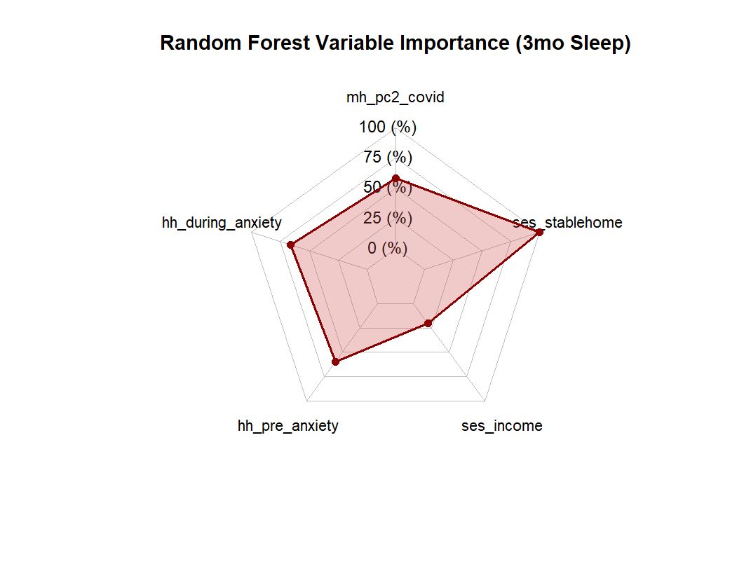

**🧮 Linear Regression Summary: Infant Sleep at 12 Months**

**📌 Model Overview**

* **Outcome:** outcome_sleep_12mo (total sleep score at 12 months)
* **N:** 3827 participants
* **R²:** 0.049 → Model explains **4.9% of the variance**
* **F-statistic:** 21.89, *p* < .001 → Model is statistically significant overall

**🔍 Significant Predictors (p < .05)**

| **Predictor** | **β Estimate** | **Interpretation** |
| --- | --- | --- |
| **Household income** (ses_income) | **+0.82** | Higher income predicts **more sleep** |
| **Stable housing** (ses_stablehome) | **–6.55** | Unstable housing predicts **less sleep** |
| **COVID distress** (mh_pc2_covid) | **–1.07** | Greater COVID-related distress predicts **less sleep** |
| **Pre-pregnancy depression** (hh_pre_depression) | **–1.58** | Linked to **less sleep** |
| **Pregnancy-specific anxiety** (mh_pc3_preganx) | **–1.10** | Associated with **less sleep** |

**❌ Non-Significant Predictors**

| **Predictor** | **β Estimate** | **p-value** |
| --- | --- | --- |
| Pre-pregnancy anxiety (hh_pre_anxiety) | –0.72 | 0.197 |
| Food scarcity (ses_foodscarce) | +1.56 | 0.165 |
| Physical activity (hb_pa_godin) | +0.02 | 0.114 |
| Prenatal depression (hh_during_depression) | +0.36 | 0.704 |

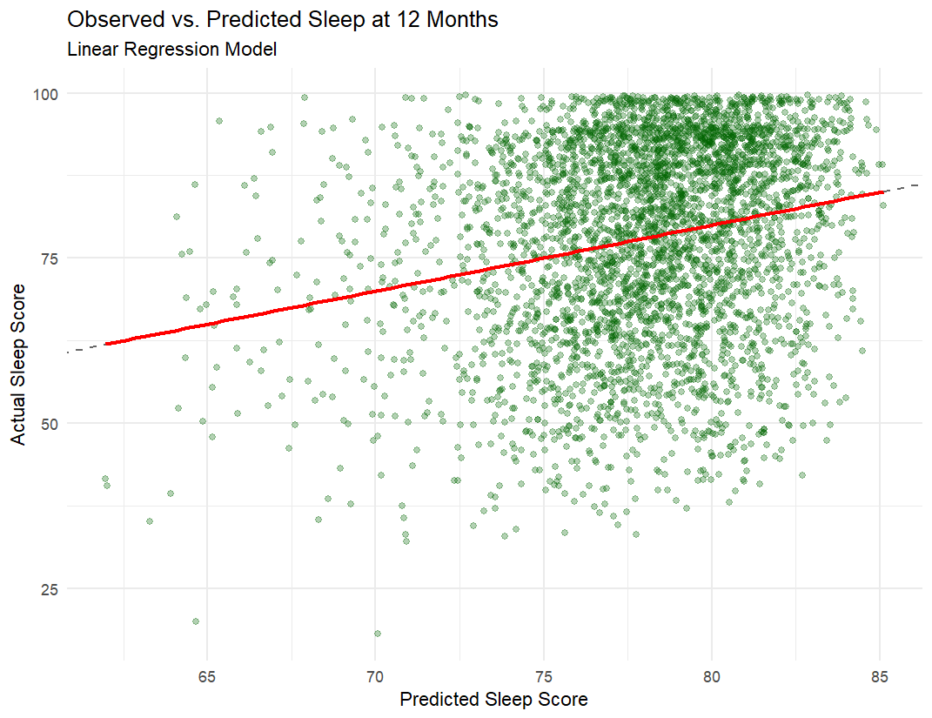

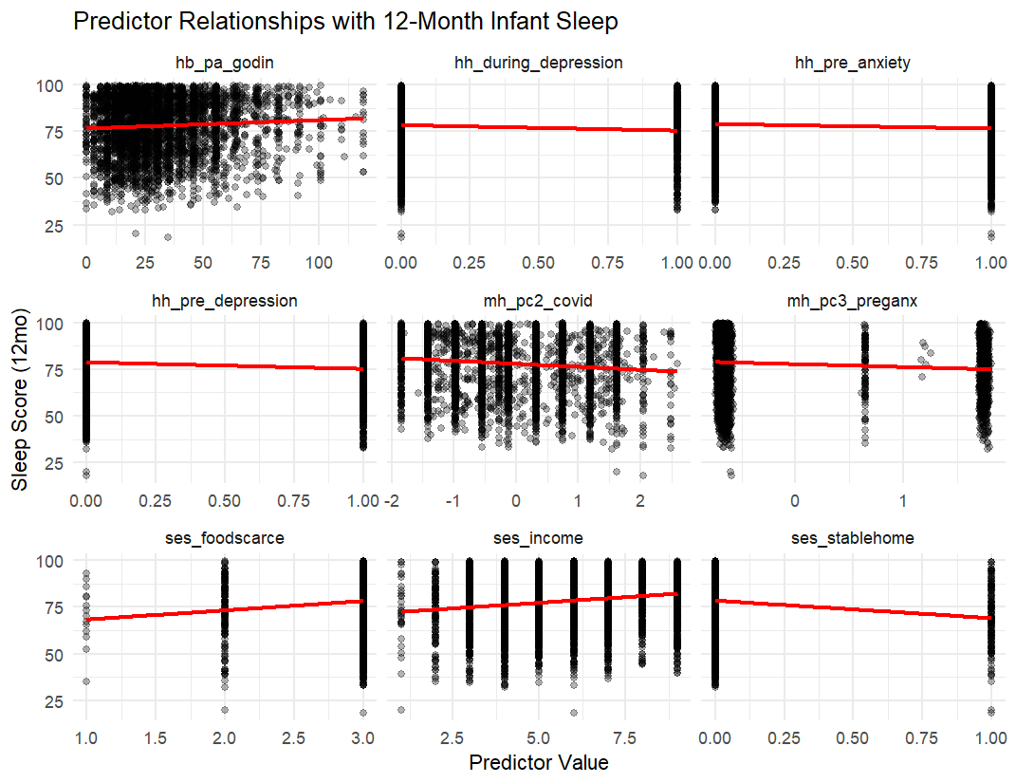

**🌲 Random Forest Summary: Infant Sleep at 12 Months**

**📌 Model Overview**

* **Outcome:** outcome_sleep_12mo (total sleep score at 12 months)
* **N:** (based on your modeling dataset)
* **RMSE:** 9.166 → Indicates the typical error between predicted and actual scores
* **R²:** **0.836** → Model explains **83.6% of the variance** in infant sleep scores  
  ✅ This is **substantially higher** than the linear model (R² = 0.049)

**🔍 Variable Importance (% Increase in MSE if Omitted)**

| **Predictor** | **%IncMSE** | **Interpretation** |
| --- | --- | --- |
| **Pregnancy-specific anxiety** (mh_pc3_preganx) | **28.9** | Most critical predictor; strongly impacts sleep |
| **COVID distress** (mh_pc2_covid) | 21.3 | High prenatal distress → poorer sleep |
| **Stable housing** (ses_stablehome) | 12.8 | Instability strongly predicts worse sleep |
| **Pre-pregnancy depression** (hh_pre_depression) | 12.0 | Strongly reduces sleep duration |
| **Household income** (ses_income) | 11.8 | Higher income improves sleep |
| Physical activity (hb_pa_godin) | 7.8 | Moderate importance |
| Prenatal depression (hh_during_depression) | 5.0 | Some predictive value |
| Food scarcity (ses_foodscarce) | 3.6 | Modest influence |
| Pre-pregnancy anxiety (hh_pre_anxiety) | 2.5 | Least influential among included variables |

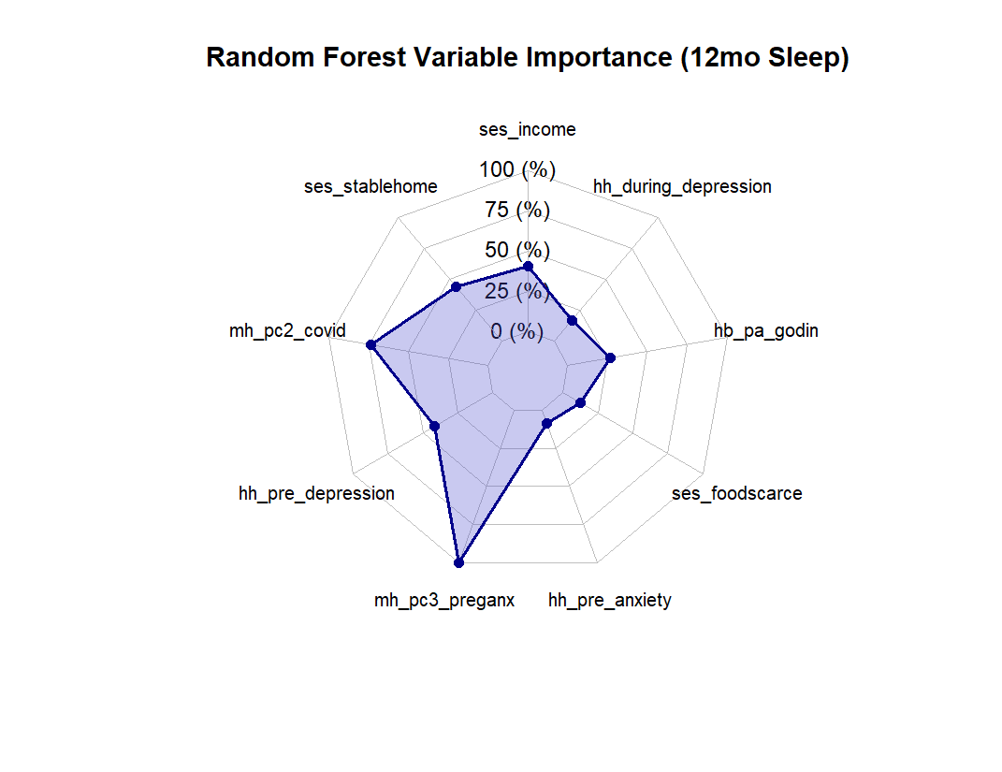

**🧠 Recommended Next Steps**

* Investigate **brain-behavior links**, focusing on sleep-related circuits:
  + **Amygdala–mPFC**: Emotion–sleep regulation
  + **Thalamus–mPFC**: Sleep initiation
  + **PCC–mPFC**: DMN activity and arousal control
* Consider:
  + Mediation models (e.g., does COVID distress affect sleep via maternal anxiety?)
  + Timing effects (e.g., trimester-specific analyses)