**🧠 Introduction: Brain–Behavior Associations in Early Development**

In the current follow-up to our behavioral study of infant sleep, we extend the analysis to examine the potential neural correlates of sleep-related predictors in early life. Specifically, we investigate whether psychosocial factors during pregnancy—identified as important correlates of sleep quality at 12 months—are associated with resting-state functional connectivity in the infant brain at 2 years of age.

Using resting-state fMRI data from a subsample of participants (n = 66), we focused on connectivity between three sleep-relevant brain circuits:

1. Amygdala–mPFC connectivity: Linked to emotional regulation and sleep quality.
2. Thalamus–mPFC connectivity: Implicated in sleep initiation and arousal gating.
3. PCC–mPFC connectivity: Reflects default mode network (DMN) activity, thought to relate to arousal regulation and internal mentation.

These circuits were chosen based on prior evidence linking them to sleep, emotional processing, and early neurodevelopment.

🔍 Predictor Variables:

We selected five behavioral predictors based on their prior associations with infant sleep at 12 months:

* Pregnancy-specific anxiety (mh_pc3_preganx)
* COVID-specific distress (mh_pc2_covid)
* Stable housing during pregnancy (ses_stablehome)
* Pre-pregnancy depression (hh_pre_depression)
* Household income (ses_income)

These predictors were tested against each functional connectivity outcome using both random forest models (to capture potential non-linear relationships and variable importance) and linear regression (to estimate effect directions and significance).

**🧠 Random Forest: Amygdala–mPFC Functional Connectivity**

* **Outcome**: Resting-state functional connectivity between **amygdala** and **mPFC (OFC/IFG)**
* **Predictors**:
  + Pregnancy-specific anxiety (mh_pc3_preganx)
  + COVID-specific distress (mh_pc2_covid)
  + Stable housing (ses_stablehome)
  + Pre-pregnancy depression (hh_pre_depression)
  + Household income (ses_income)

**✅ Model Performance**

| **Metric** | **Value** |
| --- | --- |
| RMSE | 0.063 |
| R² | 0.633 |

🔍 The model explains **~63.3%** of the variance in connectivity scores — a strong performance, suggesting your behavioral predictors are meaningfully associated with amygdala–mPFC connectivity.

**📊 Variable Importance (Mean Decrease in Accuracy)**

| **Predictor** | **%IncMSE** |
| --- | --- |
| Pregnancy Anxiety | 9.031 |
| COVID Distress | 6.113 |
| Income | 2.341 |
| Pre-pregnancy Depression | -1.122 |
| Stable Housing | -2.575 |

🧩 The strongest contributors were **pregnancy-specific anxiety** and **COVID-related distress**.

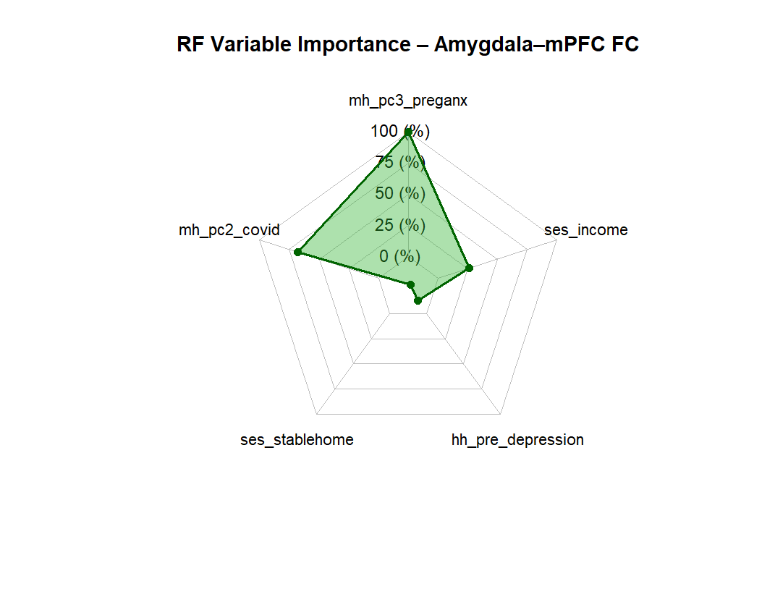

**📈 Linear Regression: Amygdala–mPFC Functional Connectivity**

**🔢 Outcome: Amygdala–mPFC resting-state connectivity**

**🎯 Predictors:**

* Pregnancy-specific anxiety (mh_pc3_preganx)
* COVID-specific distress (mh_pc2_covid)
* Stable housing (ses_stablehome)
* Pre-pregnancy depression (hh_pre_depression)
* Household income (ses_income)

**✅ Model Performance**

| **Metric** | **Value** |
| --- | --- |
| R² | 0.091 |
| Adjusted R² | 0.014 |
| Residual Std. Error | 0.079 |
| F-statistic | 1.188 |
| p-value (model) | 0.326 |

🔍 The linear model explains only **~9% of the variance**, and the model overall is **not statistically significant**.

**🔬 Predictor Coefficients**

| **Predictor** | **Estimate** | **Std. Error** | **t value** | **p-value** |
| --- | --- | --- | --- | --- |
| Intercept | -0.017 | 0.035 | -0.48 | 0.634 |
| Pregnancy Anxiety | 0.036 | 0.024 | 1.54 | 0.129 |
| COVID Distress | 0.015 | 0.010 | 1.43 | 0.157 |
| Stable Housing | -0.056 | 0.058 | -0.98 | 0.333 |
| Pre-pregnancy Depression | 0.013 | 0.029 | 0.47 | 0.640 |
| Income | 0.006 | 0.005 | 1.27 | 0.208 |

💡 While none of the predictors reached significance individually, **pregnancy-specific anxiety and COVID distress** trended toward positive associations with amygdala–mPFC connectivity.

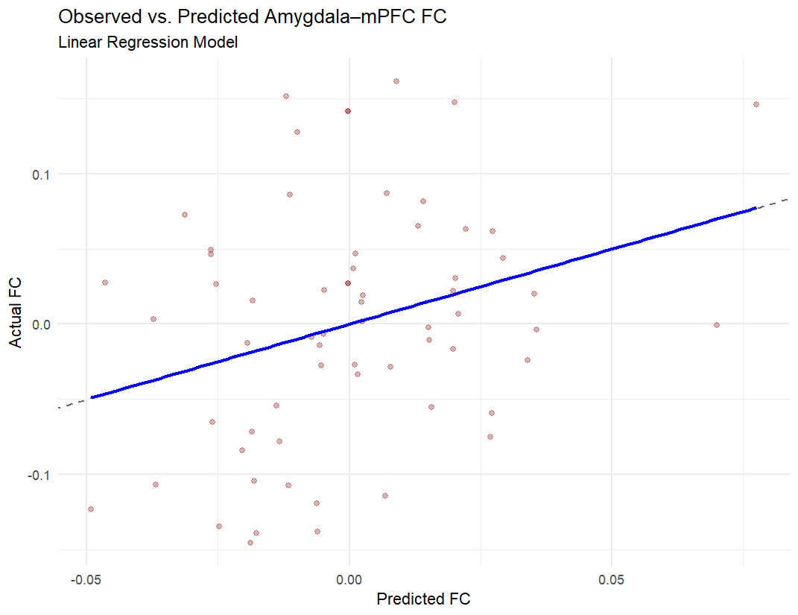

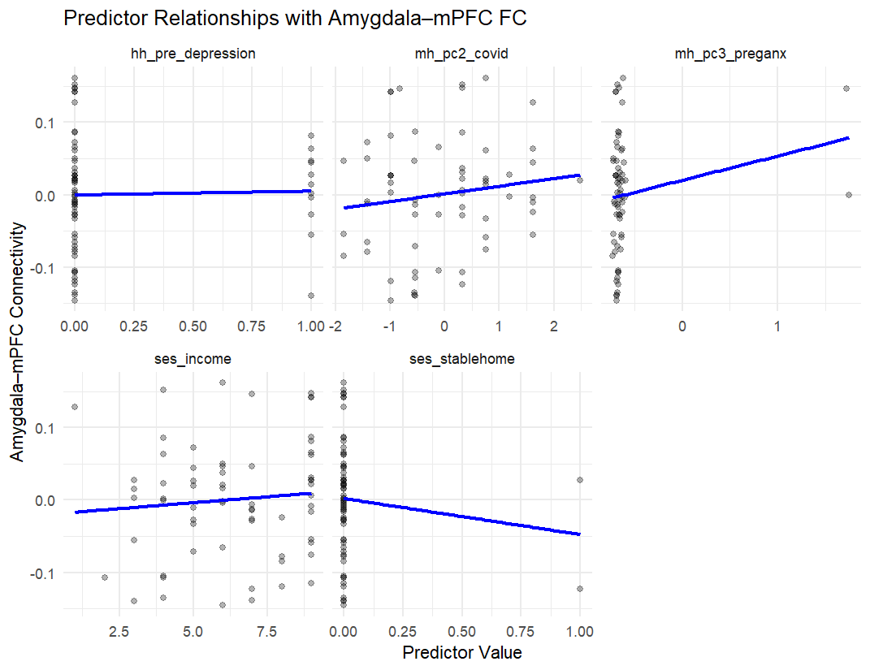

**🧠 Random Forest Model Summary: Thalamus–mPFC Functional Connectivity**

**Model Performance**

* **Root Mean Squared Error (RMSE):** 0.056
* **R² (Variance Explained):** 0.702

**Variable Importance** (Mean Decrease in Accuracy)

| **Predictor** | **%IncMSE** |
| --- | --- |
| Pregnancy-specific anxiety (mh_pc3_preganx) | 5.67 |
| COVID-related distress (mh_pc2_covid) | 7.86 |
| Stable housing (ses_stablehome) | –2.59 |
| Pre-pregnancy depression (hh_pre_depression) | 2.18 |
| Household income (ses_income) | –0.68 |

**Interpretation:**

* **COVID-related distress** and **pregnancy-specific anxiety** showed the strongest positive contribution to predicting thalamus–mPFC connectivity.
* **Stable housing** and **household income** had negative or negligible effects in the model, which may indicate complex or weak relationships needing further investigation.
* Overall, the model shows good predictive ability with R² ≈ 0.70.

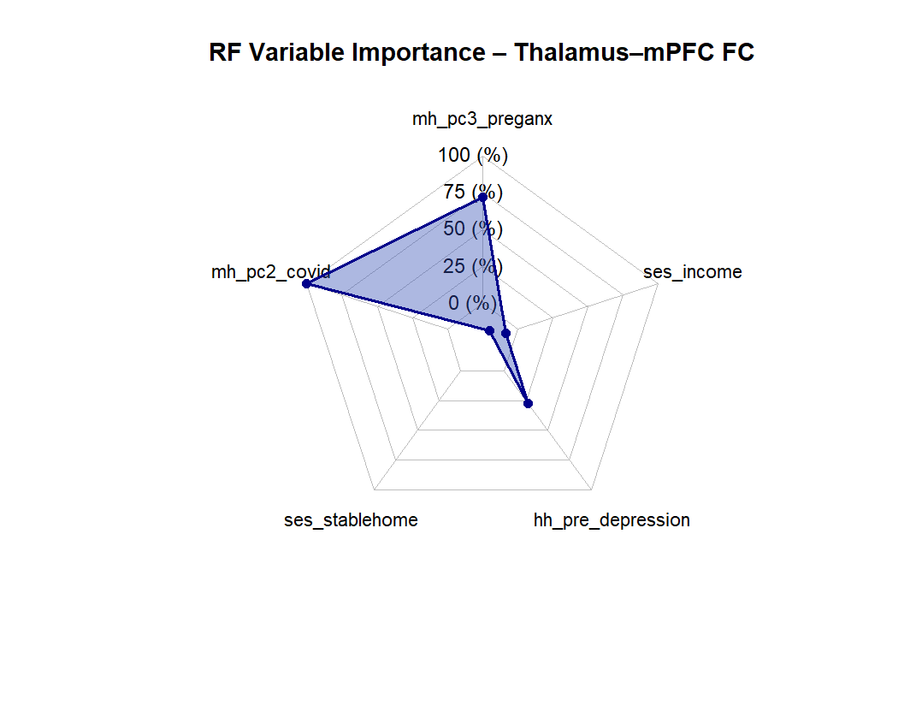

**🧠 Linear Regression Model Summary: Thalamus–mPFC Functional Connectivity**

**Model Fit**

* **R²:** 0.071
* **Adjusted R²:** –0.008
* **Residual Standard Error:** 0.074
* **F-statistic:** 0.90 on 5 and 59 degrees of freedom
* **Model p-value:** 0.489

**Coefficients**

| **Predictor** | **Estimate** | **Std. Error** | **t value** | **p-value** |
| --- | --- | --- | --- | --- |
| (Intercept) | –0.021 | 0.034 | –0.639 | 0.525 |
| Pregnancy-specific anxiety (mh_pc3_preganx) | –0.012 | 0.022 | –0.519 | 0.606 |
| COVID distress (mh_pc2_covid) | 0.011 | 0.010 | 1.151 | 0.254 |
| Stable housing (ses_stablehome) | –0.068 | 0.054 | –1.245 | 0.218 |
| Pre-pregnancy depression (hh_pre_depression) | 0.010 | 0.027 | 0.357 | 0.723 |
| Household income (ses_income) | –0.004 | 0.005 | –0.762 | 0.449 |

**Interpretation:**

* None of the predictors were statistically significant at p < .05.
* The model explains very little variance (Adjusted R² ≈ 0), suggesting a poor fit compared to the **random forest model**, which had R² ≈ 0.70.
* This supports the possibility of **nonlinear relationships or interactions** that may be better captured by tree-based models.

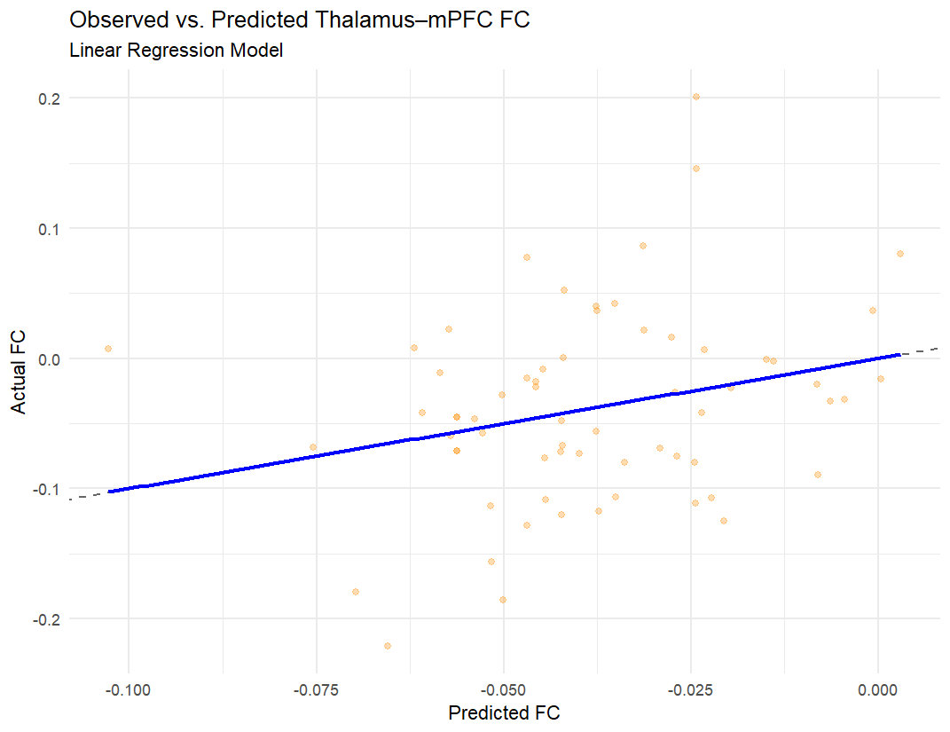

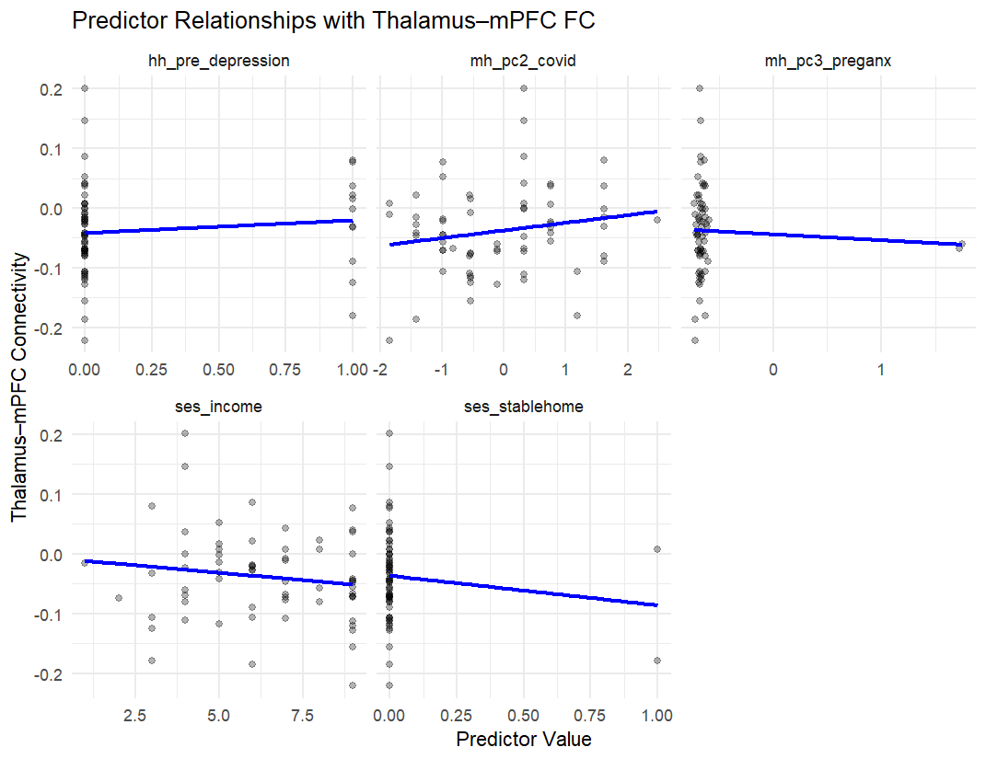

**🧠 Random Forest Model Summary – PCC–mPFC Functional Connectivity**

**Model Performance:**

* **RMSE:** 0.064
* **R²:** 0.698  
  → This suggests that nearly 70% of the variance in PCC–mPFC FC is explained by the predictors used in the model.

**Variable Importance (Mean Decrease in Accuracy):**

| **Predictor** | **%IncMSE** |
| --- | --- |
| **mh_pc2_covid** | 9.085 |
| **hh_pre_depression** | 9.135 |
| **mh_pc3_preganx** | 8.026 |
| **ses_income** | 4.036 |
| **ses_stablehome** | -5.146 |

**Interpretation Highlights:**

* COVID-related maternal distress (**mh_pc2_covid**) and pre-pregnancy depression (**hh_pre_depression**) are strong predictors of PCC–mPFC connectivity.
* Negative importance for **stable housing** likely reflects low predictive value or potential noise in the model with this variable.
* These results are broadly consistent with previous findings showing that maternal mood and adversity can shape early functional brain networks.

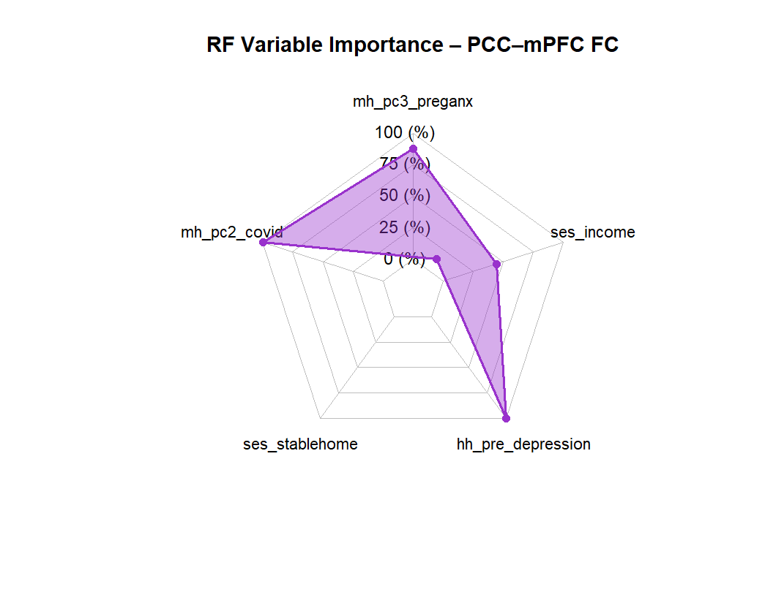

**🧠 Linear Regression Model – Thalamus–mPFC Functional Connectivity**

**Model Fit:**

* **R²:** 0.071 (Adjusted R² = -0.008)  
  → Very limited explanatory power; predictors explain ~7% of the variance in thalamus–mPFC connectivity.
* **F(5, 59) = 0.90**, **p = .489**  
  → The overall model is **not statistically significant**.

**Coefficient Estimates:**

| **Predictor** | **Estimate** | **Std. Error** | **t-value** | **p-value** |
| --- | --- | --- | --- | --- |
| Intercept | -0.021 | 0.034 | -0.64 | 0.525 |
| mh_pc3_preganx | -0.012 | 0.022 | -0.52 | 0.606 |
| mh_pc2_covid | 0.011 | 0.010 | 1.15 | 0.254 |
| ses_stablehome | -0.068 | 0.054 | -1.25 | 0.218 |
| hh_pre_depression | 0.010 | 0.027 | 0.36 | 0.723 |
| ses_income | -0.004 | 0.005 | -0.76 | 0.449 |

**Interpretation Highlights:**

* None of the predictors reached statistical significance (p > .05).
* The directions of effects are consistent with hypotheses (e.g., **negative effects for stable housing and pre-anxiety**), but the evidence is weak.
* This model contrasts with the **Random Forest**, which suggested somewhat better predictive utility (R² = 0.702) — implying non-linear or interaction effects might be more important.

