Промежуточная аттестация. Гоняева Екатерина

От 06.12.21

// 1.Найти самый дорогой товар. Вывести имя товара и его цену.

SELECT goods.name, prices.value FROM goods

JOIN prices ON prices.goods_id = goods.id

WHERE value = ( SELECT MAX (value) FROM prices)

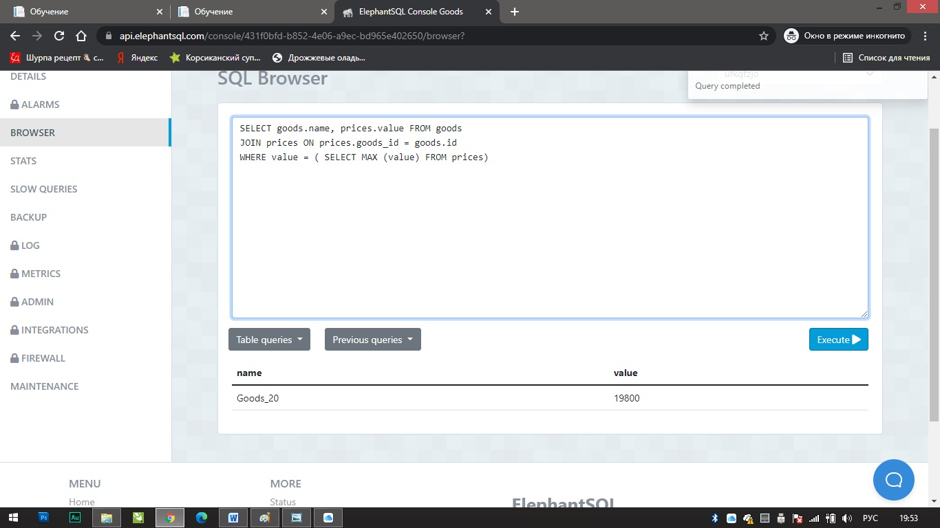

//2.Найти товары с нулевым остатком. Вывести имя товара и его цену.

SELECT name ,prices.value FROM goods

JOIN prices ON prices.goods_id = goods.id

JOIN quantity ON quantity.goods_id = goods.id

WHERE quantity.value = 0

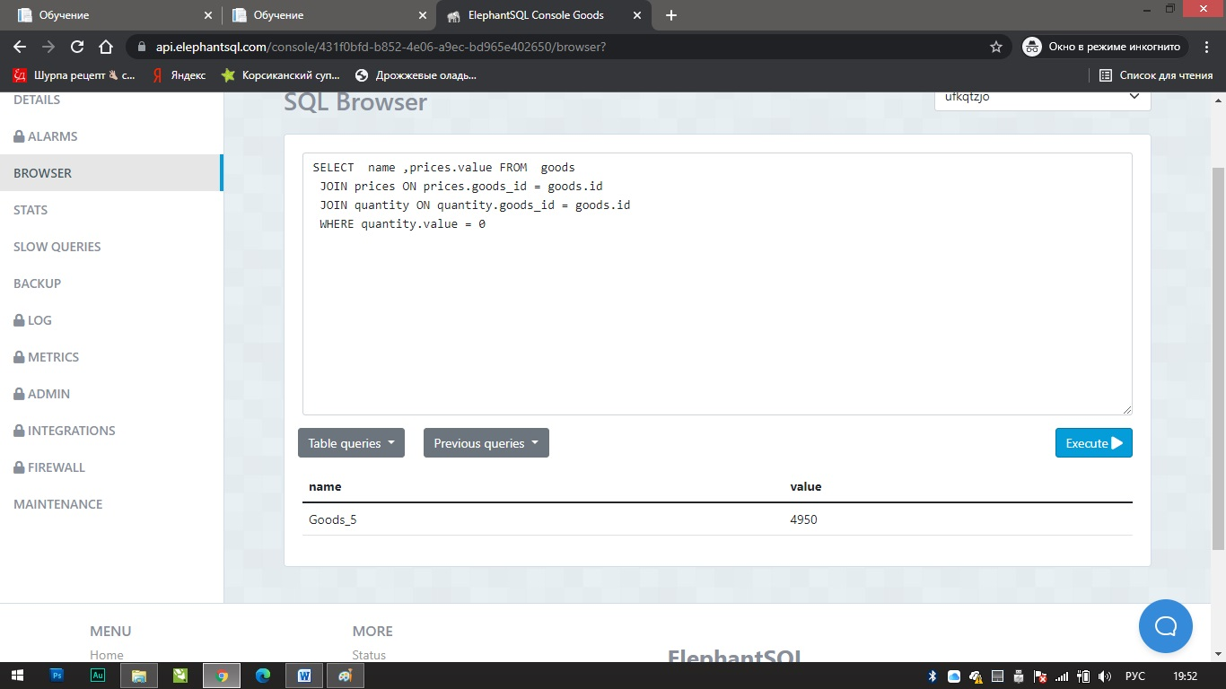

// 3.Найти производителя с самой большой средней ценой за товары. Вывести имя производителя и среднюю стоимость.

SELECT manufacturer.name, ROUND (AVG(prices.value),2) FROM manufacturer

JOIN suppliers ON suppliers.manufacturer_id = manufacturer.id

JOIN goods ON goods.supplier_id = suppliers.id

JOIN prices ON prices.goods_id = goods.id

JOIN quantity ON quantity.goods_id = goods.id

GROUP BY manufacturer.name

ORDER BY AVG(prices.value)

DESC

LIMIT 1

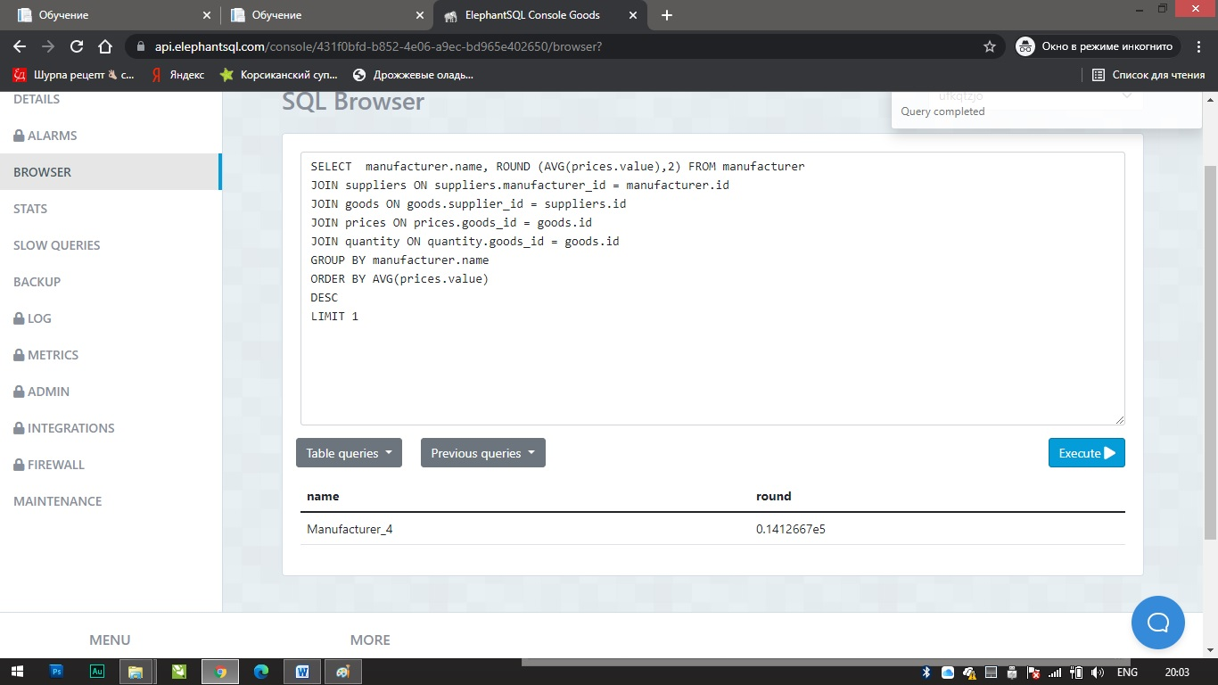

Или

SELECT manufacturer.name, ROUND (AVG(prices.value),2) FROM manufacturer

JOIN suppliers ON suppliers.manufacturer_id = manufacturer.id

JOIN goods ON goods.supplier_id = suppliers.id

JOIN prices ON prices.goods_id = goods.id

JOIN quantity ON quantity.goods_id = goods.id

GROUP BY manufacturer.name

HAVING AVG (prices.value) >= all ( SELECT AVG (prices.value) FROM manufacturer

JOIN suppliers ON suppliers.manufacturer_id = manufacturer.id

JOIN goods ON goods.supplier_id = suppliers.id

JOIN prices ON prices.goods_id = goods.id

JOIN quantity ON quantity.goods_id = goods.id

GROUP BY manufacturer.name)

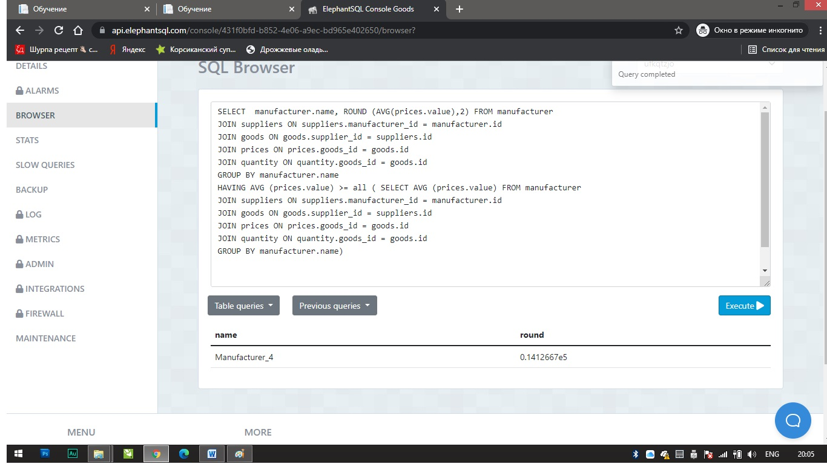

//4. Найти все товары производителей из Москвы. Вывести имена товаров, их цены и имена производителей.

SELECT goods.name AS goods_name, prices.value, manufacturer.name AS manufacturer_name FROM goods

JOIN prices ON prices.goods_id = goods.id

JOIN suppliers ON suppliers.id = goods.supplier_id

JOIN manufacturer ON manufacturer.id = suppliers.manufacturer_id AND manufacturer.location = 'Moscow'

