Attachment_analysis_LFP

1. **Notes for Final_CreateResultsTable_LFPonly**

Note1.1: line 10

electrodeTable.mat: %Table with macro, micro and neuron information

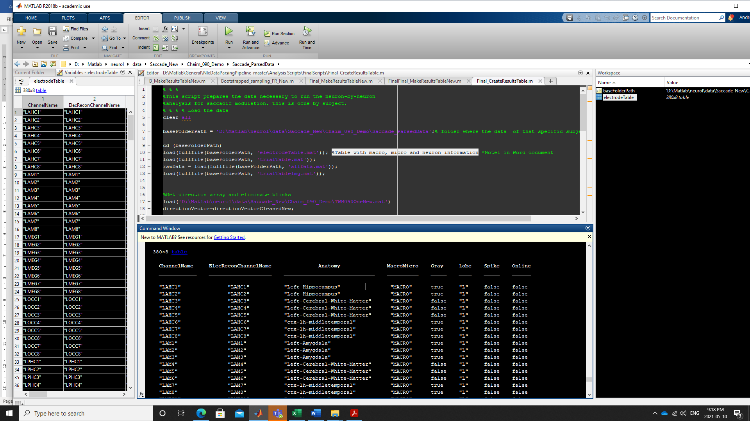

Note 1.2: Line 11

trialTable.mat: %Table with trial information: ImageNumber, saccades starts and stops and duration

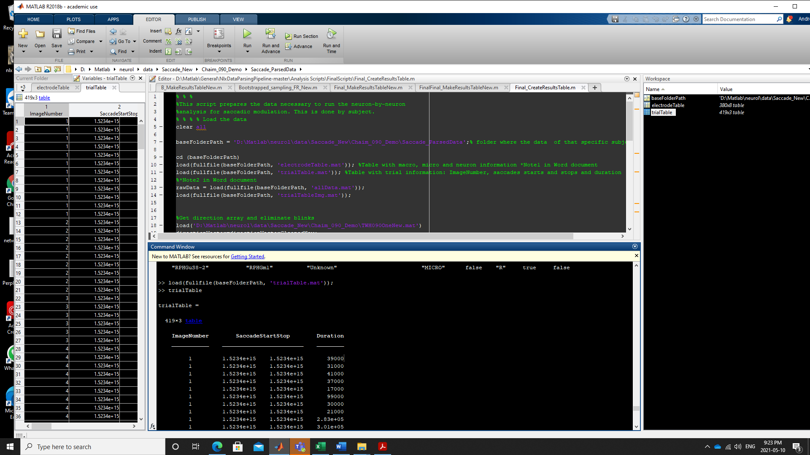

Now we run “Final_MakeResultsTablenew_LFPonly”

Note 2.1: Line 90

RMS amplitude: we measured the RMS amplitude of the signal 10ms after saccade onset (to remove artifact +500 ms.

To measure RMS I used The rms function in matlab: <https://www.mathworks.com/help/signal/ref/rms.html>

I calculated RMS for the raw and the normalized signal, although for the paper we only used the normalized signal (by the STD of the LFP of that channel during the entire experiment).