Getting started with DocBook in the Eclipse IDE
Eclipse is a venerable libre-software IDE primarily for Java. Its architecture is heavily modular, with most features being supplied through plugins. Among these is a plugin supporting DocBook, an XML-based markup language designed for creating technical documentation. In combination with transforms defined in XSL, DocBook files can be rendered into almost any document file format. The workflow when using DocBook is to compose and edit documents in XML, and to render them into user-friendly formats using tools such as Saxon, Pandoc, and Apache Ant, with the original XML serving as single source of truth. Because XML is text-based, it is well adapted to Git-powered version control. Eclipse combines all of these components into a single workspace environment.

Installing Eclipse
- Download the Eclipse installer.
- Unzip and run the installer from the command line. From the list of IDE options, choose Eclipse IDE for Java Developers.
- Start the installation and accept the license.
- Launch Eclipse, accepting the default workspace.
- On Eclipse Welcome page, click Launch the Eclipse Marketplace.
- In the Find (search) box, type “docbook processing” and then press Enter.
- Click the Install button for DocBook Editing and Processing for Eclipse (DEP4E).
- Accept the license and click Finish.
- Select all trusted source boxes and click Trust Selected.
- Select the additional trust for “unsigned” and click Trust Selected.
- Click Restart Now. Squash the Welcome page if it comes up. Eclipse is now ready for use.

Configuring Eclipse
At this point you need a populate a perspective, which is specific layout of the IDE workspace, with appropriate views, which a panes for displaying information or performing actions.

DocBook support has its own perspective. To load it, click the Open Perspective icon in the toolbar:

Choose DocBook and click Open. The perspective loads and the toolbar now contains an icon picturing a duck, which is not a logo for DocBook (DuckBook?), but is the random illustration on the cover of the O'Reilly book about DocBook:

In the menu bar, navigate to Window > Show View, the click Project Explorer. (For some reason the default perspective doesn't include this, and you need it.) I dragged the resulting tab off to the right of the workspace, making it permanently visible. You can drag and resize any of the view panes to create a more agreeable workspace, and then save the result by navigating to Window > Perspective > Save Perspective As..., giving your customized perspective a unique name, and saving it.

Now if you navigate to Window > Perspective > Open Perspective > Other, you'll see that the list of perspectives has an additional duck icon with the name of your customized perspective. Click your perspective to open it, and note that you have yet another duck icon in the toolbar, which the tool-tip reveals to be the icon for your custom perspective.

My completed environment looks like this:
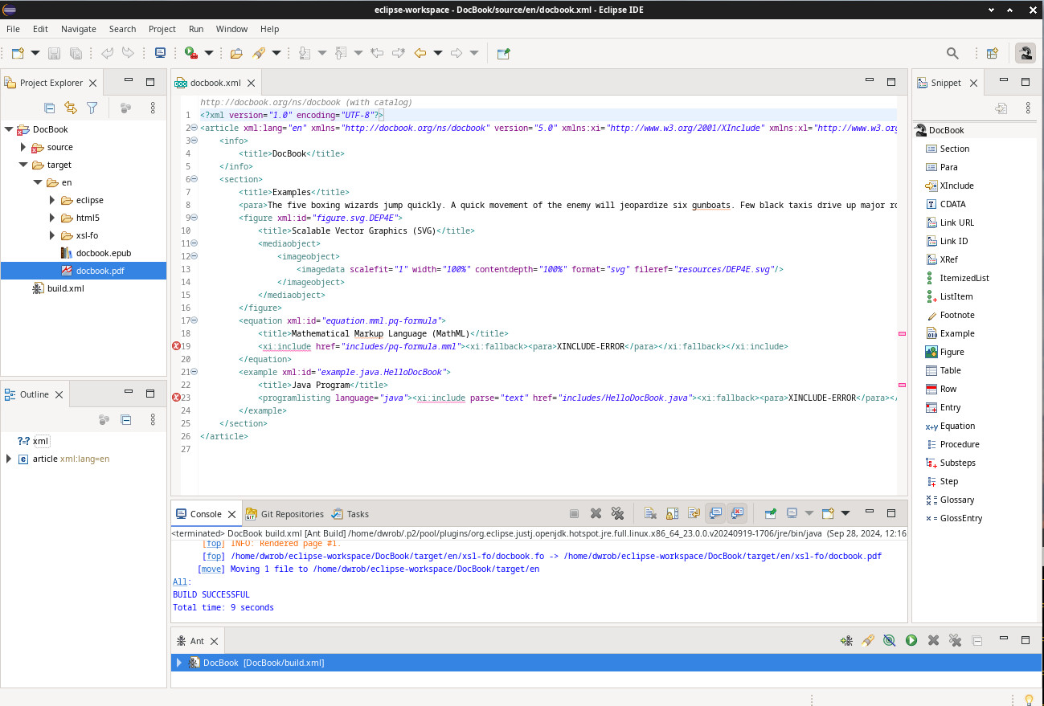

An important hack
To make the dummy DocBook project more useful, you need to modify its build configuration.

In the Project Explorer, double-click the file build.xml to open it in the editor. The file has the following content:

<?xml version="1.0" encoding="UTF-8"?>
<project name="DocBook" default="All">
<property name="docbook.xml.filename" value="docbook" />
<property name="docbook.xml.language" value="en" />
<import file="${net.sourceforge.dep4e.resources}/ant/docbook_5-0.xml" />
</project>

In the line “<property name="docbook.xml.filename" value="docbook" />”, change the value from “docbook” to “*” and save the file. The end product should be as follows:

<?xml version="1.0" encoding="UTF-8"?>
<project name="DocBook" default="All">
<property name="docbook.xml.filename" value="*" />
<property name="docbook.xml.language" value="en" />
<import file="${net.sourceforge.dep4e.resources}/ant/docbook_5-0.xml" />
</project>

Now you can now edit Katzenpost documentation files by copying them to the source/en/ directory, which is a system directory path relative to the default workspace directory you specified during installation. Building these files as PDFs or HTML will be discussed below.

About the editor
The XML editor provides the following functions:

- XML, XSLT, and XPath validation. The editor flags any XML that is not well-formed, that references undefined elements or directives, or that contains an invalid path.
- Element definitions. Mousing-over on an XML tag raises a tool-tip containing a definition of the element, the element's parent and children, and available attributes.
- Spell-check. Of course -- what are we, barbarians?
- Support for external and tokenized content. But see the note...

Note:
The default editor settings do not permit parsing of DocBook shared-text “entities” that are defined outside the current file context. This results in false errors. These do not affect Ant's build operations, but they are distracting to look at in the editor. To fix this, change the settings as follows:
- From the menu bar, navigate to Window > Preferences > XML (Wild Web Developer) > Validation & Resolution.
- Select Allow resolution of external entities (Security risk).
- Click Apply and Close.

The Eclipse DocBook editor does not support a WYSIWYG view.

Menu-driven insertion of DocBook tagging is provided through the Snippets view.

Building documentation files
Eclipse comes with Apache Ant integrated into its workspaces. While Ant is primarily a build-scripting system for Java code, it also is used for building PDF, HTML, Epub, and other outputs from XML source documents.

In the Project Explorer, create a DocBook 5.0 Project, naming it whatever you like. (The default is “DocBook”.) This results in a dummy DocBook project that is intended for testing, but which you can convert to your own purposes. The project's XML code is displayed in the editor, and its name is displayed in the Ant view.

If you double-click the name in the Ant view, the project builds, with build progress scrolling by in the console view. To inspect the built files in the Project Explorer, you'll need to click F5 for the display to refresh. The output files are under the target directory.

Ant attempts to build everything in the source folder when you double-click the name of the project in the Ant view. If any of the files are invalid XML, the entire build operation will fail.

