Multi ping with Python

I would like to describe a way how to ping multiple networking devices such as cisco routers and switches using python. Especially how to ping them at once with multiprocessing.

I think good idea is to prepare a template with code we want to run such as ping. Later we will create a script which will use this template to create as many python ping scripts as we want. Then these python scripts will be used by multiprocessing script which will run all these ping processes at once.

I’m using virtual machine running linux CentOS 7 as a workstation connected to the virtual network within GNS3.

We will create four files to automate the ping process. I’ll call them:

devices.txt – contains IP addresses

template_ping_v2.txt

process_maker.py – creates all the ping processes

multiping.py – uses output from process_maker.py to run all pings at once

The template code written in the plain text file may look like this:

*****************************************************

import subprocess

results = []

p_count = 2

print(f"Process {p} is running...")

for ping in range(p_count):

result = subprocess.call(["ping", "-c 1", ip_add], stdout=subprocess.DEVNULL)

results.append(result)

if 0 in results:

print(f"The host {ip_add} is reachable.")

else:

print(f"The host {ip_add} is down.")

******************************************************

Let me write a few words about the code above.

* p_count variable holds the number of pings we want to run, it generates the number of cycles in the for loop
* I’m using for loop to control the ping so I can capture the result of the ping one by one and store them in the list. In this way I can display the result of the ping only once and not for example seven times if I sent 7 packets to each device
* variables p and ip_add will be assigned by python script which will take the template and create all the processes

Now we can get to the python script called let’s say process_maker.py:

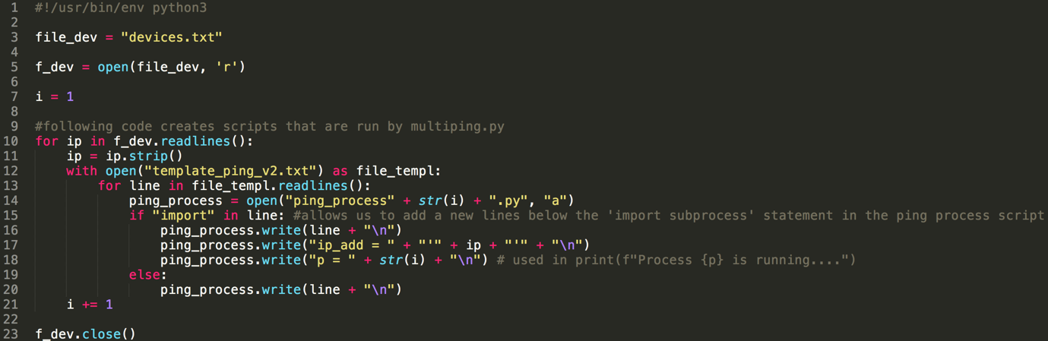

First I open a file called devices.txt where I store all IP addreses.

And then for every IP address in the devices.txt I open the template and use it to construct a python ping script.

As you can see I call individual python scripts as ping_process1.py, ping_process2.py etc. The variable i is used to count the number of proceses (or loop cycles).

Now it’s time for multiprocessing script we can call multiping.py:

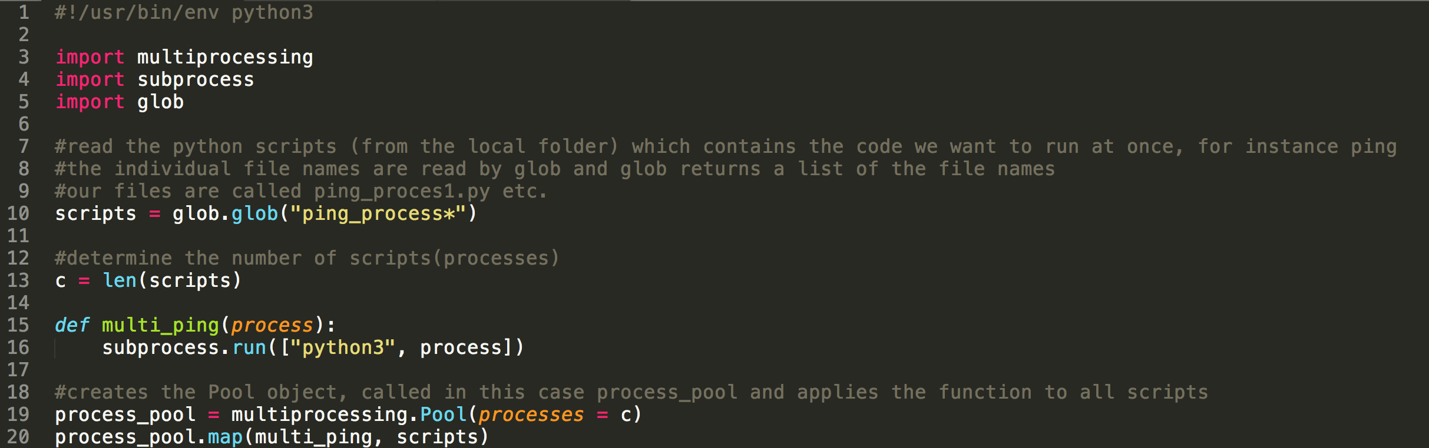

First the glob reads all the file names located in path you enter. In this case it’s just the local folder.

Glob returns a list of those file names. I store it in the list called scripts.

Next step is to define a function which will be responsible for runnning the individual ping scripts.

And then we will use map to apply this function (called multi_ping) to all processes at the same time.

Results of the individual pings will be printed to the terminal only at this moment. But the advantage of the template is that we can add some code there that will for instance redirect the result of each ping process to the file so we can examine it later.

Thank You and have a nice day.