Crop Analysis Q3 2013

John Smith

May 3rd, 2014

Class 05 Graphics and plots with R Narrative text that I can style **bold** and *italic* and add links to the [webpages](https://aerialrevolution.com/)

# Section 2A: line plot  
  
weight <- read.table("bimm143_05_rstats/weight_chart.txt", header = TRUE)  
  
plot(weight, pch = 9, cex = 1.5, lwd = 2, ylim=c(2,10), xlab="Age (months)", ylab="Weight (kg)", main="Babies age and weight")

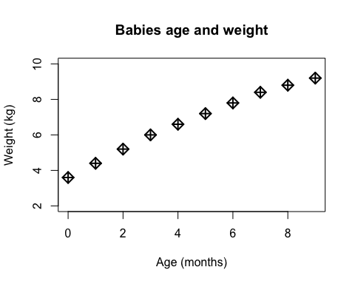

# Section 2B: bar plot  
  
feat <- read.table("bimm143_05_rstats/feature_counts.txt", header = TRUE, sep="\t")  
  
par(mar=c(5, 12, 4, 9))  
barplot(feat$Count, names.arg = feat$Feature, las=1, horiz = TRUE, xlab = "Counts", las=1,   
 col = "purple", main = "Number of features in the mouse GRCm38 genome", xlim = c(0,80000))

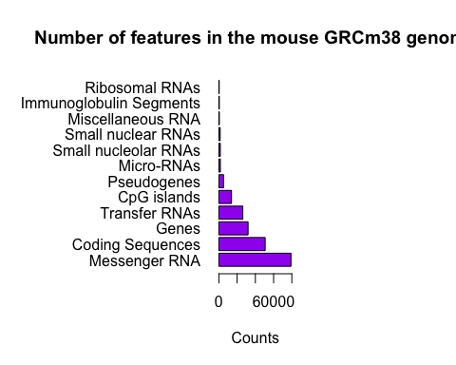

# Section 3A: colors in plots  
  
mf <- read.delim("bimm143_05_rstats/male_female_counts.txt", header = TRUE, sep = "\t")  
  
barplot(mf$Count, names.arg = mf$Sample, las = 2, col = c("blue3", "red3"), ylab = "Counts", ylim = c(0,20))

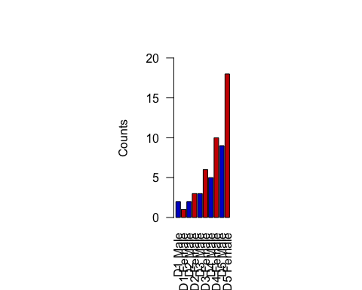

barplot(mf$Count, names.arg = mf$Sample, las = 2, col = cm.colors(nrow(mf)), ylab = "Counts", ylim = c(0,20))

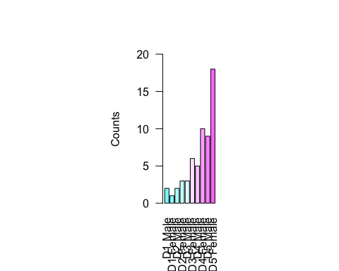

# Section 3B: coloring by value  
  
genes <- read.delim("bimm143_05_rstats/up_down_expression.txt")  
table(genes$State)

##   
## down unchanging up   
## 72 4997 127

plot(genes$Condition1, genes$Condition2, col = genes$State,   
 xlab = "Expression Condition 1", ylab = "Expression Condition 2")

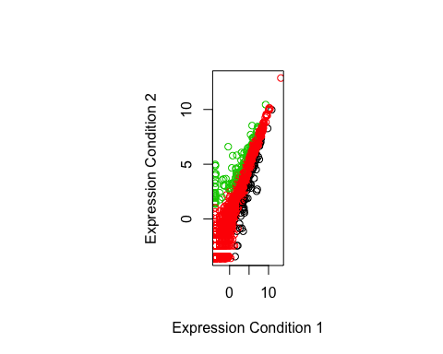

palette()

## [1] "black" "red" "green3" "blue" "cyan" "magenta" "yellow"   
## [8] "gray"

palette(c("blue", "gray", "magenta"))  
plot(genes$Condition1, genes$Condition2, col = genes$State,   
 xlab = "Expression Condition 1", ylab = "Expression Condition 2")

