MEAN.JS Alphabet Animal Book Application
CS637-900 Software Engineering Process II Group Project
Group 1: Bill Morgan, Siddharth Toteja, Keith Aubin
Video 1 Setup and Running: VIDEO TBD, past video example
Video 2 Tour of code: VIDEO TBD, past video example
Clone URL: https://github.com/kaubin/CS637-900_GroupProject.git
GitHub Repository: https://github.com/kaubin/CS637-900_GroupProject
Setup Directions: This document or README.md located in GitHub repository
We constructed a web application using the MEAN.JS Open-Source Full-Stack Solution For MEAN Applications. MEAN.JS provides Yeoman templates to provide our starting point. The stack will then be expanded with some GUI modifications and additional DBs creating the Alphabet Animal Book web application.
We chose MEAN.JS since it provides a rapid approach to generating a polyglot development environment suitable for web application development. This application will employ domain specific languages (HTML/CSS/Javascript) and the functional language AngularJS and web services.
Most of this content is also available within the repository README.md file.
Development IDE: JetBrains IntelliJ IDEA
How to start the application (necessary only the first time)

Clone the repository or download ZIP and extract it to a directory.
Open shell or command prompt, traverse to {EXTRACTED_DIR}\CS637
Install dependencies using grunt:
npm install
Provided MongoDB with a location to store databases. Create directory C:\Windows\Temp\MongoDb.

Running the application
Start MongoDB (looks to be the same for mac):
mongod --dbpath C:\Windows\Temp\MongoDb
To run application using grunt:
grunt

Playing with the application
Open a web browser to http://localhost:3000
Create an account: Click Sign Up (upper right corner), enter information for your user, Click blue Sign Up button. Application will bring you to the MEAN.JS entry page.
APPLICATION SPECIFIC INSTRUCTIONS TBD
View Database TABLETBD: http://localhost:3000/TABLETBD
Book Application Features:
TBD

Architectural Overview
Structurally a MEAN.JS project organization separates code according to AngularJS concepts such as config, routes, views, controllers and services (to name a few) where each implementation exists in separate javascript files. Files are stored in corresponding concept folders. Folders are stored in respective module folders. Finally, modules functionality is broken out into client and server or public and app folders respectively as seen on the left side of the Figure below.
Functionally this application leverages many modern architectural features. The Node.JS library Mongoose translates data in MongoDB to JavaScript objects providing a cross platform database model. Mongoose refers to these as documents. The documents are transmitted along TCP as BSON strings.
Express.js is also a Node.JS framework provides utilities and middle-ware for building we and mobile applications. Middle-wear used in this application includes error handling and binding functionality to the express instance (anywhere you see app. Something, that's Express).
Angular.JS is central to this architecture as implied earlier. The Angular modules provided by the stacks Yoeman Generator allows quick generation of Create, Read, Update and Delete (CRUD) modules that use MongoDB with Mongoose between. This app uses most of what Angular offers employing dependency injection, web UI domain language for view template generation, declarative programming for views, imperative programming for business logic and of course two way data-binding by way of MVVM.
MVVM Image: http://www.adevedo.com/content/why-use-angularjs-very-short-introduction
Declarative and Imperative Description Image: http://en.wikipedia.org/wiki/Model_View_ViewModel
Node.js provides a non-blocking server side run-time environment for networking applications.
This application integrates socket-io providing asynchronous network event handling using lambda functions. The lambda functions are called when an event arrives on either the server or client.
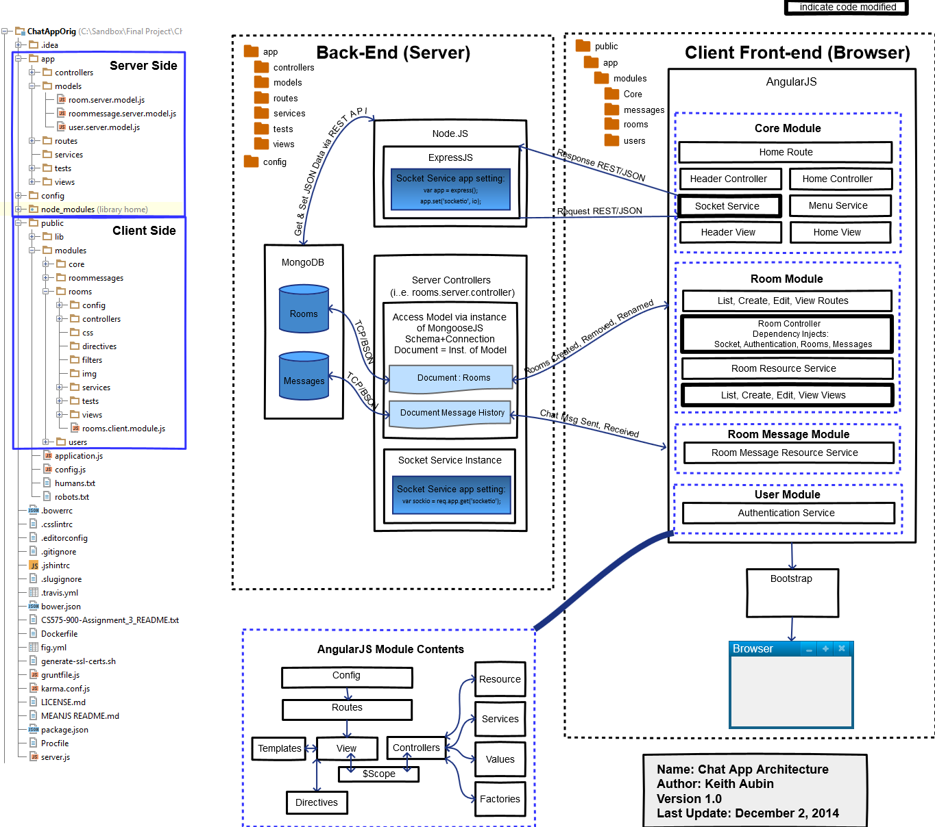
Above represents an EXAMPLE CONCEPTUAL DESIGN. Conceptual diagram to be provided...
The stack was modified in a few portions outlined using bold boxes in the Figure below. The stack started off with CRUD modules (generated using MEAN.JS yo generators) to store application data. I changed the message module views/model/controller to display room name, user name and message data. The room module list-room.client.html was modified to use the dependency injected authentication instance to show or hide edit and delete buttons next to rooms created by that user. The room module view-room.client.html file was modified to include chat room the markup and interact with the controller to send chat messages.
The socket service exists within the core of the application so that I can be accessed by any module. Socket instances are dependency injected into the room controller provided the ability to send and receive chat related events with the server (config/express.js). The room message controller was also provided via dependency injection to the room controller so that chat messages can be stored in the database (room message model). The message history will be available when the application is stopped and restarted since its saved to the database.

Adding Socket.IO (explained in video)
The application uses socket.io to transmit chat events between the server and browser. Socket.io on the server side was implemented via config/express.js while socket listener is enabled in server.js. Server controllers (ChatApp/app/controller) can then access the back-end socket instance via the express app config setting named socketio. See rooms.server.controller.js, create() function.
Socket.io on the client browser side is made available via an angular factory socket service defined in ChatApp/public/modules/core/services/socket.js. The application uses the angular-socket-io component installed via Bower to listen and emit events between the server and bowser. Javascript socket.io files are included in ChatApp/app/views/layout.server.view.html. The angular-socket-io component itself was integrated into the application via angular dependency injection. Dependencies are defined in public/config.js. To use the dependency, the angular controller definition ChatApp\public\modules\rooms\controllers\rooms.client.controller.js was modified to include the Socket. The Socket service was registered within the core module. Therefore, Socket instances can be utilized across the app. Its also injected into the message controller though it not used at the moment.
This approach was outlined in a few angular tutorials. The best was http://vexxhost.com/blog/mean-socket-io-integration-tutorial/. Its the approach Brian Ford uses in his chat room examples.
Note: The second video also outlines a small issue I found when navigating from view to view. Since the socket needs be resolved each time you enter a new angular scope, server defined information can be lost. The solution was adding a private method to the room controller named checkSocket() that requests a socket reinitialization whenever $scope.name (users chat alias) is not defined on the client. This was not a problem in any existing tutorial I could find since they were all single page applications. This app requires the user to navigate though multiple views so it was noticeable. Chromes JavaScript console was very helpful in figuring out what was going on.

