AngularJS Alphabet Book Application
CS637-900 Software Engineering Process II Group Project
Group 1: Bill Morgan, Siddharth Toteja, Keith Aubin
Clone URL: https://github.com/kaubin/CS637-900_GroupProject.git
GitHub Repository: https://github.com/kaubin/CS637-900_GroupProject
Setup Directions: This document or README.md located in GitHub repository
We constructed a web application using the MEAN.JS Open-Source Full-Stack Solution For MEAN Applications. MEAN.JS provides Yeoman templates to provide our starting point. A stack will then be expanded with some GUI modifications and additional DBs and or file IO to generate a book where each page represents a letter in the child’s name. The parent will also be given an opportunity to create a story teaching their child how to spell their name along the way. A single image can also be added to each page to further the learning experience.
We chose MEAN.JS since it provides a rapid approach to generating a polyglot development environment suitable for web application development. This application will employ domain specific languages (HTML/CSS/Javascript) and the functional language AngularJS and web services.
Most of this content is also available within the repository README.md file.
Development IDE: JetBrains IntelliJ IDEA

How to start and Run the application (necessary only the first time)

See CS637-900_GroupProject\AlphebetBook\root\README.md for information on Node.js prerequesites and how to start the web application server.

Starting the application
Open a web browser to http://localhost:8000.

How to use the application
Type your name. Observe animal images appear with a statement or narrative.
Click the animal to open the customization page.
Modify the image by clicking one of the thumbnails.
Modify the narrative by selecting another from the list.

Technology Overview
Structurally a project organization separates code according to AngularJS concepts such as config, routes, views, controllers and services (to name a few) where each implementation exists in separate javascript files. Files are stored in corresponding concept folders. Folders are stored in respective module folders. Finally, modules functionality is broken out into client and server or public and app folders respectively as seen on the left side of the Figure below.
Functionally this application leverages many modern architectural features. The Node.JS library Mongoose translates data in MongoDB to JavaScript objects providing a cross platform database model. Mongoose refers to these as documents. The documents are transmitted along TCP as BSON strings.
Express.js is also a Node.JS framework provides utilities and middle-ware for building we and mobile applications. Middle-wear used in this application includes error handling and binding functionality to the express instance (anywhere you see app. Something, that's Express).
Angular.JS is central to this architecture as implied earlier. The Angular modules provided by the stacks Yoeman Generator allows quick generation of Create, Read, Update and Delete (CRUD) modules that use MongoDB with Mongoose between. This app uses most of what Angular offers employing dependency injection, web UI domain language for view template generation, declarative programming for views, imperative programming for business logic and of course two way data-binding by way of MVVM.
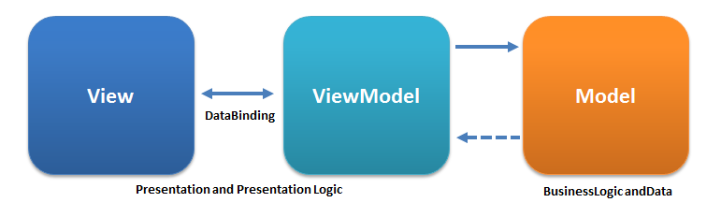 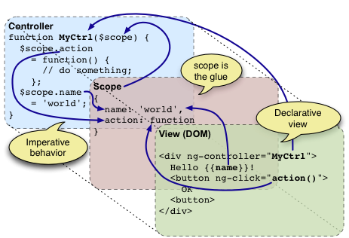
MVVM Image: http://www.adevedo.com/content/why-use-angularjs-very-short-introduction
Declarative and Imperative Description Image: http://en.wikipedia.org/wiki/Model_View_ViewModel
Node.js provides a non-blocking server side run-time environment for networking applications.
This application integrates socket-io providing asynchronous network event handling using lambda functions. The lambda functions are called when an event arrives on either the server or client.

Development Strategy
The ultimate goal is to provide a single page web application that generates a PDF book based on a child’s name. Each page in the book tells a story spelling the name and displaying images. Our limited time constraints require an iterative approach to achieve success.
Final application feature set should encapsulate most of the details from the end user.
- User enters First, Middle and Last Name.
- User enters birth date.
- User enters optional dedication and sender name promoting sales as gift.
- User selects child’s gender.
- User select a basic story structure based on Gender. This selection dictates which image library to be employed to generate a story.
- Animals with story narrative selected at random from a list of available animals for each letter in the child name.
- User is able to preview book in the browser.
- Shopping cart web platform could be employed to sell PDF copies of the story. Print could then be a logical evolution at a higher price point.
For Cycle 1 (encompassing this class) we intend to build some basic building blocks that could be further expanded upon in later cycles to achieve the rich feature set itemized above. See Illustration 1 below for a depiction features in cycle 1.
Features for cycle 1:
- User enters first, middle and last name.
- User enters birth date.
- User presses button or site automatically displays one image for each letter in the child name. Each image will depict an animal. The file name or meta data will indicate the animal. The first letter of each animal will match a corresponding letter in the child’s name.
- Each image will appear along side a text area for the user to enter a story narrative manually.
- (Optional given time) User presses a button to generate a PDF file where each page contains one picture and its narrative.

Conceptual Design
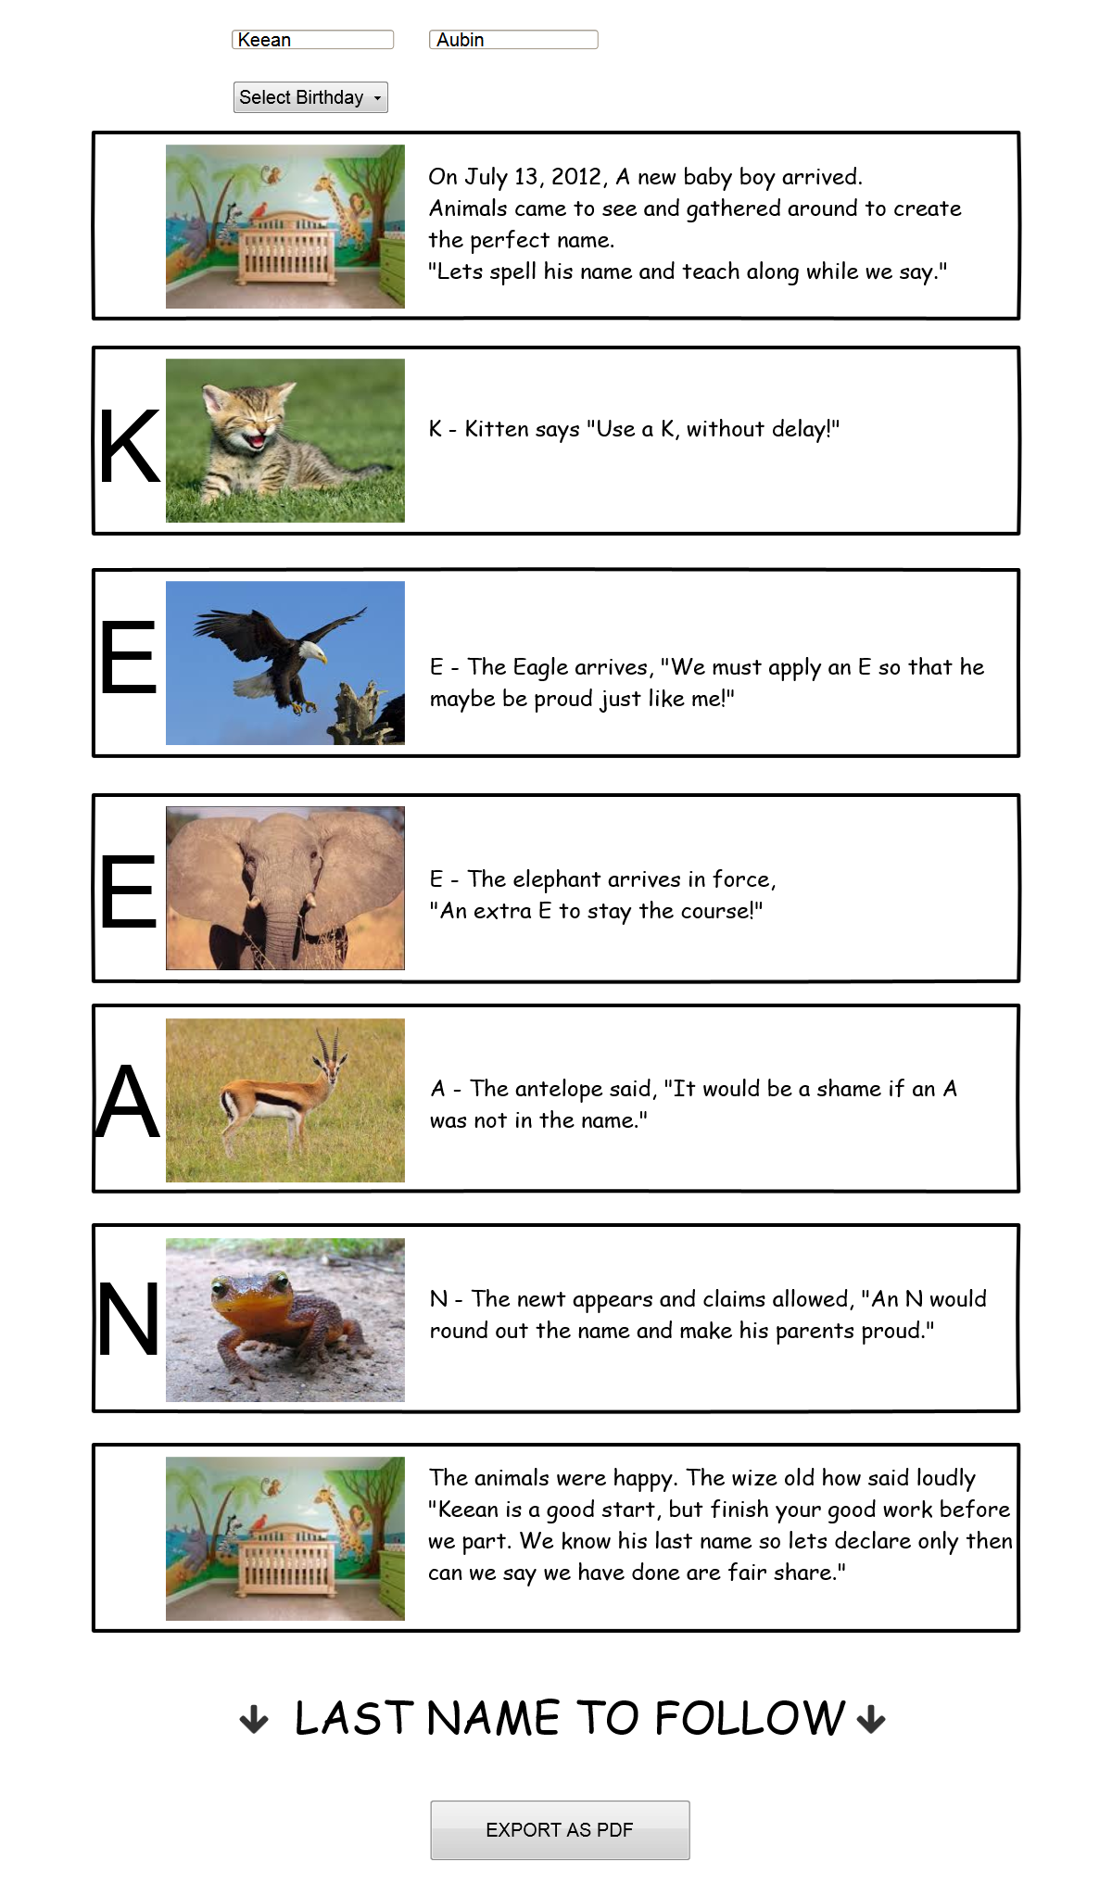Illustration 1: Cycle 1 Conceptual Wireframe
This conceptual wire-frame generally depicts how the prototype web applications may appear. User would enter a name then press a button to generate the listing of name letters, images based on the name letter and text areas for narrative. If time allows we intend to attempt to generate the book as a PDF file.
This minimal-fiction working subset of the final product should provide a baseline ability to generate the basic structure of an Alphabet book. We will hope to gain insight into how we might manage sizing and positioning text relative to an image without obstructing that image.
Future enhancement is a focus in cycle 1. The book generation portion of the program could later be expanded to include narrative as well as images based on a story structure selected by the user. The website could then be expanded with additional content using the same underlying architecture.
Cycle 1 will visually display the book generation for testing and feature verification.

