

**SOFTWARE PROTO TYPE REPORT**

**ON**

**Election Analysis**

**by**

**Vaibhav Pawankar 202201070124**

**Ayush Fating 202201070127**

**Kaustubh Mahajan 202201070128**

SCHOOL OF E&TC ENGINEERING

MIT ACADEMY OF ENGINEERING

ALANDI (D), PUNE

2022 - 2023

**MIT ACADEMY OF ENGINEERING**

**ALANDI (D), PUNE**

SCHOOL OF COMPUTER ENGINEERING & INFORMATION TECHNOLOGY

**1.CERTIFICATE**

This is to certify that the software prototype project entitled **“Election Analysis"** has been carried out by Mr Kaustubh Mahajan, Mr Ayush Fating , Mr Vaibhav Pawankar under the guidance in partial fulfillment of Second Year School of Computer Engineering and Technology of Savitribai Phule Pune University, Pune during the academic year 2022-23.

Mrs. PADMA NIMBHORE Mrs. R.M.GOUDAR

**Course Instructor**   **Dean, SCE**

**2. Abstract**

The "Election Analysis Report" offers a comprehensive examination of recent electoral processes, shedding light on the dynamics, trends, and implications of these elections. This report is a valuable resource for policymakers, political scientists, analysts, and the general public, providing a thorough understanding of the electoral landscape.

The report includes an election overview, historical context, candidate profiles, voter demographics analysis, election results, policy analysis, voter turnout data, electoral maps, comparative analysis with previous elections, future implications, and recommendations. It aims to promote data-driven discussions, informed decision-making, and greater transparency in the electoral process. This report is an indispensable resource for anyone interested in the political dynamics and consequences of recent elections.

**INDEX**

|  |  |  |  |
| --- | --- | --- | --- |
| **Topic** | | | **Page No.** |
|  |  | |  |
| 1. | **Introduction** | | 1 |
|  | 1.1 | Problem Statement | 1 |
|  | 1.2 | Background and Motivation | 2 |
|  | 1.3 | AEIOU Framework | 2 |
| 2. | **Requirement Analysis** | | 3 |
|  | 2.1 | User Requirements | 3 |
|  | 2.2 | Functional Requirement/Non-functional | 4 |
|  | 2.3 | SRS(table of each functional req) | 5 |
|  | 2.4 | Limitations | 11 |
|  | 2.5 | Analysis | 11 |
| 3. | **Design Documents** | | 12 |
|  | 3.1 | UML: Use Case Design, Sequence Design, Activity Design | 12 |
|  | 3.2 | Low Fidelity, High Fidelity | 19 |
| 4. | **Working Prototype UI Design** | | 22 |
|  | 4.1 | Screen shots | 22 |
| 5. | **Conclusion & Future Work** | | 27 |
| 6. | **References(4-5):books name, article, tools etc** | | 28 |

Chapter 1 : Introduction

**1.1 Problem Statement**

The need for election analysis, therefore, is not merely a matter of academic interest but a fundamental requirement for the effective functioning of democratic societies. By addressing this need, we can enhance transparency, promote informed decision-making, engage the public, facilitate academic research, and safeguard the integrity of our electoral processes.

**1.2 Background and Motivation**

**1.3 AEIOU Framework** 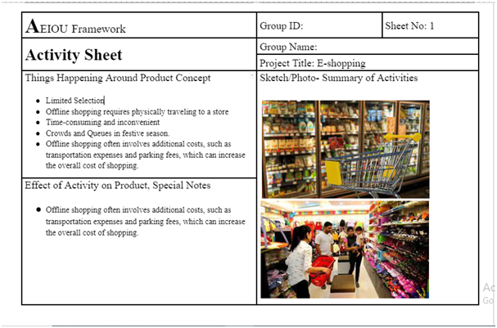

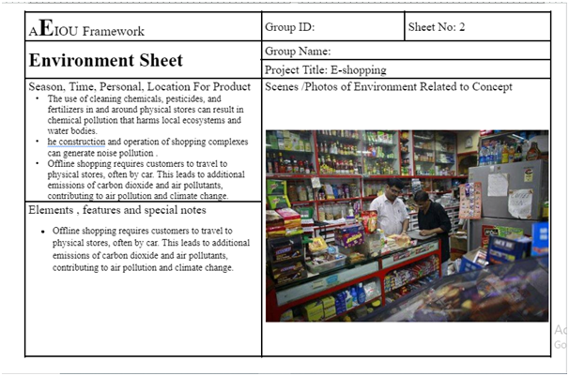

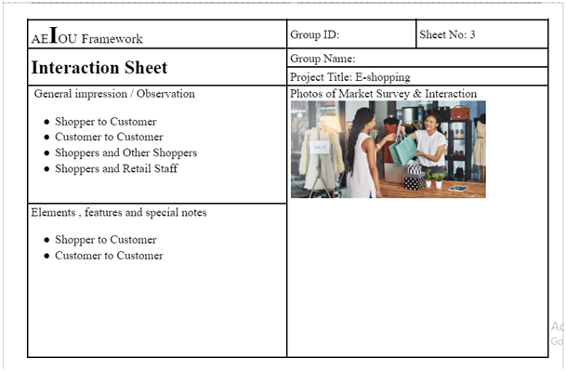

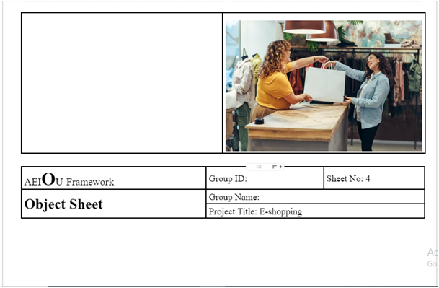

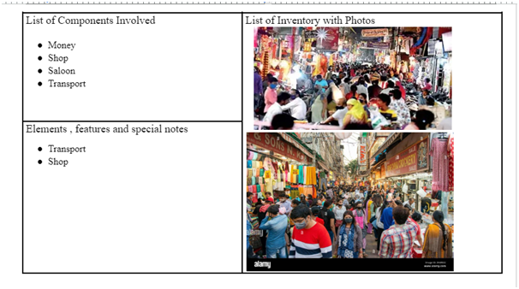

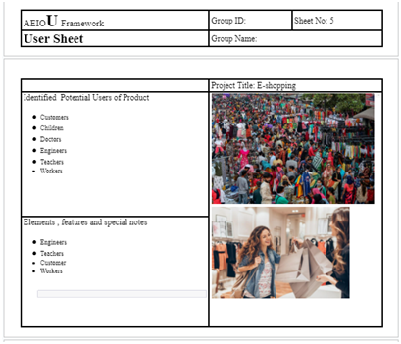

**Chapter 2 : Requirement Analysis**

**2.1 User Requirements :**

• Easy and user interface

• Easy to access

• Secure and easy checkout.

• Personal account management

• Discount, deal and promotions

**2.2 Functional Requirements**

• Application and server should work smoothly

• User registration and profile management

• Checkout and payment

• Account settings

**2.3 System Requirement Specification (SRS)**

• Non Functional Requirements

1. Performance of the app should be smooth.

2. App programs must load faster on any system.

3. Software Hardware sync must be very efficient. Commands given by hardware must execute quickly and properly.

4. There must be high end 2D graphics

**2.2 Functional Requirement/Non-functional :**

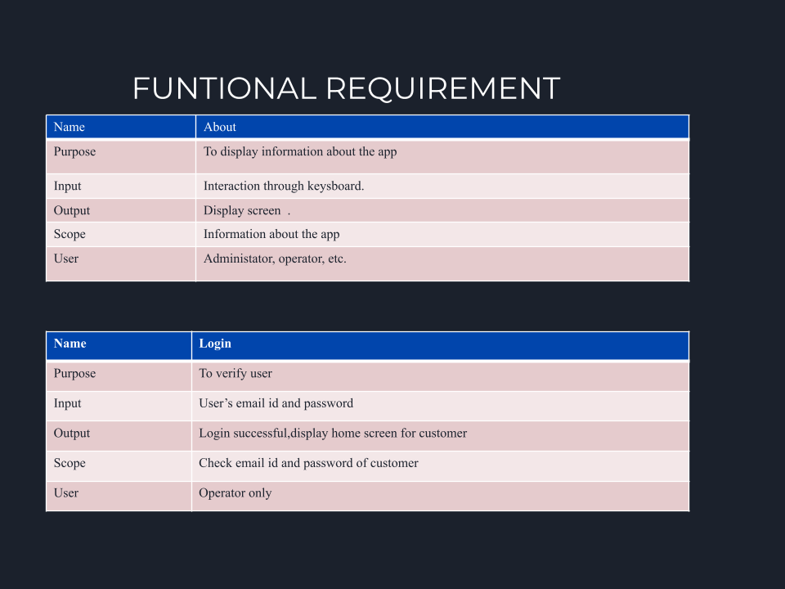

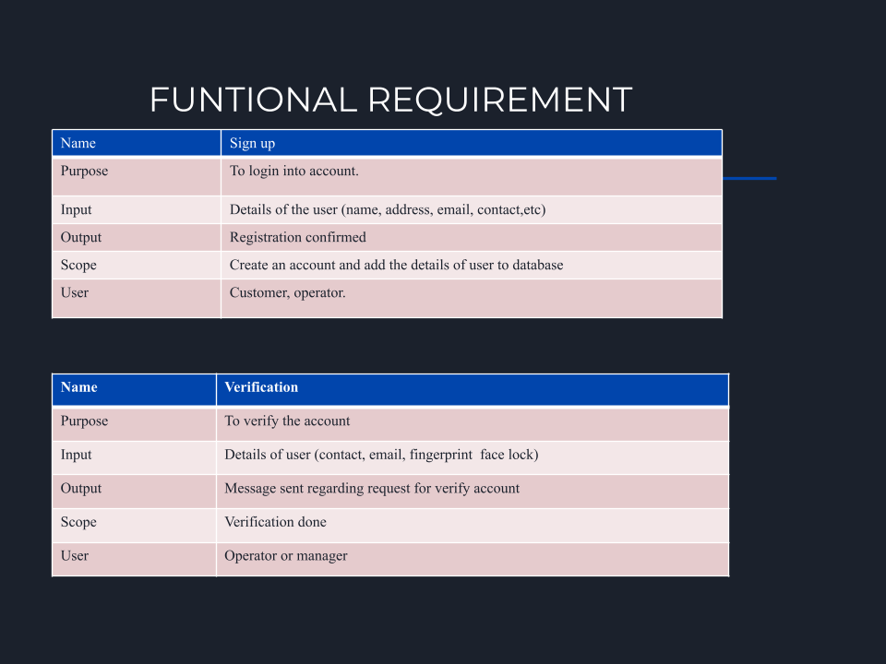

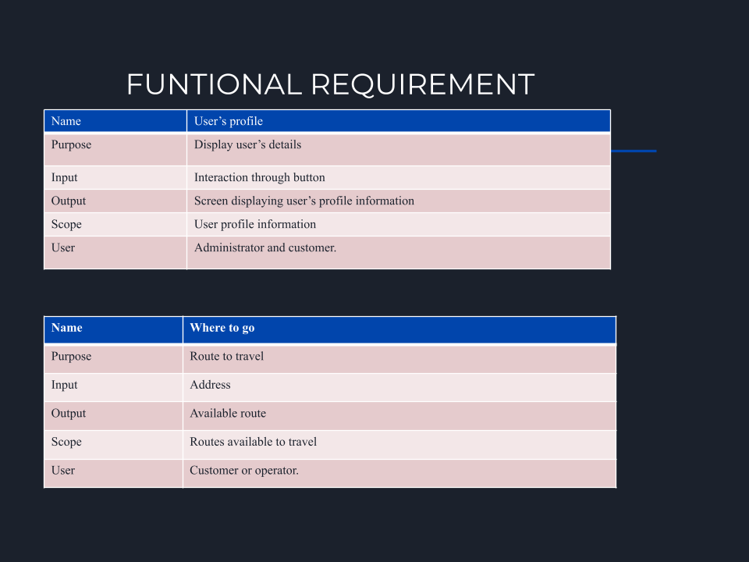

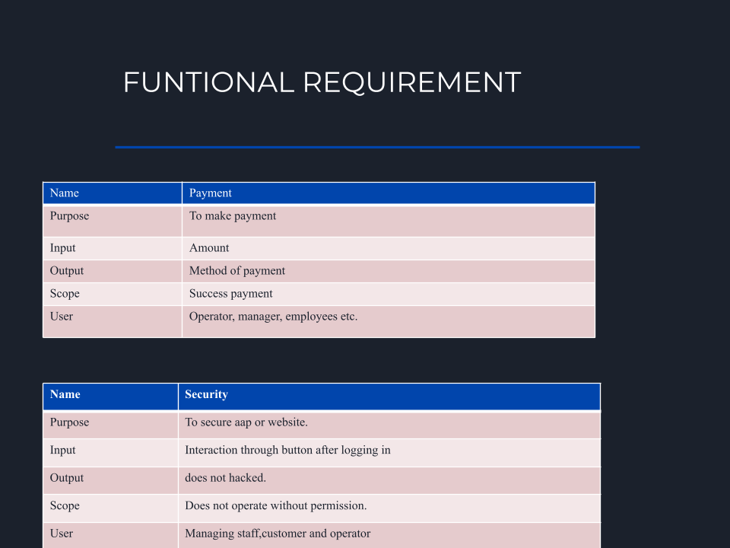

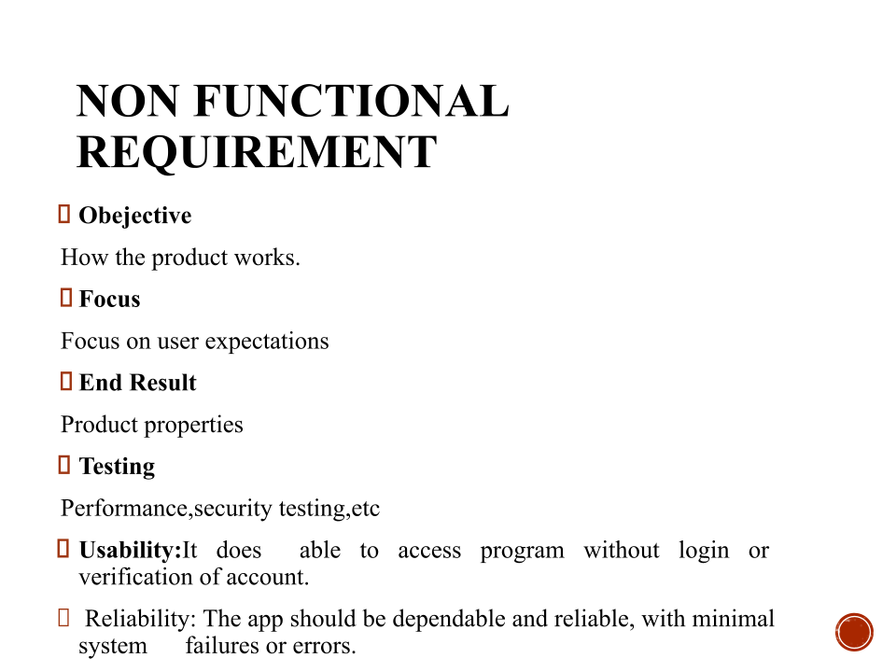

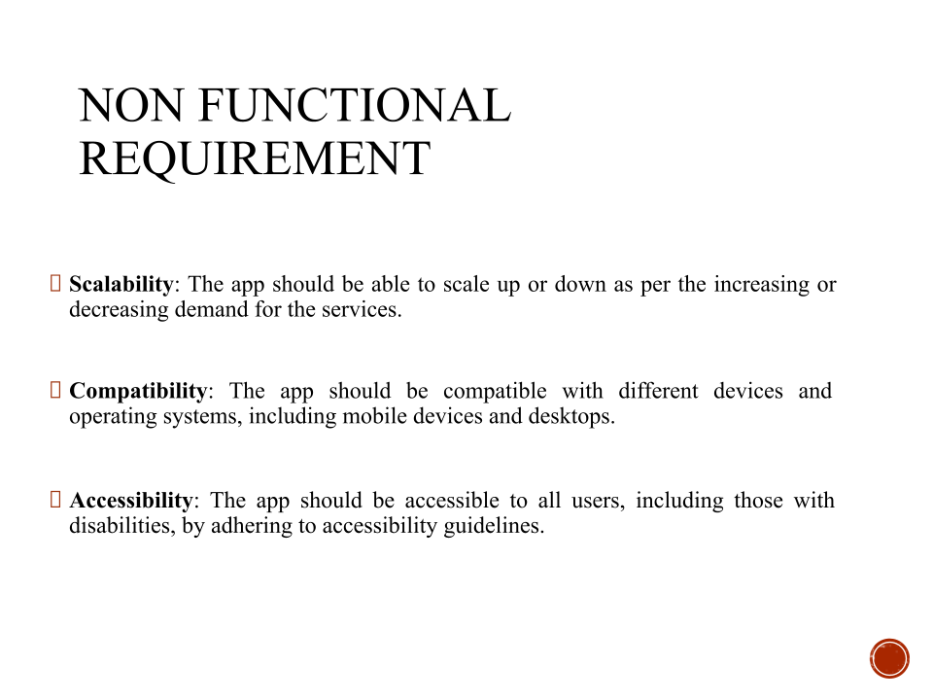

**2.4 Limitations**

• Internet availability is required

• Basic knowledge of chemical reactions is required

**2.5 Analysis**

• Easy to understand the difference between optimum temperature and real temperature.

• Only the optimum temperature will be displayed and will have to change physically.

• Interfaces and instructions are simple for the user.

• Application works smoothly even in 4G or 5G networks.

**Use case Diagram**

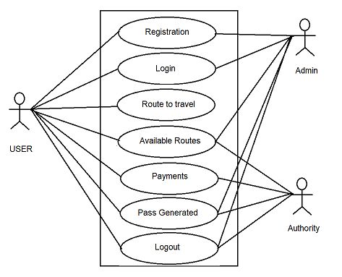

**Sequence Diagram**

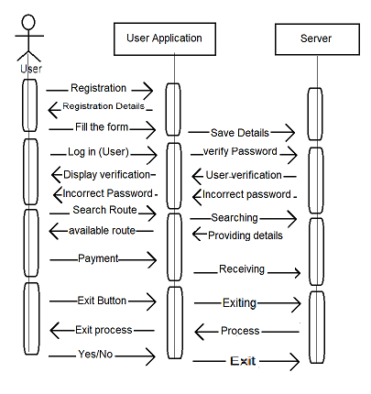

**Activity Diagram**

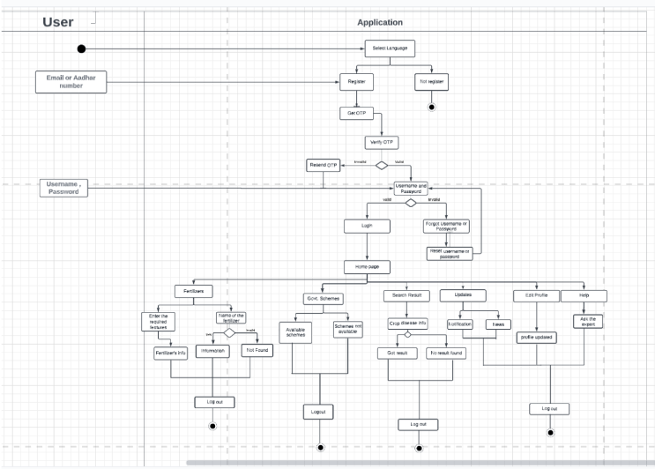

**3.2 Low Fidelity/High Fidelity**

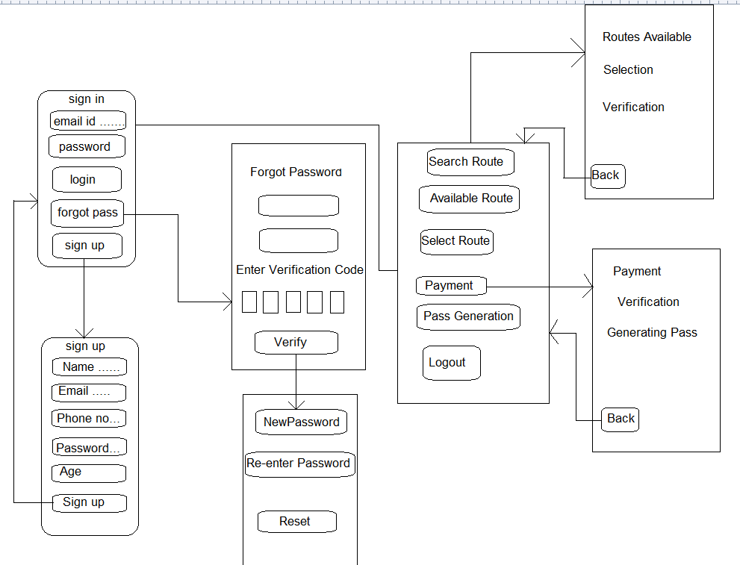

**4 Working prototype UI Design**

**4.1 Screenshots**

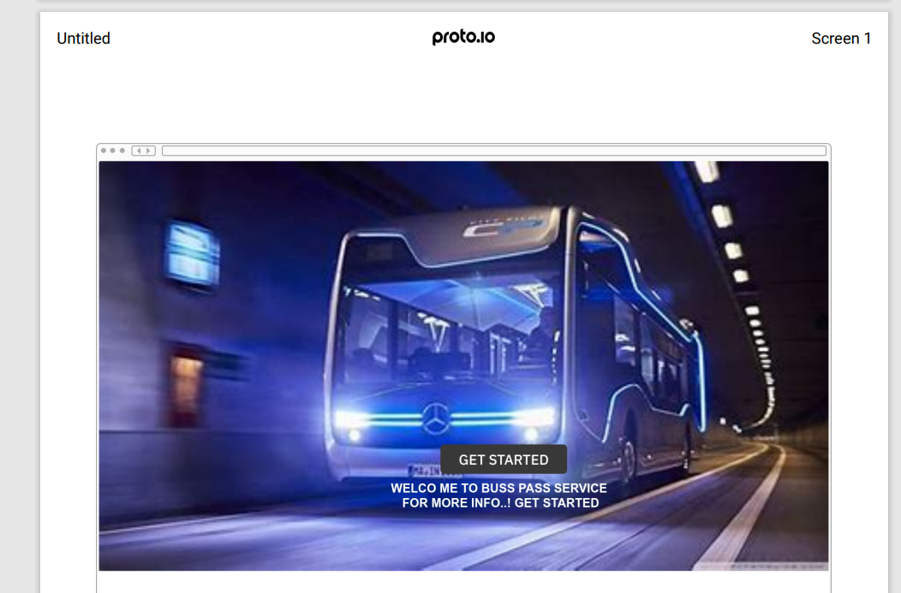

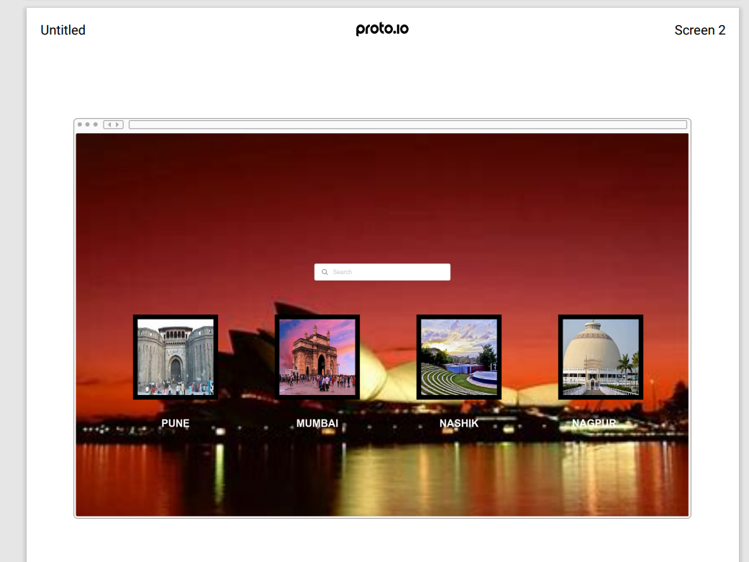

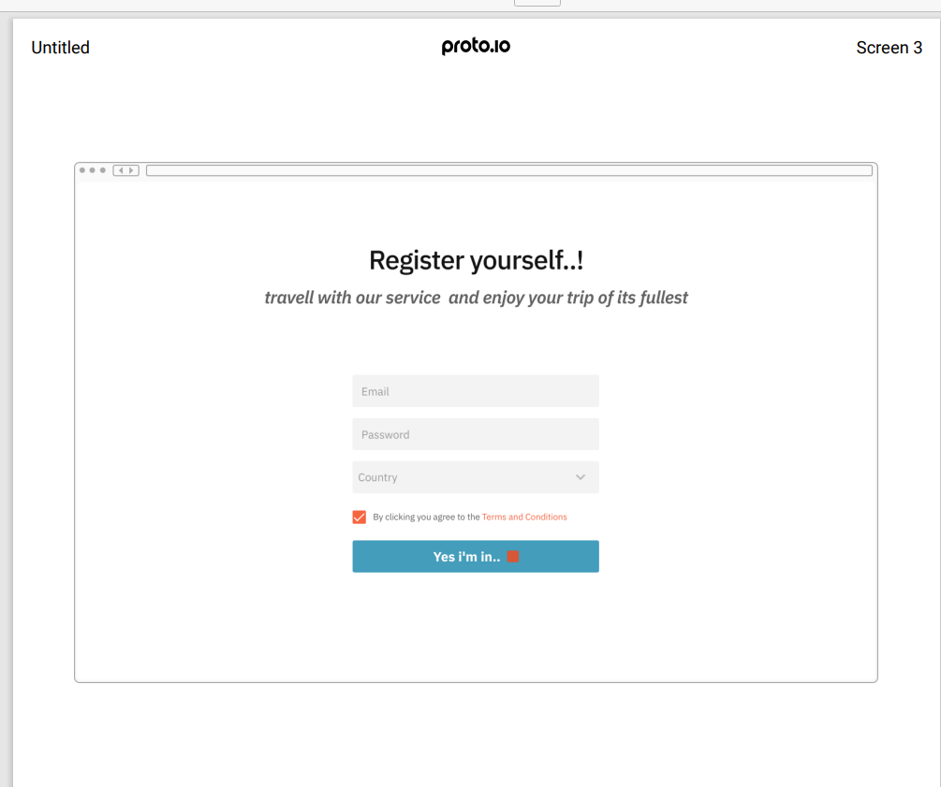

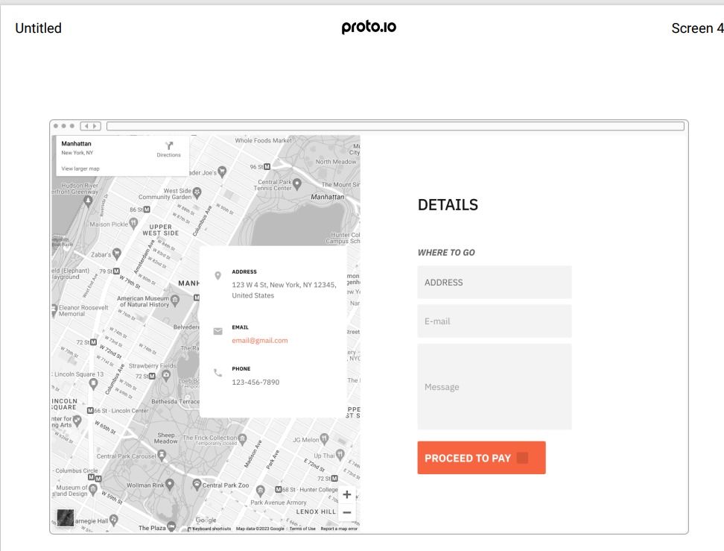

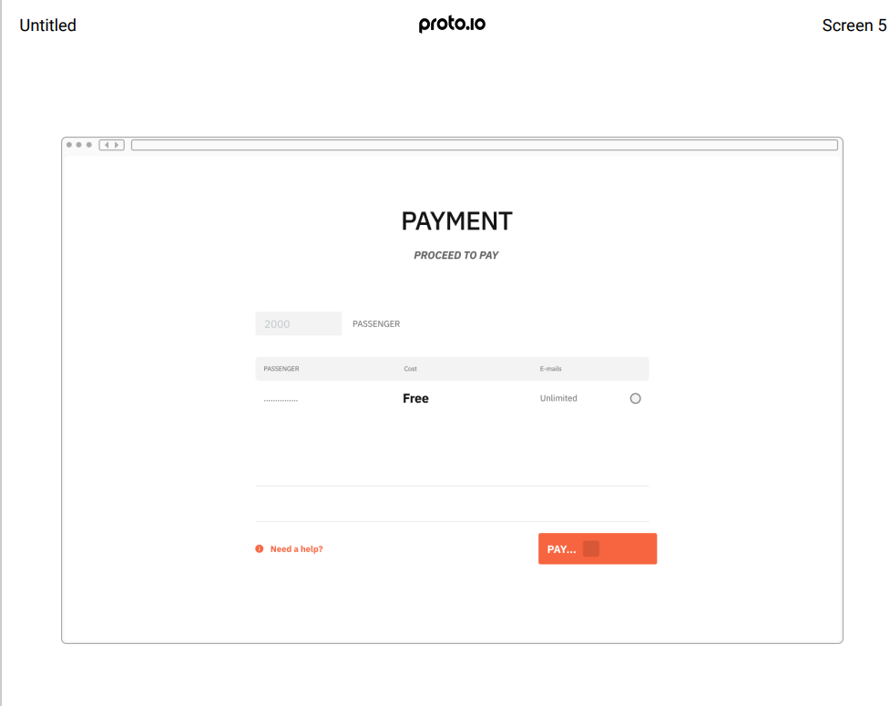

**5 Conclusion**

In today's busy life we have made an app which helps people to commute through public transport in a much easier way, completely paperless procedure one step towards digital india time saving hassle free and easy process . Further we would like to increase our app throughout India.

**6 References**

1. Institute of electrical and electronic engineers - P Pandimurugan 2019
2. Smart Bus app - k Agarwal