

A Report on

Soap case Mechanism

**Course – Mech Prototype**

**Division - B**

**Batch – B3**

**Branch - ENTC ENGINEERING**

Submitted By –

|  |  |
| --- | --- |
| 202201070124 | Vaibhav Pawankar |
| 202201070127 | Ayush Fating |
| 202201070128 | Kaustubh Mahajan |
| 202201070132 | Alvin Abraham |
| 202201070134 | Chinmay Parite |

|  |  |  |  |
| --- | --- | --- | --- |
| Sr no. |  | Name of topic | Page no . |
| 1 |  | Introduction to Mechanical Prototyping |  |
|  | 1.1 | Advantages |  |
|  | 1.2 | Limitations |  |
|  | 1.3 | Applications |  |
|  | 1.4 | Techniques of Rapid Prototyping |  |
| 2 |  | Concept Representation |  |
| 3 |  | CAD Modelling |  |
|  | 3.1 | Project |  |
| 4 |  | Methodology |  |
|  | 4.1 | Pre-Processing |  |
|  | 4.2 | Post -Processing |  |
|  |  | Application of Project and Group Assembly |  |
| 6 |  | Conclusion |  |
| 7 |  | Reference |  |
|  |  |  |  |
|  |  |  |  |

**CONTENTS**

**ABSTRACT**

This paper highlights the pressing need for a versatile, durable, and aesthetically pleasing soap case that optimizes space, promotes convenience, and caters to modern lifestyle demands. By addressing this need, the prototype aims to revolutionize the way we approach personal hygiene organization, offering an efficient and sustainable solution for diverse settings, including homes, travel, and shared living spaces..

**ACKNOWLEDGEMENT**

We would like to extend our sincere gratitude to all those who contributed to the successful completion of this soap case project. Their support, expertise, and dedication were instrumental in achieving our goals.

First and foremost, we would like to express our appreciation to our project team members for their tireless efforts and commitment. Each member brought unique skills and perspectives that greatly enriched the project.

We are indebted to our project advisor ,whose guidance and mentorship were invaluable throughout the project. He provided invaluable insights and ensured that we stayed on the right track.

**INTRODUCTION OF MECHANICAL PROTOTYPING**

Welcome to the innovative world of bathroom convenience! Introducing our mechanical prototype soap case, thoughtfully designed to seamlessly integrate functionality and space-saving features for a more organized and efficient daily hygiene routine. This cutting-edge soap case not only holds your favourite soap securely but also boasts extra space ingeniously crafted to accommodate your toothbrush, ensuring a clutter-free and convenient experience. Embrace the future of bathroom organization and simplicity with our mechanical prototype soap case – where practicality meets modern design.

The process of mechanical prototyping encompasses a wide range of techniques and methodologies, from traditional craftsmanship to cutting-edge technologies like 3D printing and computer-aided design (CAD). Regardless of the specific methods employed, the goal remains the same: to bring a concept to life in a tangible form, facilitating rigorous testing, iteration, and improvement.

**ADVANTAGES**-

* Space Optimization: The soap case is engineered to maximize space utilization in the bathroom. By accommodating both soap and a toothbrush, it declutters the countertop and creates a more organized bathroom environment.

Environmentally Friendly: By consolidating your soap and toothbrush in a single case, you reduce the need for additional plastic or disposable packaging, contributing to a more sustainable and eco-friendly lifestyle.

LIMITATIONS –

* Cost: Creating physical prototypes can be expensive, particularly when using high-quality materials and specialized equipment. Costs can include materials, labor, and equipment maintenance.
* Time-Consuming: Building physical prototypes takes time, which can slow down the product development process. The time required depends on the complexity of the prototype and the chosen fabrication method.
* Limited Precision: The precision of a physical prototype may not always match the exact specifications of the final product. This limitation can be

APPLICATION –

Home Use: The soap case is ideal for daily use in homes, offering a practical solution to keep soap and toothbrush organized in bathrooms. It promotes a neat and tidy countertop, enhancing the overall look and feel of the bathroom.

* Traveling: Travelers can take advantage of the compact and portable nature of this soap case. It securely holds the essentials, ensuring a hygienic and organized travel experience, whether for a weekend getaway or an extended trip
* Hotels and Guest Houses: Hospitality establishments can provide this soap case to guests, enhancing their overall experience during their stay. It showcases a thoughtful and modern approach to guest amenities, leaving a positive impression.

**TECHNIQUES OF RAPID PROTOTYPING –**

* Fused Deposition Modeling (FDM):

FDM is one of the most popular 3D printing methods. It involves melting and extruding a thermoplastic filament through a nozzle, layer by layer, to build up the desired object.

* Stereolithography (SLA):

SLA uses a laser to solidify liquid resin layer by layer, creating highly detailed and accurate prototypes. It's commonly used for producing intricate, high-resolution parts.

* Selective Laser Sintering (SLS)

SLS utilizes a laser to sinter (fuse) powdered materials, such as plastic, metal, or ceramics, layer by layer. It's ideal for creating functional prototypes and complex geometries.

**CONCEPT PRESENTATION**

Problem Statement - To make space efficient soap case which will include space for different things like tooth brush etc.

.

**METHODOLOGY**

**Project Design and CAD Modeling:**

* Begin by designing the 3D model of the soap case using CAD software (e.g., Autodesk Fusion 360, SolidWorks).
* Ensure the model includes all necessary details and specifications, such as dimensions, features, and any customizations required for the prototype.

**Slicing Software and G-code Preparation:**

* Import the CAD model into a slicing software (e.g., Cura, PrusaSlicer).
* Configure slicing settings, including layer height, infill density, print speed, and support structures, to optimize print quality and efficiency.
* Generate the G-code, which contains the instructions for the 3D printer, based on the slicing software settings and the 3D model.

**RAPID PROTOTYPING TECHNIQUES –**

To commence the design process, we engage in the conceptualization phase, brainstorming ideas that encompass aspects such as size, shape, and material selection. Autodesk Fusion 360, a sophisticated Computer-Aided Design (CAD) software, becomes our indispensable tool for converting these concepts into reality. With Fusion 360's capabilities, we create a detailed 3D digital model of the soap case, paying meticulous attention to precise measurements, design features, and the flexibility of parametric modeling.

**PROCESS OF RAPID PROTOTYPING**

**1.Fusion Modelling:**

Using sophisticated Computer-Aided Design (CAD) software, such as Autodesk Fusion 360, the process begins with creating a highly detailed and accurate 3D digital model of the C-clamp. This CAD model serves as the blueprint, encapsulating precise measurements, intricate design features, and customizable parameters. With Fusion 360's versatile tools, designers can efficiently sketch, extrude, and manipulate the components of the clamp, ensuring that it aligns perfectly with the project's specifications.

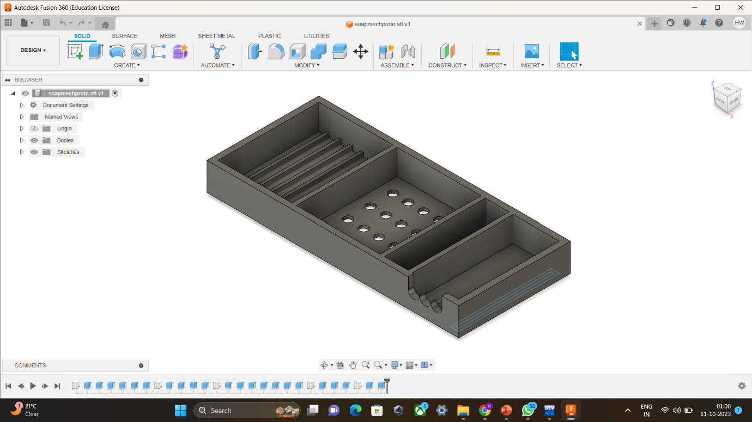

2. PRE-PROCESSING

Cura software plays a pivotal role in the development of a C-clamp prototype, offering powerful capabilities for translating design concepts into a physical reality. Cura, a popular slicing software, acts as the intermediary between the 3D CAD model and the 3D printer, enabling the seamless conversion of the digital design into a series of precise instructions, known as G-code, which the printer follows to create the physical prototype. With Cura, designers have granular control over the printing process, allowing them to fine-tune parameters such as layer height, infill density, print speed, and support structures to optimize the quality and efficiency of the prototype.

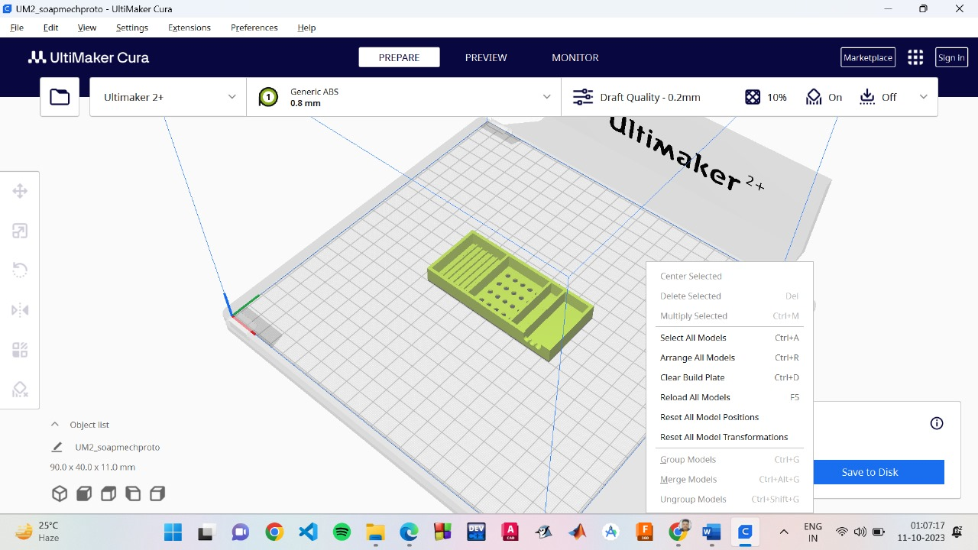

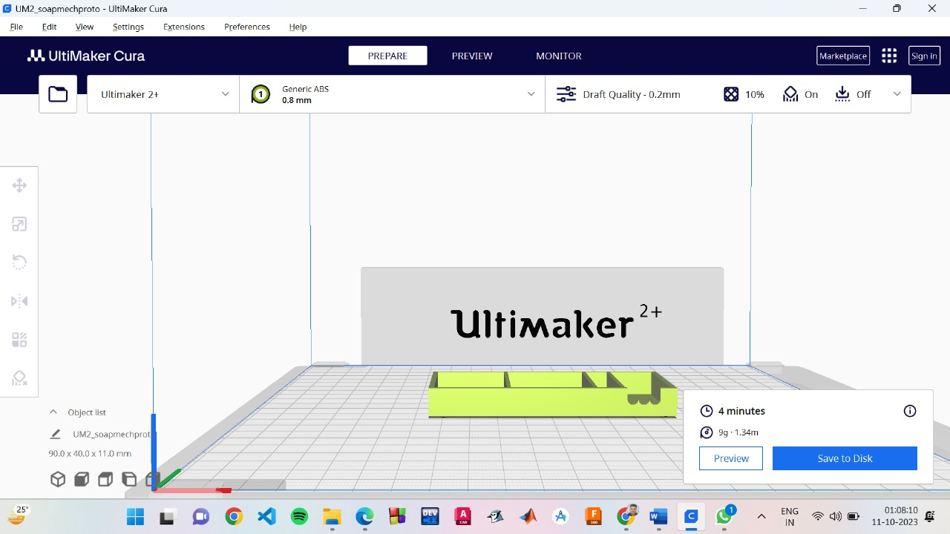

**APPLICATIONS OF PROJECT**

Home Use: The soap case is ideal for daily use in homes, offering a practical solution to keep soap and toothbrush organized in bathrooms. It promotes a neat and tidy countertop, enhancing the overall look and feel of the bathroom.

Traveling: Travelers can take advantage of the compact and portable nature of this soap case. It securely holds the essentials, ensuring a hygienic and organized travel experience, whether for a weekend getaway or an extended trip.

Gym and Fitness Centers: Individuals can utilize the soap case at gyms or fitness centers to carry their soap and toothbrush for a post-workout shower. Its efficient design simplifies the process of packing and ensures hygiene during workouts.

Hotels and Guest Houses: Hospitality establishments can provide this soap case to guests, enhancing their overall experience during their stay. It showcases a thoughtful and modern approach to guest amenities, leaving a positive impression.

Dormitories and Shared Living Spaces: In shared living environments such as dorms or communal housing, the soap case is invaluable for personal hygiene organization. It helps each resident keep their soap and toothbrush separate and accessible in a shared bathroom.

Camping and Outdoor Adventures: Outdoor enthusiasts can benefit from the soap case while camping or engaging in outdoor activities. Its durable construction and efficient design make it suitable for storing soap and a toothbrush in a compact and organized manner during trips.

Offices and Workplaces: Individuals can use the soap case at their workplace to maintain personal hygiene and keep their soap and toothbrush discreetly organized at their desk or in a communal bathroom.

Healthcare Facilities: In healthcare settings, the soap case can serve as a useful tool for patients, allowing them to store personal soap and a toothbrush in a hygienic and organized manner.

**CONCLUSION**

In conclusion, our innovative mechanical prototype soap case, thoughtfully designed with an additional compartment for a toothbrush, presents a versatile and practical solution for modern hygiene needs. Through a blend of space optimization, convenience, durability, and a touch of modern aesthetics, this soap case caters to a range of applications in both personal and shared spaces.

Whether used at home to declutter bathroom countertops, during travels for a seamless hygiene routine on the go, or in communal environments like gyms, hotels, and dormitories to promote organization and personal space, this soap case stands as a testament to the evolving landscape of hygiene solutions.

As we strive for efficiency, hygiene, and sustainability, the integration of this soap case into daily routines offers not only a streamlined approach to personal care but also a step towards a more eco-friendly lifestyle. With its durable construction and eco-conscious design, it aligns with the principles of reducing waste and minimizing environmental impact.

Embrace the future of hygiene with our mechanical prototype soap case, an embodiment of functionality and style, enhancing the way we approach everyday cleanliness, and making a positive impact on our living spaces and the environment.

**REFERENCES**

<https://www.stockyourhome.com/products/modern-innovations-acrylic-soap-dish-shatterproof-clear-plastic-soap-dish-crystal-clear-soap-dish-for-bar-soap-holder-sponge-holder-or-small-bathroom-tray-in-showers-kitchens-hotels-and-more>

<https://www.designerpeople.com/blog/soap-box-packaging-design/>