# Abstract

Central America is one of the regions with the highest vulnerability to climate change, with negative effects projected to affect its economy and food security. To address this issue, an integrative farm management approach such as Climate-Smart Agriculture can help reorient agricultural practices towards climate adaptation and food security. Past studies have shown that several factors can either hinder or encourage the adoptions of Climate-Smart practices, including subjective expectations and perceptions. Building on this literature, we analyze farmers´ climate awareness and their perceptions regarding the change in climate patterns as well as their choices of farming practices to adapt to these changes. We show that reforestation was the preferred adaptation strategy among interviewed farmers and that educational profiles and the size of landholdings drive the adoption of this and other practices. Soil management and introduction of new crops are preferred by literate farms with large farmlands, whereas illiterate farmers with smaller farmland tend to move towards farm intensification with an increase in the utilization of external inputs. Our findings provide evidence to support the design of capacity development interventions targeting specific groups of farmers according to their main crop and education profile.

**Keywords:** Adaptation to climate change; Bradley-Terry Model; Central America Dry Corridor; Climate Change; Climate-Smart Agriculture; Farmer Field Schools; Reforestation; Smallholder

# Introduction

Trends in greenhouse gases emissions to 2050 indicate a low contribution of Central America to global warming (Marchal et al., 2011), and yet the region is highly vulnerable to the effects of climate change. Several climate-related impacts have been projected for the region, indicating changes in evapotranspiration, temperature, precipitation, species suitability, farm productivity, and forest loss, mainly across the drier zones (Hannah et al., 2017; Lyra et al., 2017). Therefore, promoting farm practices to strengthen resilience and productivity of agricultural systems is crucial to help farmers in Central America adapt to climate change and thus ensure food provision and income generation.

Climate change has increased the risks and uncertainties associated with agriculture, particularly in developing countries (Altieri and Nicholls, 2017; Imbach et al., 2017). Changes in the frequency and intensity of extreme climatic events in the tropics due to climate change have increased the concerns for farm adaptation among scientists (Hannah et al., 2017; Harvey et al., 2014; Mbow et al., 2014) and farmers (Elum et al., 2017; Khatri-Chhetri et al., 2017; Singh et al., 2017). It is argued that the adoption of Climate-Smart Agriculture (CSA) practices will help vulnerable farmers cope with the effects of climate variability and change (Lipper et al., 2014; Steenwerth et al., 2014). Climate-Smart Agriculture is an integrative approach designed to help farmers reorient their agricultural practices to sustainably rise agricultural productivity to ensure increases in farm incomes and food security, while adapting and mitigating climate change. These practices include farm sustainable intensification and diversification of production, agroforestry, varietal selection, plant breeding, ecosystem management, crop patterns identification, and integrated practices to minimize the need of external inputs (FAO 2010).

The adoption and impact of agricultural practices and technologies has been a focus of study for several years (see Mwangi and Kariuki (2015), for a literature review on adoption, and Ogundari and Bolarinwa (2018), for a recent meta-analysis on the impacts of agricultural technologies). The literature shows that the adoption of technologies by smallholder farmers mostly has a positive effect on welfare and production outcomes, and that adopting technology packages as opposed to individual components can further increase these benefits (Khonje et al., 2018).

Nevertheless, several socio-economic barriers can hinder technology adoption, even in countries that enjoy higher levels of technological innovation and well-established institutions (Long et al., 2016). The presence of certain policies, such as input subsidies (Koppmair et al., 2017), and technology specific characteristics (Senyolo et al., 2018; Wassie and Pauline, 2018) can also influence whether and which technologies farmers adopt. Likewise, intrinsic factors, such as perceptions and knowledge of farmers, play a role on shaping technology adoption (Meijer et al., 2015).

One strain of this body of literature on technology adoption uses the theory of planned behavior (Ajzen, 1991) to understand how perceptions and other underlying psychological constructs affect technology adoption. In a study about the adoption of improved natural grassland in Brazil, Borges et al. (2014) find that farmers’ expectations about the benefits of this new technology, their perceptions about social pressure, and their perceptions about their own skills are significantly correlated with the intention to adopt. Similarly, Wauters et al. (2010) show that attitudes towards soil conservation practices are one of the biggest determinants of adoption among Belgium farmers. Regarding sustainable agricultural practices for climate adaptation, several studies conclude farmers’ awareness and perceptions of climate change are correlated with adoption (Elum et al., 2017; Niles and Mueller, 2016; Schattman et al., 2016; Singh et al., 2017).

Building on this body of literature, the objective of this study is to understand how farmers´ awareness of climate change and their socioeconomic profiles drive the utilization of sustainable farm management practices in Central America. We assess farmers’ climate awareness by identifying farmers´ perceptions of climate variability and compare it with observed climate anomalies using time series data. Additionally, we implement a Bradley-Terry model to assess how socioeconomic profiles and farm characteristics influence farmers´ choices in the adoption of sustainable agriculture practices.

# Materials and methods

## Study area and household data

We used surveyed data from 283 households participating in the Mesoamerican Environmental Program (MAP), a rural development program conducted in Central America between 2009 and 2017 that used Farmer Field Schools (FSS) to promote CSA practices and gender integration (see Gutierrez-Montes et al. (2018), for details on the methodology applied in the FFS). We used two sets of data: *(i)* a household survey on farmer´s perceptions on climate change (Supplementary information Text S1), and *(ii)* household socioeconomic data and information records of practices adopted by the farmers after participating in FFS obtained from MAP’s annual monitoring.

Farmers were located across the two main ecoregions of Central America (Fig. 1): the Central American Dry Corridor (or Dry Forests), corresponding to El Salvador, Guatemala, Honduras, and part of Nicaragua (districts of Jinotega and Matagalpa); and the Central American Rainforests in Nicaragua (districts of Jinotega, Matagalpa, and Atlántico Norte). Farms across the Dry Corridor have an annual average precipitation of 1,400 mm (1,000–2,100 mm), mean annual temperature of 22 °C (14–25 °C) and mean elevation of 750 m a.s.l. (300–1,950 m a.s.l.). Farms across the Rainforests present annual average precipitation of 2,200 mm (1,500–2,400 mm), mean annual temperature of 22 °C (19 – 25 °C) and mean elevation of 570 m a.s.l. (240–1,200 m a.s.l.) (Hijmans et al., 2005). Agricultural and livestock production are the main economic activities developed across the research sites.

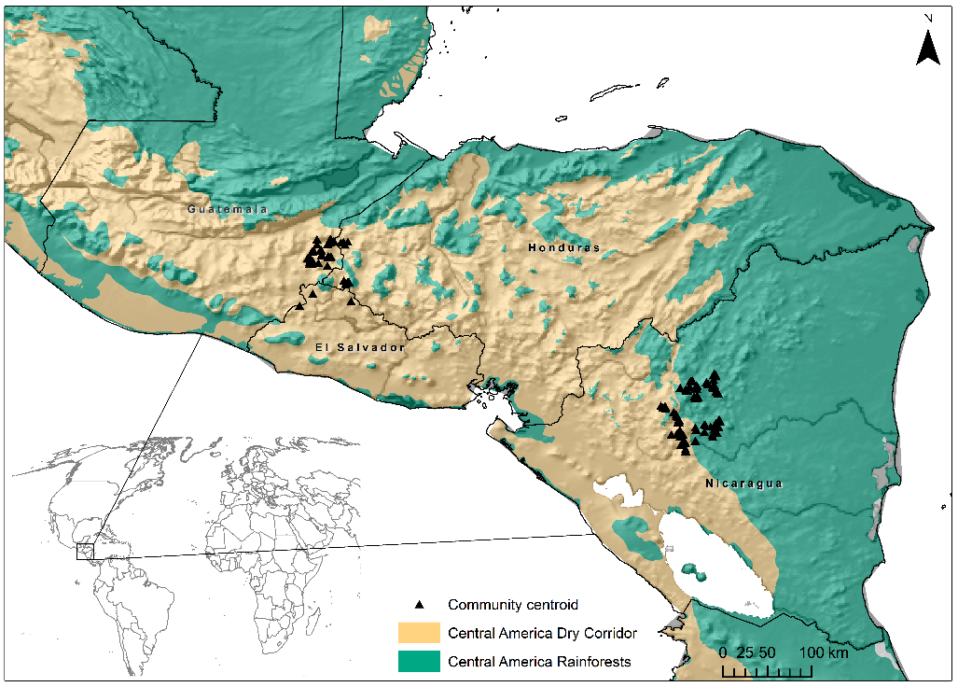

Fig. 1. Research sites across Central America.

Precipitation is key for determining the crop seasons in Central America, especially for the annual crops. The first growing season, called *Primera*, starts in May and ends in September, when the second season (*Postrera*) begins. The last growing season, *Apante*, starts in November and ends in January. This season presents a gradual decrease in rainfall until the beginning of the dry season (*Verano*) in January (Fig. 2).

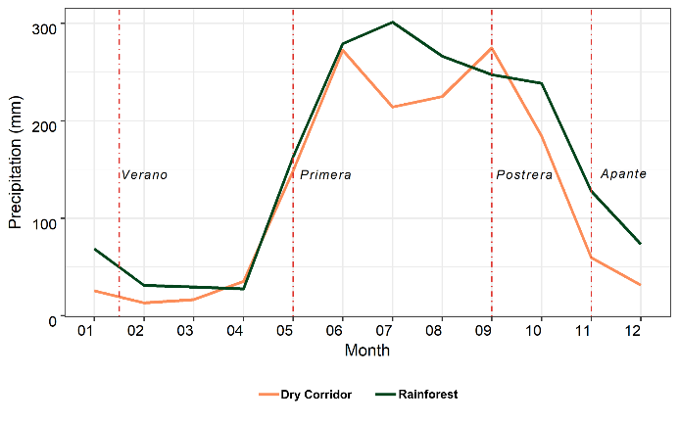

Fig. 2. Average monthly precipitation between 1891–2016 per crop season across the research sites in Central America.

To collect the household data, in 2014, we applied a questionnaire to identify the perceptions of farmers regarding changes in climatic patterns and how they responded to these events in terms of farm management practices. Farmers were questioned about their perceptions regarding changes in precipitation and temperature over the 10 years before the interviews (2005–2014). Farmers who reported to have felt changes in climatic patterns were asked to list the farm management practices they have adopted in their crop systems to cope with such changes. These practices were ranked by the order they were mentioned by the farmers. In Table 1 we show descriptive statistics of the socioeconomic data from the 283 households disaggregated by ecoregion.

Table 1. Socioeconomic characteristics of interviewed households by ecoregion.

|  |  |  |  |  |
| --- | --- | --- | --- | --- |
| Variables | Dry Corridor | | Rainforests | |
|  | Mean | S.D. | Mean | S.D. |
| Age of the HH head | 51.69 | 13.19 | 50.89 | 12.85 |
| *Level of education of the HH head* |  |  |  |  |
| Illiterate (1/0) | 0.320 |  | 0.280 |  |
| Primary school (1/0) | 0.600 |  | 0.700 |  |
| Secondary school (1/0) | 0.080 |  | 0.020 |  |
| Number of HH members above 60 years | 1.490 | 0.570 | 1.380 | 0.490 |
| Number of HH members between 15 – 60 years | 3.880 | 1.950 | 3.810 | 1.850 |
| Number of HH members between 5 – 15 years | 1.910 | 0.910 | 2.040 | 1.080 |
| Production diversity* | 2.760 | 1.060 | 4.510 | 1.610 |
| PPI** | 37.67 | 16.20 | 36.63 | 15.54 |
| Farm area (ha) | 5.380 | 12.05 | 10.17 | 12.13 |
| Area of main system (ha) | 5.640 | 55.40 | 1.070 | 0.830 |
| N | 159 |  | 124 |  |

Note: HH, household. *Number of crops cultivated in the farmland. **PPI, Progress Out of Poverty Index.

## Retrieving environmental data to validate farmers’ perceptions

We took farmers´ perceptions of changes in climatic patterns and compared them to a gridded time series precipitation database from the Climate Hazards Group InfraRed Precipitation with Station data (CHIRPS) (Funk et al., 2015). This database incorporates global daily rainfall data since 1983 with a resolution of 2.5 arc-min (~ 5 km2), which is obtained by weather stations and combined with remote sensing. Changes in precipitation were assessed by calculating three extreme precipitation indices relevant for Central America (Aguilar et al., 2005): *(i)* SDII, simple daily intensity index (precipitation amount/rainy days ≥ 1 mm); *(ii)* Rx5day, maximum 5-day precipitation (days); and *(iii)* MLDS, maximum length of consecutive dry days (< 1 mm). Information on temperature was not assessed due to the lack of consistent high-resolution time series data for Central America. We performed a multiple correspondence analysis for quantitative and categorical variables (Lê et al., 2008) to identify the association of observed changes in precipitation (based on CHIRPS data) and farmers’ perceptions.

## Ranking farmers’ strategies to cope with climate variability

We analyzed the strategies each farmer claimed to have adopted to cope with perceived changes in climate patterns by using a Bradley-Terry model (Bradley and Terry, 1952; Turner and Firth, 2012) to create partial ranks of 5 (the five first strategies mentioned by each farmer). The Bradley-Terry model estimates the “worth parameter” or the relative importance of the different strategies in pairwise comparisons and, under the Model-Based Recursive Partitioning approach, identifies sub-groups of farms with similar choices (Hothorn and Zeileis, 2015; Strobl et al., 2011).

We added six variables to the splitting algorithm: *(i)* the ecoregion (Dry or Rainforest), *(ii)* the Progress Out of Poverty Index (PPI), *(iii)* the literacy level of the head of household, *(iv)* the area of the main crop system (ha), *(v)* the age of the head of household, and *(vi)* the number of practices adopted by the farmers after participating in the FFS. Under this approach, if the difference in chosen strategies was significant (α < 0.05), then the model would create different groups. Based on practices reported by farmers, we ranked 10 options: *(i)* Change in Agricultural Calendar, *(ii)* Change in Varieties, *(iii)* Production Diversification, *(iv)* Introduction of New Crops, *(v)* Less Fertilizers and Pesticides, *(vi)* Reforestation and Restoration, *(vii)* Sustainable Soil Management, *(viii)* Sustainable Water Management, *(ix)* Leave Farming System, and *(x)* More Fertilizers and Pesticides. These practices vary in terms of effort, costs, and information level required for its implementation (for details see FAO (2013)). We used *Production Diversification* as a reference in the Bradley-Terry model, since this is one of the main strategies to reduce risks of food insecurity and climate vulnerability (Campbell et al., 2016). Finally, the likelihood of farmers using these practices was assessed by analyzing the relationship of the farmers’ main crop system and their list of reported practices (Theus and Urbanek, 2008).

# Results

## Farmers perceived changes in precipitation with some accuracy

From the group of 283 interviewed farmers, 255 (90%) felt changes in climate patterns over the 10 years prior to the survey (2005–2014). Trends during this period in the precipitation time series data show statistical differences in all three precipitation indices used in this analysis. The frequency of heavy precipitation in Rx5day was progressively reduced over the period of 2005–2014 across both ecoregions (Fig. 3). The negative anomaly (historical mean minus year mean) in Rx5day is seen in most of the observed years, with significant decreases in the Rainforests. The daily precipitation intensity (SDII) shows important changes across the Rainforests, with no significant changes across the Dry Corridor. This index also indicates strong negative anomalies in the Rainforests, mainly in 2014. Both ecoregions had gradual increment on the length of consecutive dry days (MLDS), with significant changes occurring in the Rainforests (Fig. 3).

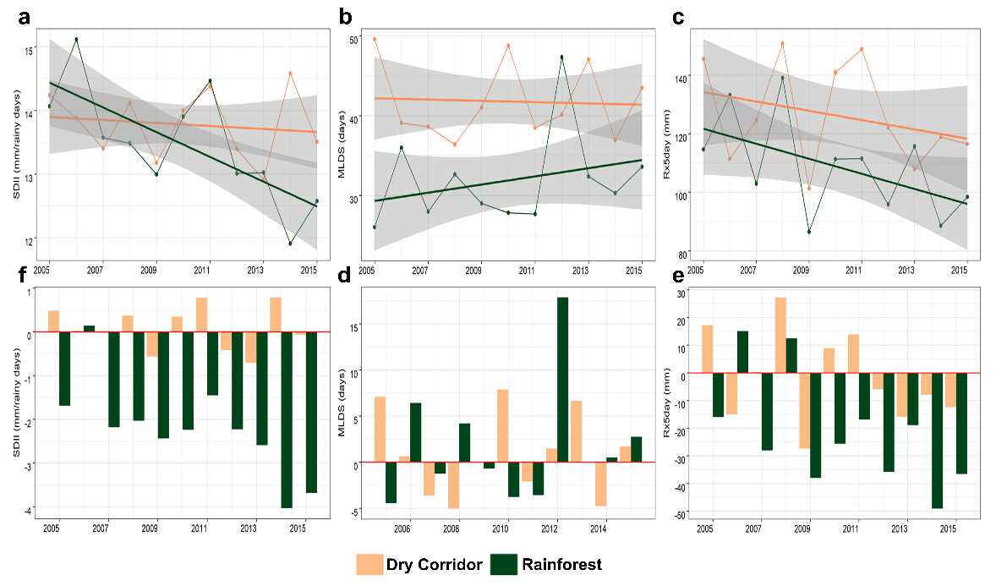

Fig. 3. Trends in precipitation indices (a, b, c) and anomaly (d, e, f) from 2005 to 2014 across the Central America Dry Corridor and Rainforests. SDII, simple annual precipitation index (mm/rainy days); Rx5day, maximum 5-day precipitation (mm); MLDS, maximum length of consecutive dry days (< 1 mm).

The multiple correspondence analysis of farmers’ perceptions versus observed anomalies shows partial correlations between farmers’ perceptions and observed time series data (Fig. 3). Farmers who perceived uncertainty regarding the start/end of the rainy season correlate with observed decrease in heavy precipitation (Rx5day), decrease in daily precipitation intensity (SDII), and increase of the length of consecutive dry days (MLDS). Farmers who perceived less annual precipitation correlate with observed increase in SDII and Rx5day. Finally, those who perceived more precipitation or heavy precipitation are not correlated with any of the observed changes from the time series data (Fig. 4).

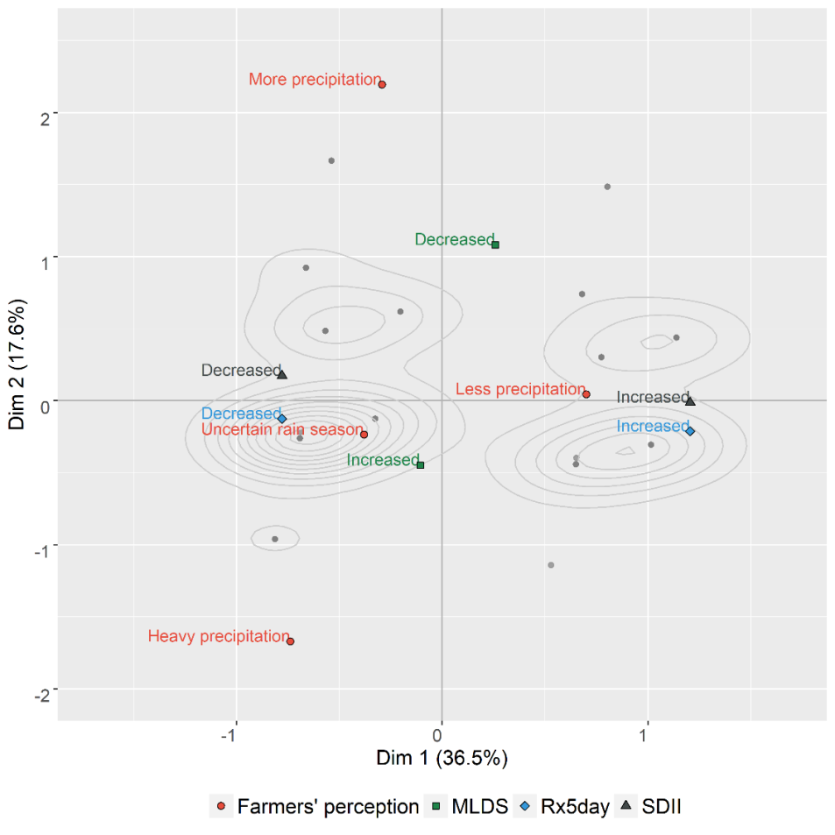

Fig. 4. Correspondence between farmers’ perception on changes in precipitation and observed anomalies in precipitation indices over 2005–2014 across the Central America Dry Corridor and Rainforests. MLDS, maximum length of consecutive dry days (< 1 mm); Rx5day, maximum 5-day precipitation (mm); SDII, simple annual precipitation index (mm/rainy days).

## Socioeconomic factors led to the utilization of new practices

The worth estimates for ranked practices from the Bradley-Terry model show significant differences between practices employed to adapt with perceived changes in climatic patterns across the research sites (Table 2). Worth estimates for *Reforestation and Restoration*, *Introduction of New Crops*, and *Sustainable Soil Management* are significantly higher than the reference *Production Diversification*. The other practices are ranked below the reference, with *Leave Farming System* and *Change Agricultural Calendar* on the bottom of ranked practices to cope with perceived changes in in climatic patterns (Table 2).

Table 2. Model estimates from farmers’ management practices employed to adapt to perceived changes in climate patterns in Central America.

|  |  |  |  |  |  |
| --- | --- | --- | --- | --- | --- |
| Practices | Estimate | Std. Error | z value | Pr(>|z|) | Signif. |
| Reforestation and Restoration | 1.5120 | 0.0811 | 18.6470 | < 0.0001 | *** |
| Introduction of new crops | 0.7572 | 0.0844 | 8.9680 | < 0.0001 | *** |
| Sustainable soil management | 0.2554 | 0.0834 | 3.0620 | 0.0022 | *** |
| **Production diversification** | **0.0000** | **--** | **--** | **--** | **--** |
| Change in varieties | -0.2805 | 0.0883 | -3.1770 | 0.0015 | ** |
| Sustainable water management | -0.6814 | 0.0919 | -7.4140 | < 0.0001 | *** |
| Use of more fertilizers and pesticides | -0.7658 | 0.0925 | -8.2820 | < 0.0001 | *** |
| Use of less fertilizers and pesticides | -0.8516 | 0.0942 | -9.0400 | < 0.0001 | *** |
| Leave farming system | -1.4053 | 0.1069 | -13.1440 | < 0.0001 | *** |
| Change in agricultural calendar | -1.5276 | 0.1095 | -13.9520 | < 0.0001 | *** |

Significance levels: ‘***’ 0.001 ‘**’ 0.01 ‘*’ 0.05 ‘.’ 0.1

The recursive partitioning algorithm split the data in four sub-groups by the following variables: ecoregion, literacy level and farm area (Fig. 5). Overall, *Reforestation and Restoration* was the first choice in the four sub-groups. The first group includes those farmers living in the Dry Corridor, illiterates and with farm area ≤ 0.5 ha. Additionally to reforestation, farmers from this sub-group chose practices such as *Sustainable Soil Management*, *Introduction of New Crops*, *Use of* *More Fertilizers and Pesticides* and *Production Diversification* as the main practices to respond to the effects of perceived climate variability.

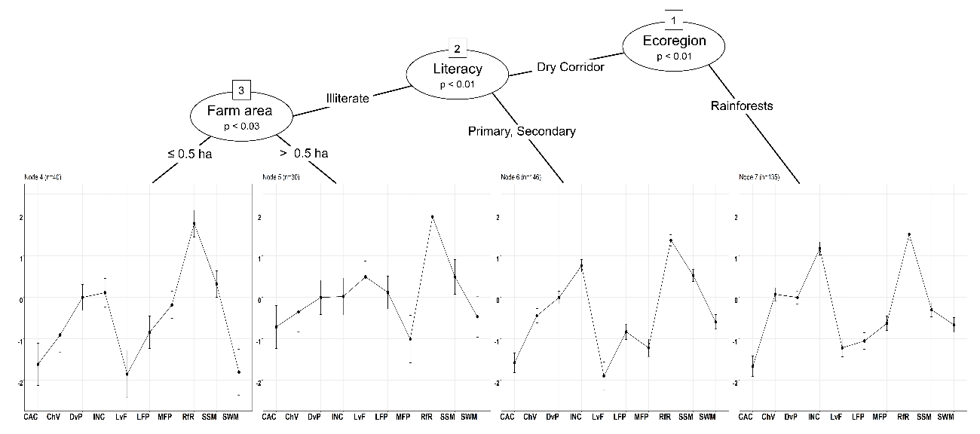

Fig. 5. Recursive partitioning of Bradley-Terry model of farmers’ management practices employed to adapt to perceived changes in climate patterns in Central America. Intervals show quasi-standard errors. CAC = Change in agricultural calendar, Chv = Change in varieties, Dvp = Production diversification, INC = Introduction of new crops, Lvf = Leave farming system, LFP = Use of less fertilizers and pesticides, MFP = Use of more fertilizers and pesticides, RfR = Reforestation and restoration, SSM = Sustainable soil management, SWM = Sustainable water management.

The second splitting group comprises the farmers living in the Dry Corridor, illiterates and with farm area > 0.5 ha. In this sub-group, the main chosen practices were *Sustainable Soil Management*, *Leave Farming System*, and *Use of Less Fertilizers and Pesticides*. In the third sub-group, we identify literate farmers (primary or secondary degree) living in the Dry Corridor who chose, additional to reforestation, the *Introduction of New Crops*, *Sustainable Soil Management* and *Production Diversification.* Farmers living in the Rainforests corresponds to the fourth sub-group whose preferred practices for climate adaptation were *Introduction of New Crops* and *Change Varieties*.

## Choices in practices influenced by the type of crop system

The type of farming system also influenced how farmers chose to adapt to changes in perceived climate patterns. Interviewed cocoa growers showed higher likelihood to use *Change in Agricultural Calendar*, *Introduction of New Crops,* and *Leave Farming System*, as well as a lower likelihood to implement *Sustainable Soil Management* and *Use of Less Fertilizer and Pesticides*. Similarly, farmers who cultivate fruit trees have a higher likelihood to use *Production Diversification* and *Reforestation and Restoration*. On the other hand, livestock farmers are likely to use *Change in Varieties* (livestock grass varieties) and less likely to adopt *Sustainable Practices for Soils and Water Management*. Farmers whose main crop system is vegetables show a higher likelihood to use *Sustainable Soil and Water Management* and *Less Fertilizers and Pesticides*, with low preferences for *Reforestation and Restoration*, *Production* *Diversification,* and *Change in Varieties* (Fig. 6).

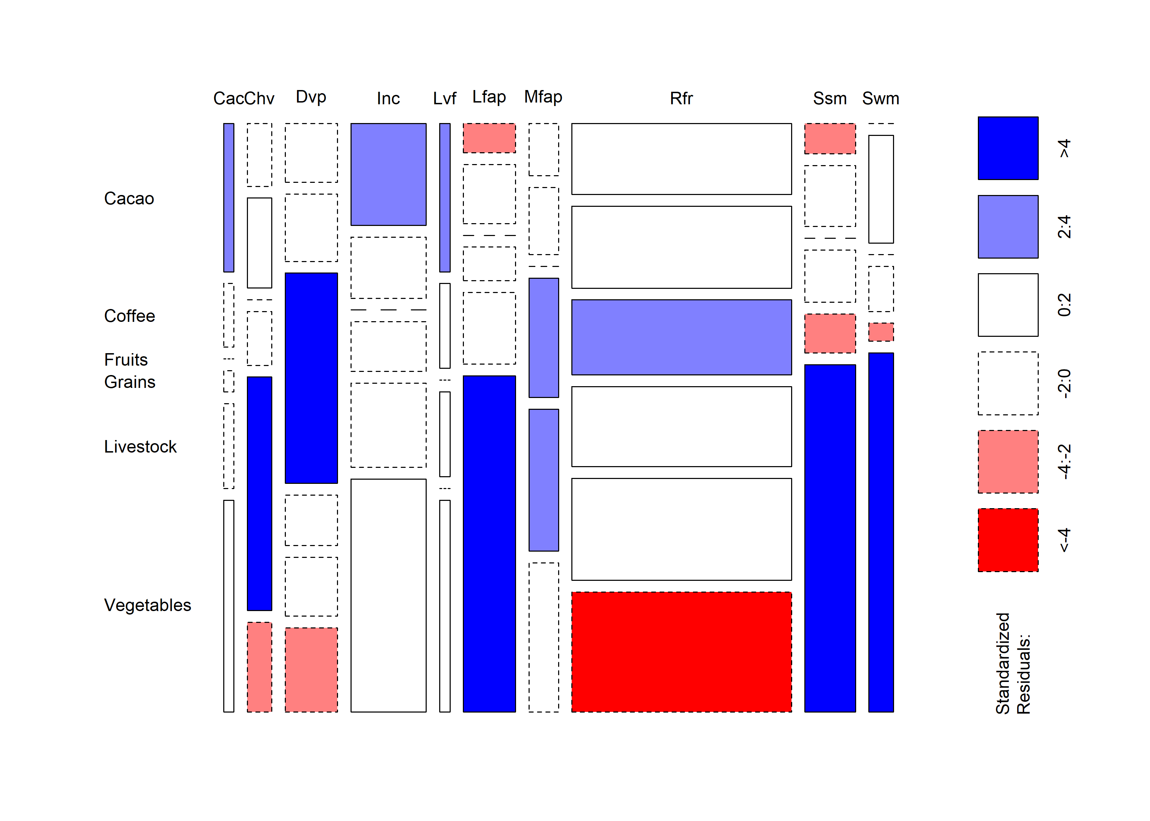

Fig. 6. Relationship between preferred adaptation practices and the main crop systems across the Central America Dry Corridor and Rainforests. CAC = Change in agricultural calendar, Chv = Change in varieties, Dvp = Production diversification, INC = Introduction of new crops, Lvf = Leave farming system, LFP = Use of less fertilizers and pesticides, MFP = Use of more fertilizers and pesticides, RfR = Reforestation and restoration, SSM = Sustainable soil management, SWM = Sustainable water management. Blue color indicate that the observed value is higher than the expected value if the data were random. Red color indicate that the observed value is lower than the expected value if the data were random.

# Discussion

We show that Central American farmers are aware of the change in climate patterns caused by climate change, with partial correlations between farmers’ perceptions and the historical precipitation data. These partial correlations may be explained by the difficulty to properly observe the changes as they occur without the aid of measuring devices (e.g. weather station, garden moisture meter) or without up-to-date weather information from other sources. However, even if farmers do not perfectly perceive these changes in climate patterns, they do observe reductions in their yields and at times losses of their crops, which draws their attention to climate-related problems and increases their willingness to innovate and try new farm management practices.

Reforestation was the preferred choice among farmers independent of education profiles, farm size, and ecoregion. This practice is advocated as the best way to cope with the effects of climate change, since it includes both mitigation and adaptation by providing carbon sink, microclimate regulation and protection to extreme climate events (Caudill et al., 2015; Locatelli et al., 2015; Torres et al., 2017). Farmers demonstrated high willingness to adopt reforestation despite low governmental incentives, which often can act as disincentives given the restrictions and bureaucratic regulations for the utilization of trees outside forests (mainly for timber) in many Central American countries (Detlefsen and Scheelje, 2012). Despite the lack on incentives to grow trees, we show that across the Rainforest, agroforestry (reforestation + introduction of new crops) was the first approach employed by farmers to adapt their systems, which is in accordance with the recent analysis conducted by Somarriba et al. (2017) in this region. Considering, however, the expected impacts of climate change on distribution and suitability of the most common tree species used in Central America (de Sousa et al., 2017), it is necessary to increase farmer’s awareness to select the best climate suited trees for their farms.

Illiterate farmers with small landholdings living in the Dry Corridor chose a set of approaches to adapt their systems and intensify the production that includes the adoption of new crops, soil management, and increased use of fertilizers. These practices, when integrated and well managed, can help smallholders to achieve high yields (Cassman, 1999) while reducing the need to expand the production to new crop areas. However, two concerns arise for this group. First, it is not clear if the increased utilization of fertilizers is employed under an optimal level to ensure sustainability and soil conservation, considering the crop and soil requirements. Second, the adoption of this technological package could, in the long run, lead to a high dependency of external inputs, a non-desired outcome in the concept of Climate-Smart Agriculture. To avoid this risk, farmers could employ integrated nutrient practices such as the utilization of nitrogen-fixing plants and green manures (Kang, 1997), which could be utilized as the only approach or integrated with a reduced amount of synthetic inputs.

Farmers living in the Dry Corridor with large farmland also selected reforestation and sustainable soil management as adaptation approaches. However, this group considered leaving the farm system as the third best adaptation strategy, which raises concerns about the future sources of food and household income to these families. The insufficient family workforce (~ 4 people with 15–60 years-old per family) in a large family farmland may drive farmers to this alternative. An approach for this group could be the intensification of small parts of their farms and utilization of intercropping systems such as *quesungual*, a high advocated alternative for drylands in Central America (Ayarza et al., 2010; Kang, 1993).

Changing agricultural calendar was one of the least preferred choices among interviewed farmers, which is unfortunate, as it is one of the simplest approaches to adapt to the effects of climate variability (Yegbemey et al., 2014). By adopting this approach, farmers can adjust the planting season to operate in a time-efficient manner and avoid extreme climatic events during sensitive growing phases, such as flowering (Sacks et al., 2010). The low preference for this approach may be the result of the scarce up-to-date agroclimatic information and forecasts on upcoming growing seasons, which are also in accordance with the partial correlations between farmers perceptions and the historical data observed in our analysis. The establishment of information services and early warning systems to provide seasonal forecasting and agroclimatic information can help farmers make the best decisions to adapt their systems under seasonal climate variability.

We show that the participation in long-term outreach projects can influence farmers’ decision to adopt sustainable practices (Gutierrez-Montes et al., 2018; Mercado et al., 2017). In this study, we provide evidence to support the design and implementation of outreach projects oriented for specific groups of farmers according to their main livelihood, ecoregion, and education profile. For example, when dealing with livestock and illiterate farmers, these findings are very important since they are more likely to increase the use of fertilizers and pesticides and reduce practices for soil and water management. Also, we identified that the preference of farm practices is closely related with the main crop produced by the farmer. For example, the utilization of *Reforestation and Restoration* in farms producing fruits is increased by climate variability, while it is not a preferred option in farms producing vegetables. This finding demonstrates the importance of tailoring the Farmer Field Schools curricula to the farmers´ characteristics and the main crop they produce. For example, the need to learn about climate-smart practices related to reforestation may be lower when regarding tree growers.

# Conclusions

Our study provides an overview of farmers’ perception of the changes in climate patterns in Central America and we argue that these perceptions to some extent drive the adoption of Climate-Smart Agriculture practices across the region. We demonstrate the relationship between farmers’ awareness of climate variability and their responses through the use of climate-smart practices. Overall, farmers demonstrated self-motivation to adapt their systems to climate variability. Nevertheless, most of them require technical guidance to adopt sustainable practices for sustainable agriculture. The participation in Farmer Field Schools can help farmers make the best decisions to adapt their agricultural systems to climate variability.

As we have shown, there is a strong correlation between some socioeconomic characteristics and the adoption of specific technological packages. Illiterate farmers, for instance, adopted a set of practices that includes the utilization of more fertilizers, which may affect farmers in the long term by increasing their dependency on external inputs and increase financial risks. Therefore, we recommend tailoring the Farmer Field Schools curricula to the needs of each specific group, taking into account their farm size, educational level and main crop.

Although farmers demonstrated awareness to climate change and to its effects the lack of up-do-date agroclimatic information is still an issue that hinders making the best decision regarding crop management, especially for the annual crops. The promotion of community weather stations can help farmers obtain accurate information regarding the climate and thus close this information gap. Furthermore, local and international development agencies and NGOs should make use of the weather information and models already available to foster the adoption of short and long-term technological packages tailored to specific ecoregions.

Given the uncertainties of the multiple effects of climate change in agriculture (Howden et al., 2007; Vermeulen et al., 2013), farmers and stakeholders must be constantly updated about the latest recommendations for each climatic region and for each crop activity. Recent experiences with citizen-science in Central America, Africa and Asia (Beza et al., 2017; Mancini et al., 2017; Steinke et al., 2017; Steinke and van Etten, 2017; van Etten et al., 2016) showed that farmers and decision-makers can track the responses of crop systems to the changing climate patterns as they occur in the farm and take the best decision towards climate adaptation. Therefore, it is important to stay in the loop and understand that adaptation requires constant evaluations on the state of farming system and on the outcomes of employed practices in terms of climate adaptation and productivity.

# Acknowledgments

This work has been possible thanks to the financial support from the Royal Embassy of Norway (contract no. CAM-2647-12/0004, MAP Norway Second Phase). We would like to thank the farmers for their contributions in data collection and to Mirna Barrios, Danilo Padilla, Oscar Mattus, Ana Cristela Gutiérrez, Sayra Talelo, Amada Olivas, and Liseth Hernandez for their support in logistics across the research sites.

# References

Aguilar, E., Peterson, T.C., Obando, P.R., Frutos, R., Retana, J.A., Solera, M., Soley, J., García, I.G., Araujo, R.M., Santos, A.R., Valle, V.E., Brunet, M., Aguilar, L., Álvarez, L., Bautista, M., Castañón, C., Herrera, L., Ruano, E., Sinay, J.J., Sánchez, E., Oviedo, G.I.H., Obed, F., Salgado, J.E., Vázquez, J.L., Baca, M., Gutiérrez, M., Centella, C., Espinosa, J., Martínez, D., Olmedo, B., Espinoza, C.E.O., Núñez, R., Haylock, M., Benavides, H., Mayorga, R., 2005. Changes in precipitation and temperature extremes in Central America and northern South America, 1961–2003. J. Geophys. Res. 110, D23107. https://doi.org/10.1029/2005JD006119

Ajzen, I., 1991. The theory of planned behavior. Organ. Behav. Hum. Decis. Process. 50, 179–211. https://doi.org/10.1016/0749-5978(91)90020-T

Altieri, M.A., Nicholls, C.I., 2017. The adaptation and mitigation potential of traditional agriculture in a changing climate. Clim. Change 140, 33–45. https://doi.org/10.1007/s10584-013-0909-y

Ayarza, M., Huber-Sannwald, E., Herrick, J.E., Reynolds, J.F., García-Barrios, L., Welchez, L.A., Lentes, P., Pavón, J., Morales, J., Alvarado, A., Pinedo, M., Baquera, N., Zelaya, S., Pineda, R., Amézquita, E., Trejo, M., 2010. Changing human–ecological relationships and drivers using the Quesungual agroforestry system in western Honduras. Renew. Agric. Food Syst. 25, 219–227. https://doi.org/10.1017/S1742170510000074

Beza, E., Steinke, J., van Etten, J., Reidsma, P., Fadda, C., Mittra, S., Mathur, P., Kooistra, L., 2017. What are the prospects for citizen science in agriculture? Evidence from three continents on motivation and mobile telephone use of resource-poor farmers. PLoS One 12, e0175700. https://doi.org/10.1371/journal.pone.0175700

Borges, J.A.R., Oude Lansink, A.G.J.M., Marques Ribeiro, C., Lutke, V., 2014. Understanding farmers’ intention to adopt improved natural grassland using the theory of planned behavior. Livest. Sci. 169, 163–174. https://doi.org/10.1016/J.LIVSCI.2014.09.014

Bradley, R.A., Terry, M.E., 1952. Rank Analysis of Incomplete Block Designs: I. The Method of Paired Comparisons. Biometrika 39, 324–345. https://doi.org/10.2307/2334029

Campbell, B.M., Vermeulen, S.J., Aggarwal, P.K., Corner-Dolloff, C., Girvetz, E., Loboguerrero, A.M., Ramirez-Villegas, J., Rosenstock, T., Sebastian, L., Thornton, P., Wollenberg, E., 2016. Reducing risks to food security from climate change. Glob. Food Sec. 0–1. https://doi.org/10.1016/j.gfs.2016.06.002

Cassman, K.G., 1999. Ecological intensification of cereal production systems: yield potential, soil quality, and precision agriculture. Proc. Natl. Acad. Sci. U. S. A. 96, 5952–9. https://doi.org/10.1073/PNAS.96.11.5952

Caudill, S.A., DeClerck, F.J.A., Husband, T.P., 2015. Connecting sustainable agriculture and wildlife conservation: Does shade coffee provide habitat for mammals? Agric. Ecosyst. Environ. https://doi.org/10.1016/j.agee.2014.08.023

de Sousa, K., van Zonneveld, M., Imbach, P., Kindt, R., Ordoñez, J.C., 2017. Suitability of key Central American agroforestry species under future climates: an atlas. World Agroforestry Centre, Occasional Paper 26, Lima, Peru.

Detlefsen, G., Scheelje, M., 2012. Las normativas legales y el aprovechamiento de la madera en fincas, in: Detlefsen, G., Somarriba, E. (Eds.), Producción de Madera En Sistemas Agroforestales de Centroamérica. Centro Agronómico Tropical de Investigación y Enseñansa, Turriaba, Costa Rica, pp. 211–243.

Elum, Z.A., Modise, D.M., Marr, A., 2017. Farmer’s perception of climate change and responsive strategies in three selected provinces of South Africa. Clim. Risk Manag. 16, 246–257. https://doi.org/10.1016/j.crm.2016.11.001

FAO (Food and Agriculture Organization of The United Nations), 2013. Climate-Smart Agriculture: Sourcebook, 1st ed. Food and Agriculture Organization of The United Nations, Rome, Italy.

FAO (Food and Agriculture Organization of The United Nations Italy), 2010. Climate-Smart Agriculture: Policies, practices and financing for food security, adaptation and mitigation. Hague Conf. Agric. Food Secur. Clim. Chang.

Funk, C., Peterson, P., Landsfeld, M., Pedreros, D., Verdin, J., Shukla, S., Husak, G., Rowland, J., Harrison, L., Hoell, A., Michaelsen, J., 2015. The climate hazards infrared precipitation with stations—a new environmental record for monitoring extremes. Sci. Data 2, 150066. https://doi.org/10.1038/sdata.2015.66

Gutierrez-Montes, I., Arguedas, M., Ramirez-Aguero, F., Mercado, L., Sellare, J., 2018. Contributing to the construction of a framework for improved gender integration into climate-smart agriculture projects monitoring and evaluation: MAP-Norway experience. Clim. Change 1–14. https://doi.org/10.1007/s10584-018-2231-1

Hannah, L., Donatti, C.I., Harvey, C.A., Alfaro, E., Rodriguez, D.A., Bouroncle, C., Castellanos, E., Diaz, F., Fung, E., Hidalgo, H.G., Imbach, P., Läderach, P., Landrum, J.P., Solano, A.L., 2017. Regional modeling of climate change impacts on smallholder agriculture and ecosystems in Central America. Clim. Change 141, 29–45. https://doi.org/10.1007/s10584-016-1867-y

Harvey, C.A., Rakotobe, Z.L., Rao, N.S., Dave, R., Razafimahatratra, H., Rabarijohn, R.H., Rajaofara, H., MacKinnon, J.L., 2014. Extreme vulnerability of smallholder farmers to agricultural risks and climate change in Madagascar. Philos. Trans. R. Soc. B Biol. Sci. https://doi.org/10.1098/rstb.2013.0089

Hijmans, R.J., Cameron, S.E., Parra, J.L., Jones, P.G., Jarvis, A., 2005. Very high resolution interpolated climate surfaces for global land areas. Int. J. Climatol. 25, 1965–1978. https://doi.org/10.1002/joc.1276

Hothorn, T., Zeileis, A., 2015. partykit: A Modular Toolkit for Recursive Partytioning in R. J. Mach. Learn. Res.

Howden, S.M., Soussana, J.-F., Tubiello, F.N., Chhetri, N., Dunlop, M., Meinke, H., 2007. Adapting agriculture to climate change. Proc. Natl. Acad. Sci. U. S. A. 104, 19691–19696. https://doi.org/10.1073/pnas.0701890104

Imbach, P., Beardsley, M., Bouroncle, C., Medellin, C., Läderach, P., Hidalgo, H., Alfaro, E., Van Etten, J., Allan, R., Hemming, D., Stone, R., Hannah, L., Donatti, C.I., 2017. Climate change, ecosystems and smallholder agriculture in Central America: an introduction to the special issue. Clim. Change 141, 1–12. https://doi.org/10.1007/s10584-017-1920-5

Kang, B.T., 1997. Alley cropping—soil productivity and nutrient recycling. For. Ecol. Manage. 91, 75–82. https://doi.org/10.1016/S0378-1127(96)03886-8

Kang, B.T., 1993. Alley cropping: past achievements and future directions. Agrofor. Syst. 23, 141–155. https://doi.org/10.1007/BF00704912

Khatri-Chhetri, A., Aggarwal, P.K., Joshi, P.K., Vyas, S., 2017. Farmers’ prioritization of climate-smart agriculture (CSA) technologies. Agric. Syst. 151, 184–191. https://doi.org/10.1016/j.agsy.2016.10.005

Khonje, M.G., Manda, J., Mkandawire, P., Tufa, A.H., Alene, A.D., 2018. Adoption and welfare impacts of multiple agricultural technologies: evidence from eastern Zambia. Agric. Econ. https://doi.org/10.1111/agec.12445

Koppmair, S., Kassie, M., Qaim, M., 2017. The influence of farm input subsidies on the adoption of natural resource management technologies. Aust. J. Agric. Resour. Econ. 61, 539–556. https://doi.org/10.1111/1467-8489.12220

Lê, S., Josse, J., Husson, F., 2008. FactoMineR: An R Package for Multivariate Analysis. J. Stat. Softw. 25, 1–18. https://doi.org/10.18637/jss.v025.i01

Lipper, L., Thornton, P., Campbell, B.M., Baedeker, T., Braimoh, A., Bwalya, M., Caron, P., Cattaneo, A., Garrity, D., Henry, K., Hottle, R., Jackson, L., Jarvis, A., Kossam, F., Mann, W., McCarthy, N., Meybeck, A., Neufeldt, H., Remington, T., Sen, P.T., Sessa, R., Shula, R., Tibu, A., Torquebiau, E.F., 2014. Climate-smart agriculture for food security. Nat. Clim. Chang. 4, 1068–1072. https://doi.org/10.1038/nclimate2437

Locatelli, B., Catterall, C.P., Imbach, P., Kumar, C., Lasco, R., Marín-Spiotta, E., Mercer, B., Powers, J.S., Schwartz, N., Uriarte, M., 2015. Tropical reforestation and climate change: beyond carbon. Restor. Ecol. 23, 337–343. https://doi.org/10.1111/rec.12209

Long, T.B., Blok, V., Coninx, I., 2016. Barriers to the adoption and diffusion of technological innovations for climate-smart agriculture in Europe: evidence from the Netherlands, France, Switzerland and Italy. J. Clean. Prod. 112, 9–21. https://doi.org/10.1016/J.JCLEPRO.2015.06.044

Lyra, A., Imbach, P., Rodriguez, D., Chou, S.C., Georgiou, S., Garofolo, L., 2017. Projections of climate change impacts on central America tropical rainforest. Clim. Change 141, 93–105. https://doi.org/10.1007/s10584-016-1790-2

Mancini, C., Kidane, Y.G., Mengistu, D.K., Pè, M.E., Fadda, C., Dell’Acqua, M., 2017. Joining smallholder farmers’ traditional knowledge with metric traits to select better varieties of Ethiopian wheat. Sci. Rep. 7, 9120. https://doi.org/10.1038/s41598-017-07628-4

Marchal, V., Dellink, R., van Vuuren, D., Clapp, C., Château, J., Lanzi, E., Magné, B., van Vliet, J., 2011. Chapter 3: Climate Change, in: OECD Enrironmental Outlook to 2050.

Mbow, C., Smith, P., Skole, D., Duguma, L., Bustamante, M., 2014. Achieving mitigation and adaptation to climate change through sustainable agroforestry practices in Africa. Curr. Opin. Environ. Sustain. 6, 8–14. https://doi.org/10.1016/J.COSUST.2013.09.002

Meijer, S.S., Catacutan, D., Ajayi, O.C., Sileshi, G.W., Nieuwenhuis, M., 2015. The role of knowledge, attitudes and perceptions in the uptake of agricultural and agroforestry innovations among smallholder farmers in sub-Saharan Africa. Int. J. Agric. Sustain. 13, 40–54. https://doi.org/10.1080/14735903.2014.912493

Mercado, L., Aguilar, A., Padilla, D., Cerda, R., Ospina, A., Arguedas, M., 2017. Programa Ambiental Mesoamericano (MAP) Noruega 2013-2017: Principales resultados y lecciones aprendidas. Turriaba, Costa Rica.

Mwangi, M., Kariuki, S., 2015. Factors Determining Adoption of New Agricultural Technology by Smallholder Farmers in Developing Countries. J. Econ. Sustain. Dev. 6, 208–216.

Niles, M.T., Mueller, N.D., 2016. Farmer perceptions of climate change: Associations with observed temperature and precipitation trends, irrigation, and climate beliefs. Glob. Environ. Chang. 39, 133–142. https://doi.org/10.1016/j.gloenvcha.2016.05.002

Ogundari, K., Bolarinwa, O.D., 2018. Impact of agricultural innovation adoption: a meta-analysis. Aust. J. Agric. Resour. Econ. 62, 217–236. https://doi.org/10.1111/1467-8489.12247

Sacks, W.J., Deryng, D., Foley, J.A., Ramankutty, N., 2010. Crop planting dates: an analysis of global patterns. Glob. Ecol. Biogeogr. 19, no-no. https://doi.org/10.1111/j.1466-8238.2010.00551.x

Schattman, R.E., Conner, D., Méndez, V.E., 2016. Farmer perceptions of climate change risk and associated on-farm management strategies in Vermont, northeastern United States. Elem. Sci. Anthr. 4, 000131. https://doi.org/10.12952/journal.elementa.000131

Senyolo, M.P., Long, T.B., Blok, V., Omta, O., 2018. How the characteristics of innovations impact their adoption: An exploration of climate-smart agricultural innovations in South Africa. J. Clean. Prod. 172, 3825–3840. https://doi.org/10.1016/J.JCLEPRO.2017.06.019

Singh, R.K., Zander, K.K., Kumar, S., Singh, A., Sheoran, P., Kumar, A., Hussain, S.M., Riba, T., Rallen, O., Lego, Y.J., Padung, E., Garnett, S.T., 2017. Perceptions of climate variability and livelihood adaptations relating to gender and wealth among the Adi community of the Eastern Indian Himalayas. Appl. Geogr. 86, 41–52. https://doi.org/10.1016/J.APGEOG.2017.06.018

Somarriba, E., Carreño-Rocabado, G., Amores, F., Caicedo, W., Oblitas Gillés de Pélichy, S., Cerda, R., Ordóñez, J.C., 2017. Trees on Farms for Livelihoods, Conservation of Biodiversity and Carbon Storage: Evidence from Nicaragua on This “Invisible” Resource. Springer, Cham, pp. 369–393. https://doi.org/10.1007/978-3-319-69371-2_15

Steenwerth, K.L., Hodson, A.K., Bloom, A.J., Carter, M.R., Cattaneo, A., Chartres, C.J., Hatfield, J.L., Henry, K., Hopmans, J.W., Horwath, W.R., Jenkins, B.M., Kebreab, E., Leemans, R., Lipper, L., Lubell, M.N., Msangi, S., Prabhu, R., Reynolds, M.P., Sandoval Solis, S., Sischo, W.M., Springborn, M., Tittonell, P., Wheeler, S.M., Vermeulen, S.J., Wollenberg, E.K., Jarvis, L.S., Jackson, L.E., Smith, J., Smith, P., Sykes, M., 2014. Climate-smart agriculture global research agenda: scientific basis for action. Agric. Food Secur. 3, 11. https://doi.org/10.1186/2048-7010-3-11

Steinke, J., van Etten, J., 2017. Gamification of farmer-participatory priority setting in plant breeding: Design and validation of “AgroDuos.” J. Crop Improv. 1–23. https://doi.org/10.1080/15427528.2017.1303801

Steinke, J., van Etten, J., Zelan, P.M., 2017. The accuracy of farmer-generated data in an agricultural citizen science methodology. Agron. Sustain. Dev. 37, 32. https://doi.org/10.1007/s13593-017-0441-y

Strobl, C., Wickelmaier, F., Zeileis, A., 2011. Accounting for Individual Differences in Bradley-Terry Models by Means of Recursive Partitioning. J. Educ. Behav. Stat. 36, 135–153. https://doi.org/10.3102/1076998609359791

Theus, M., Urbanek, S., 2008. Interactive Graphics for Data Analysis: Principles and Examples. Taylor & Francis.

Torres, C.M.M.E., Jacovine, L.A.G., Nolasco de Olivera Neto, S., Fraisse, C.W., Soares, C.P.B., de Castro Neto, F., Ferreira, L.R., Zanuncio, J.C., Lemes, P.G., 2017. Greenhouse gas emissions and carbon sequestration by agroforestry systems in southeastern Brazil. Sci. Rep. 7, 16738. https://doi.org/10.1038/s41598-017-16821-4

Turner, H., Firth, D., 2012. Bradley-Terry Models in R: The BradleyTerry2 Package. J. Stat. Softw. 48, 1–21.

van Etten, J., Beza, E., Calderer, L., van Duijvendijk, K., Fadda, C., Fantahun, B., Kidane, Y.G., van de Gevel, J., Gupta, A., Mengistu, D.K., Kiambi, D., Mathur, P.N., Mercado, L., Mittra, S., Mollel, M.J., Rosas, J.C., Steinke, J., Suchini, J.G., Zimmerer, K.S., 2016. First experiences with a novel farmer citizen science approach: Crowdsourcing participatory variety selection through on-farm triadic comparisons of technologies (tricot). Exp. Agric. 1–22. https://doi.org/10.1017/S0014479716000739

Vermeulen, S.J., Challinor, A.J., Thornton, P.K., Campbell, B.M., Eriyagama, N., Vervoort, J.M., Kinyangi, J., Jarvis, A., Läderach, P., Ramirez-Villegas, J., Nicklin, K.J., Hawkins, E., Smith, D.R., 2013. Addressing uncertainty in adaptation planning for agriculture. Proc. Natl. Acad. Sci. U. S. A. 110, 8357–62. https://doi.org/10.1073/pnas.1219441110

Wassie, A., Pauline, N., 2018. Evaluating smallholder farmers’ preferences for climate smart agricultural practices in Tehuledere District, northeastern Ethiopia. Singap. J. Trop. Geogr. 39, 300–316. https://doi.org/10.1111/sjtg.12240

Wauters, E., Bielders, C., Poesen, J., Govers, G., Mathijs, E., 2010. Adoption of soil conservation practices in Belgium: An examination of the theory of planned behaviour in the agri-environmental domain. Land use policy 27, 86–94. https://doi.org/10.1016/J.LANDUSEPOL.2009.02.009

Yegbemey, R.N., Kabir, H., Awoye, O.H.R., Yabi, J.A., Paraïso, A.A., 2014. Managing the agricultural calendar as coping mechanism to climate variability: A case study of maize farming in northern Benin, West Africa. Clim. Risk Manag. 3, 13–23.