Data Management System Proposal for Computer Training Solutions

|  |
| --- |
| Kauê Reis de Assis Pereira |

# Introduction

Computer Training Solutions (CTS) is a small New Zealand company that provides computer related services like training, selling and maintenance. The company currently seeks to improve their existing data management setup, which consists of a set of Excel worksheets hosted on OneDrive. This record contains important information about customers, helpdesk jobs, vendors, products, training, office environment issues, and staff meetings. This report presents an interface design prototype and proposes the implementation of a new data management system for CTS.

# Current Implementation and Goals of the New Project

As this is an internal data management system, the target users of the project are the Computer Training Solutions staff members. As mentioned, CTS currently uses a set of Excel spreadsheets hosted on OneDrive to manage their data. There are some problems with this current implementation. One of them is the weak security on the worksheets, what could lead to data leaks. Another problem with this system is the amount of time it takes for the staff to do simple tasks like viewing, adding, updating and deleting data, which frequently leads to data backlog. Additionally, this kind of system is limited, because although worksheets can be very useful, they are built to serve many purposes, and many of its functionalities are not useful for what CTS needs, while a system built with CTS’ use case in mind should be a much better fit.

This new management system interface was thought of with two goals in mind. The first goal is to organize the process of managing data by providing an intuitive and efficient way to list, create, update, and delete data. The other goal is to improve the overall user experience and reduce the need to rely on staffs’ memory, therefore reducing the risk of data loss.

# Ethical and Legal Principles and Data Privacy

The proposed interface suggests how the research, development, and implementation of the new system could address some legal, professional and ethical aspects of CTS` work culture. Following the ITPNZ Code of Ethics, the new system was designed using user-centered principles and can promote transparency, accuracy, and professionalism in handling customer data, matters in which the current system fails. The current system is also inefficient, and most importantly, security flaws and potential for data leak, which prevents CTS from following the Privacy Act (2020) strictly. Implementing the new system, CTS would be ensuring to keep customer data safe and private, thus complying with the Act and preventing any legal issue regarding that matter.

# Wireframe



# Prototype

#### Home Page

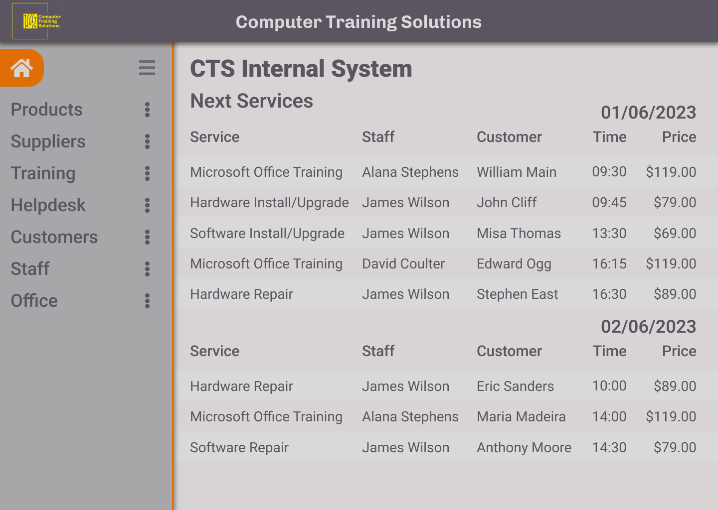

#### Context Menu

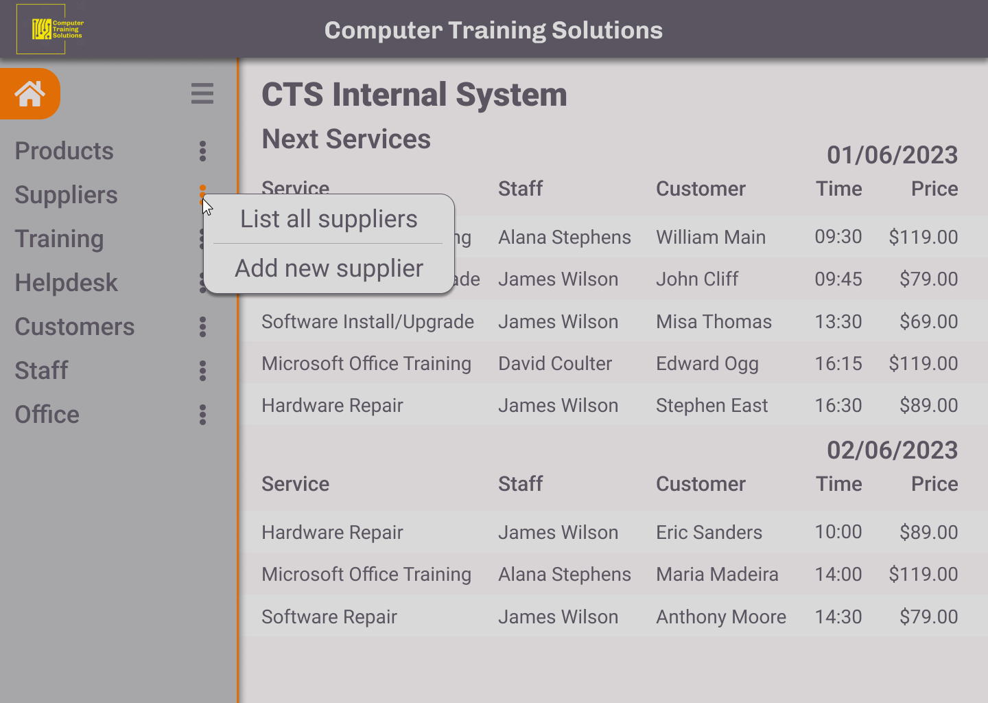

#### Listing all entries from table

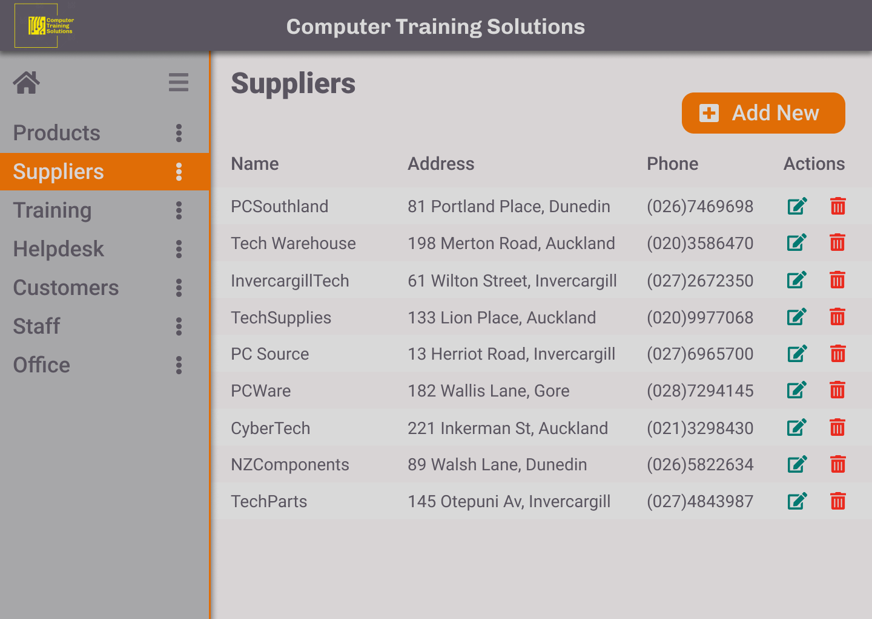

#### Adding new entry to table

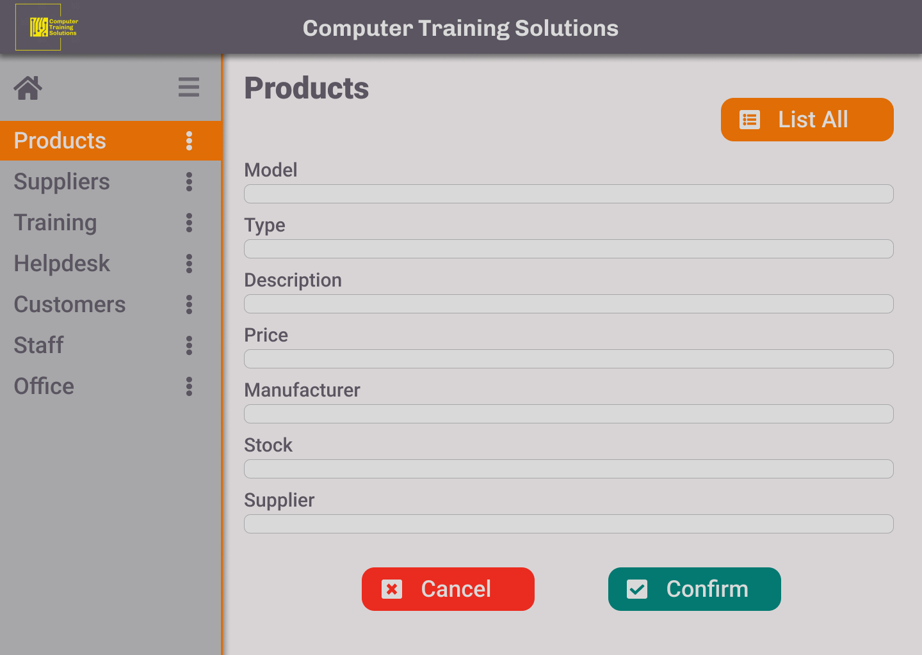

#### Editing existing entry

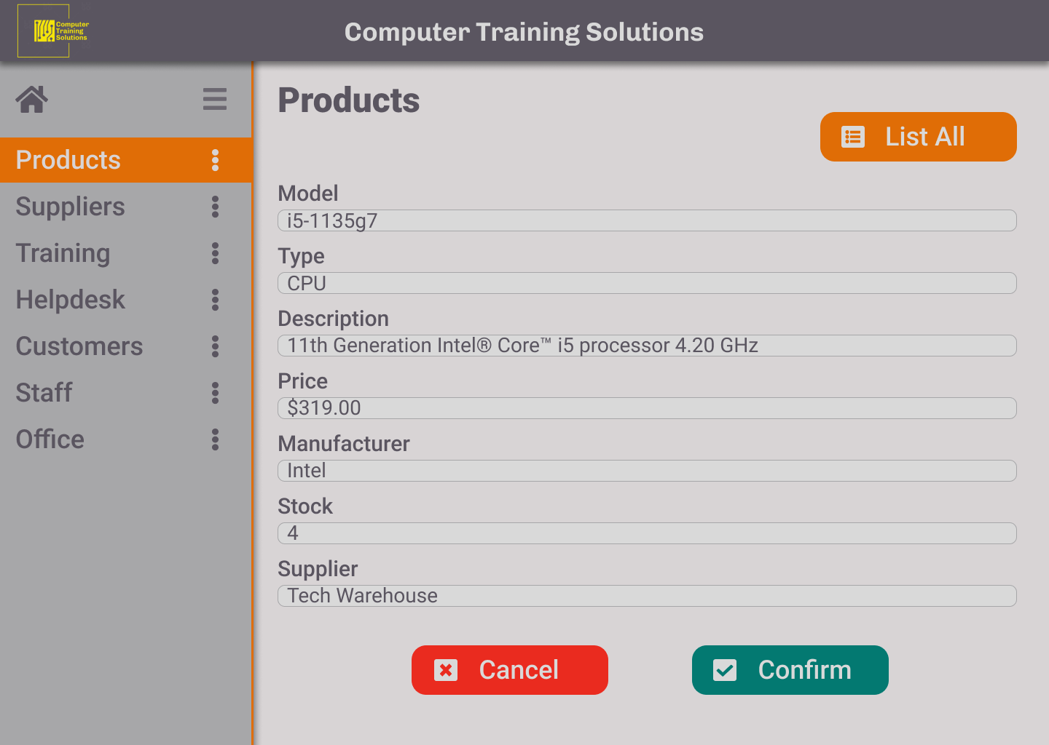

# UX/UI Interaction Design Principles

I’ve selected some UI/UX design principles to serve as evaluation criteria to check if the prototype meets the expected standards of user experience. The selected UI/UX design principles are:

* Consistency:  
  This principle refers to maintaining uniformity and coherence in the design elements and interactions throughout the interface. The interface must have standardized visuals and behaviors, with logical placement of elements and no unexpected response to user interaction.
* Efficiency:  
  It focuses on minimizing the time and effort required for users to accomplish their tasks within the interface. It involves having a logical workflow, reducing unnecessary steps, and providing shortcuts or automation features.
* Learnability:  
  This principle refers to how easily users can understand how the system should be used and become proficient in using it. The workflows has to be intuitive and self-explanatory.
* Visual Hierarchy:  
  This principle involves organizing and presenting interface elements in a way that makes the user pay attention to where attention is necessary. Details like color, size, fonts, and placement indicate the importance and relationships between the elements.

Tests and Evaluation

I've conducted tests to evaluate the prototype based on the four principles: Consistency, Efficiency, Learnability, and Visual Hierarchy. Although the prototype is not interactive, I used the wireframe and visual prototype of the screens to simulate user interactions.

1. Consistency: The prototype demonstrates a consistent design language with uniform button styles, icons, and color scheme across screens. Generally, the elements are cohesively placed, however, a few inconsistencies were identified in the placement of navigation elements, which will be adjusted to maintain consistency.

2. Efficiency: Although actual task completion time couldn't be measured due to the lack of interactivity, the interface design shows how efficient the workflow can be. The layout and organization of information are intuitive, and the flow of screens is logical.

3. Learnability: The workflow is easy to understand, the purpose of each screen is logical. However, tooltips for icons and buttons could be provided for better learnability.

4. Visual Hierarchy: Attention is drawn to important information and actions due to the clear visual hierarchy established in the prototype. The use of size, color, and placement effectively guides focus.

Although the prototype couldn't be fully tested in an interactive manner, the evaluation provided valuable insights. The feedback received will be considered during the iterative design process to refine the interface further. Future testing with an interactive prototype should allow for more comprehensive assessment and validation of the design decisions made based on the principles of consistency, efficiency, learnability, and visual hierarchy.  
  
  
Refinements

Based on the evaluation of the prototype and its results, I’ve selected some potential refinements that can be considered for future versions:

Improve the clarity of icons used in the interface by providing tooltips or explanatory labels. This will help users better understand the functionality and purpose of each icon. Identify opportunities to streamline the workflow and reduce the number of steps required to complete tasks. This can enhance the overall efficiency of the system and improve user productivity. Design versions of the interface so it can be responsive for different screen sizes, adjusting size and placement of elements and text, making it usable not only in computers with monitors of different sizes, but also other types of devices, like smartphones and tablets. Implement clear error handling mechanisms and provide informative feedback to users when they encounter errors or perform actions. This will help users understand the cause of errors and guide them towards resolving them. Additionally, we could ensure the prototype meets accessibility standards by incorporating features such as alternative text for images, proper color contrast, and keyboard accessibility. This will make the system usable for a wider range of users, including those with disabilities.

References

*LinkedIn. (n.d.). The Basics of UX/UI Design Principles:*

<https://www.linkedin.com/pulse/basics-ux-ui-design-principles-chris-direduryan>

*Springboard. (n.d.). 10 Essential UX Design Principles to Follow:*

<https://www.springboard.com/blog/design/ux-design-principles/>