**Lab 1**

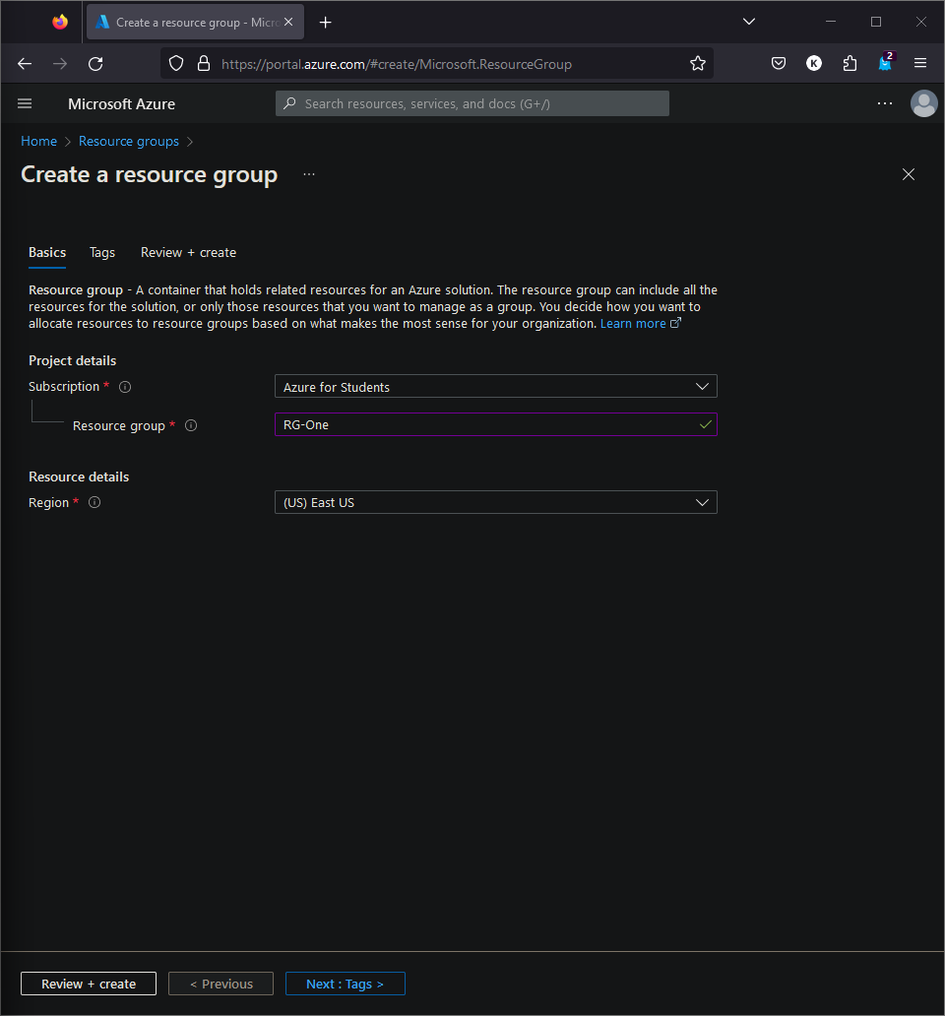

**Lab 8**

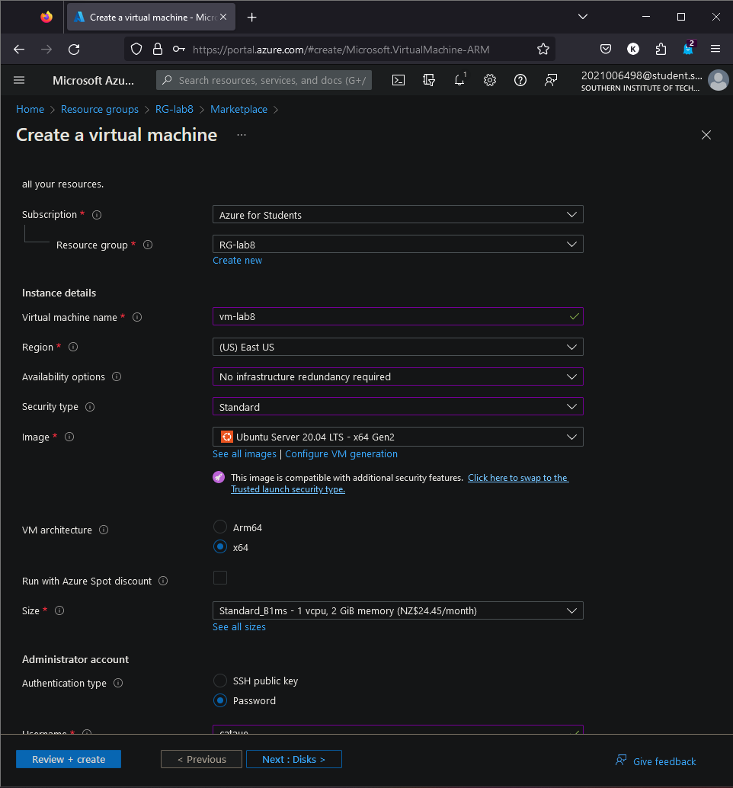

**Lab 3**



