**ITC606 Lab. Week 10**

Student Number 2021006498

Name Kauê Reis de Assis Pereira

**Upload to Black Board Labxx**

**File name: ITC606Labxx_*YourFirstName***

1. **Screenshot of Solution 1**

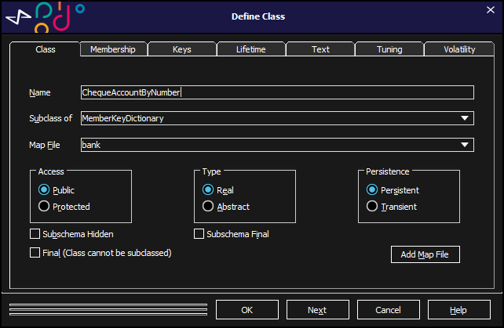

1. **Screenshot of Solution 2**

1. **Screenshot of Solution 3**

1. **Screenshot of Solution 4**

1. **Screenshot of Solution 5**

1. **Screenshot of Solution 6**

1. **Screenshot of Solution 7**

1. **Screenshot of Solution 8**

1. **Screenshot of Solution 9**

1. **Screenshot of Solution 10**

1. **Screenshot of Solution 11**

1. **Screenshot of Solution 12**

1. **Screenshot of Solution 13**

1. **Screenshot of Solution 14**

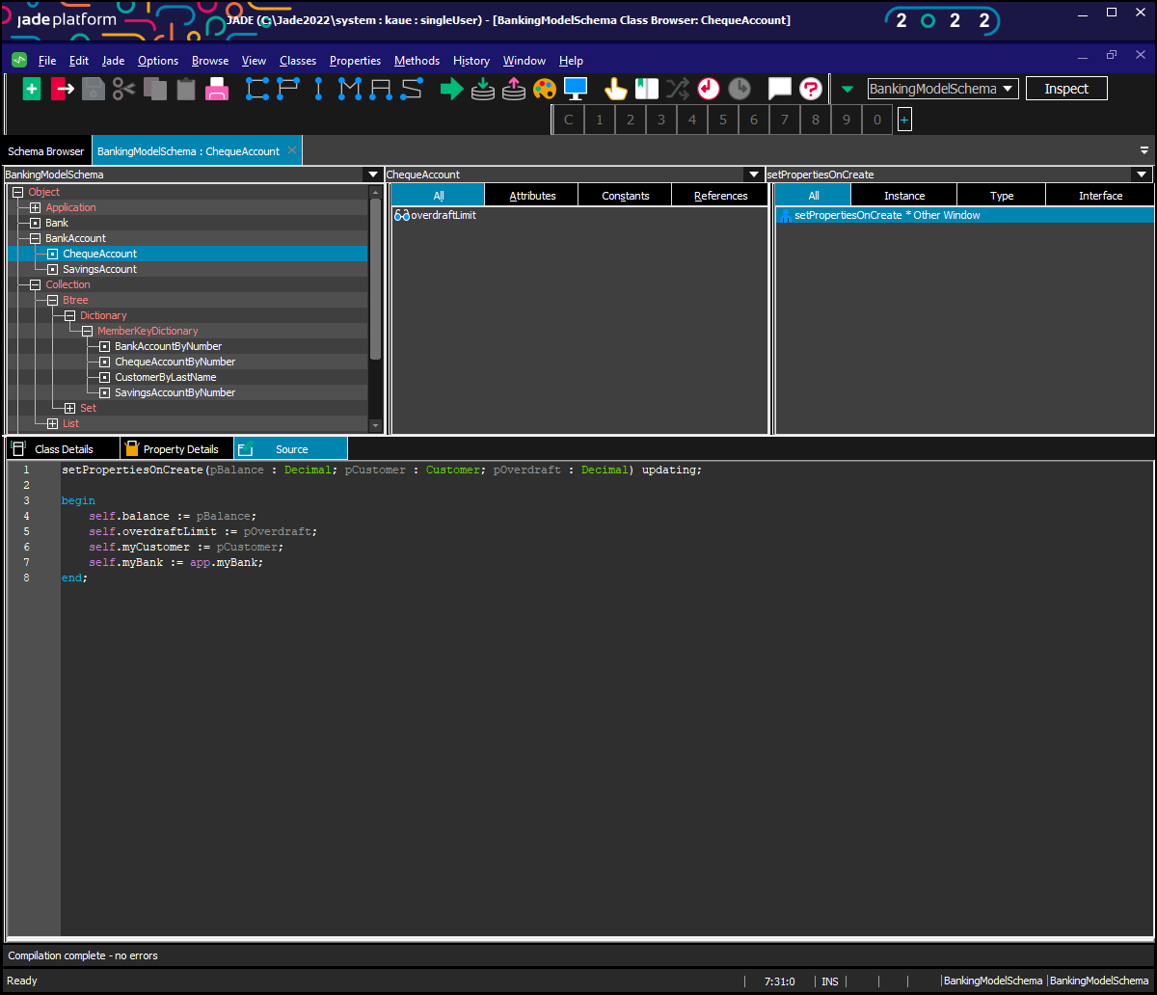

1. **Screenshot of Solution 15**

1. **Screenshot of Solution 16**

1. **Screenshot of Solution 17**

